Ruabon News Letter 615


"Extreme" North Wales temperatures in North Wales have caused school closures, train service disruption and led to council operations being curtailed with the mercury hitting 34C across large parts of the region.

A new record high temperature has been set for June for the second day in a row as the UK swelters in a punishing heatwave.
The Met Office said temperatures had reached 36.4C at Yeovilton, Somerset, on Thursday afternoon, provisionally making it the UK’s hottest June day on record.

The new high surpasses both the previous record set on Wednesday, when temperatures reached 36.1C in Gosport, Hampshire, and the long-standing record for June heat which dates back to the infamous summer of 1976.

A number of schools have been closed across North Wales today, with rail services also affected. A red weather warning for parts of South Wales and England are in place, and amber heat warnings are in place across North Wales. A Met Office thunderstorm warning then comes into force for North Wales at midnight, and remains in place until 10am.

**********************************

Wrexham is getting ready to welcome a brand-new summer event for children and families, with Kids-fest bringing live music, activities, street food, crafts and plenty of festival fun to the city centre.

The event will take place on Saturday, 1st August, from 12pm to 7pm on Llwyn Isaf, giving families a full day of music, creativity and play during the summer holidays.

Kids-fest is being brought to Wrexham by Wrexham County Borough Council, in collaboration with Nightingale House Hospice, sponsored by Read Construction, and supports Wrecsam2029, Wrexham’s bid to become UK City of Culture 2029.

Created as a music festival for children, Kids-fest will offer a vibrant day out in the heart of Wrexham. Visitors can look forward to live music, hands-on activities, delicious food and drink, crafts and more, with the full line-up and schedule to be announced soon.
Play and playfulness are key themes in Wrexham’s bid for UK City of Culture 2029, and Kids-fest will help bring those ideas to life through music, creativity, family activity and shared experiences in the city centre.Donations to Nightingale House Hospice are encouraged to enter the event.Cllr Nigel Williams, Lead Member for Business, Economy and Tourism at Wrexham County Borough Council, said:
“It’s fantastic to be bringing a new family event like Kids-fest to Wrexham this summer.”

“We know the school holidays can be a busy and expensive time for families, so having a low-cost event in the city centre where children enjoy live music, activities and a proper festival atmosphere is something really positive.”
- Info -

“It will be great to see Llwyn Isaf full of families, music and colour, and we hope it will bring lots of people into the city centre to enjoy the day, visit our shops, cafes and restaurants, and support local businesses.”Elise Jackson, Event, Campaigns and Community Fundraising Manager at Nightingale House Hospice, said:
“We’re incredibly excited to be part of bringing Kids-fest to Wrexham. At Nightingale House Hospice, community is at the heart of everything we do, and this event is a wonderful opportunity to bring families together for a day of fun, creativity and music.
“We hope it not only creates special memories for children and their families but also helps raise awareness of the vital care and support we provide across the region.”

Further details about Kids-fest, including the full music line-up, activities and event schedule, will be shared in the coming months.

The Latest Press Information is Now Available Below

“Recently, 6 gifted Year 10 mathematicians were invited to participate in a 'Maths Conference' hosted in Wrexham University.
Along with other schools across Wrexham and Denbighshire, they were involved in talks exploring a range of mathematical concepts designed to enthuse and engage them in the subject.

They learnt about flight motion and the forces involved, volume and the structure of 3D shapes, and they even tried their hand at an international trade game involving shapes.

Part of this year's conference was to celebrate Women in Mathematics and the contribution to codebreaking they made in the Second World War!

Mrs Emma Beveridge, Curriculum Leader for Maths said:
''The students were fantastic and extremely well behaved and polite to the speakers.

They did themselves proud and really enjoyed the very challenging concepts that were involved in the day.
Da Iawn 👏👏''.

Left to right on picture 5 outside the school are the pupils -
Verna Abih, Maddie Clucas, Jennifer Hughes, Maisy Jones,
Noah Thomas and Thomas Harrison.

**********************************





Wrexham’s Leading Attractions Unite to Launch New Venture Trail
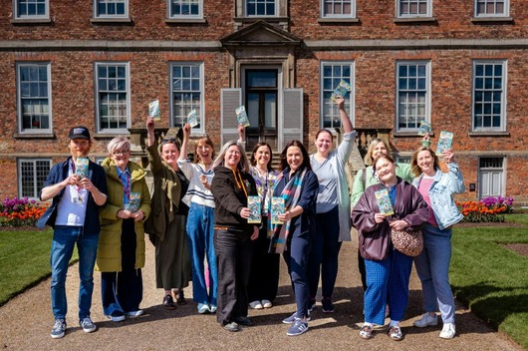

Eight of Wrexham’s most loved attractions have come together in a new joint venture designed to showcase the very best the county borough has to offer.
The trail highlights eight must-see locations across the area, guiding visitors through a journey that spans 314 million years of history, from ancient, fossilised forests industrial heritage to modern culture, creativity, innovation, science and the future we are building today.
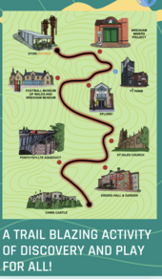 |  | Participating attractions include:  - Stori Brymbo (opening June 2026)  - Xplore! Science Discovery Centre  - Football Museum of Wales and Wrexham Museum (opening 2026)  - Wrexham Miners Project  - St Giles’ Church  - Erddig Hall & Garden  - Chirk Castle & Garden  - Pontcysyllte Aqueduct & Visitor Centre  Pick up a map/guide brochure from any of the attractions or view the trail online here
An investigation is underway after the Shocking Discovery of a Dog Dumped in the River Dee in a Black Sports Bag.

The Dead Dog had been Zipped Inside the Bag and Weighted Down with Rocks.This appalling incident followed a very similar discovery made just 24 hours earlier in Bristol, England. On that occasion a lurcher-type puppy was found on a stream edge with its legs trapped beneath a large rock, seemingly deliberately.

North Wales Police were alerted to the River Dee discovery on June 26, passing the details to RSPCA officers. A member of the public found the submerged Adidas bag near the A534 bridge at Holt, Wrexham. It’s a popular walking area.

The dog was a dark-coloured, unneutered male. It’s thought to be a Pocket Bully, a smaller variant of the American Bully. The dog’s tail may have been docked.


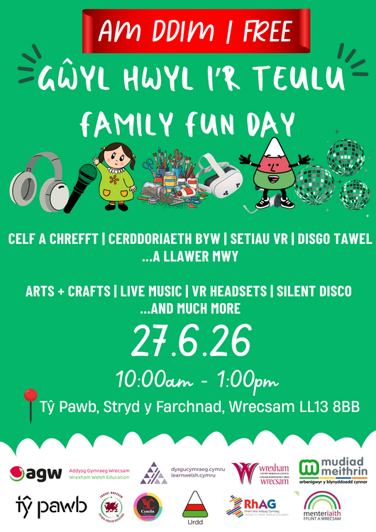

Tŷ Pawb has teamed up with local Welsh language organisations to host a free family fun day.

The event will take place on Saturday 27th June from 10am-1pm and will include a silent disco, arts and crafts, virtual reality headsets, face painting and even a special visit from ‘Mistar-Urdd’!
There will also be live music in the Food Court from 12pm with Wrexham’s Andy Hickie, local choir The James Lambert Singers, and Selar EP of the Year Winner & S4C Cân i Gymru finalist Rhi Jorj a’r band.

The event is open to everyone! You won’t need to be able to speak Welsh to enjoy the activities – but there's never been a better time to start learning and this will be a fantastic opportunity to find out more about all the brilliant Welsh language education, support and services available locally for children and adults in the Wrexham area.

Music Festival for Kids coming to Wrexham this August
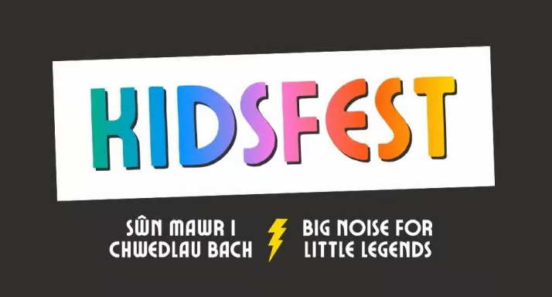

The event will take place on Saturday, 1st August, from 12pm to 7pm on Llwyn Isaf, giving families a full day of music, creativity and play during the summer holidays.

Kids-fest is being brought to Wrexham by Wrexham County Borough Council, in collaboration with Nightingale House Hospice, sponsored by Read Construction, and supports Wrecsam2029, Wrexham’s bid to become UK City of Culture 2029.

Created as a music festival for children, Kids-fest will offer a vibrant day out in the heart of Wrexham. Visitors can look forward to live music, hands-on activities, delicious food and drink, crafts and more, with the full line-up and schedule to be announced soon.
Newyddion Llyfrgelloedd
Library News
Newyddion Llyfrgelloedd am yr wythnos yn dechrau 5 Gorffennaf
Library News for the week beginning
5th July

Cyfnewid Llyfrau LHDTCRhA+ yn Llyfrgell Wrecsam
LGBTQIA+ Book Swap at Wrexham Library
Bring your pre-loved LGBTQIA+ books to Wrexham library any time the library is open between the 11th and the 24th of July and receive a token for every book you hand in.
Then on 25th July come to Wrexham library with your tokens to swap them for books brought in by other people! Any genre and style is accepted including graphic novels and non-fiction, but books must be in good condition. Any leftover books will be donated to Wrexham Library.

Cyfnewid Cardiau Pokémon yn Llyfrgell Coedpoeth
Ydych chi'n casglu cardiau Pokémon? Beth am ymuno â ni yn llyfrgell Coedpoeth am gyfnewid Cardiau Pokémon ar 24 Gorffennaf, 1.00-3.00pm. Mae'r cyfnewid cardiau ar agor i blant o bob oed yn unig.
Pokémon Card Swap at Coedpoeth Library
Do you collect Pokémon cards? Why not join us at Coedpoeth library for a Pokémon Card swap on 24 July, 1.00-3.00pm. The card swap is open to children of all ages only.

Sgwrs am Enwau Lleoedd Hanesyddol yn Llyfrgell Wrecsam
Dewch i glywed y Swyddog Enwau Lleoedd, Dr James January-McCann, yn trafod enwau lleoedd hanesyddol yng Nghymru, ac ymdrechion parhaus y Comisiwn Brenhinol i'w diogelu ar gyfer cenedlaethau'r dyfodol. Cynhelir y digwyddiad yn Llyfrgell Wrecsam ddydd Mercher 29 Gorffennaf rhwng 2.30 a 3.30pm. Mae'n rhad ac am ddim ond mae archebu'n hanfodol; cysylltwch â'r llyfrgell ar 01978 292090 | library@wrexham.gov.uk
Historic Place Names talk at Wrexham Library
Come and hear Place Names Officer Dr James January-McCann discussing historic place names in Wales, and the Royal Commission's ongoing efforts to protect them for future generations. The event takes place at Wrexham Library on Wednesday 29th July 2.30-3.30pm. It is free of charge but booking is essential contact the library on 01978 292090 | library@wrexham.gov.uk

PressReader
Mae PressReader yn ap a fydd yn rhoi mynediad am ddim i chi i bapurau newydd a chylchgronau, o 120 o wledydd ledled y byd, 24/7. Mae'r cyhoeddiadau ar gael mewn testun llawn, ar ddiwrnod eu cyhoeddi ac yn edrych yn union fel yr argraffiad printiedig. Gellir eu gweld ar-lein trwy borwr gwe, neu drwy’r ar ffôn smart neu lechen. Y cyfan sydd ei angen yw cerdyn llyfrgell dilys a mynediad at ddyfais ddigidol. Ewch i www.wrecsam.gov.uk/llyfrgelloedd a dilynwch y ddolen gwasanaethau ar-lein i’n app, yna chwiliwch am PressReader. Bydd gennych fynediad i holl brif bapurau newydd dyddiol a phenwythnos y DU gan gynnwys The Daily Post, Western Mail, Y Cymro, Wales on Sunday a llwer mwy.
Press Reader
PressReader is an app which will give you free access to newspapers and magazines, from 120 countries around the world, 24/7. The publications are available in full text, on the day of publication and look just like the printed edition. They can be viewed online through a web browser, or via the app on a smart phone or tablet. All you need is a valid library card and access to a digital device. Visit www.wrexham.gov.uk/libraries and follow the online services link to app, then search for Press Reader. You will have access to all of the major UK daily and weekend newspapers including The Daily Post, Western Mail, Y Cymro, Wales on Sunday and many more.

Oeddech chi'n gwybod…?
Oeddech chi'n gwybod bod gan Lyfrgell Wrecsam adran ar gyfer llyfrau sy'n ymroddedig i straeon byrion? Felly, os ydych chi'n teimlo nad oes gennych chi ddigon o amser i fuddsoddi mewn nofel, beth am roi cynnig ar stori fer? Gall staff eich helpu i ddod o hyd i rywbeth yr hoffech chi, felly rhowch wybod i ni beth yw eich dewisiadau darllen.
Did you know…?
Did you know Wrexham Library has a section for books dedicated to short stories? So, if you feel you don’t have enough time to invest in a novel then why not try a short story? Staff can help you find something you’d like so please let us know your reading preferences.

Adolygiad Llyfr Saesneg
Adrift gan Will Dean
Adroddir y stori mewn penodau bob yn ail rhwng Peggy Jenkins a'i mab pedair ar ddeg oed, Samson (Sammy), sy'n byw ar ddarn anghysbell o gamlas yng Nghanolbarth Lloegr. Gyda'i gilydd maent yn brwydro yn erbyn y gŵr a'r tad - Drew, personoliaeth narsistaidd ystrywgar a rheoli, sy'n mynnu unigedd i "ganolbwyntio ar ysgrifennu," ond mewn gwirionedd mae'n defnyddio'r unigedd i ddominyddu ei deulu, gan reoli eu bwyd, eu symudiad a'u rhyngweithiadau cymdeithasol. Os bydd unrhyw 'fygythiad' canfyddedig yn ymddangos, mae Drew yn symud y cwch ymhellach o wareiddiad i dynhau ei afael, gan arwain at droell drychinebus o ddigwyddiadau. Mae hon yn llyfr gyffro seicolegol tywyll iawn sy'n canolbwyntio ar deulu sydd wedi'u dal ar gwch camlas, yn delio â cham-drin domestig dwys, cam-drin meddyliol, bwlio, nwy-oleuo, ac unigedd. Nid yw'n ddarllen hawdd ac efallai y bydd rhai yn ei chael yn ofidus, ond i ddyfynnu'r awdur weithiau 'mae angen y teimlad hwnnw o gamu i mewn i lyfr, cerdded yn esgidiau rhywun arall am ychydig, empatheiddio â'u sefyllfa bywyd.' Os ydych chi yn y meddwl cywir, fyddwch chi ddim eisiau rhoi'r un hon i lawr!
Book Review
Adrift by Will Dean
The story is told in alternate chapters between Peggy Jenkins and her fourteen-year-old son, Samson (Sammy), who live on a remote stretch of canal in the Midlands. Together they battle against the husband and father - Drew, a manipulative and controlling narcissistic personality, who insists on isolation to "focus on writing," but actually uses the isolation to dominate his family, controlling their food, movement, and social interactions.
******************************************************


If EVER you need to contact a person who is Extremely Clever at finding out what is wrong –with your computer, then I can honestly recommend Mr Chris Williams.
(Who is also a very kind and considerate Gentleman.)

***************************************************

FOOT CARE By PODIATRIST THOMAS JENESON @ Grosvenor Lodge(1 Grosvenor Road, Wrexham) 01978 800777 tajeneson@gmail.com.

*****************************************

Best Wishes AND Thank You (from Sybil Bremner)

