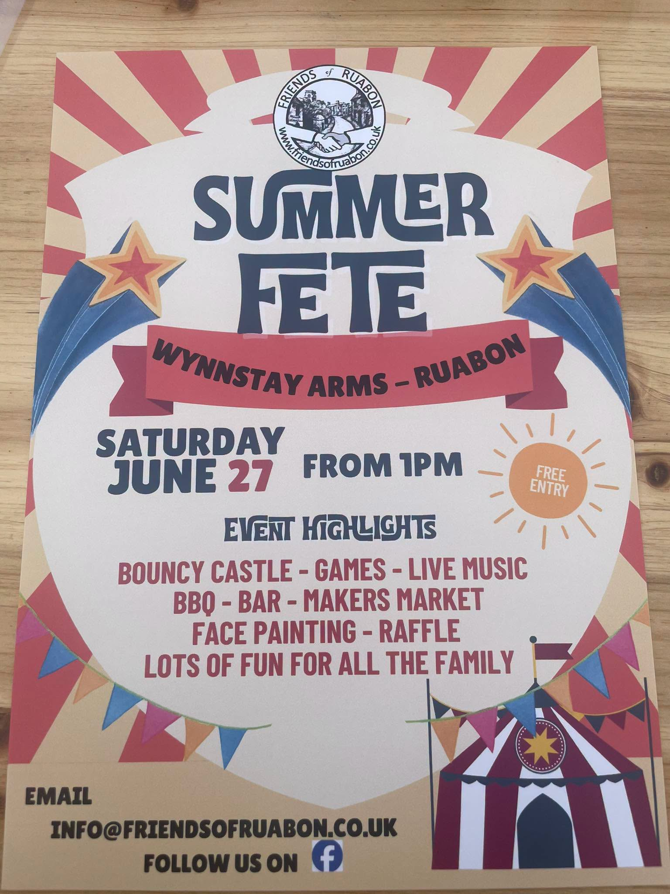
Ruabon News Letter 614
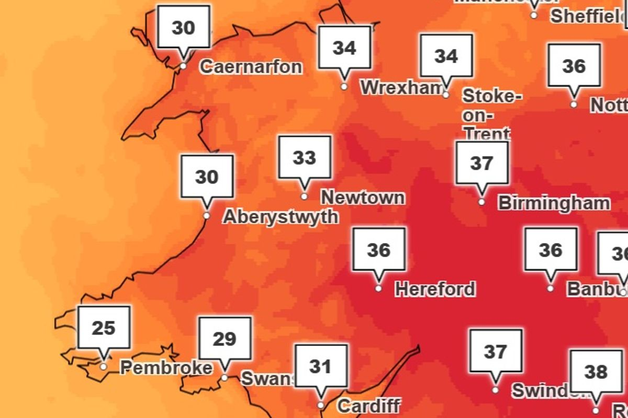
Met Office warns of 'severe weather event' with 38C high in four-day heatwave

The Met Office has warned next weeks heatwave is developing into a "severe weather event". Met Office Amber Extreme Heat Warnings have been issued from Monday through to Thursday with temperatures widely exceeding 35°C. Temperatures will quickly rise on Monday morning and are forecast to reach 34°C in southern parts of England.
The heat will build further into Tuesday, with highs of 37°C forecast for southern England and 35°C southeast Wales. The peak of the heatwave is now forecast for Wednesday and Thursday, when temperatures are expected to climb to 38°C. By Friday conditions will be less hot, with highs of 33°C forecast across eastern areas.

Overnight temperatures will also be very high, with widespread Tropical Nights, where the temperature does not drop below 20°C, across southern parts of England especially in urban areas. Humidity is also a factor, making this heatwave even more impactful with heat stress a danger to all. In North Wales the peak of the heatwave is expected to hit on Thursday with highs of 34C predicted for Wrexham and north east Wales.
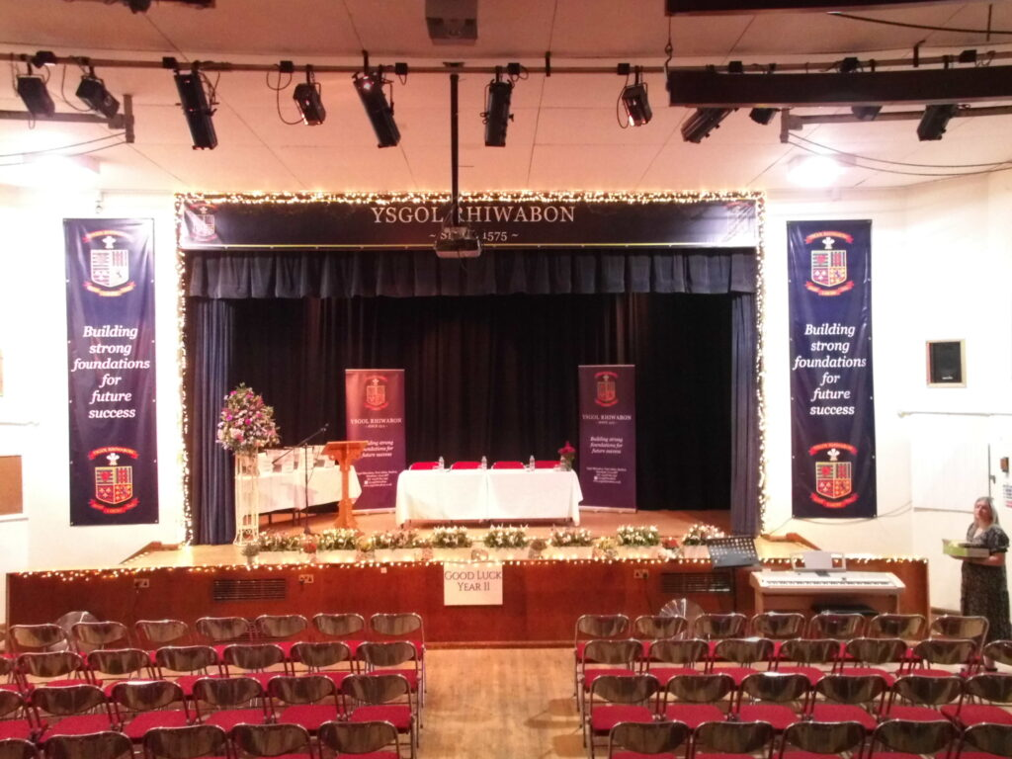
2026 Celebration and Prom 1

The Ysgol Rhiwabon Year 11 Personal Profile Ceremony was held on June 18th, followed by the Prom celebrations at The Rossett Hall Hotel.
On a picture-perfect, sunny evening, the Year 11 students met at the school, with just over 250 parents and family members waiting to greet them and take photographs in the school grounds.
There were some marvellous vehicles on show bringing students to the ceremony from a range of cars to motorbikes, numerous supercars and even a commercial lorry and a beautifully decorated horse.
The Personal Profile ceremony was hosted by Mrs Davies Bottomley Lead Learner for Year 11 who delivered an emotional speech, in front of our families, as she said a fond farewell to her students wishing them happiness and success in the future.

The achievement files were presented by the Chair of Governors, Mrs Joan Lowe and Headteacher, Mrs Melanie Ferron-Evans, supported by the Year 11 Form Tutors.

Mrs. Joan Lowe, Chair of Governors said:

‘It is a privilege to see our Year 11 students and recognise the journey that they have followed during their time in Ysgol Rhiwabon. The Governors and staff wish them well as they venture into the wider world and the school sends their best wishes to all of them for the future. We are very proud of them.’ The students then travelled to Rossett Hall Hotel for their Prom Party where they danced the night away in high spirits, matched by the weather. It was an amazing evening!

Here are some pictures from a magical evening –








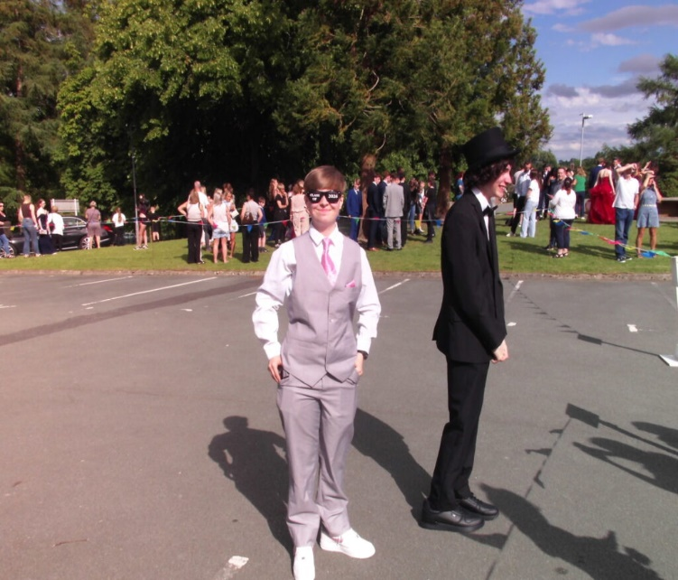

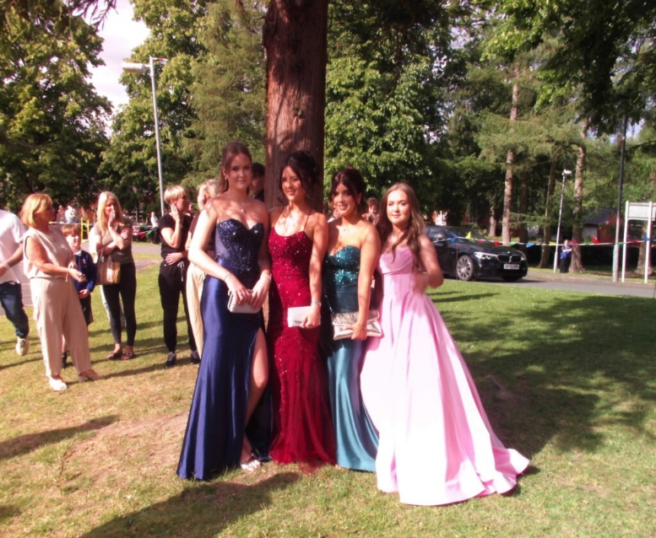

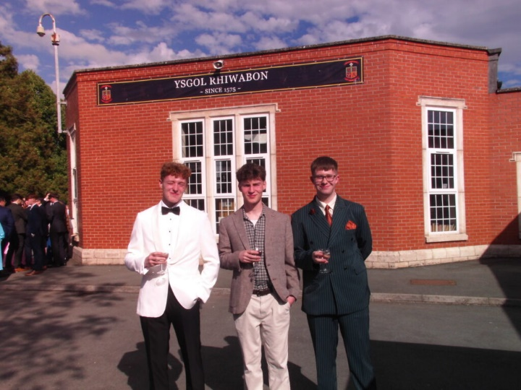



Rounders champions!

Tuesday, 23rd June 2026
An amazing week of rounders for all of our teams.
All year groups competed in the Wrexham area rounders tournament.
Every girl who represented Ysgol Rhiwabon did both themselves and the school proud!

Their behaviour, effort and attitude was exemplary and their hard work really has paid off!
Year 7 – 1st place – COUNTY CHAMPIONS
Year 8 – 1st place – COUNTY CHAMPIONS
Year 9 – 4th place
Year 10 -2nd place

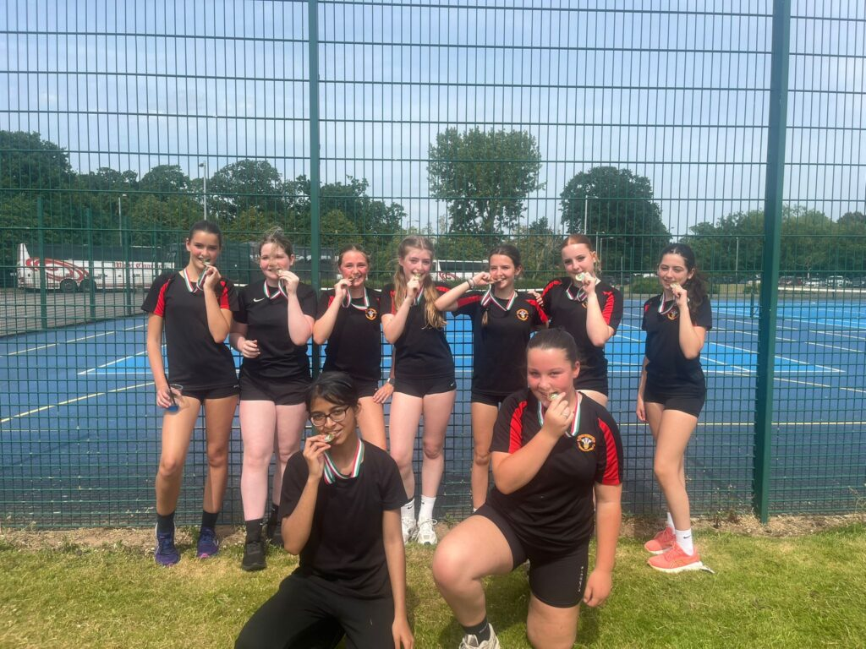
A special thank to Mrs. Davies-Bottomley for all of her hard work and enthusiasm.
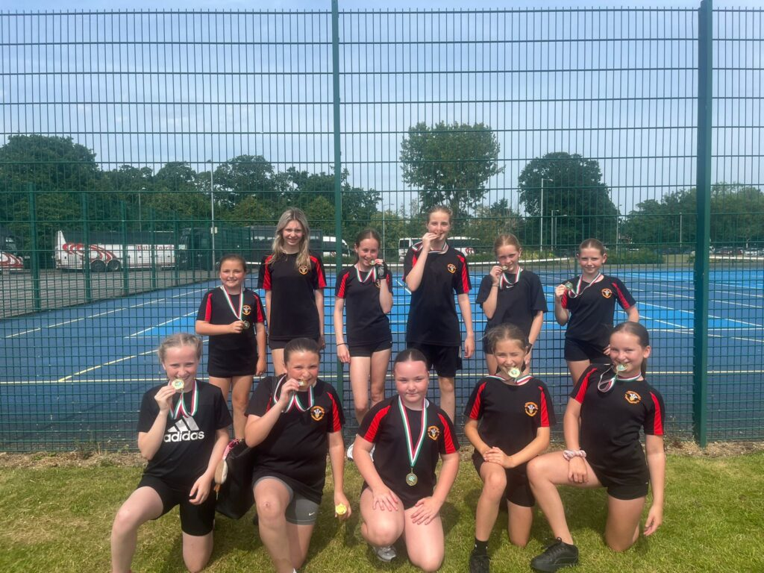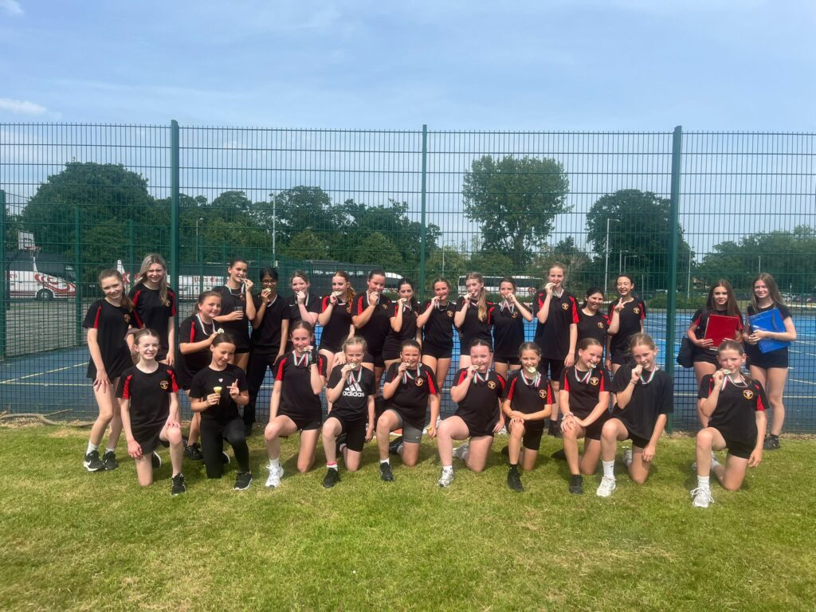

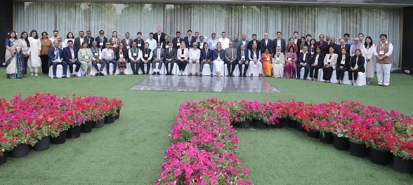
Dates: 14-16 April 2026 Location: New Delhi, India
Participants: Regional Consultation brought together more than 90 participants (both face-to-face and virtual) from all ten Member States, the SEAR-ITAG, vaccine manufacturers, academic institutions, regulatory authorities, and development partners.

Kate O'Brien, Director of the Department of Immunization, Vaccines and Biologicals at WHO
At the mid-way point of Immunization Agenda 2030 (IA2030), countries gathering at the Seventy-ninth World Health Assembly (WHA79) marked an important moment in reaffirming their commitment to reaching everyone, everywhere with life-saving vaccines.
Member States and global health partners strongly reasserted their support for the strategy, goals, and programmatic implementation of IA2030, recognizing immunization as one of the most powerful, cost-effective and equitable health interventions available. They also recognized that strong immunization programmes are a centre piece for emergency preparedness and response. This renewed commitment sends a clear message: vaccines are not only essential for disease prevention, but are also foundational to resilient health systems, global health security and equity.
Yet progress remains fragile. In too many countries, routine immunization coverage is slipping. Outbreaks of vaccine-preventable diseases are occurring in a wider range of countries, inequities are increasing even further affecting zero-dose children, and growing challenges linked to misinformation, conflict, climate pressures and constrained financing. These are not abstract risks — they are realities affecting more and more communities around the world. Discussions at WHA79 underscored that no country can afford complacency.
Initiatives such as The Big Catch-Up show what can be achieved through strong political commitment, financing and partnership. Countries have not only reached children who missed vaccinations during the COVID-19 but pandemic have also strengthened primary health care systems to help ensure no child is left behind in the future. However, recovery alone is not enough. We must go further to reach chronically missed populations, debunk misinformation that is striking communities, build up trust, and strengthen routine immunization programmes so they can withstand future shocks, which are inevitable.
This also means strengthening preparedness for health emergencies by ensuring rapid vaccine mobilization, reinforcing contingency planning, and tightening up the integration of immunization, surveillance and emergency response systems. The ability to anticipate, prepare for and respond to outbreaks of vaccine-preventable diseases will be increasingly critical in a complex and evolving local and global environment.
This past month also brought encouraging new evidence of the impact vaccines can achieve.
Newly published evidence on the public health use of the RTS,S malaria vaccine in the first African countries to offer the vaccine confirms that the malaria vaccine saves child lives and will have significant impact in wider rollout. Over four years, an estimated one in eight child deaths child deaths were averted among those eligible to receive the malaria vaccine in Ghana, Kenya and Malawi.
Today, with 25 countries in Africa offering malaria vaccines, the impact of vaccines will grow—to prevent malaria, drive down child mortality, and create additional health care touchpoints to deliver other essential health services. This is what integrated, life-course immunization looks like in practice.
At the same time, progress in other areas reminds us of the work still to be done.

Newyddion Llyfrgelloedd
Library News
Newyddion Llyfrgelloedd am yr wythnos yn dechrau 7 Mehefin
Library News for the week beginning 7 June

Archifau ac Astudiaethau Lleol Wrecsam
Mae Archifau ac Astudiaethau Lleol Wrecsam wedi symud i Lyfrgell Wrecsam. Maent ar agor i aelodau'r cyhoedd ar ddydd Llun, dydd Mawrth a dydd Mercher 9.00am-5.00pm. Wedi’i greu yn 1996, mae’r gwasanaeth gwerthfawr hwn wedi cronni cofnodion hanesyddol, mapiau a ffotograffau yn ymwneud ag awdurdodau lleol, ysgolion, eglwysi a chapeli amrywiol, busnesau lleol, cymdeithasau a sefydliadau, teuluoedd ac ystadau a llawer mwy o fewn y Fwrdeistref Sirol.
*Sylwer na all staff y llyfrgell gael mynediad at y gwasanaeth hwn y tu allan i oriau agor yr Archifau.

Wrexham Archives and Local Studies
Wrexham Archives and Local Studies have relocated to Wrexham Library. They are open to members of the public on Mondays, Tuesdays and Wednesdays 9.00am-5.00pm. Created in 1996, this valuable service has accumulated historic records, maps and photographs relating to local authorities, schools, various churches and chapels, local businesses, societies and organisations, families and estates and much more within the County Borough.
*Please note library staff cannot access this service outside of Archives opening hours.

Llyfrau ‘Dewis Cyntaf’
Ydych chi'n adnabod rhywun sy'n cael trafferth darllen, neu a ydych chi'n rhywun sydd angen magu eich hyder wrth ddarllen llyfrau? Mae gan Lyfrgell Wrecsam ddetholiad o lyfrau i’ch helpu i fagu hyder wrth ddarllen llyfr a fydd wedyn yn eich galluogi i ymlacio a mwynhau’r straeon sy’n cael eu hadrodd. Mae llyfrau'n amrywio o eiriau a brawddegau byr sylfaenol iawn, i nofelau byr hawdd eu darllen ac mae'r staff yno i'ch helpu i ddewis y llyfrau rydych chi'n teimlo'n fwyaf cyfforddus yn eu darllen. Beth am alw i mewn i weld beth allwn ni ei wneud i'ch helpu chi?
‘First Choice’ Books.

Do you know someone who is struggling to read, or are you someone who needs to build your confidence with reading books?
Wrexham Library has a selection of books to help you gain your confidence reading a book which will then enable you to relax and enjoy the stories being told. Books range from very basic short words and sentences, to short easy to read novels and the staff are there to help you choose the books that you feel most comfortable reading. Why not call in to see what we can do to help you?

Pythefnos HiVis: Llyfrgelloedd yn Cefnogi Darllenwyr â Nam ar eu Golwg
Mae pythefnos HiVis yn cael ei gynnal ledled y wlad o 1-14 Mehefin 2026 ac mae'n rhoi cyfle i lyfrgelloedd ledled y DU dynnu sylw at wasanaethau a chymorth i'r rhai â nam ar eu golwg. Os oes gennych nam ar eich golwg gall eich llyfrgell leol eich helpu o hyd i gael mynediad at ddeunyddiau darllen a llenyddiaeth dda. Mae pob llyfrgell yn cadw llyfrau mewn print bras sydd fel arfer mewn ffont 16 neu 18 (print arferol yw 10 neu 12). Mae gennym ddewis da o lyfrau sy'n cwmpasu pob genre mewn clawr meddal a chaled. Mae gennym hefyd gasgliadau o lyfrau sain ar gryno ddisg. Neu gallwch ddefnyddio ein hadnoddau digidol sy'n cynnwys e-lyfrau ac e-lyfrau sain gyda nodweddion hygyrchedd. Hefyd mae gennym fynediad i gylchgronau digidol a phapurau newydd. Gellir dod o hyd i'n holl ddeunyddiau digidol yn www.wrecsam.gov.uk/llyfrgelloedd a dilynwch y ddolen gwasanaethau ar-lein. Os oes angen cymorth arnoch, ffoniwch eich llyfrgell leol lle gallwn gynnig cymorth ar gyfer eich holl ofynion darllen.

HiVis fortnight: Libraries supporting visually impaired people
HiVis fortnight takes place around the country from 1-14 June 2026 and provides libraries across the UK the opportunity to highlight services and support for those with a vision impairment. If you are visually impaired your local library can still help you to have access to reading materials and good literature. All libraries stock books in large print which are generally in a 16 or 18 font (regular print is usually 10 or 12). We have a good selection of books covering all genres in paperback and hardback. We also have collections of audio books on CD. Alternatively, you can use our digital resources which contain e-books and e-audio books with accessibility features. Plus, we have access to digital magazines and newspapers. All of our digital materials can be found at www.wrexham.gov.uk/libraries and follow the online services link. If you need help then please do call your local library where we can offer assistance for all your reading requirements.

Theory Test Pro (gan gynnwys HGVs)
Nawr bod rhai o'r cyfyngiadau sy'n ymwneud â rhoi cynnig ar rai profion gyrru wedi'u lleddfu neu eu newid beth am ddefnyddio Theory Test Pro i'ch helpu gyda'ch dysgu. Mae Theory Test Pro yn wefan ar-lein sy'n cynnwys y banc cwestiynau prawf swyddogol cyfan, clipiau fideo canfyddiad perygl a fersiwn ar-lein o'r Cod Priffyrdd - y cyfan sydd ei angen arnoch i'ch helpu i basio'ch prawf gyrru theori. Mae ganddo fynediad i fanciau prawf ar gyfer categorïau ceir, beic modur, cerbyd cludo teithwyr a cherbydau nwyddau trwm. Gellir cyrchu'r wefan anhygoel hon yn rhad ac am ddim ar eich cyfrifiadur cartref, y cyfan sydd ei angen yw cerdyn llyfrgell dilys. I gael mwy o wybodaeth, ewch i www.wrexham.gov.uk/libraries a dewis Gwasanaethau Ar-lein.

Theory Test Pro (inc. HGVs)
Now that some of the restrictions around trying certain driving tests have been eased or changed why not use Theory Test Pro to help you with your learning. Theory Test Pro is an online site which contains the entire official test question bank, hazard perception video clips and an online version of the Highway Code – all you need to help you pass your theory driving test. It has access to test banks for car,

motorcycle, passenger carry vehicle and heavy goods vehicle categories. This amazing site can be accessed free of charge on your home computer, all you need is a valid library card. For more information visit www.wrexham.gov.uk/libraries and select Online Services.

Oeddech chi'n gwybod…?
Oeddech chi'n gwybod bod llyfrgelloedd yn benthyg dros 150 miliwn o lyfrau'r flwyddyn? Mae 3,712 o lyfrgelloedd cyhoeddus (gan gynnwys llyfrgelloedd symudol) yn y DU. Mae bod yn ddefnyddiwr rheolaidd o'r llyfrgell hefyd yn gysylltiedig â chynnydd o 1.4 y cant yn y tebygolrwydd o nodi iechyd cyffredinol da, a werthir ar sail arbediad cost meddygol sy'n gysylltiedig ag ymgysylltu â llyfrgelloedd o £1.32 y pen y flwyddyn.
Did you know…?
Did you know libraries issue over 150 million books a year? There are 3,712 public libraries (including mobile libraries) in the UK. Being a regular library user is also associated with a 1.4 per cent increase in the likelihood of reporting good general health, valued at a medical-cost saving associated with library engagement at £1.32 per person per year.

Adolygiad Llyfr Saesneg
The Family Friend gan Claire Douglas
Pan ddywedir wrth Imogen ei bod wedi etifeddu tŷ gwledig ger Caerfaddon, mae hi'n meddwl bod rhaid ei fod yn gamgymeriad. Gwelodd ei berchennog diwethaf, yr artist unig Dorothea Roe, un mlynedd ar bymtheg yn ôl, yn ystod haf trasig a newidiodd ei bywyd am byth. Nawr, gyda'i phartner Josh yn ei dilyn, mae'n gyfle i ddechrau o'r newydd. Ond ar ôl darganfod hen flwch gyda'i henw arno yn astudiaeth wag Dorothea, mae Imogen yn dechrau credu bod y fenyw yn ceisio anfon neges gyfrinachol ati. A phan fydd sibrydion yn dechrau troelli bod Dorothea wedi'i llofruddio, mae hi'n dechrau amau ​​nad yr anrheg hon oedd yr unig ffordd o achub y byd yr oedd hi'n ei feddwl. Mae'r naratif yn amrywio rhwng y presennol, wedi'i adrodd o safbwynt Imogen, a'r gorffennol, wedi'i adrodd o safbwynt Dorothea wrth iddi adrodd ei dyddiau olaf. Cymysgedd o ddirgelwch a chyffro, yn frawychus gyda thensiwn sylfaenol, yn hanfodol i gefnogwyr ffilmiau cyffro seicolegol sy'n gorffen gyda thro neu ddau!

Book Review
The Family Friend by Claire Douglas
When Imogen is told she's inherited a country house near Bath, she thinks it must be a mistake.
She last saw its owner, reclusive artist Dorothea Roe, sixteen years ago, during a tragic summer which changed her life for ever. Now, with partner Josh in tow, it's a chance for a fresh start. But after discovering an old box with her name on it in Dorothea's abandoned study, Imogen starts to believe the woman was trying to send her a secret message. When rumours begin to swirl that Dorothea was murdered, she starts to suspect that this gift might not be the life-line she thought it was.


If EVER you need to contact a person who is Extremely Clever at finding out what is wrong –with your computer, then I can honestly recommend Mr Chris Williams.
(Who is also a very kind and considerate Gentleman.)

***************************************************

FOOT CARE By PODIATRIST THOMAS JENESON @ Grosvenor Lodge(1 Grosvenor Road, Wrexham) 01978 800777 tajeneson@gmail.com.

*****************************************

Best Wishes AND Thank You (from Sybil Bremner)

