Ruabon News Letter 613
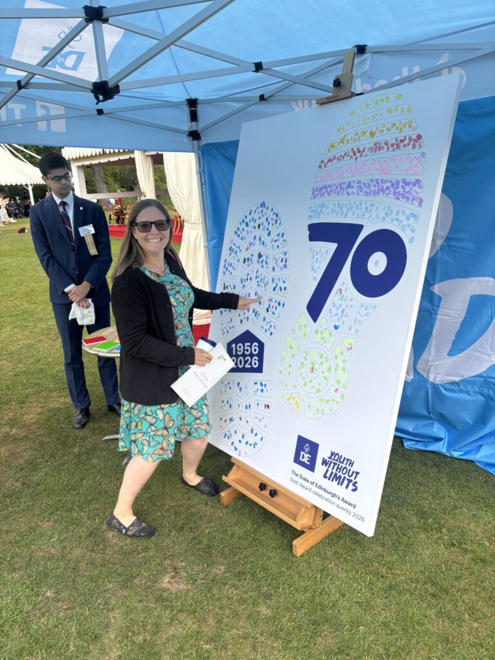
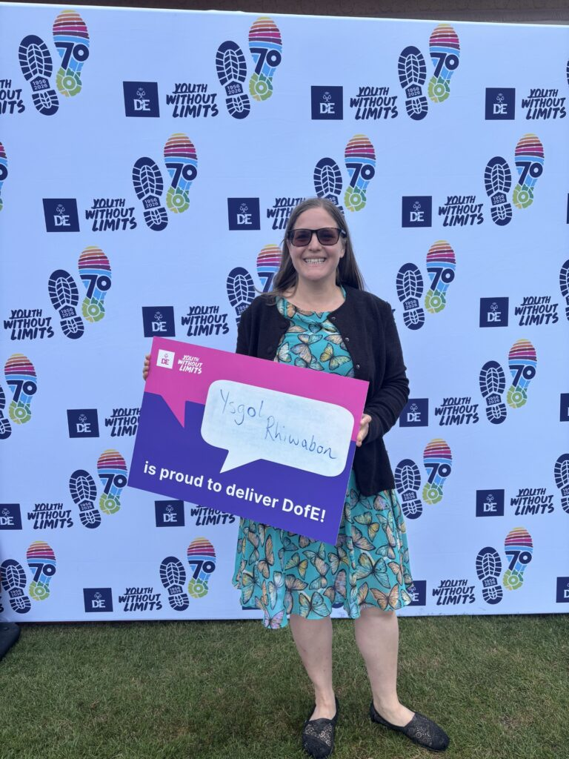

Buckingham Palace again!

Recently, Mrs. Naomi White, Curriculum Lead for Geography and the Duke of Edinburgh Award (DofE) attended a Buckingham Palace garden party to celebrate 70 years of the DofE Award running. It was attended by volunteers, gold award winners, DofE staff and the Duke of Edinburgh himself.

The Duke of Edinburgh Awards ( DofE) celebration events are designed for attendees to be able to enjoy a variety of activities within Buckingham Palace Garden whilst celebrating outstanding achievements through the DofE Award.

Central to each event are speeches from the West Terrace to reflect on all that has been achieved and to offer encouragement.
Mrs White said: ‘I mentioned our fantastic Year 9 students to the Duke when I spoke to him and how well they did on their recent practice expedition’.

Attached are pictures of Mrs. White at Buckingham Palace.
Further information about the Award Celebrations are available on the link below –https://www.dofe.org/do/gold-award-celebration/london/

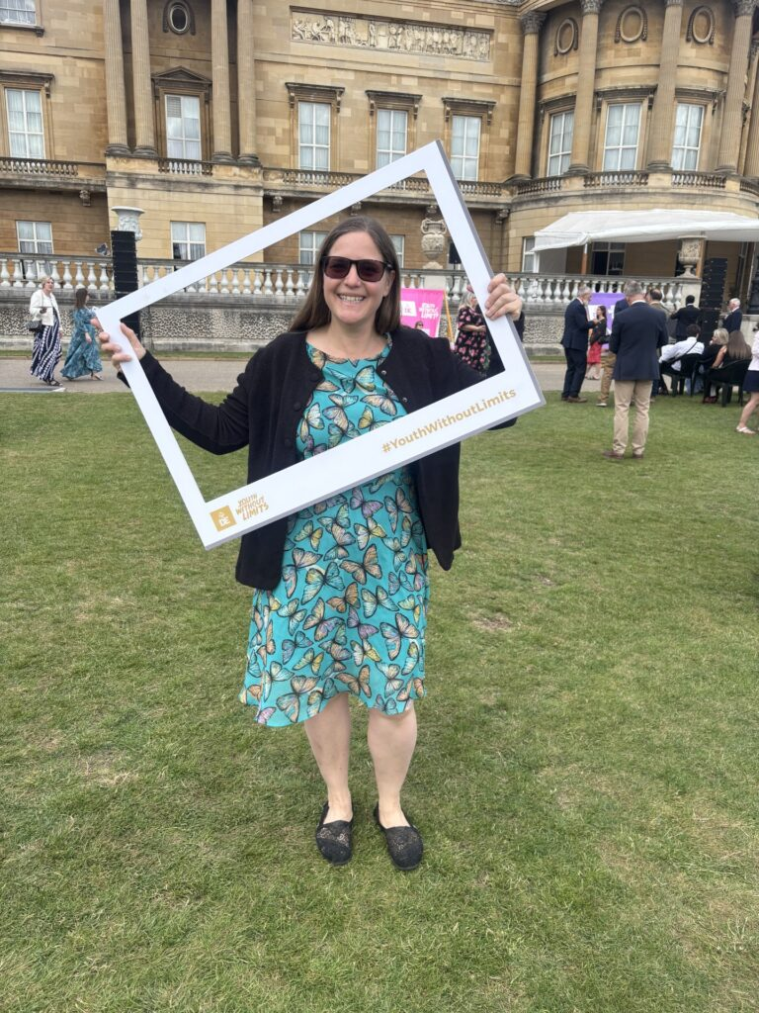

Wrexham AFC has now announced the full pre-season tour matches for the summer of 2026


Wrexham AFC are set to return to the United States this summer for WREXHAM IN THE USA 2026, a three-match pre-season tour across the East Coast. This marks Wrexham AFC’s third trip Stateside and first since 2024, representing a milestone as the Club’s first tour featuring exclusively Premier League opponents.

The first match takes place on Saturday, July 25, as Wrexham AFC face Leeds United at Raymond James Stadium in Tampa, Florida. On Wednesday, July 29, the Red Dragons travel to New York City to meet Liverpool at Yankee Stadium, a headline fixture at one of the US’ most iconic sporting stages.

The tour concludes on Sunday, August 2, when Wrexham AFC return to Subaru Park in Philadelphia to take on Sunderland AFC. In addition to the men’s first team, Wrexham AFC will bring along notable Club figures and former player legends, who audiences have come to love from the Emmy® Award-winning Welcome to Wrexham docuseries. Fans will have the chance to engage with these personalities, experiencing the magic of the Welsh city in the US.

WREXHAM IN THE USA 2026 continues the Club’s commitment to connecting with supporters worldwide. Following last summer’s tour of Australia and New Zealand, the US schedule – promoted by TEG Sport as part of the Summer Soccer Series – brings together four historic UK clubs for high-profile matches across the East Coast. These fixtures give fans the chance to see Wrexham AFC compete at renowned venues and are anticipated to deliver high-intensity contests that underline the Club’s ambition and rising international prominence.

Pre-sale tickets for the 2026 Summer Soccer Series will be available beginning March 10, with general on-sale commencing March 12. Full ticketing details, including purchasing information, kick-off times and broadcast arrangements, will be announced in due course.

Wrexham AFC manager Phil Parkinson said: “We are all looking forward to returning to the US as part of our pre-season preparations. We have had terrific support on our last trips to the States, and we can’t wait to see our supporters out there again, while also playing against three quality opponents in matches that will play a key part in us getting ready for the 2026/27 campaign.”

Wrexham AFC CEO Michael Williamson added: “WREXHAM IN THE USA 2026 takes us back to the United States for the first time since 2024 and in the same year the FIFA World Cup is being held in the States. The tour provides a fantastic opportunity for our growing fan base, especially those living in the US, to follow the team in action across three high profile matches. It is exciting to be playing in Florida and New York for the first time, and of course to be returning to Philadelphia, our co-chairman Rob Mac’s home city. The fact that we are playing Leeds United, Liverpool and Sunderland, all teams currently playing in the Premier League, promises three great occasions on big stages, and we look forward to seeing and meeting our fans there.”

STORI BRYMBO



A 314 Million Year Journey: From Fossil to Coal, Iron to Steel, Closure to Rebirth. We’re Stori Brymbo - the not-for-profit organisation that plans to bring Brymbo Heritage Area to life as a visitor attraction, learning centre, community hub and a go-to venue in North Wales. We’re local people working together to use our history to make our future. We hold a range of events and activities see our website for details and be sure to follow us on social media for all our latest updates.





Wrexham Business Start-up / Development Clinics

Grant funding of up to £1,500 available
Wrexham Council’s Business and Investment Team is pleased to deliver a new series of Wrexham Business Start-up / Development Clinics, providing practical guidance and support to individuals and early-stage businesses (trading less than 12 months). The initiative also offers the opportunity to access a 100% upfront grant, ranging from £500 to £1,500, for eligible applicants.

Clinic Dates and Format
The business clinics will take place at the Development Bank of Wales office, Wrexham, on the following dates:
- 3rd June

- 10th June

- 17th June

All sessions will run between 10:00am and 4:00pm. Booking is essential, as places are limited.
Each participant will be allocated a 30-minute appointment to present their business / idea to a panel of support organisations, including Business Wales, Prime Cymru, The King’s Trust, and the Development Bank of Wales. The panel will provide constructive feedback, guidance, and information on potential support available.

Participants who meet the eligibility criteria and demonstrate a viable business idea may be invited to progress to a Dragon’s Den–style pitch event, where there is the opportunity to secure grant funding of up to £1,500.
Eligibility Criteria
Applicants must meet the following criteria:
- The applicant (owner/director of the business) is aged 30+
- The business has not yet launched or has been trading for less than 12 months
- The business has an operating address within Wrexham County Borough
- The business has not previously received funding through this initiative

Football Museum of Wales and Wrexham Museum

On our blog you’ll find all the latest news and updates from the project plus special articles featuring stories from the vaults of Welsh football history and selected highlights from the Welsh Football Collection.
Join the Football Museum mailing list to get the latest articles delivered straight to your inbox.



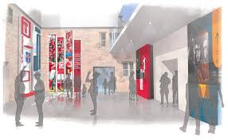

(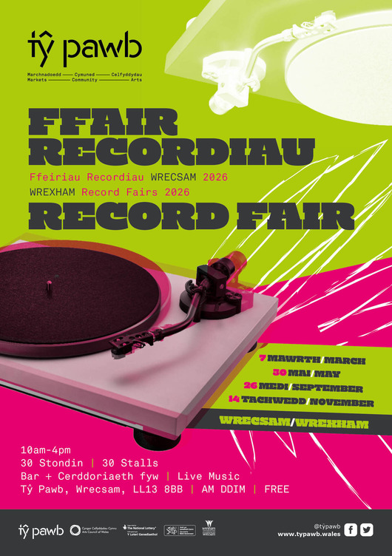

Dewch draw i archwilio trysorfa o recordiau o dros 30 o stondinau sy’n cynnwys prif werthwyr recordiau’r DU a fydd yn gwerthu finyl o bob cyfnod a genre. Dewch i ddod o hyd i fargen neu’r record brin honno rydych chi wedi bod yn ei hel.

Drwy gydol y dydd, bydd setiau DJ a cherddoriaeth fyw hefyd, bydd y bar ar agor a bydd bwyd gwych ar gael o’n Ardal Fwyd.

Bar, Ardal Fwyd, marchnad ac oriel ar agor drwy’r dydd – ynghyd â’n siop recordiau ein hunain ReVibed Records.

Darganfod mwy

Atyniadau Mwyaf Blaenllaw Wrecsam yn Uno i Lansio Llwybr Ymwelwyr Newydd


Mae wyth o atyniadau mwyaf poblogaidd a nodedig Wrecsam wedi dod at ei gilydd mewn menter ar y cyd newydd a gynlluniwyd i arddangos y gorau sydd gan y fwrdeistref sirol i'w gynnig.

Mae'r llwybr yn tynnu sylw at wyth lleoliad y mae'n rhaid eu gweld ar draws yr ardal, gan arwain ymwelwyr trwy daith sy'n cwmpasu 314 miliwn o flynyddoedd o hanes, o goedwigoedd hynafol, ffosilaidd, treftadaeth ddiwydiannol i ddiwylliant modern, creadigrwydd, arloesedd, gwyddoniaeth a'r dyfodol rydym yn ei adeiladu heddiw.

be selling vinyl of all eras and genres.

Come find a bargain or that rare record you’ve been chasing.

Throughout the day, there will also be DJ sets and live music, the bar will be open and great food will be on offer from our food court, plus our very own record shop ReVibed Records!

Find out more

FREE lunchtime concerts return to Tŷ Pawb


Free lunchtime concerts are returning to Tŷ Pawb for a new spring/summer season.

The concerts will take place between 1pm-2pm on selected Wednesdays from May until the end of July.

Performances will feature classical and contemporary music and will take place in the Performance Space.

The lineup assembled includes harpist Heledd Newton, winner of the Pendine Young Musician of Wales 2024 at the North Wales International Music Festival.

Also on the programme are two concerts with North Wales Opera Studio, and introduction to chamber music with Ensemble Cymru and a solo cello performance with Rebekah Clarke.

Entry is free – donations welcome.

Full programme

3 June
North Wales Opera Studio
Eve Callahan (soprano)
Ross Craigmile (piano)

17 June
North Wales Opera Studio
Khrystyna Makar (Ukranian soprano)

1 July
Heledd Newton
Harpist (Pendine Young Musician of Wales 2024 at the North Wales International Music Festival)

15 July
North Wales Opera Studio
Samantha Lewis (mezzo soprano)
Elizabeth Haughan (piano)

29 July
Rebekah Clarke
Solo cello performance

Find out more

 | 
 | GWASANAETHAU DANYSGRIFWYR: |  | SUBSCRIBER SERVICES:
 | Rheoli tanysgrifiadau |  | Manage subscriptions
 | Cysylltwch â ni |  | Contact us
 | Dad-danysgrifio |  | Unsubscribe
 | Newyddion Cyngor Wrecsam |  | Wrexham Council News
 | Help |  | Help

 | Arhoswch yn Gysylltiedig: |  |  |  | Stay Connected:

Diweddaru eich tanysgrifiadau, newid eich cyfrinair neu’ch cyfeiriad
e-bost, neu i ddifodd eich tanysgrifiadau ar unrhyw adeg ar eich Tudalen Gosodiadau Tanysgrifwyr. Bydd angen eich cyfeiriad e-bost i fewngofnodi. Os oes genych unrhyw gwestiynau neu broblemau gyda’r gwasanaeth tanysgrifiadau, ewch i cymorthidanysgrifwyr.govdelivery.com
Darparwyd y gwasanaeth hwn i chi gan Gyngor Bwrdeistref Sirol Wrecsam am ddim.

Update your subscriptions, modify your password or email address, or stop subscriptions at any time on your Subscriber Preferences Page. You will need to use your email address to log in. If you have questions or problems with the subscription service, please visit subscriberhelp.govdelivery.com.
This service is provided to you at no charge by Wrexham County Borough Council.

Anfonwyd yr e-bost hwn at bremner.millhouse@btinternet.com gan ddefnyddio cwmwl cyfathrebu GovDeliver ar ran: Cyngor Bwrdeistref Sirol Wrecsam Wrecsam Cyngor Bwrdeistref Sirol · Neuadd y Dref · Wrecsam · LL11 1AY - This email was sent using GovDelivery Communications Cloud on behalf of: Wrexham County Borough Council · Guildhall · Wrexham · LL11 1AY | 

If EVER you need to contact a person who is Extremely Clever at finding out what is wrong –with your computer, then I can honestly recommend Mr Chris Williams.
(Who is also a very kind and considerate Gentleman.)

***************************************************

FOOT CARE By PODIATRIST THOMAS JENESON @ Grosvenor Lodge(1 Grosvenor Road, Wrexham) 01978 800777 tajeneson@gmail.com.

*****************************************

Best Wishes AND Thank You (from Sybil Bremner)

