
Ruabon News Letter 611

Rhos Aelwyd Football U12’s are Champions!
Some of our Year 7 boys are members of CPD Rhos Aelwyd U12’s who have become League champions of the Wrexham Youth Football League. The boys have worked really hard and showed true determination working together. They are a great example on the pitch whilst playing, having good manners and fantastic camaraderie together. The Ysgol Rhiwabon pupils are:

Bobby George Jones
Jacob Waring
Jensen Edwards
Sonny Rowlands
Jack Evans
Cai Thorpe Owen
Oscar Baker


Ruabon 9 Plas Kynaston - 1 from Brian Davies (151@gmail.com)

***********************************


Focus Wales 7th – 9th May
There’s already a certain buzz and atmosphere within the city centre, and that can only mean one thing – Focus Wales is just around the corner! Wrexham is getting ready for three days of live music performed by artists and bands from around the world, plus a BAFTA-qualifying film festival, and talks from music industry experts. There will be over 300 live gigs at venues across the city centre – check out tickets here – there really is something to suit everyone! And even if you don’t get gig tickets, it’s a great festival atmosphere within Wrexham. Focus Wales just keeps getting bigger and better!

Xplore! the new Planetarium!
The wait is over – you can now visit Wrexham’s latest visitor attraction, the Planetarium at Xplore! Bringing the wonders of space alive for all ages, you can now include the planetarium as an add-on to your general admission ticket or your annual pass, as well as a stand-alone cosmic adventure! Inside the dome there’s a mix of comfy cinema-style seats and relaxed floor seating to enjoy the current show, which is ‘From Earth to Universe’. Book here!

Wrexham Attractions!
We love collaboration here in Wrexham, and there’s been some brilliant work between eight of our most-loved and distinctive attractions, working together to promote a great new visitor trail!
The joint venture is designed to showcase the very best the county borough has to offer. The collaboration brings together a diverse mix of heritage, culture, science and natural attractions to create an easy-to-follow, family-friendly visitor trail that encourages both residents and tourists to explore, connect and discover Wrexham in a new way.
The trail highlights eight must-see locations across the area, guiding visitors through a journey that spans 314 million years of history, from ancient, fossilised forests, industrial heritage to modern culture, creativity, innovation, science and the future we are building today.
Participating in the trail are:
- Stori Brymbo
- Xplore! Science Discovery Centre
- Football Museum of Wales and Wrexham Museum
- Wrexham Miners Project
- St Giles’ Parish Church
- Erddig Hall and Garden
- Chirk Castle and Garden
- Pontcysyllte Aqueduct Visitor Centre
Also included is Wrexham’s multi-award-winning markets, arts and community hub, and home of Wrexham Visitor Information Centre, Tŷ Pawb.
Visitors are encouraged to follow the illustrated trail, explore each site and engage with interactive experiences along the way, collecting stickers at each stop to enhance the journey.
The trail officially goes live today, with maps available across participating sites and at Wrexham Visitor Information Centre, as well as online at www.wrexhamattractions.co.uk

Ty Mawr’s Unique Bug Hotel

If You’ve Already had your Photograph Taken With the WRECSAM Letters in Queen’s Square,

You can now grow your collection with a visit to
Ty Mawr Country Park.

They too have WRECSAM letters, which are uniquely made out of bug hotels! Perfect for the country park, these lovely letters are situated with a backdrop of the viaduct and will provide a great environment for many tiny creatures, not to mention a wonderful addition to the attractions of Ty Mawr itself. Happy bug-hunting!

******************************************************************************

EARLY YEARS AND CHILDCARE FUNDING APPLICATION PACK

The Early Years and Childcare Small Capital Grant application process is now available.
Applications will be viewed in line with the Appendix 1 of the guidance document: criteria for applications. Applications will be considered on a first come, first served basis provided they meet the criteria.
Application pack and guidance documents can now be requested via the childcare team.
Settings may request support from their Childcare Officer to help them to make an appropriate application. For support with your application, email on childcareteam@wrexham.gov.uk
The closing date for applications will be 12pm on 18/05/2026
Please read all guidance thoroughly prior to considering making an application.
Our next panel will be held on the 04/06/2026.
***********************************************************************************************************************
Hello!
Welcome to the latest edition of the Health and Social Care Climate Emergency National Programme Newsletter. Here you will find regular National Programme updates, examples of inspirational and sector transforming activity and resources and details of how you can get involved.
In this edition:
- Spotlight on Health Education Improvement Wales (HEIW)
- Programme Related Update
- Get involved
- What's on

SPOTLIGHT ON.....
Health Education Improvement Wales (HEIW)

Green care, everyday practice – explore the Climate Education Hub |  | 
The new Climate Education Hub from HEIW brings together flexible, role-specific learning resources to help you build knowledge, skills and confidence in climate-smart practice, whether you’re an educator, trainee, leader or part of the wider workforce.
The Hub makes it easier to build sustainability into your everyday role. It’s about small, practical changes that add up to a big impact – not as an added extra, but as part of how we deliver daily care.
If you work in NHS Wales, you already make decisions that affect the environment. The good news - many of the changes that make care more sustainable also make it more efficient. No grand gestures required, just consistent and practical habits.
Take 10 minutes to explore the Hub, choose one change to try this week, and share what works with your team.

Programme Related Update

NHS Wales Sustainability Conference and Awards |  | 
Following the fantastic success of last year’s NHS Wales Sustainability Conference and Awards at Swansea Arena, we’ve received a number of enquiries about plans for the next event.
While there won’t be a conference or awards ceremony in 2026, this planned “fallow year” gives us valuable time to reflect on what we’ve achieved so far and to plan the next steps.
We’ll continue to share any updates or announcements through this newsletter, so please keep an eye out for further details.
Climate Emergency Spread and Scale Academy |  | 
Although the awards are taking a pause this year, there is still an exciting opportunity to get involved in the upcoming Climate Emergency Spread and Scale Academy.
The Academy will take place over three days from 5-7 October 2026 in Cardiff to support teams to develop, strengthen, and expand their climate-related projects. Participants will be encouraged to think beyond their own organisations, exploring how successful approaches can be spread and scaled across NHS Wales and the wider health and social care system.
The Academy offers a focused and supportive environment, bringing together peers from across the system to share learning, test ideas, and build momentum.
It is open to teams working on both adaptation and decarbonisation projects.
If you have a project you would like to put forward, or would like more information, please contact the Programme Team at HSC.ClimateChangeAndEPH@gov.wales
Get Involved!

The Climate and Nature Crisis is a Health Crisis  Get Involved - Your Help Matters! |  | 
Following the National Emergency Briefing on Climate and Nature held at Westminster in November 2025, you now have the chance to bring this vital conversation into your workplace.
A 45-minute highlight film of the event has been produced, and the NEB team is inviting volunteers to organise screenings in healthcare settings.
All that’s needed is a 60–90 minute session (film plus guided discussion). Sessions can fit into existing teaching slots such as Grand Rounds, Clinical Conferences or departmental teaching. Screenings are encouraged during Great British Green Week (8–15 June 2026) but can take place at any time.
Once your date and venue are confirmed, complete this form so partners including HEIW and the All-Wales Climate Smart Education Group can help promote your event.
- Find hosting guidance and discussion materials
- Register to access the film
What's On?
No Mow May – Boost Biodiversity
Help nature thrive by leaving your lawn to grow. Simply mowing less and allowing plants to flower can provide up to ten times more nectar for bees and other pollinators – and you may even spot new wildflowers appearing.
No lawn? You can still play a part. Spend time outdoors, enjoy spring, and think about small ways to boost nature where you live or work.
At work, why not raise the nature emergency at a team meeting or run a nature-focused anchor day? Even small, local actions can improve biodiversity while supporting staff health and wellbeing.
It’s also a chance to reflect: could your policy or service be delivered in a more wildlife-friendly way, or benefit from nature-based solutions as our climate changes?
9 July - All Wales Therapeutics and Toxicology Centre (AWTTC) Best Practice Day
AWTTC Best Practice Day 2026 will take place in Cardiff, bringing colleagues together around the theme “Medicines Optimisation for a Sustainable Future.”
Expect an inspiring day packed with expert insights, shared learning from across health boards, and valuable networking opportunities with peers from across Wales.
There’s also the chance to enter the poster competition—a fantastic opportunity to showcase your work and innovation. Full submission details will be shared on the webpage soon, so start planning your entries!
Register to secure your place and share this opportunity with colleagues across your teams and networks.
Watch and Learn
We have produced two short bilingual explainer videos to simply describe the main aims and objectives of the National Programme and what you can do to help.  Please share our videos with your teams, stakeholders and networks to communicate the work we are doing. |  | 


Our Call to Action
Tell staff and colleagues about the Climate and Health Emergency and our work
Ask your organisation about their Decarbonisation Action Plan
Share our newsletter and videos
Connect with your local Green Group
Contact us to find out more at:
HSC.ClimateChangeandEPH@gov.wales
Get Involved!
We want to share and celebrate your sustainability best practice and case studies across Health and Social Care in Wales!
If you would like to include an item in a future edition of this newsletter:
1. Draft a 30 - 50 word explanation
2. Include any appropriate links to webpages / PDFs / images
3. Send it to HSC.ClimateChangeandEPH@gov.wales

***********************************************************

'Blown away' by North Wales campsite named one of the nation's best - Camping season is officially underway in Wales and it could be the perfect time to book a trip away
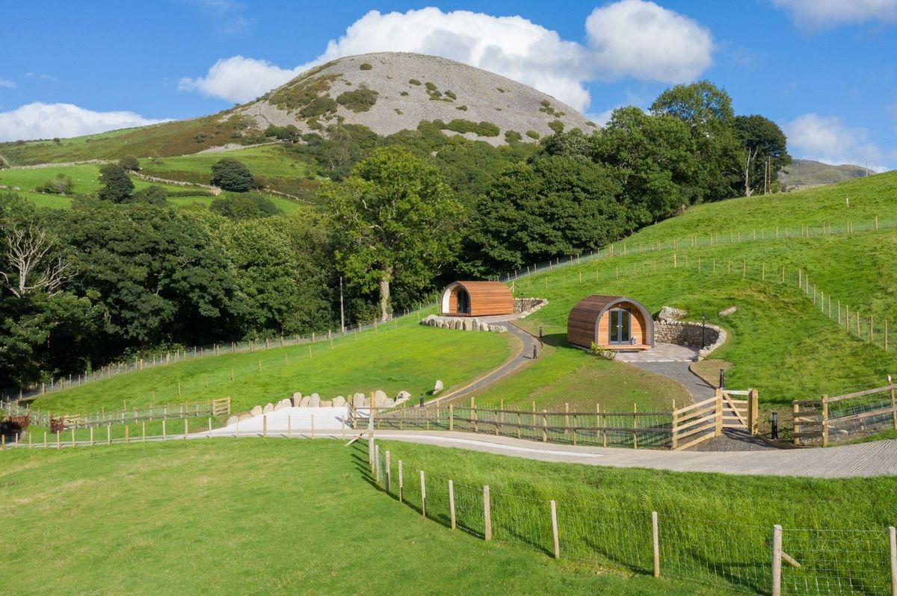

Three Streams Glamping, located in the coastal town of Llanfairfechan, was listed by Campsites.co.uk as one of the best campsites in Wales and is just minutes from the North Wales coast and beaches such as Penmaenmawr. This small, adult-only glamp site is at the foot of the soaring Carneddau mountains and offers epic land-and-sea views from swish pods.

A previous Winner of Best Glamping Site in the annual Campsites.co.uk Camping and Glamping Awards, you have an idyllic base here to explore the very best North Wales has to offer, from blustery walks along beaches to mountain biking in forested trails and summiting the highest peaks in the country.

You'll also find an equipped kitchenette with a table and chairs, crockery, a microwave and grill, a fridge, a kettle, and a toaster for all your self-catering needs. There's also a Smart TV and Wi-Fi. Though why look at a screen when you can enjoy glorious views like these?

Outside is a private hot tub, perfect for a bubbly soak with your favourite as the sun sets over the ocean. Utter bliss. Post-soak, there is a BBQ, loungers, and a seating area for chilled sundowners, where the only noise you'll likely hear is the baaing of local sheep.


If EVER you need to contact a person who is Extremely Clever at finding out what is wrong –with your computer, then I can honestly recommend Mr Chris Williams.
(Who is also a very kind and considerate Gentleman.)

***************************************************

FOOT CARE By PODIATRIST THOMAS JENESON @ Grosvenor Lodge(1 Grosvenor Road, Wrexham) 01978 800777 tajeneson@gmail.com.

*****************************************

Best Wishes AND Thank You – Sybil (Bremner)

