Ruabon News Letter 607

Library News
Library News for the week beginning 15th March 7pm Wrexham Carnival of Words

Wrexham Carnival of Words
Sunday Times bestselling author Mark Edwards will be appearing at Wrexham Library on Saturday 25th April 2026 at 5:00 pm as part of the Wrexham Carnival of Words literary festival. During the event, Mark will discuss his latest psychological thriller, The Wasp Trap, which recently reached number one on both the Sunday Times and Waterstones bestseller charts. Known for writing "scary things that happen to ordinary people," the author has sold over five million books since his 2013 debut, The Magpies. Mark has received high praise from both Elly Griffiths and T.M. Logan previous Carnival guests. Tickets for the event are available through www.wrexhamcarnivalofwords.com | 01978 292090. Don’t forget there is a festival tickets too, with an Earlybird price of £35 if you buy before the end of March!
North Wales Integrated Autism Service
Are you Autistic? Do you support an Autistic child or adult? North Wales Integrated Autism Service will now be holding drop in sessions at Ruabon Library on the fourth Monday of the month 2-4pm and Coedpoeth Library on the last Tuesday of the month 10-12pm starting on Tuesday 24th March. If you would like advice, support or just a general chat why not call in. Alternatively, if you’re not able to visit these libraries you can also visit them Brynteg Library on the 2nd Friday of the month 2-4m or Chirk library on the second Monday of the month 2-4pm.

Chirk Library Family Board Games
Chirk library will now hold weekly family board game sessions courtesy of Glyn Wylfa, Community Based Social Enterprise who have very kindly provided a grant to buy the games for the library. The games afternoon will take place at the library every Monday afternoon 3.00-5.00pm. Come along and join in the fun!
Bydd llyfrgell y Waun bellach yn cynnal sesiynau gemau bwrdd teuluol wythnosol trwy garedigrwydd Glyn Wylfa, Menter Gymdeithasol Gymunedol, sydd wedi rhoi grant yn garedig iawn i brynu'r gemau ar gyfer y llyfrgell. Cynhelir y prynhawn gemau yn y llyfrgell bob prynhawn dydd Llun rhwng 3.00 a 5.00pm. Dewch draw i ymuno yn yr hwyl!
Llay Library Board Games for Young Teens
Llay library will be offering Board Games for young teens every Monday 4.30-5.30pm. So, if you are aged 12-15 and fancy a game of Jenga, Chess, Connect 4, Scrabble, Uno, Draughts, Dominoes, Crosswords or if you just fancy reading a book, then please do call in – we’d love to see you there!
Bydd llyfrgell Llai yn cynnig Gemau Bwrdd i bobl ifanc bob dydd Llun rhwng 4.30 a 5.30pm. Felly, os ydych chi rhwng 12 a 15 oed ac yn awyddus i chwarae gêm o Jenga, Gwyddbwyll, Connect 4, Scrabble, Uno, Drafftiau, Dominos, Croeseiriau neu os ydych chi eisiau darllen llyfr, yna galwch heibio – byddem wrth ein bodd yn eich gweld chi yno!

Oeddech chi'n gwybod…?
Oeddech chi'n gwybod mai Llyfrgell Dinas Wrecsam yw'r llyfrgell gyhoeddus brysuraf yng Ngogledd Cymru?
Did you know…?
Did you know Wrexham City Library is the busiest public library in North Wales?

Welsh Language book review
Adolygiad Llyfr
Dathlu gan Rhian Cadwaladr
Ar drothwy eu pen-blwyddi yn 60 oed, mae pedair o ffrindiau oes yn mentro ar daith arbennig. Ond a hwythau wedi byw bywydau gwahanol iawn, a fydd chwarae'n troi'n chwerw? Yn sicr, mae'r nofel yn cynrychioli asbri a rhyddid, dau beth fu'n ddigon prin yn ddiweddar, a hefyd anogaeth i fwynhau bywyd i'r eithaf beth bynnag eich oed a'ch amgylchiadau.
*Bydd Rhian Cadwaladr yn ymddangos yng Ar drothwy eu pen-blwyddi yn 60 oed, mae pedair o ffrindiau oes yn mentro ar daith arbennig. Ond a hwythau wedi byw bywydau gwahanol iawn, a fydd chwarae'n troi'n chwerw? Yn sicr, mae'r nofel yn cynrychioli asbri a rhyddid, dau beth fu'n ddigon prin yn ddiweddar, a hefyd anogaeth i fwynhau bywyd i'r eithaf beth bynnag eich oed a'ch amgylchiadau.
*Bydd Rhian Cadwaladr yn ymddangos yng Ngŵyl Geiriau Wrecsam dydd Llun Ebrill 27, 2.00pm. Mae tocynnau ar gael o www.wrexhamcarnivaofowords.com| 01978292090

Welsh Language book review

Adolygiad Llyfr
Dathlu gan Rhian Cadwaladr
Ar drothwy eu pen-blwyddi yn 60 oed, mae pedair o ffrindiau oes yn mentro ar daith arbennig. Ond a hwythau wedi byw bywydau gwahanol iawn, a fydd chwarae'n troi'n chwerw? Yn sicr, mae'r nofel yn cynrychioli asbri a rhyddid, dau beth fu'n ddigon prin yn ddiweddar, a hefyd anogaeth i fwynhau bywyd i'r eithaf beth bynnag eich oed a'ch amgylchiadau.
*Bydd Rhian Cadwaladr yn ymddangos yng Ar drothwy eu pen-blwyddi yn 60 oed, mae pedair o ffrindiau oes yn mentro ar daith arbennig. Ond a hwythau wedi byw bywydau gwahanol iawn, a fydd chwarae'n troi'n chwerw? Yn sicr, mae'r nofel yn cynrychioli asbri a rhyddid, dau beth fu'n ddigon prin yn ddiweddar, a hefyd anogaeth i fwynhau bywyd i'r eithaf beth bynnag eich oed a'ch amgylchiadau.
*Bydd Rhian Cadwaladr yn ymddangos yng Ngŵyl Geiriau Wrecsam dydd Llun Ebrill 27, 2.00pm. Mae tocynnau ar gael o www.wrexhamcarnivaofowords.com| 01978292090

***********************************************************************************************************

Championship Play-Off Race to go 'To the Wire'



George Thomason believes the Championship play-off race will go "down to the wire" after Wrexham suffered a setback at Watford.

The Red Dragons' six-game unbeaten away run came to an end as they were beaten 3-1 by the Hornets on Tuesday.
Despite the loss, Phil Parkinson's men remain in the top six, although seventh-placed Southampton have a game in hand and face Norwich City on Wednesday.

And midfielder Thomason - currently operating at left wing-back - has urged his team-mates to "attack" the final eight games of the campaign.
"I have no doubt that every team pushing for the play-offs is going to have their own bumps in the road come the end of the season," said Thomason.
"I'd imagine it goes right down to the wire and it's not going to be smooth sailing for every team."
Thomason says the unpredictability of the second tier is the "beauty of the division".

"Anyone can beat anyone. The team that strings a bit of consistency together, especially at this time of the season, will be the ones that will probably sneak themselves in there," he added.
"There's a chasing pack, there's a little pack that's already in and amongst it and we're the ones occupying the sixth spot in the division at the moment.
"I'd say the message is not to be fearful, just go and attack it."

A sloppy first-half display proved costly as Wrexham lost an away match for the first time in 2026 despite their significant second-half improvement. And Thomason feels his side were taught a "harsh lesson" at Vicarage Road.

"We probably lost it on our own mistakes and [it was our] fault really. Nothing to do with an effort point of view, more of a technical point of view," he added. "In the first half, I thought we were a little bit loose in possession. We played against a team that were really good on the transition and counter-attacking moments. "When you lose possession and get punished and concede two goals, it's hard to fight back from."
Max Cleworth pulled a goal back for Wrexham early in the second half at Watford, but Parkinson's side were unable to find an equaliser.

Any hope of avoiding defeat was wiped out when Edoardo Bove scored the hosts' third goal in stoppage time.
"I thought we were going to grab a second [goal] to be fair but it just never came and obviously they score their third and bury the game in the 94th minute," Thomason said.
"But I'm really proud of the boys' application and effort. I thought we all left it out there and on another day we go and get something from the game.

"I think that's just the harsh lessons of the Championship. You can't afford to go two goals down, home or away, and fight back every single time."
Wrexham return to action with another away game at Sheffield United on Saturday (15:00 GMT).
The Blades are 10 points adrift of the play-off places in 15th.


St Patrick’s Day 2026



Thousands of people were in high spirits across Liverpool city centre yesterday (Tuesday) as St Patrick's Day celebrations continued into the evening. The city welcomed the annual parade through the city centre, with spectators turning the streets into a sea of green, white and gold.

This year was the 10th time Liverpool has hosted a St Patrick's Day parade. Fields of Eire Ltd was behind this year's event. The parade assembled the Old Irish Centre (Mount Pleasant) and set off at 3pm.
The procession was led by three full marching bands, bringing music and colour to the city centre. While thousands of people packed out bars and pubs across the city centre, the ECHO brought you live updates from the parade and shared glimpses of the amazing celebrations across the city.




'Dangerous' cliff-edge drops on popular North Wales beach as river alters course

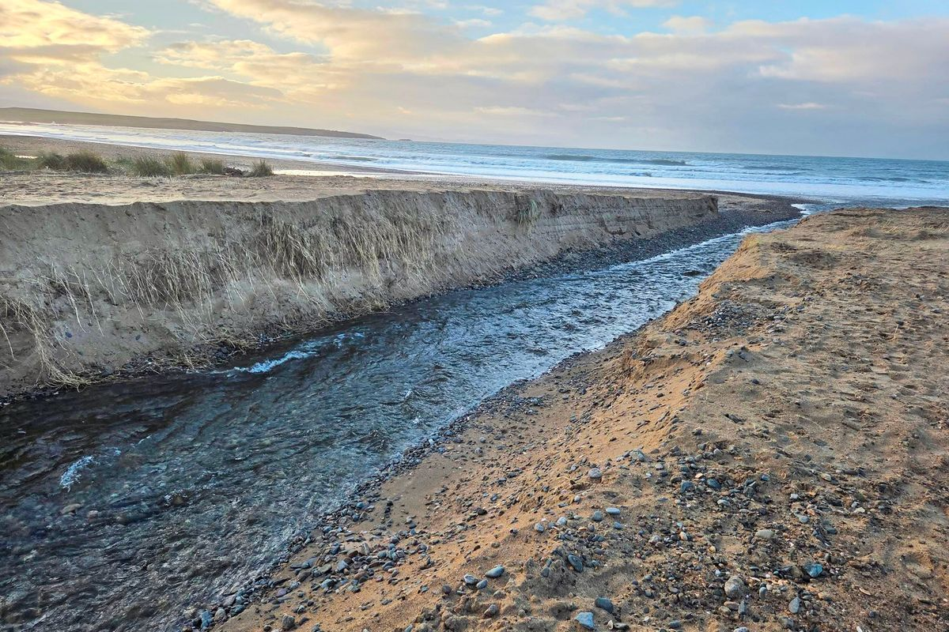

The river has carved out steep banks on the beach (Image: Wendy Challis-Jones)

A river running through sand dunes to a popular Anglesey beach has altered course following flood prevention works. Locals have been alarmed by the changes, claiming riverbanks have been left with steep and dangerous drops. The river runs from Llyn Maelog, a 65-acre lake near Rhosneigr, to Traeth Llydan, one of the resort’s two main beaches. Being dog friendly, the beach and dunes are popular with walkers, some heading to The Oyster Catcher bar and restaurant.

Since the start of the year, residents have noticed the river becoming shallower after cutting a reshaped path through the dunes. Warning of “unstable and dangerous” riverbank drops, some locals complained a riverside path is being eroded away, forcing more people to head to the dunes rather than the beach. Others are more laid back, noting that winter storms can alter the river and that, in time, these and high tides will restore its equilibrium.

DELIVERING BETTER HEALTH FOR YOU
 |  | Pharmacies carry out record number of consultations for common health issues  Pharmacies across Wales carried out more than 600,000 clinical consultations for a wide range of common health issues in the last 12 months.  Almost 346,000 people used the common ailments service, which offers free advice and treatment for 27 common conditions and is available in 99% of pharmacies across Wales.

 |  | Wales first UK nation to launch 10 year plan to tackle child sexual abuse  The Welsh Government has unveiled its landmark ten-year strategy to prevent and respond to child sexual abuse.

 |  | Engagement Events - Consultation on the draft National Strategy for Unpaid Carers  We are holding a series of engagement sessions across Wales to discuss the draft National Strategy for Unpaid Carers. In-person sessions will take place in North (19 March), South (23 March) and West Wales (26 March), along with two virtual sessions on 27 and 31 March. The sessions are open to anyone interested.

 |  | Vote for three of the 2026 Social Care Accolades winners!  The Accolades are annual awards, run by Social Care Wales, that recognise, celebrate and share excellent social care, social work and childcare, play and early years work in Wales. We need your help to choose the winners of three awards.

BETTER HEALTH IN YOUR LOCAL AREA
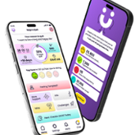 |  | New free Help Me Quit App launched to help people in Wales stop smoking  A new free digital app has been launched to support adults in Wales to quit smoking, offering personalised, evidence-based help in both Welsh and English. The Help Me Quit App has been designed specifically for smokers in Wales and provides round-the-clock support for those who want to quit smoking.

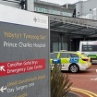 |  | £42m funding secured for final phase of Prince Charles Hospital redevelopment  Cwm Taf Morgannwg University Health Board has secured £42 million of funding from Welsh Government to deliver the third and final phase of the major refurbishment programme at Prince Charles Hospital (PCH), Merthyr Tydfil.

 |  | Newtown health and wellbeing hub takes major step forward  Welsh Government have approved the Outline Business Case (OBC) for a new health and wellbeing hub in Newtown. This is a major milestone and an important vote of confidence in the need for modern, integrated facilities to support people’s health and wellbeing in Powys. It brings nearly £30m of Welsh Government investment in North Powys a step closer.

oral statements
The Welsh Government response to the UK Covid-19 Inquiry Module 2, 2A, 2B, 2C Report
written statements
Launch of Transformation of Children’s Services Legacy Report
Confirmation of successful applicant for Welsh-Medium Childcare Qualification grant programme 2026–2029
The Welsh Government response to the UK Covid-19 Inquiry Module 2, 2A, 2B, 2C Report
Reporting of referral to treatment (RTT) waiting times data - BCUHB
Launch of the National Strategy for Preventing and Responding to Child Sexual Abuse
Open Consultations
Draft dementia strategy for Wales 2026 to 2036
Consultation closes: 3rd April 2026.
Changes to two codes of practice: Part 6 and Special Guardianship Orders
Consultation closes: 7th April 2026
Removing profit from children's care: local authority sufficiency plan duty
Consultation closes: 7th April 2026
Draft national strategy for unpaid carers 2026
Consultation closes: 13th April 2026
Development of a Social Care Negotiating Body for Wales to set Fair Pay Agreements for the social care workforce
Consultation closes: 28th April 2026.
Talk with Me Phase 2: Speech, Language and Communication (SLC) Delivery Plan 2026 to 2030
Consultation closes: 30th April 2026.

Women’s Health Hubs in Every Part of Wales
A women’s health hub is now open in every health board area in Wales, bringing menopause, contraception and menstrual health services closer to home.
First published 17 March 2026
Last updated: 17 March 2026
The Welsh Government committed to opening the seven women’s health hubs by the end of March 2026, in response to the Women’s Health Plan.
Each of the hubs have been tailored to meet local needs. Some will operate over multiple sites and others will be accessed online initially. Every hub is designed to improve access to specialist care and deliver services in the community.

First Minister Eluned Morgan said:
Improving access to women’s health services is a top priority for me because so many women have told me how they wanted them improved. It’s a real landmark achievement of this Senedd that we now have a women’s health hub in every health board area across Wales.
These hubs show that when we make a commitment, we make it happen. The hubs will make a real difference to women's healthcare.
Sarah Murphy, Minister for Mental Health and Wellbeing, said:
I am very proud that all the hubs are now open, offering women access to contraception, menopause care and menstrual care.
We’ll continue to listen to what women are telling us and look to adapt services with these hubs, ensuring they offer the right care, in the right place, for women now and in the future.
Dr Helen Munro, National Clinical Lead, NHS Wales Performance and Improvement said:
Establishing a women’s health hub in every health board area marks a major step forward for women’s healthcare in Wales.
Through the NHS Wales Women’s Health Plan, we have listened to the voices and experiences of thousands of women and are transforming that insight into practical change.
These hubs will make it easier for women to get the help they need at every stage of life. By improving access to information, support, and personalised care closer to home, we are helping to close the gender health gap and ensure women’s health is given the priority it deserves across Wales.
In many health boards an initial pathfinder hub has opened, including those at Ysbyty Cwm Cynon, in Mountain Ash, the Sexual Integrated Health Building in Aberystwyth, the Maelfa Hub in Llanedeyrn, Cardiff, in Llandudno Hospital and Nevill Hall Hospital, in Abergavenny.
In Powys and Swansea Bay health board areas, the hubs are operating as online portals, which signpost women to support and services.
All the hubs have been designed with women to fit around women’s lives. Some services will be referral-based and others will be open access.
Since the Women’s Health Plan was published in December 2024, extensive training for GPs and healthcare workers about endometriosis and other women’s health conditions has been rolled out across the country. Health boards have also been moving more services into local communities. In Swansea Bay University Health Board, for example, uro-gynae physiotherapy is now available through primary care services instead of at hospital.
Information about the women’s health hubs and how to access them are included in a new national website dedicated to women’s health in Wales which was launched yesterday (Monday 16 March 2026). The website will make it easier for people to find reliable, clinically verified guidance on a wide range of women’s health topics and understand what services and support are locally available to them.
The Women’s Health Plan sets out how NHS organisations in Wales will close the gender health gap by providing better health services for women, ensuring they are listened to and their health needs are understood. It includes more than 60 actions across eight priority areas to improve healthcare for women and is based on feedback from around 4,000 women across Wales.
Each health board received £300,000 this year to support the development of the pathfinder women’s health hubs. They will be evaluated later this year.
Share this page
- Share this page viaX
- Share this page viaFacebook
- Share this page viaEmail
Outside Gov. Wales
- Women's Health Wales
On the Women's Health Wales website
- The Women's Health Plan for Wales
On the NHS Wales Performance and Improvement website

First published: 17 March 2026 Last updated:17 March 2026

***************************************


If EVER you need to contact a person who is Extremely Clever at finding out what is wrong –with your computer, then I can honestly recommend Mr Chris Williams. (Who is also a very kind and considerate Gentleman.)

***************************************************

FOOT CARE By PODIATRIST THOMAS JENESON @ Grosvenor Lodge
(1 Grosvenor Road, Wrexham) 01978 800777 tajeneson@gmail.com.

*****************************************

Best Wishes AND Thank You – Sybil (Bremner)

***********************************************************

