Ruabon News Letter 606


Wrexham kept pace with their rivals for the Championship play-offs as Ollie Rathbone's fine first-half strike earned them victory over Charlton Athletic at the Valley.

The superb 30th-minute effort – Rathbone's sixth in the Championship since returning from injury in December – ensured Phil Parkinson's side retained a four-point cushion over the sides chasing a top-six spot.

But the hosts could have every right to feel hard done by after carving out the game's best chances, only to fail to find the net and make it four games without a win. Wrexham needed a brilliant 90th-minute save from goalkeeper Arthur Okonkwo to deny Sonny Carey as their unbeaten away run extended to a sixth game. It only added to Charlton's frustration. They remained seven points clear of the relegation places after a defeat where manager Nathan Jones will rue his side's wastefulness.

Even before Rathbone's opener - a superb flick and skidding volley - three times Charlton had found themselves in space inside the Wrexham box, and three times they returned without joy.

Luke Berry had taken a second too long to pull the trigger to allow Issa Kabore to block superbly. Then former Addick George Dobson threw himself at the ball to stop Carey. There was no visiting player for Harry Clarke to blame when he got his angles wrong and skewed wide when he really should have scored as Charlton's counter continued to cause problems.

But an encouraged Valley was collectively shaking its head just moments later as Rathbone did with half a chance what the hosts had failed to do with far better opportunities.

It came as Callum Doyle's cross was headed away to the edge of the area where Rathbone proceeded to flick the ball away from the defender and on to his left foot before his volley skimmed into the far corner. Lewis O'Brien should have doubled Wrexham's lead four minutes after the restart when he met Kieffer Moore's cross, but Kayne Ramsay did well to thwart the danger.

Yet while Wrexham had improved after the break, Charlton again could blame a lack of clinical edge as a string of openings were not finished off, a wayward header from Tyreece Campbell the most glaring. And when Carey did hit one on target, they found Okonkwo at full stretch and at his best to protect Wrexham's result.
****************************************************************

Newyddion Llyfrgelloedd Library News
Library News for the week beginning 1ST March
Can you help us?
This year has been designated the National Year of Reading and Wrexham Library has set itself a mission and we need your help to achieve it! We would like to beat the number of books which were issued to you last year.
To accomplish this, we need you to borrow more books than you did last year.
As the total for the year rises so will the ‘mercury’ in our thermometer. We have made a good start, so please come along and visit us, browse our collections and borrow our books (or e-books from our BorrowBox app). We can’t wait to see you!

This year has been designated the National Year of Reading and Wrexham Library has set itself a mission and we need your help to achieve it!
We would like to beat the number of books which were issued to you last year
To accomplish this, we need you to borrow more books than you did last year. As the total for the year rises so will the ‘mercury’ in our thermometer.
We have made a good start, so please come along and visit us,
browse our collections and borrow our books (or e-books from our BorrowBox app). We can’t wait to see you!
An Introduction to Borrow Box
Did you know that you can get e-books and e-audio books from your library? If you’re new to e-books or struggling to use them then come along to Wrexham Library on Thursday 5th March between 2.00-4.00pm to learn how to download e-books and e-audio books free of charge. There is no need to book just call in; and don’t forget to bring your device with you.

The 43-year-old mum credits her transformation to the Simple app and now feels 'healthier inside and out'
This article contains affiliate links, we will receive a commission on any sales we generate from it.
Find things to do

All events Music Comedy Theatre Family Food & Drink Clubs Workshops Days out Virtual All dates today tomorrow this weekend
Search

Our Radio Days at Rhos Library
Tune in and turn back the clock as Rhos library brings you the soundtrack to your youth, celebrating the iconic radio theme tunes that defined a golden era of broadcasting. Join us at Rhos library for a fascinating talk by Alan Tiltman on Friday 13th 2.00-3.00pm. The event is free of charge, but you must reserve your pace by contacting the library on 01978 840328 | rhos.library@wrexham.gov.uk

Gŵyl Geiriau Wrecsam
Galwad i bawb sy’n caru barddoniaeth! Mae gennym ddau ddigwyddiad enfawr i bobl sy’n caru barddoniaeth eleni. Mae Brian Bilston yn cael ei ganmol yn eang fel "bardd llawryfog Twitter" ac yn athrylith fodern, yn cael ei ddathlu am ei farddoniaeth ffraeth, glyfar, ac yn aml yn deimladwy sy'n cyfuno hiwmor â mewnwelediad dwfn. Mae ei waith yn aml yn mynd yn firaol am ei berthnasedd, ei chwarae hefo geiriau, a'i fformatio creadigol, fel diagramau Venn neu gerddi siâp, gan ennill dilyniant ymroddedig iddo. Mae Hanan Issa, Bardd Cenedlaethol Cymru (2022–2027), wedi cael ei dathlu'n eang am ei gallu i blethu edafedd diwylliannol amrywiol ynghyd ac am ei rôl fel llais arloesol mewn llenyddiaeth Gymreig. Mae beirniaid a chynulleidfaoedd wedi nodi ei "chryfder mewnol anhygoel" a'i phŵer i "eich cyffwrdd â dim ond ychydig o eiriau a ddewiswyd yn dda". I archebu tocynnau ar gyfer y ddau ddigwyddiad hyn ac am fwy o fanylion am yr ŵyl gyfan ewch i www.wrexham.gov.uk

Wrexham Carnival of Words
Calling all poetry fans! We have two huge events for poetry lovers this year. Brian Bilston is widely lauded as the "Twitter poet laureate" and a modern genius, celebrated for his witty, clever, and often poignant poetry that blends humour with profound insight. His work frequently goes viral for its relatability, wordplay, and creative formatting, such as Venn diagrams or shape poems, earning him a dedicated following. Hanan Issa, the National Poet of Wales (2022–2027), has been widely celebrated for her ability to weave together diverse cultural threads and for her role as a pioneering voice in Welsh literature. Critics and audiences have noted her "incredible inner strength" and her power to "move you with just a few well-chosen words,”. To book tickets for these two events and for more details of the whole festival visit www.wrexham.gov.uk

Oeddech chi'n gwybod…?
Oeddech chi’n gwybod…ni fyddwch chi’n cael dirwy bellach os yw eich eitemau llyfrgell yn hwyr yn ôl, fodd bynnag, os nad ydych chi wedi’u dychwelyd ar ôl 90 diwrnod, yna byddwch chi’n cael bil am gost amnewid yr eitem. Byddem yn gwerthfawrogi’n fawr eu bod yn dychwelyd, felly peidiwch â phoeni am eu dychwelyd yn hwyr – dewch â nhw yn ôl a meddyliwch am y llyfrau newydd y gallwch eu cymryd yn lle!

Did you know…?
Did you know…you will no longer be fined if your library items are late back, however if you’ve not returned them after 90 days then you will be billed a replacement cost of the item. We would really appreciate their return, so don’t worry about returning them late – bring them back and think of the new books you can take out instead!

Welsh language book review

Adolygiad Llyfr

Ceiri gan Hywel Williams
Hanes dychmygol ydy Ceiri am gariad, iaith a hunaniaeth; twyll swyddogol a chyfalafiaeth reibus; a gwydnwch cymeriadu yng nghymdeithas hunan ymwybodol pentref chwarelyddol bro’r Eifl. Dilynwn dri phrif gymeriad yn ystod haf 1938, Elsbeth, Guto a Dafydd wrth iddyn nhw wynebu, yn gyntaf, bygythiadau i’w hunaniaeth a’u ffyniant economaidd, ac yn llai amlwg iddynt, cynllwynio maleisus y wladwriaeth. Dros yr haf mae’r tri yn aeddfedu, yn datblygu eu barn, yn colli ac yn ennill cariad ac yn newid llwybr eu bywydau. Mae hyn oll yn digwydd o dan fygythiad i’r prif gyflogwr lleol, hanes yr Ysgol Fomio, y rhyfel yn Sbaen a’r rhyfel byd sydd i ddod, ynghyd â’r ail don o ddiwydiannu a’r Seisnigeiddio cyflym sydd ar droed yn eu sgil.

Wrexham Legend Mickey Thomas to run New York Half Marathon



Wrexham AFC legend Mickey Thomas, 71, has gone from beating cancer to taking on a half-marathon.
The former footballer will run the United Airlines New York City Half Marathon on March 15 to raise funds for the Wrexham AFC Foundation and its international partnership with Kick4Life FC.
The run, which covers 13.2 miles, will begin at Prospect Park in Brooklyn, pass through Times Square, and finish in Central Park.
On his JustGiving page Mickey says: "I’m Mickey Thomas, former Wrexham AFC player and proud supporter of the Wrexham AFC Foundation.
"On Sunday, March 15, I will be running the United Airlines New York Half Marathon to raise funds for the Foundation’s twinning partnership with Kick4Life FC."
The partnership aims to use the power of football to improve the lives of children and young people, with a particular focus on health, education, employability, and social inclusion.
Thomas described the personal significance of his involvement in the project.
He says on his page: "In 2024, Wrexham AFC and Kick4Life FC launched a groundbreaking partnership that means a great deal to me personally.
"This isn’t just about football.
"It’s about using the game we love to make a real difference.
"The partnership includes coaching exchanges between Wales and Lesotho, the development of a Football for Good curriculum, and programmes promoting women’s football and youth leadership in both communities."
The schemes hope to reach more than 3,000 vulnerable children and young people over the next three years.
Supporters can donate to Thomas’ fundraising effort through his UK JustGiving page or, for those in the United States, via every.org.
Thomas’ journey to the streets of New York is especially poignant, as he announced in 2021 that he was cancer-free following a two-year battle with stomach cancer.
He was diagnosed in January 2019 and began treatment the following month.
In a statement at the time, he compared his fight against the disease to a football match.
He wrote: "Great result yesterday – after CT scan my results came back and now I’m cancer-free. So happy."
The Wrexham AFC Foundation team will also join him in the race.
Fans are encouraged to follow Thomas’ marathon journey and training updates on the Foundation’s social media channels.

St David's Day Celebrated on Llangollen and Corwen Railway

The Steam Train was renamed Saint David for the day (Image: Llangollen Railway)
MUSIC, steam trains, and community spirit set the scene for a lively celebration of heritage.
The Llangollen and Corwen Railway marked St David’s Day with a packed day of steam journeys and Welsh-language entertainment, drawing visitors from across the region to enjoy a uniquely Welsh experience.
Visitors travelled the full length of the line between Llangollen and Corwen, enjoying heritage steam services alongside a programme of music, Welsh language announcements and a special Welsh-themed menu in the station café.
Daffodils, flags and traditional music set the scene, with the award-winning Llangollen Silver Band performing on Platform 1 at Llangollen before boarding the train to Corwen, where they continued their performance.
Wayne Ronneback, Corwen station master, even took a turn at conducting the band, earning enthusiastic applause from the crowd.
Joel Whittaker, a volunteer with the railway and member of the Froncysyllte Male Voice Choir, said: "It was a real privilege to help mark St David’s Day on the railway.
"This line runs through the heart of North Wales, and celebrating our language and culture is incredibly important.
"Hearing Welsh spoken across our stations and trains, alongside the music and the steam, created something truly special."
Bethan, Joel, Ralph and volunteers ensured St Davids Day was celebrated properly (Image: Llangollen Railway)
Mr Whittaker and his partner, Bethan Wyn Hughes, ensured announcements were delivered confidently in Welsh throughout the day.
Ms Wyn Hughes said: "We are immensely proud of our Welsh roots.
"St David’s Day gives us the opportunity to celebrate not just our history, but our place within the community today.
"The support from passengers, performers and volunteers made it a day to remember."
The railway emphasised that the event was about more than just running trains - it is about honouring its location, heritage and community.
Volunteers played a vital role throughout the day, from those working on the footplate and in the signal boxes to catering staff and station teams welcoming guests.
Passengers enjoyed not only the festive atmosphere but also the sense of place and pride that comes with a railway rooted in Welsh history.
The event also marks the start of the railway’s 2026 season, with a line-up of events planned for the coming weeks.
Plans include the Branch Line Gala from April 10 to 12, which is expected to draw railway enthusiasts and families alike.
The Llangollen and Corwen Railway has thanked everyone who travelled, performed or volunteered, describing the day as a proud celebration of Wales, community and heritage.

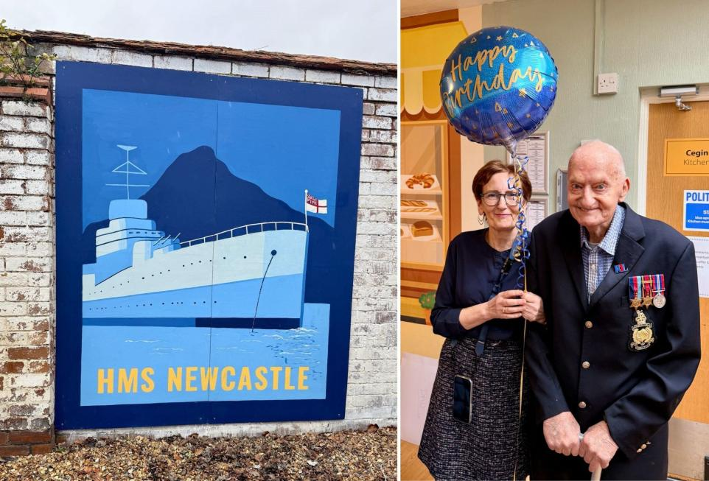
North Wales Artist's Mural Surprise at Wrexham Care Home

Jane Herbertson celebrates her dad Herbert Pritchard's 101st birthday, with a special mural reveal.
WREXHAM is no stranger to a mural but one of the latest has a very personal meaning.
To mark the 101st birthday of Burma Star veteran Herbert Pritchard, his daughter Jane Herbertson commissioned a special piece of art.
Now North Wales artist Bethan Adey-Surgenor has brought to life a painting of HMS Newcastle, the ship Herbert spent most of his time serving on during the Second World War.
Herbert Pritchard sat at his bedroom window, with the HMS Newcastle mural outside.
This unique piece is in pride of place in a garden space outside the window of ex-Royal Marine's room at the White House care home on Grove Road in Wrexham.
The reveal was also included presenting Herbert with a cake, and was attended by Mayor of Wrexham, Cllr Tina Mannering.
Jane said: "There was about nine of us in his room for the grand reveal when I opened the curtains, and everyone saw the ship.
"Dad was proud and it knocked him back into the reverie of what happened on the ship, in a good way. He was really pleased and wanted to show it to everybody. It caused quite a stir.
"It's fantastic, done in the style of a vintage poster. I've now rearranged dad's room so he can sit and look at the mural."
Mayor of Wrexham Cllr Tina Mannering joined Herbert Pritchard to mark his 101st birthday.
The HMS Newcastle mural by artist Bethan Adey-Surgenor, at White House in Wrexham.
Jane added thanks for the support given at the White House, adding: "They do a wonderful job. Debbie Shellshear and Annette Davies are the wonderful management team who lead a great team of caring professionals. They are very fond and respectful of dad."
Artist Bethan, 32, who has also just finished her largest piece to date, Hiraeth, on Central Retail Park in Wrexham, took more than a week, on and off, to complete the HMS Newcastle work.
She said: "My stuff tends to be quite abstract and geometric. I tend to base things around lettering, so this was quite a different project for me.
"There was a little pressure but it was more of a privilege to be asked to do the piece, knowing it's got sentimental value to someone."

Spring Theme for Leader Camera Club Photography Challenge
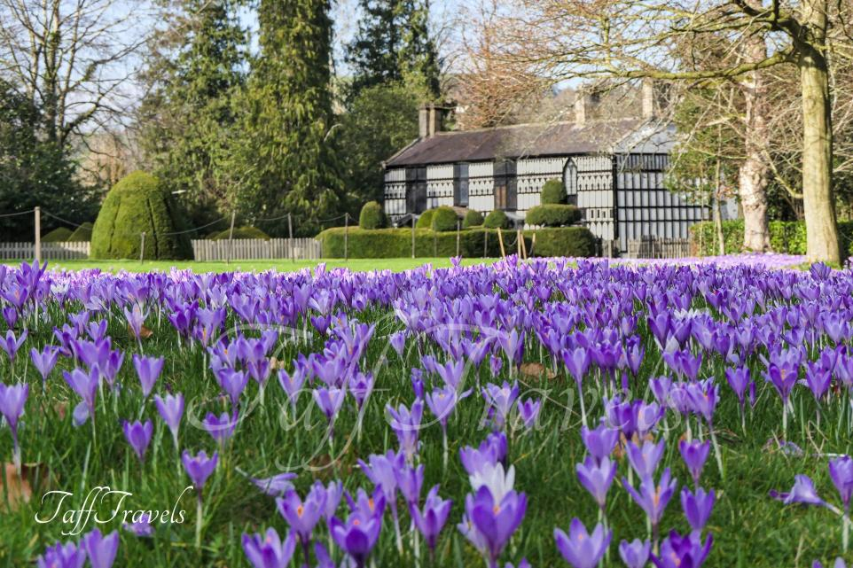

The seasonal shift is in full flow, the signs are everywhere.

With this in mind, 'spring' was the theme for the latest Leader Camera Club photography challenge.
From lambs, frogs, daffodils and blossom, they give glimmers of brighter days ahead.


If EVER you need to contact a person who is Extremely Clever at finding out what is wrong –with your computer, then I can honestly recommend Mr Chris Williams. (Who is also a very kind and considerate Gentleman.)

***************************************************

FOOT CARE By PODIATRIST THOMAS JENESON @ Grosvenor Lodge
(1 Grosvenor Road, Wrexham) 01978 800777 tajeneson@gmail.com.

*****************************************

Best Wishes AND Thank You – Sybil (Bremner)

***********************************************************

