Ruabon News Letter 605
Newyddion Llyfrgelloedd Library News
Newyddion Llyfrgelloedd am yr wythnos yn
dechrau 22 Chwefror
Library News for the 22nd January

Friendship Groups
Joining a friendship group offers a range of psychological, physical, and social benefits for people looking to make new friends or wanting to re-connect with people. Friendship groups offer you a way to share activities, discussions and can help boost your self-esteem. Regular group interaction also reduces stress and lowers the risk of depression and anxiety. If you would like to join a Friendship group there is one in Brynteg Library every Thursday 2.00-4.00pm, Ruabon Library on the first Thursday of the month 12.00-1.00pm, Llay Library every Monday 2.00-4.00pm and Rhos Library every Friday 2.00-3.00pm. There is no need to reserve your place just call in, where a warm welcome awaits you.

Family and Information Service at Brynteg Library
The Family and Information Service will be providing a drop-in session at Brynteg library from 2.15 – 3.45 on Tuesday 31st March and thereafter on the first Tuesday of the month starting 7th April . They provide advice and guidance to mums, dads and carers of children and young people from pregnancy until their child’s 20th birthday. If you need any help or information on issues such as childcare and childcare costs, activities and events after school and in the holidays, debt and benefits or much more then call in to see them.

Reading Well in Libraries
Reading Well is a campaign which supports you to understand and manage your health and wellbeing using helpful reading. All books within the collections are all recommended by health experts, as well as people with lived experience of the conditions and topics covered and their relatives and carers. Collections cover Reading Well for Families, Reading Well for Children, Reading Well for Teens, Reading Well for Mental Health and Reading Well for Dementia. With the financial support of the Books Council for Wales, we are pleased to announce we have extended these collections to more of our libraries.
If you need help, then please do call in and see us.

Fancy Dress Swap for World Book Day

Don’t forget, We have our Fancy Dress Swap Day on Saturday 28th February at Wrexham Library.
So You Don’t Have to be Without a Costume for World Book Day.

Did you know…?
Did You know…all of Wrexham’s Libraries Dedicate One Hour a Week for ‘Quiet Time’ when there are No Activities Taking Place and Where Possible Lights are Dimmed to Create a Calming and Quiet Environment.

My Name was “Eden by Eleanor Barker-White”

Eleanor Barker-White’s debut novel, My Name Was Eden,
is described as a psychological thriller, but I would perhaps describe it more as domestic noir, that delves into many themes along the way.
The story follows Lucy Hamilton, whose teenage daughter Eden survives a near-drowning incident and subsequently claims to be Eli, the twin brother she lost in the womb due to vanishing twin syndrome.
This affects Lucy greatly and challenges her understanding of her daughter.
She vows to keep her safe and to be the mother she should have always been, before the loss of Eden's twin consumed her, all those years ago.
A sinister chain of events starts to unfold, revealing dark secrets the family has been keeping.
The narrative is told through multiple points of view, including Lucy's present-day viewpoint; her childhood experiences, and the perspective of Eden's best friend, Charlie.
The story was captivating and, together with the short chapters, meant I flew through this book, never quite sure where it was going to end!
Lynda

***********************************************************************************************************

Friends of Ruabon What’s On 2026
Friends of Ruabon Monthly Meetings 2026

- Saturday January 10th 10am Saturday July 4th 10am
- Wednesday February 4th 7pm Wednesday August 5th 7pm
- Saturday March 7th 10am Saturday September 5th 10am
- Wednesday April 1st 7pm Wednesday October 7th 7pm
- Saturday May 2nd 10am Saturday November 7th 10am
- Wednesday June 3rd 7pm Wednesday December 2nd 7pm

Friends of Ruabon Litter Pick Saturdays 2026
Village Spring Clear Part 1 Saturday March 21st Summer Spruce Saturday June 6th
Village Spring Clean Part 2 Saturday April 25th Community Litter Pick Saturday September 19th
Community Litter Pick Saturday May 16th Autumn Clear Up Saturday October 17th

For litter pick equipment and to meet up with other litter pickers please meet at Ruabon Village Hall on the above dates at 10am
Friends of Ruabon Community Events 2026
- Bunny Hunt Saturday April 4th 1pm - 4pm - Park Gates Ruabon
- Ruabon Summer Fete Saturday June 27th from 1pm – Wynnstay Arms Ruabon
- Pumpkin Trail Saturday 31st October 1pm - 4pm – Park Gates Ruabon
- Santa Sleigh Ruabon Sunday December 6th & Saturday December 19th
- Frost Fayre Sunday December 6th 1pm - 4pm - Wynnstay Arms Ruabon
- Santa Sleigh Christmas Tour of surrounding villages December TBC

For more details about volunteering, meetings and all the events follow Friends of Ruabon on Facebook or email info@friendsofruabon.co.uk

********************************************************************************************
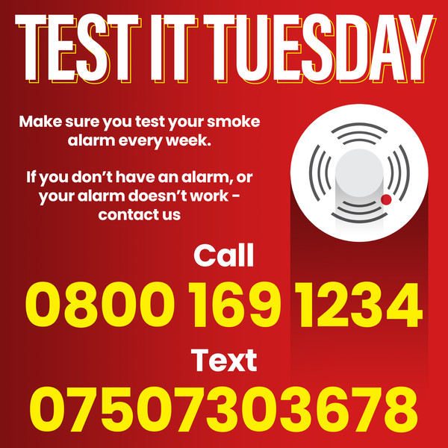

*********************************************************************************

Apprenticeships Delivered in Wales this Senedd Term.
The Welsh Government has announced more than 100,000 apprenticeships than have been created this Senedd term.
First published: 9th February 2026 Last updated: 9th February 2026
Wales has reached a milestone with the Welsh Government achieving its target of having delivered 100,000 apprenticeships in the last four years.
The milestone was announced by First Minister Eluned Morgan, to mark National Apprenticeship Week, which starts today.
Since 2021, more than 100,000 people have pursued high quality apprenticeships, giving them practical work skills and recognised qualifications.
It has also helped businesses recruit, train, and retain staff across sectors including construction, energy and the creative industries.
Opportunities range from foundation to degree level, creating clear progression routes for apprentices and supporting businesses to strengthen their workforce.
First Minister Eluned Morgan said:
Creating more jobs, especially skilled jobs, has been one of my top priorities as First Minister. Apprenticeships don't just benefit people starting their careers, they develop a skilled workforce which will benefit our economy for years to come, especially where there is a proven demand for skilled workers.
Creating more than 100,000 apprenticeships is a fantastic achievement. This is more than just numbers – it means thousands of people, especially young people, have gained valuable skills, confidence and a clear route into work.
The Welsh Government has invested more than half a billion pounds into apprenticeships in Wales this Senedd term.
Cabinet members across the Welsh Government are visiting apprentices and employers throughout Apprenticeships Week Wales to celebrate the milestone and highlight opportunities available.
Minister for Skills Jack Sargeant said:
Apprenticeships are central to delivering a stronger, fairer and greener Welsh economy. As a former apprentice myself, I know first-hand how transformative this pathway can be. They strengthen our workforce and give people the power to build their futures. This is a remarkable achievement for Wales.
I want to thank Medr, our partners, colleges, universities, providers and employers who made this possible. We will continue building on this success to ensure apprenticeships remain a powerful driver of growth in Wales.
On a visit to Real SFX, a special effects company in Cardiff, the First Minister met Will Hougham, who began his career as a Sgil Cymru apprentice in 2019 and is now a permanent member of staff, mentoring new apprentices and winning multiple awards for his work.
SFX Technician, Will Hougham said:
My apprenticeship journey with Real SFX through Sgil Cymru has been lifechanging.
The support, trust and opportunities I was given allowed me to build a career I’m proud of. I’ve gone from learning the ropes to winning awards and now mentoring apprentices and junior members of the team, which feels incredibly full circle.
Sgil Cymru and Real SFX didn’t just give me a start - they helped me believe in what I could achieve. This is a career I’m passionate about, and one I’m excited to continue building.
Real SFX works closely with Sgil Cymru and has supported 15 apprentices since opening in Cardiff in 2009.
They deliver hands hands-on training across their regional hubs in Wales and the UK and apprentices are embedded within Real SFX’s specialist teams, contributing to a broad range of high-end screen productions.
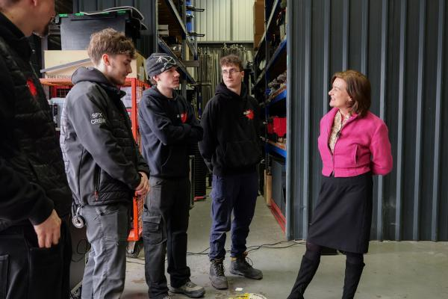

**************************************************************************************************************************
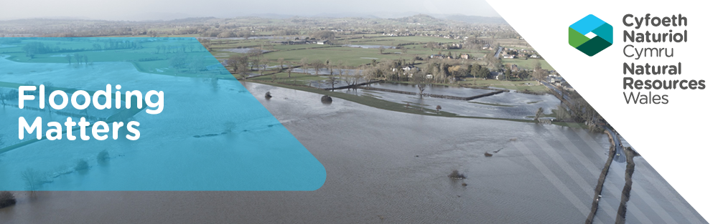

Wales experienced a succession of high impact storms and prolonged rainfall during late 2025. Storm Benjamin, Storm Claudia, and Storm Bram, combined with sustained wet conditions, caused widespread and repeated flooding. Communities, particularly across South East, South West and parts of central Wales, faced severe disruption, flooded properties, and dealing with recovery.
What Happened?
- Storm Benjamin brought heavy rain and strong winds and left the ground saturated across Wales going into November, increasing the risk of flooding when further storms arrived.
- Storm Claudia brought a month’s worth of rain in just a few days, leading to severe flooding in Monmouth, as a result of overtopping from the River Monnow for the first time since the defences were constructed in 1991.
- At the end of November, following Met Office weather warnings, there were over 40 flood alerts and warnings across Wales.
- Storm Bram in early December caused further widespread flooding, communities across South Wales faced rescues due to stranded vehicles, and rail lines were closed due to flooded or unstable ground.
Wales experienced disruption at the start of 2026 as Storm Chandra brought heavy rain, strong winds and a heightened risk of flooding, prompting weather warnings. Multiple flood warnings and alerts were issued as prolonged rainfall on already saturated ground led to flooding of low-lying land, riverside roads and some properties across several catchments.
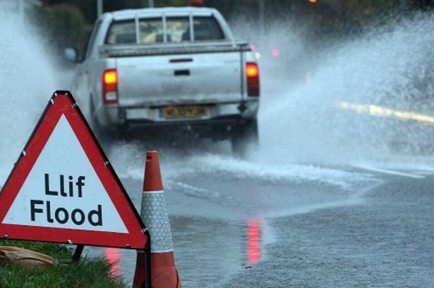
The recent weather period demonstrates how multiple storms on saturated catchments can elevate flood risk quickly and repeatedly. As weather patterns become more unpredictable, community preparedness is more important than ever.
Here are steps everyone can take:
- Know if your area is at risk of flooding – check your flood risk
- Sign up for free flood warnings and monitor Met Office weather alerts.
- Have a personal flood plan - keep essential items, medication, and documents somewhere accessible.
- Avoid walking or driving through floodwater.
- Check on neighbours who may need extra support.
We always appreciate it if you can provide us with local flood impact information so we can continually improve the timeliness and accuracy of our Flood Warning Service and our resilience advice to those at risk. For example:
- Do you have photos with specific locations taken during or after the flooding, that you would be willing to share? If they are dated and time stamped this would be helpful.
- Were there any actions from your flood plan, where you realised that you needed to make changes? Would you be willing to share anything you’ve learnt?
Get in touch

Supporting Senedd Members & Their Constituents
In October 2025, members of the National Flood Risk Services team attended the Senedd’s “Y Farchnad” event specifically to talk about advice and support for communities living with flood risk.
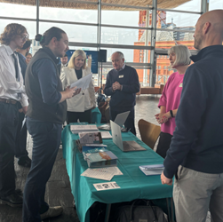 |  | Our aim was to help Senedd Members and their teams be in a better position to help their constituents who have questions around flooding - including what support and advice is available from NRW and other partners. We took with us publications and leaflets to share and demonstrated our digital services via laptops and had some interesting questions and conversations on the day.
We also followed up with links to our key information and advice resources (in Welsh and English), and asked Members and their teams to share our advice with constituents. We intend to repeat this event in the autumn after the May elections so we can meet newly elected Members from across all the political parties and help them to support their constituents.
Spotlight: Flowers against flooding?
Why Are New Estates Full of Flower Beds?
Next time you pass a new housing estate and spot flower beds or grassy channels, they’re not just decoration. These features—such as rain gardens and swales—are part of Sustainable Drainage Systems (SuDS), designed to reduce flooding and pollution. Since January 2019, Welsh law requires all new developments to use SuDS to manage rainwater sustainably.
What Are SuDS?
Traditional drains rush rainwater away in pipes, but heavy storms can now overwhelm our old sewers, causing flooding and pollution. Modern SuDS mimic nature by slowing water down, storing it, letting it soak into the ground, and then releasing it gradually into rivers. Instead of treating rain as a nuisance, SuDS manage it as a resource. Features you’ll find in SuDS include rain gardens, swales, permeable paving, green roofs, and ponds.
Rain Gardens and Swales
Rain gardens are shallow planted areas that capture runoff from roofs and roads, filtering pollutants and supporting wildlife. Swales are gently sloping, vegetated channels that slow water and help it soak away as it flows. Together, they keep water out of sewers, reduce flood risk - and look great while they do it.
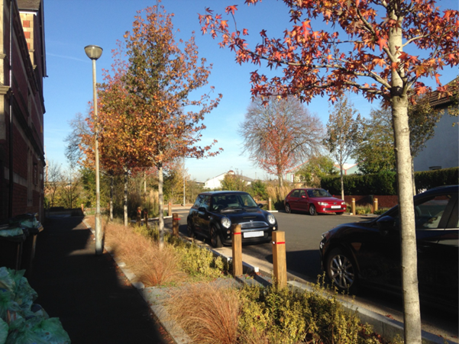
Photo: SuDS raingarden in Grangetown, Cardiff
Why Does Wales Need SuDS?
Climate change and urbanisation have increased heavy rainfall and surface water flooding. Over 140,000 properties in Wales are at risk, costing millions and causing misery. When SuDS tackle these problems they bring added benefits:
- Lower flood risk by managing water at source
- Cleaner rivers and seas through filtration
- More urban green spaces for people and wildlife
- Better wellbeing by reducing stress for residents
A Greener Future
SuDS aren’t just drainage—they create places where people and nature thrive. Those “flower beds” you see are part of a smarter, sustainable approach to rainwater management that’s now the law in Wales.


NRW Flood Warnings and Alerts are not colour coded
It is important to remember that in the UK, the Met Office forecast the weather, and NRW forecast and warn of flooding in Wales.
NRW provides 24/7 flood forecasting and a free Flood Warning Service to many areas at risk of flooding from and the sea in Wales. Sign up for free flood warnings.
We have monitoring stations across Wales that measure river levels, rainfall and sea conditions and provide us data in real-time. This data is analysed along with weather, storm surge and wave forecasts from the Met Office to help us forecast when and where flooding might happen.
We use our flood forecasts alongside local knowledge, to make decisions about issuing warnings to those at risk.
Unlike Met Office weather warnings, flood warnings and alerts are not colour-coded and they cover targeted areas and communities. There are three levels in our Flood Warning Service:
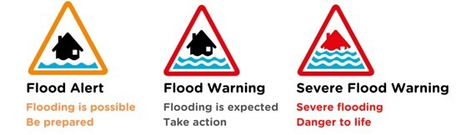
Here is a breakdown of potential impacts at each level of our Flood Warning Service:
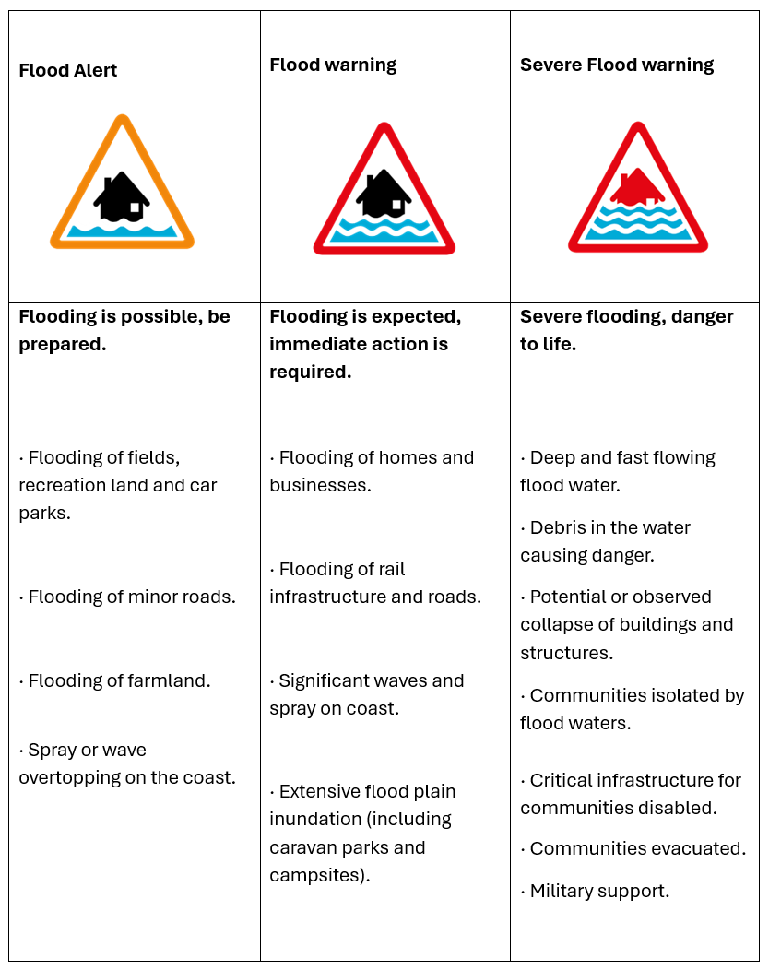

 |  | Flood Alert. Be prepared.
A Flood Alert is used to warn people of the possibility of flooding and encourage them to be alert, stay vigilant and make any necessary preparations for possible flooding.
What to do:
- prepare a flood kit of essential items
- check flood warnings and alerts
- farmers should consider moving livestock and equipment away from areas likely to flood
- do not drive or walk through flood water
- monitor local river levels rainfall and sea data
- check the 5 day flood forecast
Flood Warning. Immediate action required.

Flood Warnings are issued when flooding is expected: we think flooding of homes and businesses will happen. If you receive a Flood Warning you should take action to protect yourself, family, pets, and property by acting on your flood plan.
What to do:
- move family, pets and valuables to a safe place
- turn off gas, electricity and water supplies if it is safe to do so
- put flood protection equipment in place
Severe Flood Warning. Danger to life.

We issue Severe Flood Warnings when there is a significant risk to life or significant disruption to the community.
They are the highest warning level and are issued when dangerous deep and fast flowing floods are expected or already happening.
What to do:
- stay in a safe place with a means of escape
- be ready to leave your home
- cooperate with the emergency services
- call 999 if you are in immediate danger
What we can't forecast
Our Flood Warning Service covers around 90% of the properties at risk of flooding from main rivers or the sea in Wales,
There is also a risk of flooding from other sources which we don’t warn for:
- surface water
- small watercourses (link to main rivers)
These types of flooding can occur very quickly and are often very localised, meaning there isn’t time to issue advance warning messages which allow those at risk to take effective action.
If you are concerned about flooding from surface water or small watercourses Please contact your local authority, who will direct you to their relevant department. Sewer flooding is the responsibility of your local supplier (Find Your Supplier | Water UK)
Met Office - Weather Warnings: Supporting Flood Resilience
The weather can be highly changeable and sometimes severe, posing risks to life, property and daily activities. The Met Office and Natural Resources Wales play a vital role in mitigating these risks by issuing weather and flood warnings.
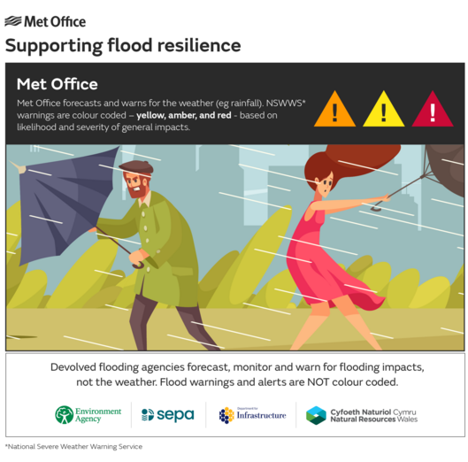
The Met Office forecasts, monitors and warns for the weather (e.g. rainfall), not flooding impacts. Warnings are colour coded (yellow, amber, red) based on the likelihood and severity of impacts over wide areas (county scale or larger).
Natural Resources Wales forecasts, monitors and warns for flooding impact at a community scale, not the weather. Flood warnings are NOT colour coded.
Why the Met Office issues weather warnings
The purpose of weather warnings is to alert people to severe weather conditions that could disrupt daily life and pose safety hazards. By providing timely and accurate warnings, the Met Office helps, individuals, businesses and emergency responders take the necessary precautions to minimise the impact of severe weather. This proactive approach is essential for public safety as it allows people to prepare for and respond to adverse weather conditions effectively.
The Met Office provides warnings for the weather, for example rainfall, up to seven days ahead. Each warning includes the following sections:
- Headline: A brief statement indicating the type of weather expected.
- What to Expect: Details on the potential impacts and their likelihood.
- What Should I Do: Provides WeatherReady advice and guidance on how to stay safe during severe weather.
- Further Details: Additional information about the forecast and any updates to the warning
The warnings are colour coded, yellow, amber or red, based on a combination of the level of impacts the weather may cause and the likelihood of those impacts occurring. This means that it is important to read each warning to know what level of impact you can expect for your chosen warning area and how likely those impacts are to occur.
The colour coding system
This system helps convey the severity and likelihood of any weather impacts:
- Yellow Warnings: Indicate potential impacts and advise people to check the forecast and take precautions.
- Amber Warnings: Suggest more significant and widespread impacts, urging people to change plans and protect themselves and their property.
- Red Warnings: Reserved for the most severe weather, indicating a high risk to life and substantial disruption. People are advised to take immediate action to stay safe.
We show this combination of impact and likelihood in a matrix, which can be seen in the ‘Further Details’ section of our warnings. To understand how likely we think the forecast impacts are, always check the matrix to see which box has been ticked.
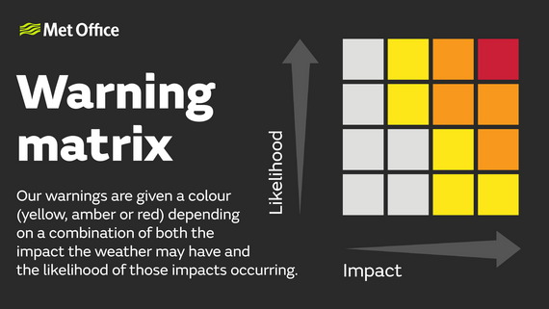
When do we warn for the weather?
From 2011, we moved to impact-based warnings, which means that weather is warned for when it is deemed to have potential impacts on people.
This was a change from previous years when warnings were issued when certain weather thresholds, or levels, were reached.
The guidance on warnings that our expert meteorologists work from today includes awareness of the wider context of the weather occurring. This means they consider other factors that could make the weather particularly impactful. These factors include:
- Time of Year: Seasonal variations can affect the severity of weather impacts.
- Time of Day: Weather conditions during rush hour can have more significant impacts.
- Location: Different regions may have varying levels of preparedness for certain weather conditions.
- Local Events: Outdoor events or activities can increase the risk of weather impacts.
- Ongoing Sensitivities: Existing vulnerabilities in an area, such as saturated ground or weakened structures, can exacerbate weather impacts.
Impacts can include damage to property, travel delays and cancellations, power cuts, and flooding and in the most severe cases bring a danger to life.
Advice from other organisations
Below are messages provided on behalf of others, which may be of interest to you.
Dŵr Cymru: Wipes Block Pipes
Between 2020 and 2025, over a quarter (27%) of flooding incidents affecting customers were linked to the flushing of items such as fats and wipes, with a further 14.5% caused by third-party interference or damage to the sewer network. This means that more than two in five flooding incidents (41.5%) could have been prevented through correct use and care of the network.
During periods of heavy or sustained rainfall, blockages reduce how effectively the sewer system can operate, increasing the risk of flooding. Records show that blockage levels are highest during the wettest months. While this reinforces the importance of continuing to invest in our network and climate resilience, it also highlights a simple change in what is put down drains and toilets can significantly improve network performance and help protect homes and communities from flooding.


Met Office: Online Community Resilience Course Prospectus
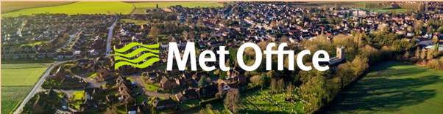
Community responders and the voluntary sector play a crucial role in the resilience of the UK. This training prospectus is aimed at those who work or volunteer in local communities to make them more resilient to severe weather events.
This prospectus outlines the courses available, includes training dates and details on how to register for a course. There is no fee to attend a course, but it is necessary to register so that you can receive joining instructions and handouts.
Met Office 2026 Online Training Prospectus

Suggestions
- What would you like to see in future issues of this newsletter?
- Is there something you’d like to know more about?
- Would you be willing to share your experiences of flooding or as a community volunteer?
- Get in touch if you missed any of our previous issues, and we can share them with you.


If EVER you need to contact a person who is Extremely Clever at finding out what is wrong –with your computer, then I can honestly recommend Mr Chris Williams. (Who is also a very kind and considerate Gentleman.)

***************************************************

FOOT CARE By PODIATRIST THOMAS JENESON @ Grosvenor Lodge
(1 Grosvenor Road, Wrexham) 01978 800777 tajeneson@gmail.com.

*****************************************

Best Wishes AND Thank You – Sybil (Bremner)

***********************************************************

