Ruabon News Letter 597
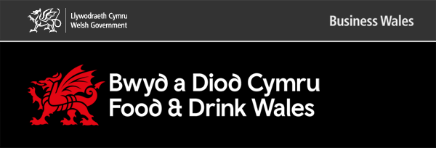
- Blas Cymru Taste Wales
- A Flavour of Success - Most Exciting New Product Award Winner - Flavour Moments
- A Taste of Success: Exclusive Study Tour to Blas Cymru
- Blas Conference and Exhibition - October 2026
- FDWIB Update – Andy Richardson
- Food Manufacture - featured on-line article
- Sustainability Shines at Blas Cymru
- Waste Reduction & Valorisation Workshops
- Fare Share and the Sustainability Cluster – Tackling Food Poverty
- The Free-Range Poultry-meat Marketing Standards (Amendment) (Wales) Regulations 2025
Bias Cymru Taste Wales
The Blas Cymru Brokerage took place on 22nd-23rd October 2025 at the ICC Wales, Newport.
The event brought together 151 producers, including 30 Rising Stars, and 321 buyers—282 from the UK and 39 international—to help drive exports and further elevate Wales’ food and drink sector on the global stage.
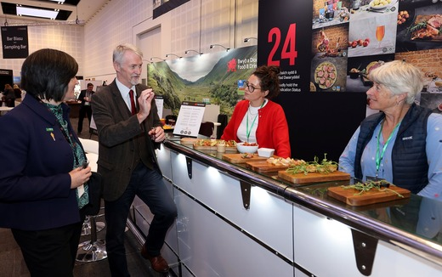

Above: Huw Irranca-Davies, Deputy First Minister and Cabinet Secretary for Climate Change and Rural Affairs at Blas Cymru Taste Wales. Below: Jack Sargeant MS, the Minister for Culture, Skills and Social Partnership, officially opened Blas Cymru Taste Wales 2025.
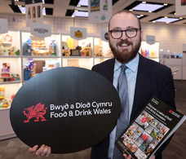 |  | “Blas Cymru Taste Wales 2025 is a celebration of the creativity and excellence that define our food and drink sector. This event brings together the best of Welsh producers, showcasing their innovation and ambition to buyers from across the globe." - Jack Sargeant MS
The Brokerage included a Ministerial welcome dinner on the eve of the event. Over the following two days, attendees participated in a wide range of activities including a networking dinner, industry showcases, and guided tours of the event, which were attended by 22 companies.

Industry showcases highlighted GI products, meat, dairy, seafood, and horticulture, with experts on hand to provide guidance and support to businesses. A total of 200 new product ranges were launched during the event.
Blas Cymru underwent a transformative change in 2024, with the exhibition and brokerage separated into two distinct events.
The inaugural Blas Cymru Conference took place in October 2024;
the next Blas Cymru Conference is scheduled for Autumn 2026 and will further build on this evolution.

The two-day conference aims to showcase the extensive infrastructure and support available to the Welsh food and Drink Industry.
The Brokerage included a Ministerial welcome dinner on the eve of the event. Over the following two days, attendees participated in a wide range of activities including a networking dinner, industry showcases, and guided tours of the event, which were attended by 22 companies. Industry showcases highlighted GI products, meat, dairy, seafood, and horticulture, with experts on hand to provide guidance and support to businesses. A total of 200 new product ranges were launched during the event.
Blas Cymru underwent a transformative change in 2024, with the exhibition and brokerage separated into two distinct events. The inaugural Blas Cymru Conference took place in October 2024; the next Blas Cymru Conference is scheduled for Autumn 2026 and will further build on this evolution. The two-day conference aims to showcase the extensive infrastructure and support available to the Welsh food and drink industry.
Back to contents
A Flavour of Success - Most Exciting New Product Award Winner - Flavour Moments
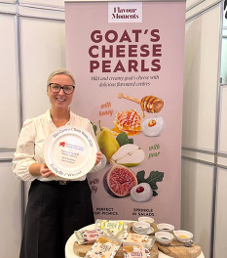 |  | Huge congratulations to Phillipa from Flavour Moments, winner of the Most Exciting New Product Award at our Blas Cymru Taste Wales 2025 event!  Based in North Wales, Flavour Moments Wales specialises in creating unique, fun and flavoursome experiences for cheese lovers who love to socialise and share. They were part of the Rising Star Market Place at the event.
This dedicated space gave buyers the chance to connect with the next big names in Welsh food and drink. At the event, Philippa got to share her innovative goat's cheese pearls with buyers, who got to sample and learn more about what makes Flavour Moments so special.
These innovations are driven by Welsh Government initiatives such as the Food Technology Centre with The HELIX Programme, Cluster Network and Cywain, which support collaboration, creativity and growth across the sector, from start-ups to established brands.
Congratulations again Phillipa, we can't wait to see what's next for Flavour Moments Wales!
See and hear more from Phillipa about winning the award.
Instagram users
Facebook users
Back to contents
A Taste of Success: Exclusive Study Tour to Blas Cymru
An exclusive study visit organised by Cywain offered participants a vital, behind-the-scenes look at Blas Cymru Taste Wales, the flagship trade and export event for the Welsh food and drink industry. This immersive tour was specifically designed to give attendees a clear understanding of what is required to attend and succeed at future events.
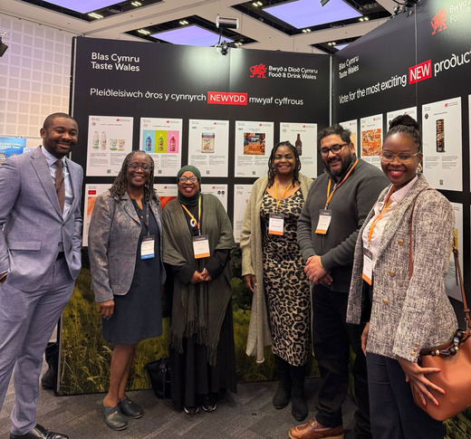
Members - Centre for African Entrepreneurship
Cywain were supported in the recruitment of the Study Tour by The Centre for African Entrepreneurship, as part of a wider Welsh Government Working Group on Diversity. The purpose of this is to increase the access to support from Cywain and other programmes in the food and drink industry and increase the diversity of the sector. 25 aspiring food and drink entrepreneurs attended gaining ideas, inspiration and insight into their category and boosting confidence in setting-up their own business. We hope that these businesses will grow and develop to exhibit at future Blas Cymru / Taste Wales events.
A key highlight was the exclusive access to the brokerage zone, a dynamic hub where approximately 150 Welsh producers were lined up to engage with nearly 300 invited buyers. Observing these high-stakes meetings provided an unparalleled insight into the trade connections and pitching skills essential for securing new business.
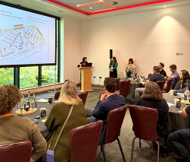 |  | The morning began with an introductory workshop, offering a comprehensive overview of the event's structure. Crucially, this included insights from producers who were actively pitching their products that year, sharing real-world experiences and tactical advice. The visit concluded with the highly valuable 'Taste Wales'
networking lunch, ensuring delegates had ample opportunity to build connections with industry peers, producers, and potential partners. The study tour proved to be an invaluable professional development opportunity, equipping participants with the knowledge and contacts needed to join the Welsh food and drink sector on the global stage.
“I enjoyed meeting other like-minded people who were in similar situations in terms of the stage of their business and hearing about challenges they've faced and how they were overcome.” - Derwydd Organics
“Inspirational… it gave a fantastic insight to what is expected of businesses when they’ll be attending Blas Cymru in the future.” - Sumptuous Bakery
Instagram users can view an informative reel that was posted during the event.
Blas Conference and Exhibition - October 2026

The Blas Cymru Taste Wales Conference and Exhibition 2024
Blas Cymru Taste Wales - Meet the Buyer was a celebration of everything that makes Welsh food and drink world-class. Diolch to everyone who joined us and helped make it such a success.
Meet the Buyer is the premier trade event in Wales for buyers and suppliers of Welsh food and drink. It is an industry trade show not open to the public.
If you are a business, trade partner, or industry stakeholder interested in exhibiting and promoting your services, or in sponsorship for Blas Cymru one of our most prestigious brands, you may be interested in the Blas Cymru Conference planned for October 2026.
Please contact: blascymru.tastewales@gov.wales
Instagram Blas Cymru Taste Wales 2025
Facebook Blas Cymru Taste Wales 2025
Back to contents
FDWIB Update – Andy Richardson
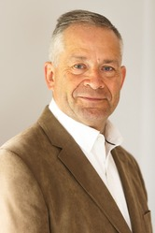 |  | Many of you will be aware that I chaired the Food and Drink Board for eight years until January 2024. I remain on the Board because I am committed to supporting its success as a vital conduit between the Welsh food and drink industry and government.  As Chair, I oversaw the Board during:  - Brexit  - Covid  - And early parts of the Ukraine crisis which sadly continues to this day
It taught me that more resilient businesses emerge stronger from these crises!
I also saw that the real power of collaboration within the industry and with government. This is something that many businesses have embraced and they have created:
- stronger supply chains
- fewer volatile businesses
- and real “win-win” business relationships
Continue Reading this update on the FDIWB Website
Back to contents
************************************************************************
Food Manufacture - Featured On-Line Article - Why support and Training are Key to Achieving Business Sustainability Goals
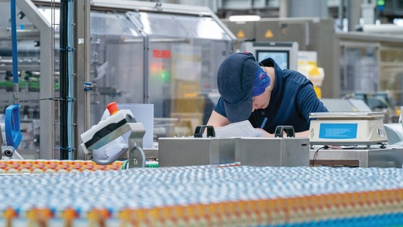
Amid all the pressures faced by today’s food & drinks manufacturers, the added challenge of meeting increasingly stringent environmental expectations can seem insurmountable. Yet, with centralised government help, gradual progression towards a greener future can bring multiple benefits, including improvement in the bottom line, as businesses based in Wales are discovering.
Continue reading the article on the Food Manufacture Website.
Back to contents
Sustainability Shines at Blas Cymru
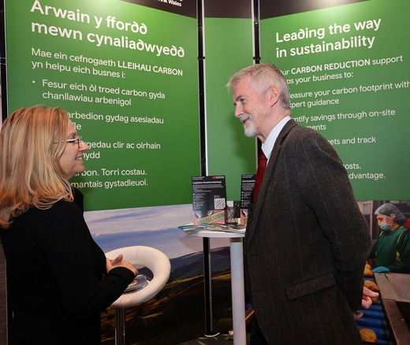
For the first time ever, sustainability had a dedicated presence at Blas Cymru’s Brokerage Zone—and it was a resounding success! The sustainability stand brought fresh energy to Wales’s flagship food and drink trade event, proving that environmental responsibility and business growth go hand in hand.
Throughout the event, the stand became a vibrant hub of activity. Producers, retailers, and industry leaders stopped by to explore practical tools, inspiring case studies, and new ideas for embedding sustainability into their operations. From Carbon Reduction to Climate Adaptation and Resilience Training, the message was clear: Welsh Government provides comprehensive and fully funded support which is not just good for the planet but also good for business.
The response was overwhelmingly positive. Many attendees shared how the stand helped them rethink their approach, sparking new collaborations and future plans. It was a powerful reminder that the Welsh food and drink sector is ready to lead the way in building a greener, more resilient future.
This milestone marks a turning point for Blas Cymru. By placing sustainability at the heart of the room and the conversation, the event showcased how innovation and environmental stewardship can drive growth, competitiveness, and long-term success.
Here’s to the businesses who are already making a difference—and to those ready to take the next step. Sustainability isn’t a side note anymore. It’s centre stage.
Find out more at Food and Drink Wales - Sustainability
Back to contents

Waste Reduction & Valorisation Workshops
The Sustainability Cluster are hosting several waste reduction and valorisation workshops to help Welsh suppliers tackle waste in their business and identify opportunities to add value to by-product and improve their profitability. Welsh food and drink producers will benefit from:
- Overview and tour of each facility
- Discussion with Industry Experts
- Producer Case Studies
- Best Practise Techniques
The workshops are being held on:
Valorisation - Friday 28th November - Aber Innovation
Waste Reduction - Thursday 4th December - Food Centre Wales
Valorisation - Friday 23rd January - Wrexham University
Waste Reduction - Wednesday 11th February - Food Technology Centre
For more information or to register, please email charlotte.parry@levercliff.co.uk
Back to contents

Fare Share and the Sustainability Cluster – Tackling


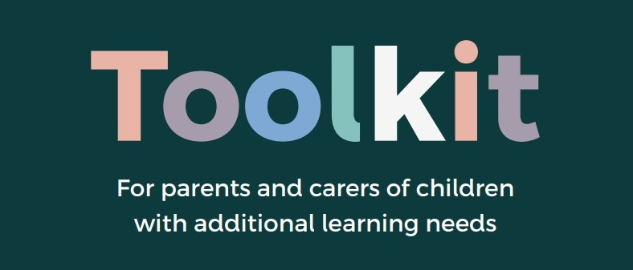
Launch of the New Welsh Government Additional Learning Needs (ALN) Parent and Carer Toolkit

Overview Following a period of development, consultation and co-production, the Welsh Government Additional learning needs (ALN) parent and carer toolkit is now live.
Developed with parents, carers and professionals from across education, health and social care, local authorities and third sector, it explains how the system works and where support is available for children, young people and families.
All resources are available in English and Welsh, with accessible versions including Easy Read.
We would be grateful if you could:
• update your website links to include the new toolkit URL
• raise awareness by sharing the resources through your local networks
Thank you for your continued input and support throughout the development of these resources. Your insight and feedback have been invaluable in ensuring they meet the needs of children, young people and their families across Wales.
**********************************************************************************
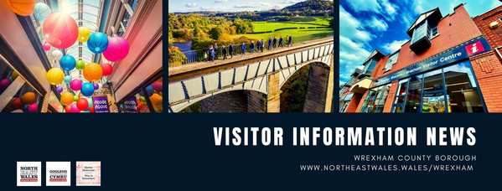

Victorian Christmas Market
It’s almost time to welcome the Victorian Christmas Market back to Wrexham city centre, and we can’t wait!
From Thursday 27th November to Sunday 30th November, you’ll be able to enjoy the atmosphere, with cosy wooden cabins lining the High Street down to St Giles Church, offering plenty of Christmas goodies, gifts and local produce! Let’s not forget the traditional Victorian funfair on Queens Square too. It’s the most wonderful time to visit Wrexham!

Chirk Frost Fair

Returning to Chirk tomorrow, Saturday 22nd November, is Chirk Frost Fair! On Colliery Rd carpark, from 12pm to 7pm, there will be a great selection of artisan market stalls featuring local makers and gifts.
Plus, a family fairground, street food and festive drinks, as well as some great music and entertainment! It’s a lovely event in the Chirk Calendar, one for all the family!

Wrexham Celebrates Wales
Ambassador Week!
This week, across Wales we have been celebrating Ambassador Week! If you’ve not come across the Wales Ambassador scheme, it’s a group of completely free online courses, in which you can learn about the history, heritage and culture of an area, what’s great about living there?
or visiting, with a whole host of interesting facts about wonderful Wales. Wrexham has had its own course for a couple of years now, and if you’ve already completed the Wrexham modules, then why not try another course? Here’s the link to the scheme, and happy Ambassador Week!

A National Trust Christmas!
Next weekend sees the start of Christmas celebrations at Wrexham’s two National Trust properties. Chirk Castle will be beautifully decorated and adorned with trees, lights and decorations, fitting with the theme of a Timeless Christmas amid 700 years of history. There will also be a woodland animal spotter trail, the ever-popular reverse grotto, and plenty of other Christmas magic.
Erddig will be celebrating the festive season with a Nutcracker Adventure, with the classic tale brought to life with beautifully decorated rooms and sparkling trees. With a fun ballet-inspired trail outside, and all the wonderful crafts, storytelling and opportunities to meet Father Christmas, it’s another Wrexham gem not to be missed.

*********************************************************************************************************

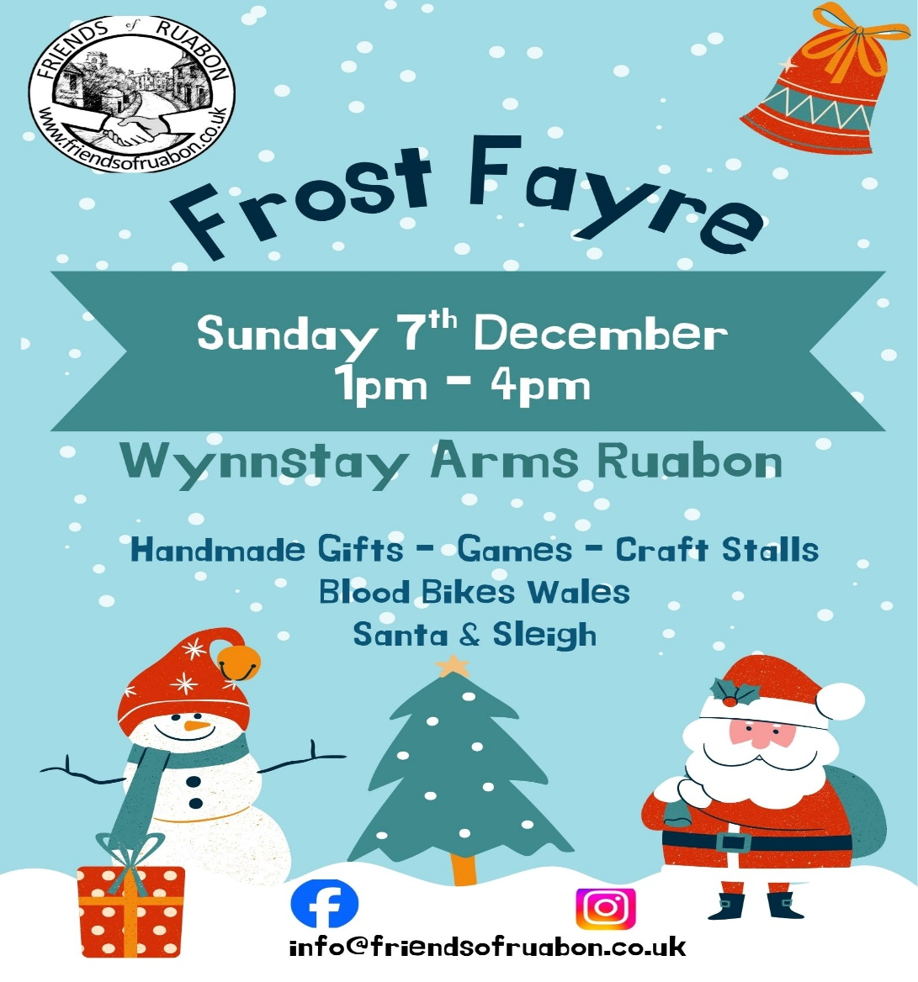

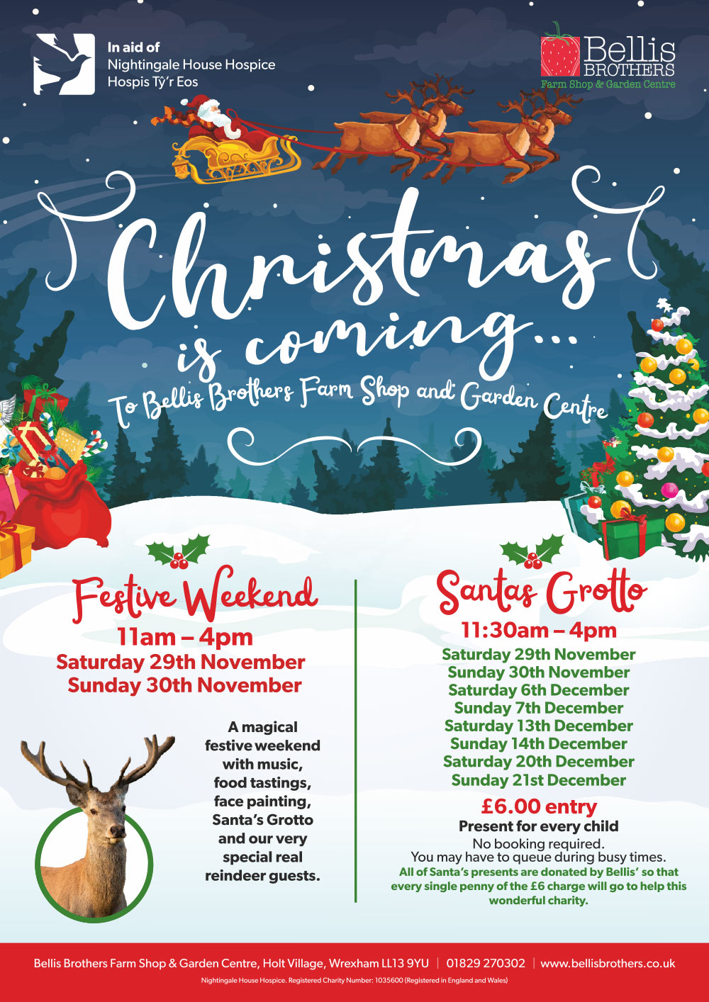



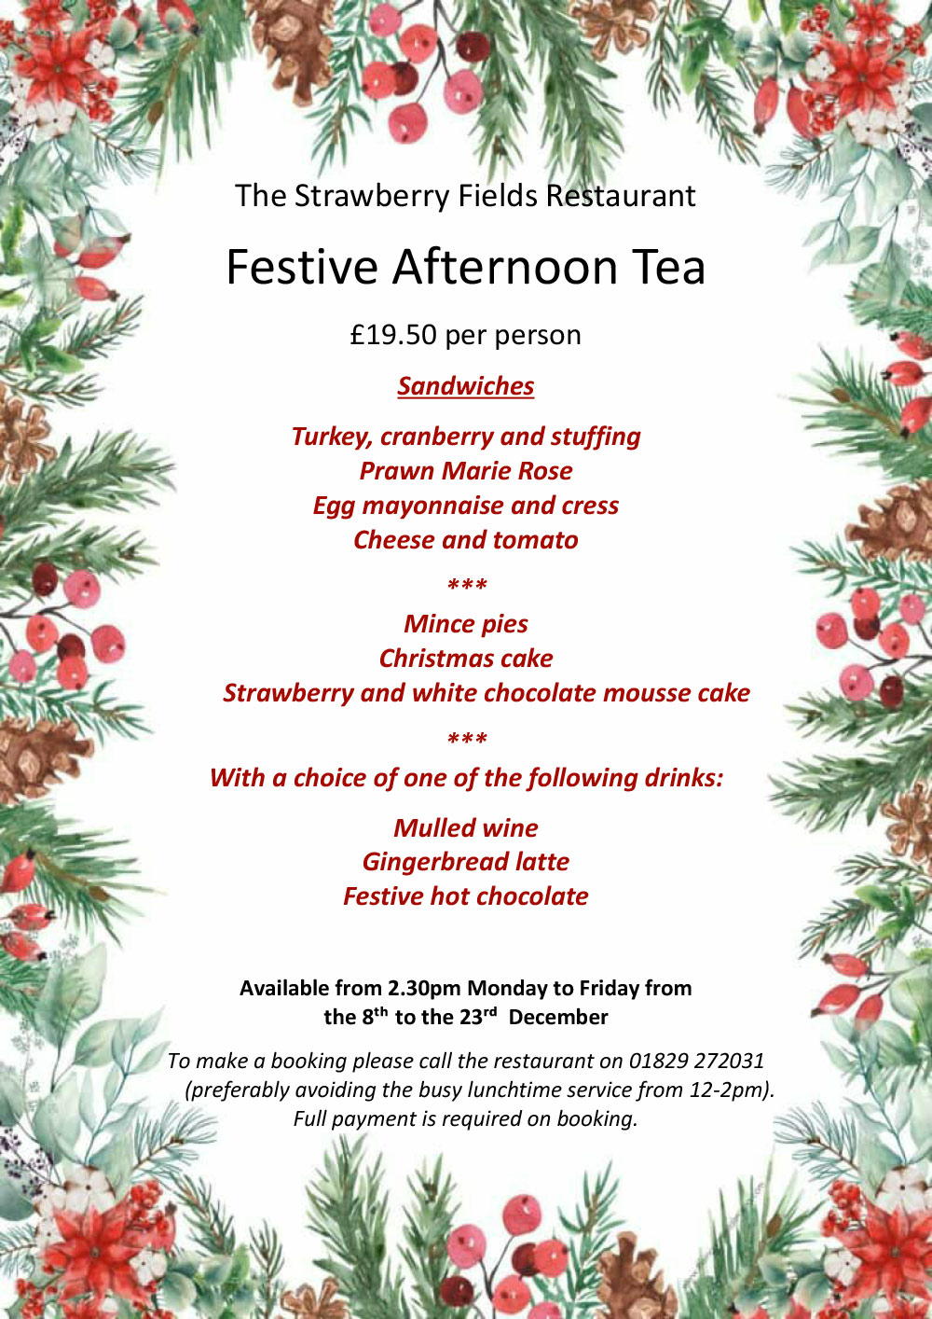

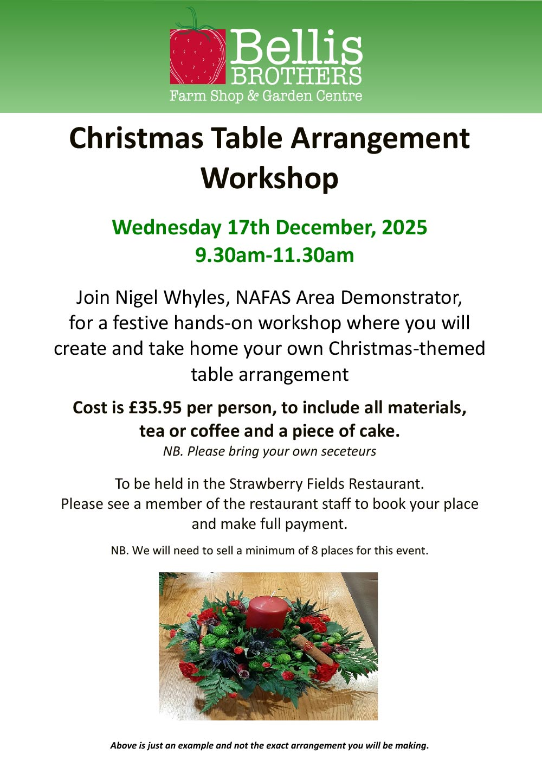



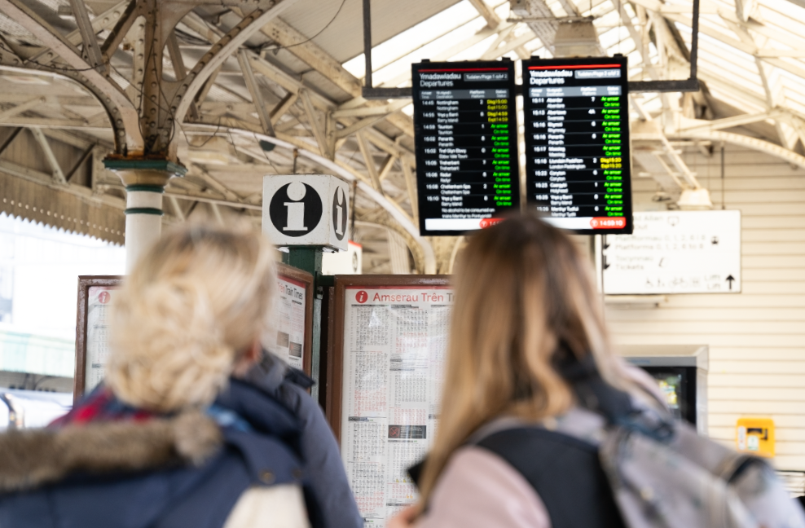

Rail timetable changes coming this December (from 14th) will offer more services across the Wales and Borders network.
Strengthening community connections, boosting the night-time economy and providing more travel opportunities, the new timetable will provide greater connectivity throughout Wales.
These are further changes as part of the Network North Wales and South Wales Metro developments.
Key changes include:
- An introduction of a new hourly service between Chester and Wrexham, doubling frequency to 2 trains per hour.
- A new midday train in each direction on the Heart of Wales line between Shrewsbury and Swansea via Llandrindod Wells, meaning 5 trains a day.
- A brand-new hourly Sunday service between Coryton and Penarth (an extension of the existing Cardiff-Penarth services) which boosts Sunday travel.
- On Fridays, there will be three later last trains from Cardiff after midnight to each of Treherbert, Aberdare and Merthyr Tydfil, including a connection from Cardiff Bay.
- The daily 11:23 service between Cardiff and Holyhead will now make additional stops at Craven Arms (12:59) and Church Stretton (13:07).
- On Mondays to Saturdays, there are new trains at 05:54 from Bidston to Wrexham General and at 20:51 from Wrexham Central to Bidston
- From Mondays to Saturdays, the existing 07:40 departure from Cardiff to Milford Haven will change to 07:21, to provide a more regular service to Swansea for peak hour commuters.
- From Mondays to Saturdays, existing services between Cardiff and Gloucester at 14:10, and Gloucester to Cardiff at 15:49, now extend to and from Cheltenham Spa.
- On Mondays to Saturdays there will be a new train at 05:37 from Bridgend to Cardiff calling at all stations and extending to Ebbw Vale, supporting early commuters.
- On Saturdays, there will be a new later evening train at 23:23 from Cardiff to Hereford plus the existing train at 22:15 from Cardiff to Hereford will be extended to Shrewsbury.
- The 20:26 Pwllheli to Machynlleth, and 21:47 Machynlleth to Pwllheli evening services on the Cambrian Line are intended to remain
Colin Lea, TfW Planning and Performance Director said: “These timetable changes are another step forward in our efforts to offer a more regular, reliable, and customer-friendly rail service across Wales and the Borders.
“By adding new services and tweaking existing ones, we’re boosting connectivity in key areas like North and mid Wales, meeting growing demand, and making smarter use of our train fleet.

“Whether it’s the new hourly service between Chester and Wrexham, the refreshed Heart of Wales line or later services for the Valleys, these updates are all about making a real difference for communities right across the country”.

For full details and to plan your journey, please check before you travel by visiting www.tfw.wales and enter journey details for a date after
14th December.

We’d be grateful if you could share the news of the changes coming in December to your networks.
To make this easier to do, we’ve attached some social media graphics, which you are welcome to use.

*************************************************************************

Take a Tour of Wrexham –
There is Plenty to Choose From!

With more and more visitors wishing to explore the City and beyond, we are really proud of the range of tours now on offer in Wrexham.

From a Saturday morning city walking tour you can fit in before the match, a public art trail which showcases Wrexham’s talent across a number of sites, to a food walking tour, a Wrexham Larger tasting tour and even, for the bravest amongst us, a Ghost Tour!
They are all calibri! see what takes your fancy and explore Wrexham in a different way!

Take a Tour of Wrexham –
There is Plenty to Choose from!
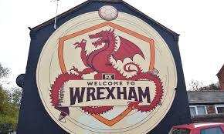

With more and more visitors wishing to explore the city, and beyond, we’re really proud of the range of tours now on offer in Wrexham.
From a Saturday morning city walking tour you can fit in before the match, a public art trail which showcases Wrexham’s talent across a number of sites, to a food walking tour, a Wrexham Larger tasting tour and even, for the bravest amongst us, a Ghost Tour!
They’re all here to see, just take your fancy and explore Wrexham in which ever way you prefer!



If EVER you need to contact a person who is
Extremely Clever at finding out what is wrong –
with your computer, then I can honestly recommend
Mr Chris Williams.
(Who is also a very kind and considerate Gentleman.)

********************************************************

FOOT CARE by PODIATRIST
Thomas Jeneson @ Grosvenor Lodge
(I Grosvenor Road Wrexham) 01978 800777
tajeneson@gmail.com

***********************************************************

BEST WISHES and THANK YOU ALL
From Sybil (Bremner)

************************************

