Ruabon News Letter 595

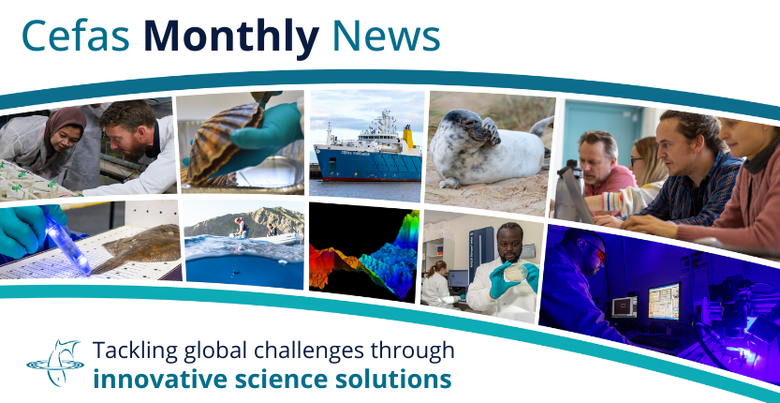
is month’s edition highlights how Cefas science continues to respond to environmental challenges — from restoring ecosystems to supporting global collaboration and from responding to emergencies to supporting sustainable use of our marine resources.
Our Science Spotlight explores how benthic communities recover from contamination near oil and gas platforms, offering valuable insight for future decommissioning and habitat restoration. We also showcase work across our international partnerships, including the Water Quality Solutions for Coastal Habitats workshop, the Indonesia PhD Programme, and updates from the Illegal Wildlife Trade Fund (IWTF).
Our People Spotlight features Freya’s work in Emergency Response, recognising the expertise and dedication that help Cefas respond swiftly and effectively to marine incidents. We also share the latest episode in our Unchatted Waters podcast, focusing on the aquarium trade and link to our recent Science Blast on the ARA case study.
Together, these stories demonstrate the depth and breadth of Cefas science — connecting local action, global collaboration, and real-world impact.
Mark Kirby - Director of Science Resilience & Response

Science Spotlight: Ecological recovery of benthic fauna near oil and gas platforms

Many oil and gas platforms in the North Sea are nearing the end of their lives, creating an urgent need to understand the legacy effects of seabed contamination on benthic communities (biological communities that live in or on the seabed).
Using industry monitoring data collected over 30 years, this study examined changes in contaminants and benthic biomass across 236 platforms. Statistical models revealed non-linear decreases in total hydrocarbon concentrations in relation to the distance from platforms — except in deeper waters north of Scotland.
Following management measures to reduce contamination, the biomass of benthic groups has largely returned to reference conditions. These findings offer a valuable functional perspective to inform ecosystem modelling, environmental assessments and future management of decommissioned sites.
Read More

Building the next generation of shark experts in Indonesia

As the world’s largest shark-fishing nation and exporter of shark products, Indonesia plays a crucial role in global shark conservation.
To help protect these species a new PhD scholarship programme supported through the Illegal Wildlife Trade Challenge Fund, has been launched to train four students in the science and policy of shark conservation.
In a new blog Joanna Murray, Marine Wildlife Trade and Bycatch Lead at Cefas and Efin Muttaqin, Programme Manager at the Rekam Nusantara Foundation, introduce the students and share highlights from a recent UK-Indonesia exchange.
Read More

Aquarium Trade - Unchatted Waters Podcast episode
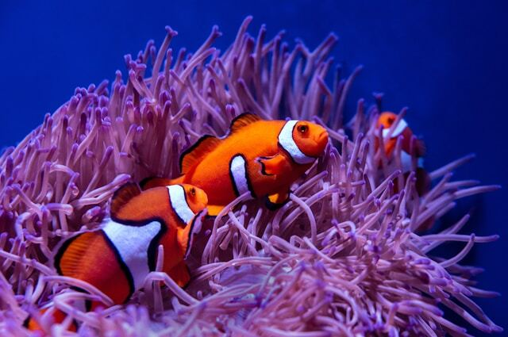
Our latest Unchatted Waters podcast is out now, exploring the world of the marine aquarium trade.
In this episode, we use a tropical fish tank to dive into coral reef ecosystems and uncover how the animals and plants in aquaria are sourced — connecting people across the globe. We journey around the world to truly “find Nemo,” discovering where aquarium species come from and the global importance of the marine aquarium trade.
Photo by David Clode on Unsplash
Listen Here

Keep an eye out for our the Unchatted Waters episode on Emergency Response, featuring Freya Goodsir and Mark Kirby, coming soon.

Media Spotlight: Cefas contribution to new research on future UK marine heatwaves

Cefas' contribution to a new study on marine heatwaves with the University of Exeter and Met Office was covered in The Guardian last month.
In the paper, scientists predict that despite the unprecedented nature of the 2023 heatwave, there is a 10% chance of a marine heatwave of this scale occurring each year in UK waters.
The findings highlight the importance of continued Cefas monitoring and science to better understand marine heatwave impacts on fisheries and marine biodiversity. Read the paper below:
Read More

ARA case study newsletter blast
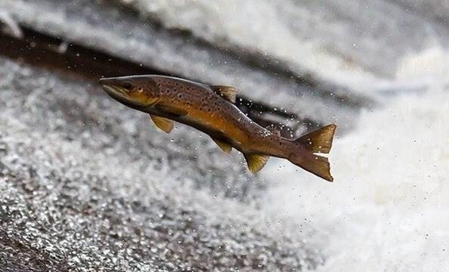
At Cefas, we are committed to support the improvement of the environment and safeguarding the essentials of life—food, water and energy.
As a critical national scientific capability for the UK Government, our science, data and advice underpin sustainable economic growth and societal wellbeing. This year’s Annual Report and Accounts highlights how our work balances the needs of the economy, society and nature to secure a resilient future for our rivers, seas and oceans.
The report features a diverse range of science case studies that illustrate our contribution to the UK’s growth objectives. These feature sustainable fisheries management, innovation in aquaculture and seafood safety, clean energy transition, marine emergency response and international scientific collaboration.
We recently published a Blast newsletter to share selected science highlights from the Annual Report.
Read More

Event Spotlight: Water Quality Solutions for Coastal Habitats workshop
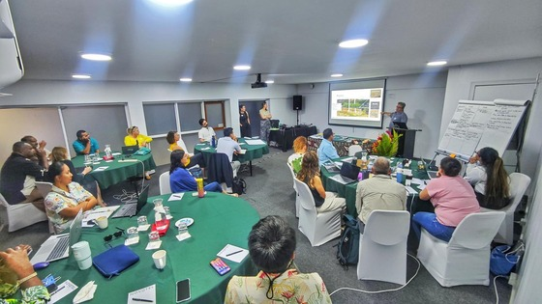
Cefas recently co-led the international Water Quality Solutions for Coastal Habitats workshop that took place in Fiji.
The workshop brought together experts from 17 countries to collaborate on solutions to tackle marine pollution affecting coastal habitats. Hosted by Cefas, G20 CORDAP (Coral Research & Development Accelerator Platform), the Wildlife Conservation Society and The Nature Conservancy, the workshop aimed to develop tools to enhance water management and quality interventions, providing a clear roadmap for future research and development priorities and practical solutions for sanitation, agriculture and nature-based strategies.
Key outcomes include the formulation of a CORDAP Roadmap and the continued development of coastal pollution toolkits. Both of these are integral to our ongoing efforts under the Ocean Decade Program – Nutrient Pollution Global Action Network (NP-GAN).
Read More

PELTIC survey – monitoring the pelagic ecosystem in the Western Channel and Celtic Sea since 2012
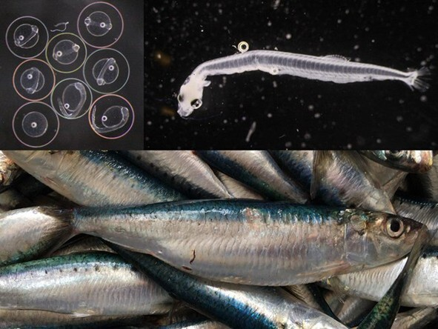
Since 2012, the PELTIC survey has been monitoring small pelagic fish in the UK's Western Channel and Celtic Sea, off the south west coast of England.
Each October, our team at Cefas heads out on the Research Vessel Cefas Endeavour to collect data on sardines, sprat, anchovy, other fish and their environment, which is vital for healthy seas, seabirds and local fisheries.
The PELTIC survey is the only survey of its kind in the region, using innovative tools and collaborating with partners including MARINE life and JNCC. The data collection and analysis contributes to supporting sustainable fisheries, food security and biodiversity and has also informed many scientific publications.
Read More

People Spotlight
Each month, we shine the spotlight on the work of a current member of Cefas staff.
"For over 25 years I’ve worked in marine pollution research and emergency response - from marine monitoring and assessment to rapid-response during major spill incidents to international workshops shaping how governments prepare for future environmental incidents.
"As Chair the Premiam Monitoring Coordination Cell, I bring together agencies and experts to monitor and assess environmental impacts during and after marine emergencies. I also oversee the Marine Pollution Emergency Response initiatives funded through the Blue Planet Fund, helping overseas partners strengthen their response capability and build long-term environmental resilience. I lead the planning and implementation of survey activities under the Clean Seas Environmental Monitoring Programme, with a focus on chemical contamination and eutrophication.
"One of the most rewarding elements of my role is working with national and international colleagues who care deeply about their coastlines and communities. Their enthusiasm and determination to protect their environments is genuinely inspiring.
"I am incredibly proud of what we have achieved together. By improving preparedness, sharing science and strengthening collaboration and communication, we are helping governments respond better to future pollution incidents. Knowing that our work could protect an entire ecosystem or help a community recover more quickly after a spill that’s what motivates me every day."
Freya Goodsir - Cefas Scientist

*********************************************************************************

Newyddion Llyfrgelloedd
Library News
Newyddion Llyfrgelloedd am yr wythnos yn dechrau 9 Tachwedd
Library News for the week beginning
9th November

Cwrdd â'r Awduron
Dewch i ymuno â ni am rai digwyddiadau Cwrdd â'r Awdur difyr. Ar ddydd Llun 24 Tachwedd, 2.00pm bydd cyn-aelod Senedd, Eleanor Burnham, yn siarad am ei llyfr Y Pethau Bychain yn llyfrgell Rhos. Bydd y sesiwn yn y Gymraeg ond bydd hefyd yn addas ar gyfer dysgwyr y Gymraeg. Cysylltwch â'r llyfrgell ar 01978 840328 i gadw eich lle. Ar ddydd Llun 1 Rhagfyr, 6.00pm bydd yr awdur David Ebsworth yn lansio ei lyfr diweddaraf gan Jack Telford, Telford’s Odyssey, yn Llyfrgell Wrecsam. Yna bydd yr awdur gwerthu gorau doniol iawn Jasper Fforde ar ddydd Mercher 3 Rhagfyr, 6.00pm. I gadw eich lle yn y ddau ddigwyddiad hyn cysylltwch â Llyfrgell Wrecsam ar 01978 292090. Mae pob digwyddiad yn rhad ac am ddim ac edrychwn ymlaen at eich croesawu!
Meet the Authors
Come and join us for some entertaining Meet the Author events. On Monday 24th November, 2.00pm ex Senedd member, Eleanor Burnham, will be talking about her book Y Pethau Bychain at Rhos library. The session will be in Welsh but will also be suitable for Welsh leaners. Please contact the library on 01978 840328 to reserve your place. On Monday 1st December, 6.00pm author David Ebsworth will be launching his latest Jack Telford book, Telford’s Odyssey, at Wrexham Library. This will be followed by hugely funny bestselling author Jasper Fforde on Wednesday 3rd December, 6.00pm. To reserve your place on these two events please contact Wrexham Library on 01978 292090. All events are free of charge and we look forward to welcoming you!

Top Ten Books
Oeddech chi’n gwybod bod Llyfrgelloedd Wrecsam yn derbyn copïau o’r 10 llyfr sydd wedi gwerthu orau i oedolion mewn clawr caled a meddal, ynghyd â’r 20 llyfr sydd wedi gwerthu orau i blant? Maent hefyd yn derbyn copïau lluosog o lyfrau ffuglen clawr caled oedolion ar gyfer eu casgliad Rapid Reads (llyfrau y mae'n rhaid i chi eu darllen o fewn wythnos), sy'n golygu bod gennych fynediad hawdd i'r llyfrau diweddaraf gan eich hoff awduron. Mae Sharpe’s Storm gan Bernard Cornwell, The Secrets of the Secrets gan Dan Brown, The Long Shoe gan Bob Mortimer a Diddly Squat: The Farmer’s Dog gan Jeremy Clarkson yn siartiau yr wythnos hon. Beth am alw i mewn i ddarganfod eich hoff lyfr newydd?
Top 10 Books!
Did you know that Wrexham’s Libraries receive copies of the top 10 best-selling books for adults in hardback and paperback, plus the top 20 best-selling books for children? They also receive multiple copies of the adult hardback fiction books for their Rapid Reads collection (books you have to read within a week), meaning you have easy and quick access to the very latest books by your favourite authors. Sharpe’s Storm by Bernard Cornwell, The Secrets of the Secrets by Dan Brown, The Long Shoe by Bob Mortimer and Diddly Squat: The Farmer’s Dog by Jeremy Clarkson all feature in this week’s charts. Why not call in and discover your new favourite book?

Awgrymiadau da ar gyfer arbed arian
Os oes angen i chi brynu oergell, popty, camera, argraffydd, bwlb golau, ffôn a mwy, sut fyddwch chi'n gwybod a yw'r model rydych chi'n ei brynu yn well na'r lleill? Ydych chi'n cael gwerth eich pres? A yw'r un drutaf yn well nag un rhatach? Beth am wirio ymlaen llaw? Ewch i Lyfrgell Wrecsam i ddarllen adroddiad ‘Which?’ am y cynnyrch rydych chi am ei brynu a dewis model yn seiliedig ar ganlyniadau profion helaeth. Mae'n lle da i ddechrau a gallech chi arbed bunnoedd i chi'ch hun.
Top tips for saving money
If you need to buy a new fridge, cooker, camera, printer, light bulb, phone and more, how will you know whether the model you’re buying is better than the others? Are you getting value for money? Is the most expensive one better than a cheaper one? Why not check- up in advance? Visit Wrexham Library to read a ‘Which?’ report about the product you wish to buy and select a model based on the results of extensive tests. It’s a good place to start and you could save yourself pounds.

Theory Test Pro (gan gynnwys HGVs)
Mae Theory Test Pro yn wefan ar-lein sy'n cynnwys y bank cwestiynau prawf swyddogol cyfan, clipiau fideo canfyddiad perygl a fersiwn ar-lein o'r Cod Priffyrdd - y cyfan sydd ei angen arnoch i'ch helpu i basio'ch prawf gyrru theori. Mae ganddo fynediad i fanciau prawf ar gyfer categorïau ceir, beic modur, cerbyd cludo teithwyr a cherbydau nwyddau trwm. Gellir cyrchu'r wefan anhygoel hon yn rhad ac am ddim ar eich cyfrifiadur cartref, y cyfan sydd ei angen yw cerdyn llyfrgell dilys. I gael mwy o wybodaeth, ewch i www.wrexham.gov.uk/libraries a dewis Gwasanaethau Ar-lein.
Theory Test Pro (inc. HGVs)
Theory Test Pro is an online site which contains the entire official test question bank, hazard perception video clips and an online version of the Highway Code – all you need to help you pass your theory driving test. It has access to test banks for car, motorcycle, passenger carry vehicle and heavy goods vehicle categories. This amazing site can be accessed free of charge on your home computer, all you need is a valid library card. For more information visit www.wrexham.gov.uk/libraries and select Online Services.
Oeddech chi'n gwybod…?
Oeddech chi gwybod...mae holl lyfrgelloedd Wrecsam yn neilltuo awr pob wythnos ar gyfer ‘Amser Tawel’ pan nad oes unrhyw weithgareddau’n cael eu cynnal a lle bo’n bosibl caiff goleuadau eu pylu i greu amgylchedd tawel a llonydd.
Did you know…?
Did You know…all of Wrexham’s libraries dedicate one hour a week for ‘Quiet Time’ when there are no activities taking place and where possible lights are dimmed to create a calming and quiet environment.

Adolygiad Llyfr Saesneg
She didn’t see it coming gan Shari lapena
Mae She Didn't See It Coming yn llyfr gyffrous iawn i gefnogwyr nofelau cyffro seicolegol a domestig. Mae'r stori'n canolbwyntio ar ddiflaniad dirgel gwraig o'u fflat moethus, sy'n troi'n gyflym yn ymchwiliad llofruddiaeth gydag amheuon yn disgyn ar gymdogion, ffrindiau a theulu. Adroddir y stori trwy lawer o safbwyntiau gwahanol sydd i gyd â gwahanol resymau dros fod eisiau cuddio'r gwir. Yn llawn troeon plot, penwaig coch, a chyfrinachau, mae'n cadw darllenwyr i ddyfalu tan y diwedd. Mae'r tro olaf yn gorffeniad go iawn ac mae bron yn addas ar gyfer dilyniant!
Book Review
She Didn't See It Coming by Shari Lapena
She Didn't See It Coming is a real page turner for fans of psychological and domestic thrillers. The story centres on a wife's mysterious disappearance from their luxury apartment, which quickly escalates into a murder investigation with suspicions falling on neighbours, friends, and family. The story is told through many different POV’s who all have different reasons for wanting to hide the truth. Packed with plot twists, red herrings, and secrets it keeps readers guessing until the very end. The final twist is a real cliffhanger and almost lends itself to a sequel!
Lynda.
**************************************************************************************
Take Time to Stop and Reflect this Armistice Day
Every year, the country gathers together to remember the ultimate sacrifices that serving men and women, past and present, gave so that we could all live in peace. Many of the local villages across Wrexham will have Remembrance events taking place this weekend. In the city centre, the Annual Service of Remembrance will take place on Sunday 9th November at 10.55 a.m. at Bodhyfryd. Armistice Day will be observed on Tuesday 11th November on Queens Square which members of the public are also encouraged to attend. The air raid siren will be sounded across the city centre at 11 a.m.

Christmas Light Switch on and Lantern Parade
Save the date, Saturday 15th November will see the start of the festive season in Wrexham City Centre!
It all starts at midday on Queen’s Square with the ever-popular artisan market. The Nightingale House Lantern Parade heads off at 4.30pm from Queen’s Square (get yourself booked in here for a lantern). Then from 5.30pm, the celebrations at Eagles Meadow begin, with lots of live music on the stage, from acts such as Living Joy and Urban Cookie Collective. Culminating in the big switch-on, exciting stuff!

The Countdown to the Victorian Christmas Market is On!
November is looking to be a busy month in the Wrexham events calendar, with the hugely popular four day Victorian Christmas Market taking place from Thursday 27th November to Sunday 30th November. The streets around St Giles Church and High Street are filled with festive cheer, as traditional wooden cabins selling a vast selection of gifts, crafts, homemade goodies and delicious food and drink create an amazing atmosphere. As well as these great opportunities for shopping, there’s always lots of entertainment and fun to enjoy, and the atmosphere’s bound to be incredible.

Wrexham’s Theatres
If you’ve not enjoyed an evening at the theatre recently, you don’t need to travel too far to get one booked in. Wrexham’s got a pretty great choice of venues, with something for everyone.
The William Aston Hall has some great acts coming up, including Sara Pascoe and Milton Jones. If a concert is more your thing, then there’s the Nightingale House Christmas Concert which promises to be very special and full of Christmas atmosphere.
The Stiwt in Rhosllanerchrugog will be welcoming audiences to its annual pantomime, this year it’s the Wizard of Oz. As well as this there will be a musical version of A Christmas Carol and the opportunity to have brunch with Santa!
The Grove Park Theatre has a performance of Cinderella throughout December, and it’s worth looking at what else they have on going into 2026.
*****************************************************************************************************

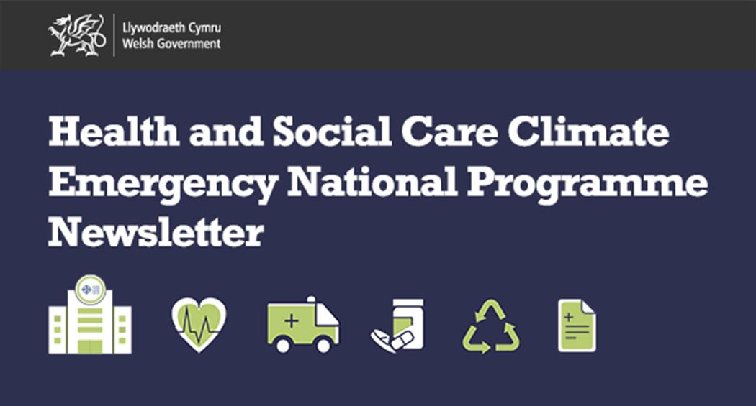

NHS Wales Decarbonisation
Strategic Delivery Plan 2025-2030
Following endorsement by the NHS Wales Leadership Board, the refreshed NHS Wales Decarbonisation Strategic Delivery Plan (SDP) has been published on the Welsh Government website:
Building on the strong foundation of the original SDP, the refreshed plan sets out ambitious initiatives to reduce emissions in the NHS in Wales.
The refreshed plan will help NHS Wales organisations to:
- Increase energy efficiency and use of renewables
- Support more sustainable travel by staff and patients
- Work with suppliers to minimise environmental impact
- Deliver environmental sustainability
- Reduce waste
- Work as sustainably as possible.
Input from across NHS Wales organisations has been invaluable in shaping the refreshed plan as we work together towards a lower-carbon, more sustainable health system.

Watch and Learn
We have produced two short bilingual explainer videos to simply describe the main aims and objectives of the National Programme and what you can do to help.  Please share our videos with your teams, stakeholders and networks to communicate the work we are doing. |  | 



Our Call to Action
Tell staff and colleagues about the Climate and Health Emergency and our work
Ask your organisation about their Decarbonisation Action Plan
Share our newsletter and videos
Connect with your local Green Group
Contact us to find out more at:
HSC.ClimateChangeandEPH@gov.wales
Get Involved!
We want to share and celebrate your sustainability best practice and case studies across Health and Social Care in Wales!
If you would like to include an item in a future edition of this newsletter:
1. Draft a 30 - 50 word explanation
2. Include any appropriate links to webpages / PDFs / images
3. Send it to HSC.ClimateChangeandEPH@gov.wales

********************************************************************************************************

Our Football Museum Wales Roadshow Heads South!


Our Football Museum Roadshow is Heading South this Week!

We'll be at Merthyr Town FC's Pendarren Park on Tuesday 11th November, 1.30pm-9.30pm - before and during their match against South Shields.

Then we'll be at Museum of Cardiff (at The Old Library, The Hayes) on Wednesday 12th November, 10am-3pm.

Experience a taste of what you can expect to see when
the Football Museum opens its doors in Wrexham in 2026:
- The origins of Welsh football
- The rise of the women’s game
- A sample of some items in the Welsh Football Collection, including old boots, balls, shirts & programmes.
- The FMW’s work and latest plans
- Test your knowledge with our Welsh football quiz
Also...

The Football Museum of Wales are always looking out for objects and memorabilia that have a story attached to them. Do you own an interesting Welsh footballing item? From old shirts and caps to programmes and sticker albums, be they for local teams or the national side, why not bring them along with you, we’d love to see them!

Wales’ New Football Museum Needs Your Fan Stories!


The New Football Museum of Wales is Reaching Out for Fans of Clubs and Country to Share Memorable Stories.

It could be an experience you had at a classic (or not so classic) match you attended, a chance encounter with a Welsh football hero, a memorable event at your local club, or just a special footballing memory from your childhood you’d like to share.

We’re particularly interested in hearing from you if you have a personal item of football memorabilia to accompany your story.

‘Exciting times for the city’ – Wrexham’s brand new national visitor attraction takes shape
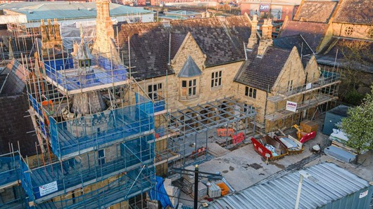

The project to create a major new national visitor attraction in Wrexham city centre is now well underway and making great progress!

One of the city’s landmark buildings, the County Buildings, formerly the home of Wrexham Museum, is being transformed into a new ‘Museum of Two Halves’.

Set to open in 2026, the ‘two halves’ of the new museum will include an enhanced and expanded museum for Wrexham, alongside a brand new football museum for Wales.

Do YOU have any objects or stories from the history of women’s football in Wales?


As part of the project to develop Wales’ first ever football museum, we want to continue building our collection of material and memorabilia (known officially as The Welsh Football Collection).

The Welsh Football Collection, cared for here in Wrexham, is the largest of its type held in public ownership in Wales.

However, it is by no means complete. In fact, we’re just getting started.
We are always keen to gather more to help us fill gaps and add to our knowledge of the rich heritage of football in Wales.

We’re particularly interested in gathering more items and stories from the history of Welsh women’s football. This is an area of the collection that is lacking at present.

This is where you can help.

Items might include shirts, match programmes, caps, photographs, trophies/medals. We’re also keen to collect anecdotes and stories.

These can relate to the season just gone or further back in history
If you’re a supporter or involved directly with the women’s game, please get in touch if you think you can help: footballmuseumwales@wrexham.gov.uk

*****************************************************************************************************************

If EVER you need to contact a person who is
Extremely Clever at finding out what is wrong –with your computer, then I can honestly recommend Mr Chris Williams.
(Who is also a very kind and considerate Gentleman.)


FOOT CARE By PODIATRIST THOMAS JENESON @
Grosvenor Lodge (1 Grosvenor Road, Wrexham)
01978 800777
tajeneson@gmail.com.

*************************************************************************
Best Wishes AND Thank You – from Sybil (Bremner)

********************************************************

