Ruabon News Letter 592


Bwletin
o'r Tîm Ymgysylltu â Rhanddeiliaid a'r Gymuned
from the Community and Stakeholder Engagement Team
Medi / September 2025

Annwyl gyfranddaliwr,
Gobeithio eich bod chi'n iawn. Rydym yn gyffrous i chi ddysgu am y gwaith yr ydym wedi bod yn ei wneud i sicrhau bod ein rhanddeiliaid yn mynd gyda ni ar y daith i drawsnewid trafnidiaeth.
Os oes gennych unrhyw gwestiynau, cysylltwch â ni drwy e-bostio engagement@tfw.wales.
Dear Stakeholder,
We hope you're well. We're excited for you to learn about the work we've been doing to ensure our stakeholders accompany us on the journey to transform transport.
If you have any questions, please get in touch with us by emailing engagement@tfw.wales.

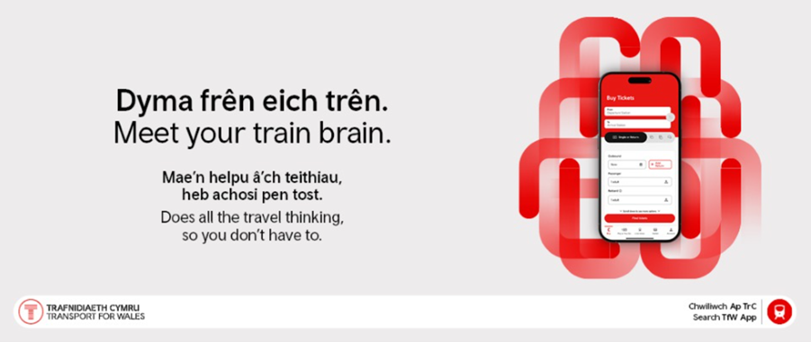
Dyma frên eich trên
Mae’n helpu â’ch teithiau, heb achosi pen tost. P'un a ydych chi'n teithio i'r gwaith, yn ymweld â ffrindiau neu'n archwilio lleoedd newydd, ap TrC yw eich cydymaith teithio clyfar.
Darganfyddwch fwy

Meet your Train Brain
Does all your travel thinking, so you don’t have to. Whether you’re commuting, visiting friends or exploring new places, the TfW app is your smart travel companion.
Find out more

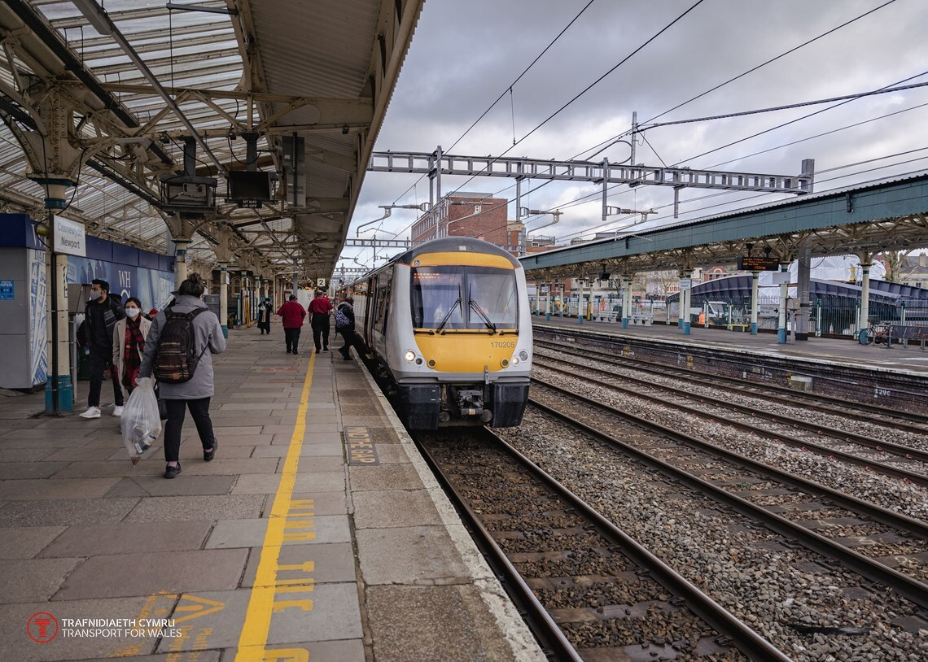
Diweddariad perfformiad Awst a Medi
Gwelodd Awst a Medi gyfnod perfformiad cryf iawn i Trafnidiaeth Cymru wrth i'n hamserlen haf barhau.
Cynhaliwyd gwasanaethau ychwanegol ar linell Calon Cymru ac ar linell Doc Penfro gan arwain at gynnydd yn nifer y cwsmeriaid.
Ar y cyfan, ein sgôr o ran prydlondeb o fewn tri munud oedd 86%, sy'n debyg iawn i'n targed o 81.1%. Roedd canslo wedi gostwng hefyd gyda dim ond 2.6% o drenau yn gorfod cael eu canslo ar y diwrnod o'i gymharu â’r targed o 3.7%.
Llinellau nodedig penodol oedd gwasanaethau Maesteg, Glynebwy a Chasnewydd a welodd welliant o flwyddyn i flwyddyn o 6.5% o ran trenau'n cyrraedd o fewn tri munud i'r amserlen a gostyngiad o 4.4% mewn cyfraddau canslo o'i gymharu â'r un cyfnod o 4 wythnos yn 2024.
Gwelodd linell Dyffryn Conwy gynnydd o 5.1% mewn trenau'n cyrraedd o fewn 3 munud i'r amserlen o'i gymharu â'r un cyfnod yn 2024 a gwelodd hefyd 0.7% yn unig o'r holl wasanaethau trên yn cael eu canslo. Mae'r llinell wedi cau am bedair wythnos er mwyn caniatáu i Network Rail wneud gwaith hanfodol yn yr hydref ac rydym yn gobeithio y bydd yr effaith tymor byr hon yn arwain at berfformiad da parhaus am weddill y flwyddyn ac i mewn i 2026.
Roedd y mis hwn hefyd yn achos dathlu gan fod y ffigurau diweddaraf a gyhoeddwyd gan Swyddfa Rheoleiddio'r Rheilffyrdd wedi datgelu ein bod wedi cyflawni'r gwelliant mwyaf mewn prydlondeb ymhlith holl weithredwyr trên y DU rhwng Ebrill a Mehefin 2025.
Yn ystod y cyfnod hwn, mae data'n dangos bod 83.7% o’i wasanaethau wedi rhedeg ar amser* - cynnydd o 1.5 pwynt canran o'i gymharu â'r un cyfnod yn y flwyddyn flaenorol. Roedd TrC yn un o ddim ond pum gweithredwr i ddangos gwelliant mewn prydlondeb yn ystod y cyfnod hwn.
Mae'r gwelliant hwn yn dilyn cyflwyno'r trenau Dosbarth 756 newydd sbon ar Linellau Craidd y Cymoedd (CVL) yn gynharach eleni, rhan o fuddsoddiad £800 miliwn Llywodraeth Cymru mewn trenau newydd.
Roedd y mis hwn hefyd yn achos dathlu gan fod y ffigurau diweddaraf a gyhoeddwyd gan Swyddfa Rheoleiddio'r Rheilffyrdd wedi datgelu ein bod wedi cyflawni'r gwelliant mwyaf mewn prydlondeb ymhlith holl weithredwyr trên y DU rhwng Ebrill a Mehefin 2025.
August and September performance update
August and September saw a particularly strong period of performance for TfW as our summer timetable continued.
Additional services were run on the Heart of Wales and on the Pembroke Dock line resulting in an upturn in customer numbers.
Overall our on time to three score was 86%, well about our target of 81.1%. Cancellations were down too with just 2.6% of trains having to be cancelled on the day compared with a target of 3.7%.
Particular lines of note were the Maesteg, Ebbw Vale and Newport services which saw a year on year improvement of 6.5% in terms of trains arriving within three minutes of schedule and a 4.4% drop in cancellations against the same 4-week period in 2024.
The Conwy Valley line saw a 5.1% increase in trains arriving within 3 minutes of schedule against the same period in 2024 and also saw just 0.7% of all trains cancelled. The line has closed for four weeks to allow Network Rail to carry out essential autumn work and we hope this short term impact will lead to continued good performance for the rest of the year and into 2026.
This month was also a cause for celebration as latest figures published by the ORR revealed we achieved the greatest improvement in punctuality among all UK train operators between April and June 2025.
During this period, data shows that 83.7% of its services ran on time*- an increase of 1.5 percentage points compared to the same period in the previous year. TfW was one of only five operators to show an improvement in punctuality during this period.
This improvement is following the introduction of the brand-new Class 756 trains on the Core Valley Lines (CVL) earlier this year, part of Welsh Government’s £800 million investment in new trains.
This month was also a cause for celebration as latest figures published by the ORR revealed we achieved the greatest improvement in punctuality among all UK train operators between April and June 2025.

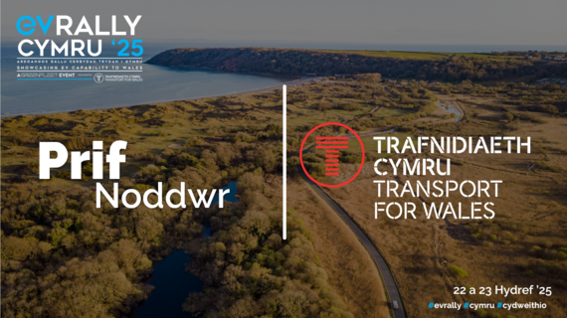
Trafnidiaeth Cymru yn brif noddwr Rali EV Cymru 2025
Rydyn ni'n falch iawn mai ni yw prif noddwr EV Rally Cymru, rali cerbydau trydan sy'n arddangos y seilwaith gwefru yng Nghymru. Cynhelir y rali dros ddau ddiwrnod ar 22 a 23 Hydref.
O Wrecsam i Gaerdydd drwy Wynedd a Sir Benfro, bydd y rali yn dangos pa mor bell mae Cymru wedi dod a pha mor bell gallwch chi deithio mewn cerbyd trydan.
Read more: CYMRU | EV Rally 2025
Transport for Wales headlines EV Rally Cymru 2025
We’re delighted to be headline sponsor of EV Rally Cymru, a two-day electric vehicle rally showcasing charging infrastructure within Wales, taking place on the 22 and 23 of October.
From Wrexham to Cardiff via Gwynedd and Pembrokeshire, the rally will highlight how far Wales has come – and how far you can travel in an EV.
Read more: CYMRU | EV Rally 2025

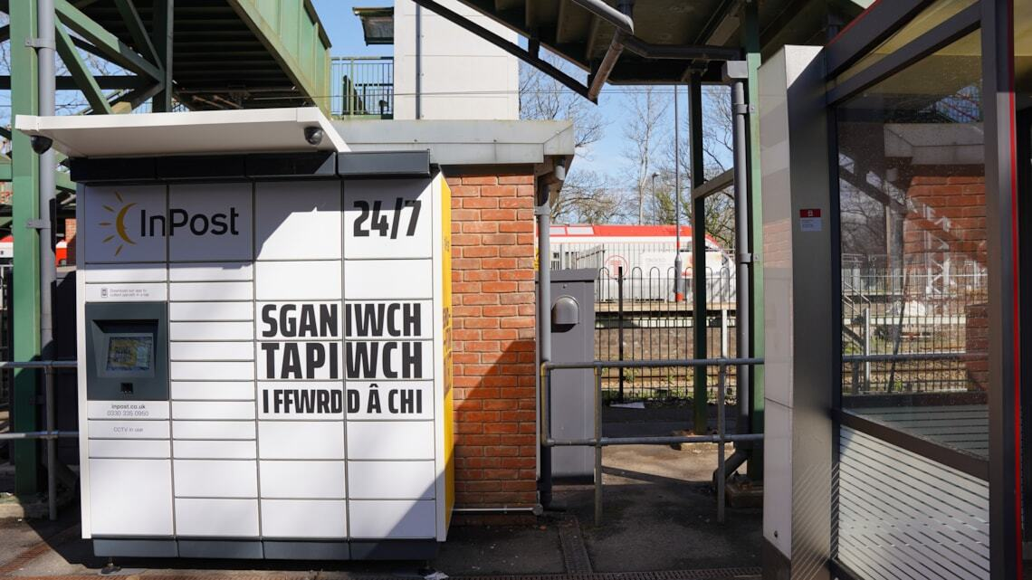
TrC yn cyflwyno cwpwrdd clo InPost i orsafoedd ar draws ei rwydwaith
Mae Trafnidiaeth Cymru (TrC) ac InPost wedi ymuno i ddod â cwpwrdd clo parseli i saith gorsaf ar draws rhwydwaith De Cymru.
Mae InPost yn ddarparwr blaenllaw mewn atebion logisteg ar gyfer diwydiant e-fasnach Ewrop. Maent yn darparu cwpwrdd clo diogel a hawdd eu defnyddio sy'n helpu i wneud siopa ar-lein yn fwy cyfleus i ddefnyddwyr.
Mae cyflwyno'r cwpwrdd clo parseli i orsafoedd dethol ar draws rhwydwaith Trafnidiaeth Cymru yn caniatáu i gwsmeriaid gyfuno anfon a derbyn parseli â'u taith bob dydd.
Darganfyddwch fwy

TfW introduces In-Post Lockers to stations across its network
Transport for Wales (TfW) and In-Post, have joined forces to bring parcel lockers to seven stations across the South Wales network.
In-Post is a leading provider in logistics solutions for the European e-commerce industry. They provide secure, easy to use parcel lockers that help make online shopping more convenient for consumers.
The introduction of these lockers to the Transport for Wales network will allow customers to conveniently send and receive parcels with their daily commute or journey.

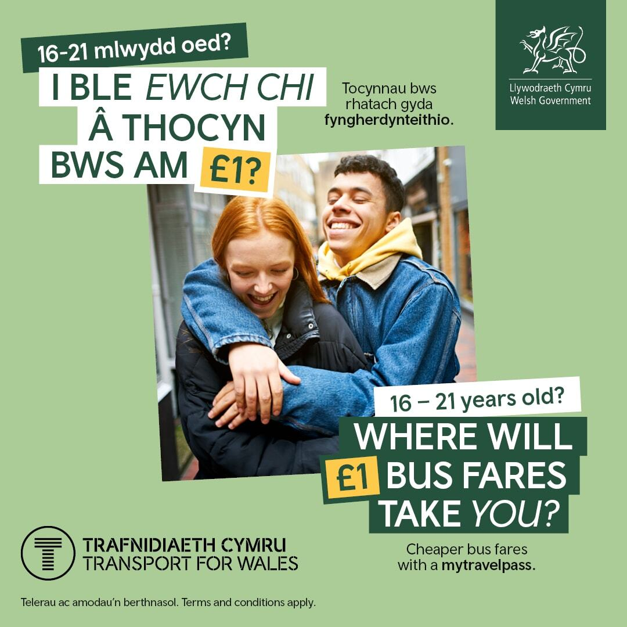
Tocyn bws £1 i bobl ifanc yng Nghymru
O ddydd Llun 1 Medi, gall pobl ifanc 16-21 oed gael tocynnau bws am £1 ledled Cymru drwy wneud cais am fyngherdynteithio am ddim.
Mae'r cynllun peilot blwyddyn wedi'i gynllunio i wneud teithio'n fwy hygyrch a fforddiadwy, gan helpu pobl ifanc i gysylltu ag addysg, cyflogaeth a chyfleoedd cymdeithasol. Yn ogystal â'r pris tocyn sengl am £1, mae tocyn dydd diderfyn hefyd ar gael am ddim ond £3.
I fanteisio ar y prisiau gostyngedig hyn, bydd angen i bobl ifanc wneud cais am eu fyngherdynteithio am ddim.
Bydd y rhaglen yn cael ei hymestyn ym mis Tachwedd i gynnwys pobl ifanc 5-15 oed, gan sicrhau bod hyd yn oed mwy o blant a theuluoedd yn elwa o'r gostau teithio is.
Gellir prynu'r prisiau gostyngol yn uniongyrchol gan yrrwr y bws neu drwy'r ap gweithredwr bysiau. Wrth ddefnyddio ap, rhaid i ddefnyddwyr gofrestru eu mytravelpass a'i gyflwyno i'r gyrrwr. Mae'r prisiau gostyngedig hefyd yn berthnasol i wasanaethau trawsffiniol, cyn belled â bod y daith yn dechrau neu'n gorffen yng Nghymru.
£1 Bus Fares for Young People in Wales
From Monday 1st September, young people aged 16-21 can get £1 bus fares across Wales by applying for a free mytravelpass
The one-year pilot scheme is designed to make travel more accessible and affordable, helping young people connect with education, employment and social opportunities. In addition to the £1 single fare, an unlimited day ticket is also available for just £3.
To take advantage of these reduced fares, young people will need to apply for their free mytravelpass.
The program will be extended in November to include young people aged 5-15, ensuring even more children and families benefit from lower travel costs.
The discounted fares can be purchased directly from the bus driver or via the bus operator app. When using an app, users must register their mytravelpass and present it to the driver. The discounted fares also apply to cross-border services, as long as the journey starts or ends in Wales.

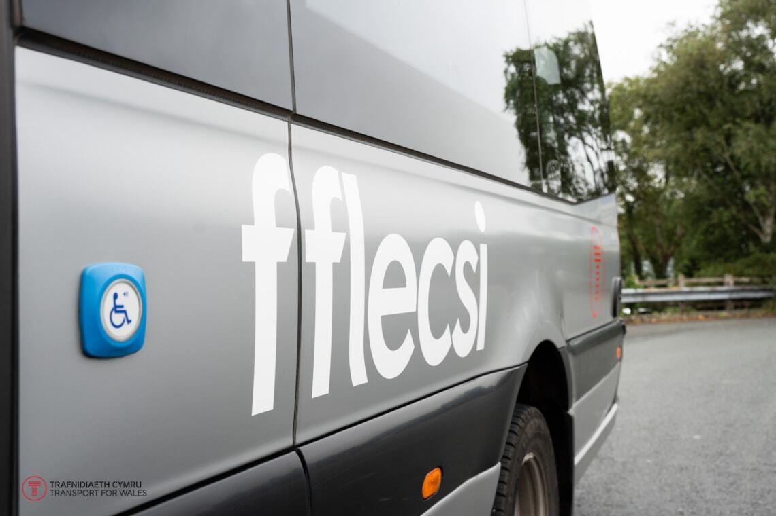
Mae TfW yn gwella'r signal i ddefnyddwyr Fflecsi ym Machynlleth
Mae system rhyngrwyd lloeren newydd yn cael ei threialu ar wasanaethau bysiau fflecsi Trafnidiaeth Cymru (TrC) ym Machynlleth, gan gysylltu teithwyr mewn ardaloedd gwledig.
Mae'r system newydd, wedi'i phweru gan rwydwaith o loerennau, yn darparu signal Wi-Fi dibynadwy, cyflym sy'n bwysig ar gyfer gwasanaethau ar alw fel fflecsi.
Mae technoleg yn gwella profiad y cwsmer trwy ddarparu diweddariadau amser real ar leoliadau bysiau ac yn cynnig Wi-Fi dibynadwy am ddim i deithwyr, hyd yn oed mewn ardaloedd anghysbell lle nad yw signalau symudol traddodiadol ar gael.
Mae'r cydweithrediad hwn rhwng Labordy Arloesi TrC, y gosodwyr Dragon WiFi, a'r gweithredwr Lloyds Coaches, yn dangos sut y gall technoleg arloesol wella hygyrchedd a dibynadwyedd trafnidiaeth gyhoeddus i bobl ledled Cymru.
Bydd y treial yn parhau tan fis Mawrth 2026. Mae treial newydd hefyd i ddechrau yng Nghonwy gyda thechnoleg OneWeb i weld a all gael effaith gadarnhaol debyg ar ddefnyddwyr fflecsi.
TfW improves signal for fflecsi users in Machynlleth
A new satellite internet system is being trialled on Transport for Wales (TfW) fflecsi bus services in Machynlleth, connecting passengers in rural areas.
The new system, powered by a network of satellites, provides a reliable, high-speed Wi-Fi signal that is important for on-demand services like fflecsi.
The technology enhances the customer experience by providing real-time updates on bus locations and offers free, reliable Wi-Fi for passengers, even in remote areas where traditional mobile signals are unavailable.
This collaboration between TfW's Innovation Lab, installers Dragon WiFi, and operator Lloyds Coaches, showcases how cutting-edge technology can improve public transport accessibility and reliability for people across Wales.
The trial will continue until March 2026. A new trial is also set to begin in Conwy with OneWeb technology to see if it can have a similar positive impact for fflecsi users.


Llwybr cerdded, olwynio a beicio newydd arfaethedig rhwng Pont-y-pŵl a Brynbuga trwy Mamhilad a Little Mill
Mae Trafnidiaeth Cymru, tîm Rhwydwaith Ffyrdd Strategol Llywodraeth Cymru a Chynghorau Bwrdeistref Sirol Torfaen a Sir Fynwy yn cydweithio i ddarparu llwybr newydd diogel a hygyrch y gall pawb yn y gymuned ei ddefnyddio i gerdded, olwynio neu feicio i gyrchfannau rhwng Pont-y-pŵl yn Nhorfaen drwodd i Frynbuga yn Sir Fynwy.
Mae'r llwybr newydd arfaethedig yn cysylltu Pont-y-moel, gorsaf Pont-y-pŵl a New Inn, Ystad Parc Mamhilad, Little Mill, Coedymynach, Radur ac Ynys Brynbuga, gan gynnig mwy o opsiynau teithio rhwng ysgolion a cholegau, gwasanaethau lleol, canolfannau cyflogaeth a'r gymuned ehangach.
Mae cyllid ar gyfer y llwybr newydd hwn wedi'i gadarnhau hyd at y cam dylunio er mwyn helpu i ddatblygu'r cynllun a chefnogi ceisiadau am gyllid yn y dyfodol.
I gael gwybod mwy am y llwybr arfaethedig newydd, rydym hefyd yn cynnal cyfres o sesiynau galw heibio ledled Torfaen a Sir Fynwy lle cynigir gwybodaeth a lle bydd cynlluniau a mapiau'r llwybr newydd yn cael eu dangos, gyda staff wrth law i ateb unrhyw gwestiynau sydd gennych ynglŷn â'r cynigion.
Bydd yr arolwg ar agor rhwng 13 – 27 Hydref 2025. Am ragor o wybodaeth, ewch i: haveyoursay.tfw.wales/pontypool-usk
Proposed new walking, wheeling and cycling route between Pontypool and Usk via Mamhilad and Little Mill
Transport for Wales is working with the Welsh Government’s Strategic Road Network team, Torfaen County Borough Council and Monmouthshire County Council to provide a new safe and accessible route that can be used by everyone in the community to walk, wheel or cycle to destinations between Pontypool in Torfaen through to Usk in Monmouthshire.
The proposed new route connects Pontymoel, Pontypool and New Inn Station, Mamhilad Park Estate, Little Mill, Monkswood, Rhadyr and Usk Island, offering more travel options between schools and colleges, local services, centres of employment, and the wider community.
Funding for this new route is confirmed up to the design stage in order to help develop the scheme and support future funding applications.
To find out more about the new proposed route, we are also running a series of drop-in information sessions across Torfaen and Monmouthshire where the plans and maps of the new route will be on show with staff on hand to answer any questions you have regarding the proposals.
The consultation and survey will be open from 13-27 October 2025. For more information head to: haveyoursay.tfw.wales/pontypool-usk

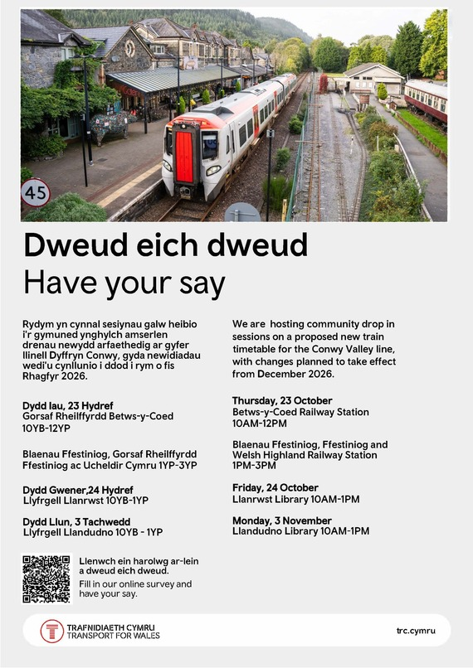
Dweud eich dweud: Newidiadau i amserlen llinell Dyffryn Conwy
Mae teithwyr a rhanddeiliaid wedi’u wahodd i roi adborth ar amserlen trenau newydd arfaethedig ar gyfer llinell Dyffryn Conwy, gyda newidiadau wedi'u cynllunio i ddod i rym o fis Rhagfyr 2026.
Mae llinell Dyffryn Conwy yn bennaf yn cefnogi teithio lleol i ac o Landudno gydag galw hamdden gynyddol yn ystod misoedd yr haf am deithiau i Eryri a Betws-y-coed.
Nod y rhestr amser newydd yw mynd i'r afael â rhai o'r problemau allweddol gyda'r gwasanaethau presennol, gan integreiddio'r amserlen trên gyda dulliau cludiant eraill a newid gwasanaethau er mwyn gwirioneddol wasanaethu cymunedau Llinell Dyffryn Conwy.
Bydd y cyfnod ymgynghori yn rhedeg o ddydd Llun, 13 Hydref 2025 i ddydd Gwener, 28 Tachwedd 2025 ac yn rhoi cyfle i deithwyr roi adborth os yw'r newidiadau arfaethedig yn bodloni eu hanghenion ac unrhyw awgrymiadau y maent yn credu y gellid gwella'r gwasanaeth.
Sut I roi adborth
Gall y cyhoedd weld y newidiadau a gynigir a rhoi eu barn yma.
Mae hefyd digwyddiadau cymunedol:
- Gorsaf Betws-y-Coed, Heol yr Orsaf, Betws-y-Coed, Conwy,LL24 0AE Dydd Iau 23 Hydref 10.00 - 12.00
- Ffestiniog and Highland Heritage Railway, Cromwell Dydd Iau 23 Hydref 1.00 - 3.00 Street, Blaenau Ffestiniog, LL41 3HG
- Llyfrgell Llanrwst , Glasdir, Plas Yn Dre, Llanrwst, Ll26 0DF Dydd Gwener 24 Hydref 10.00 - 1.00
- Llyfrgell Llandudno, 48 Mostyn Street, Llandudno, Ll30 2RP Dydd Llun 3 Tachwedd 10.00 - 1.00
Have your say: Conwy Valley line timetable changes
Passengers and stakeholders are invited to feedback on proposals for a new train timetable for the Conwy Valley line, with changes to take effect from December 2026.
The Conwy Valley line primarily supports local travel to and from Llandudno, with increased leisure demand during the summer months for journeys to Eryri and Betws-y-Coed.
The new timetable aims to address some of the key issues with current services, integrating the rail timetable with other transport methods and changing services to better serve Conwy Valley line communities.
The engagement period will run from Monday, 13 October 2025 to Friday, 28 November 2025 and gives passengers the opportunity to feedback if the proposed changes meet their needs and any suggestions they think would improve the service.
How to feedback
The public can view the proposed changes and feedback their views here.
There are also community events:
- Betws Y Coed Railway Station, Station Road, Betws Y Coed, Conwy, LL23 0AE Thursday 23 October 10.00 12.00
- Ffestiniog and Highland Heritage Railway, Cromwell Street, Blaenau Ffestiniog, LL41 3HG Thursday 23 October 1.00 - 3.00
- Llanrwst Library, Glasdir, Plas Yn Dre, Llanrwst, Ll26 0DF Friday 24 October 10.00 - 1.00
- Llandudno Library, 48 Mostyn Street, Llandudno, Ll30 2RP Monday 3 November 10.00 - 1.00

Wnaethoch chi anfon yr e-bost hwn? Hoffech chi ei anfon yn uniongyrchol atoch chi?
Were you forwarded this email? Would you like it sent directly to you?
Cofrestrwch fi'n uniongyrchol/Sign me up directly

  
    
    
  Cwmni cyfyngedig trwy warant. Cofrestrwyd yng Nghymru. Cwmni Rhif 09476013. Cyfeiriad Swyddfa Gofrestredig: Trafnidiaeth Cymru, 3 Llys Cadwyn, Pontypridd, CF37 4TH
  A Company Limited by Guarantee. Registered in Wales. Company No. 09476013. Registered Office Address: Transport for Wales, 3 Llys Cadwyn, Pontypridd, CF37 4TH
  Preferences | Unsubscribe





DELIVERING BETTER HEALTH FOR YOU
 |  | Improvements to be made to NHS Wales complaints system  The NHS complaints process in Wales will be significantly strengthened after the Senedd approved new regulations.

 |  | Welsh Government continues vital bereavement support for families  Support for families who have experienced the devastating loss of a baby is being extended.

 |  | A first for Wales in end-of-life and Palliative Care  Health Education and Improvement Wales (HEIW) has launched the first-ever All Wales Competency Framework for Adult Palliative and End of Life Care. The framework has been developed in partnership with the NHS Wales National Programme for Palliative and End of Life Care and a multi-professional steering group. Most importantly, it has been shaped by the voices of people across Wales.

 |  | Applications are now open for the 2026 Accolades  Entries and nominations are open for the 2026 Accolades, the annual awards run by Social Care Wales that recognise, celebrate and share excellent social care, social work, childcare, play and early years in Wales. The awards recognise the work of groups, teams and organisations, as well as workers from across the public, private, voluntary and co-operative sectors in Wales. The closing date for entries and nominations is 5pm on 10 November 2025.

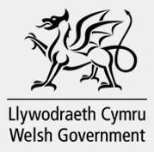 |  | Transparency agenda: NHS Wales public accountability meetings  Cabinet Secretary for Health and Social Care Jeremy Miles is holding a public accountability meeting with each health organisation during the current financial year. This will provide greater public transparency in accountability arrangements. The first meeting takes place with Cwm Taf Morgannwg University Health Board on Thursday 23 October at 3pm – this link will grant you access to view the meeting.

DELIVERING BETTER HEALTH
IN YOUR LOCAL AREA
 |  | Celebrating the Gift of Sight: New Eye Retrieval Service Launches at Cardiff and Vale University Health Board  The initiative has been launched in partnership with NHS Blood and Transplant Services and will ensure that corneal donations continue to transform the lives of patients in-need, giving people back the gift of sight.

 |  | Convo (Sign Live) is helps even more people in Powys talk to their healthcare providers  BSL signers in Powys can now use Convo (formerly called Sign-Live) to contact your local NHS GP, dentist, optician or pharmacy. Convo is a free app that connects you to a BSL interpreter. The interpreter will call the health service for you and help you talk to them in real time.

Health and care research wales evidence centre updates
What approaches have been used to implement direct payments within health systems, and how do various factors influence the effectiveness of these approaches in supporting personalisation, governance, and equitable access to care: A Rapid Evidence Summary
Annual Report 2024 - 2025
Work Programme
Consultations

Improving adoption, fostering and kinship services
Consultation ends: 20th October 2025
Corporate parenting: part 6 code of practice on looked after and accommodated children
Consultation ends: 27th October 2025.
*********************************************************************************************

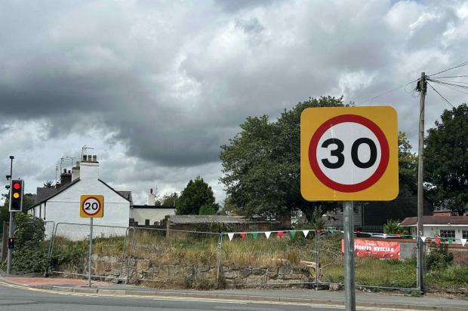
All the roads in Wrexham and Flintshire that are changing back to 30mph, dozens of roads in Wrexham and Flintshire either have already changed or have been agreed to change back to 30mph speed limits.
********************************************************************************************

Five of the best Pumpkin picking locations across Wrexham and Flintshire this Halloween.
******************************************************


If EVER you need to contact a person who is Extremely Clever at finding out what is wrong –with your computer, then I can honestly recommend Mr Chris Williams. (Who is also a very kind and considerate Gentleman.)

*********************************************************

FOOT CARE By PODIATRIST THOMAS JENESON @ Grosvenor Lodge(1 Grosvenor Road, Wrexham) 01978 800777 tajeneson@gmail.com.

********************************************************

Best Wishes AND Thank You – Sybil (Bremner)

*********************************************************

