Ruabon News Letter 584

PRESS RELEASE

August 21st, 2025

GCSE Examination Results

Following a successful academic year, August 21st, 2025, marks a very special day of celebration for Year 11 students, staff, and families in Ysgol Rhiwabon.

Not only have they achieved an excellent set of results, their success and celebrations coincide with the 450th anniversary of the founding of the school and the Year 11 cohort contribute to its proud history and bright future.

Ysgol Rhiwabon Staff and Governors are very proud of the achievements of the year group. The Class of 2025 has displayed some outstanding individual achievements and a collective success which the school and local community can celebrate together.

Just a few of the highlights include:

• A rise in the number of students securing A*/A grades across all their subjects.

• A significant increase in the highest grades in Chemistry, Physics, Biology and Mathematics.

• Impressive achievements in Art and French with half the cohort achieving A/A*.

• Student of the Year Awards for Ysgol Rhiwabon learners studying courses in college.

• The majority of learners achieving a higher pass in the Skills Challenge Certificate, evidencing their cross curricular skills.

Mrs Ferron-Evans, Headteacher, commented:

“Our students, supported by their families, have worked very hard to secure success and we are delighted to see their results. Every year I am impressed with the way school staff support these outcomes and they deserve a special mention for working tirelessly to secure this success.

I would like to take this opportunity to thank the staff, students and parents for their contribution to the incredible amount of hard work and dedication evident across such a wide range of studies and skills.

The grades achieved provide certainty and opportunity for the future. As Ysgol Rhiwabon students move forward with results which enable our young people to further their studies, or to enter the world of work, as confident and successful individuals.

We wish them continued success and happiness in the future.’’

(Pictures attached with names from left to right.)

Group Picture

Pic 1 – Group picture with Mrs Ferron-Evans

Pic 2 – Mia Swarbrick, Evie Thomas, Mia Williams

Pic 3 – Alfie Elliot, Maja Sarnowska, Amy Saunders – all 3 students achieved outstanding A/A* passes across the full range of subjects studied.

](https://www.ysgolrhiwabon.co.uk/wp-content/uploads/2025/08/IMG_8532.jpeg)

](https://www.ysgolrhiwabon.co.uk/wp-content/uploads/2025/08/IMG_8540.jpeg)

**********************************************************

**Wellbeing Portal - Help and advice**



Earlier this year in June we [launched a consultation](https://links-1.govdelivery.com/CL0/https:%2F%2Fnews.wrexham.gov.uk%2Fhelp-shape-the-future-of-adult-social-services-in-wrexham%2F/1/01000198d26c984a-bfcf1516-a0b5-4a18-a49a-e6c626fd9a9c-000000/f4yuNlCLoXBCi42A_0Jq5l1Fp4M71GMBvTf3Kbut3VI=419) asking for your thoughts to help shape the future of adult social services in Wrexham.

This consultation is now closed and we will be sharing the feedback we received, including about:

* Inclusive communication options and opportunities
* Under-represented groups
* Promoting healthy ageing
* Dementia support
* Unpaid carers
* Mental wellbeing
* Accessibility and availability of services
* Transparent decision making
* Person-centred care
* Being clear about the support adult social care can provide

As part of this public consultation to develop social care strategies, you told us that you would like to see more in-person events outside of the city centre. So, we are coming to a venue near you to share the results of the survey.

**Details of the events**

These are drop-in sessions, which means that you don’t need to book an appointment, just arrive sometime between the start and end times and you’ll be able to speak to one of our social care team members.

We can tell you about the results of the survey and you can help to shape our next steps.

One of our staff from the Wellbeing hub will also be there and can signpost you to a range of services and support you may not already know about.

Please come and join us in September or early October, if you can:

**Rhos: Rhos library**

* Tuesday, September 9, 2025
* 1 - 3pm

**Minera / Coedpoeth:** **Plas Pentwyn Resource Centre**

* Tuesday, September 30, 2025
* 10 - 11.30am

**City centre: Wellbeing hub, Crown buildings**

* Tuesday, September 30, 2025
* 1 - 2.30pm

**Acton: Acton Resource Centre**

* Wednesday, October 1, 2025
* 1 - 2.30pm

**Overton: Parish rooms, Overton Village Hall**

* Monday, October 6, 2025
* 2 - 3.30pm

**Gresford: Gresford Library**

* Tuesday, October 7, 2025
* 1 - 2.30pm

**Share the message**

These sessions are for anyone interested to hear the results of the survey in more detail.

If you know someone else who receives adult social care support in Wrexham and may be interested in coming to one of these sessions, please let them know.

Did you also know? If you’re an adult in Wrexham who is looking for wellbeing support you can check out the local services available via our [**online Wellbeing portal.**](https://links-1.govdelivery.com/CL0/https:%2F%2Fwww.wrexham.gov.uk%2Fwellbeing-portal/1/01000198d26c984a-bfcf1516-a0b5-4a18-a49a-e6c626fd9a9c-000000/OhW7U-3N5VoeselWjUekNUm4da6Cb-1ca8lm-51zjv0=419)

*************************************************************

**Little Sunflowers**

What an amazing afternoon at Plastonbury 2025 , thank you to the organisers for inviting us and as normal Early Years was packed with your little ones. A huge thank-you for your positive feedback which is as always lovely to hear, lots of love Sharon, Stacey and Charlotte xx p.s. I will be counting those

cars and bouncy animals in my sleep haha

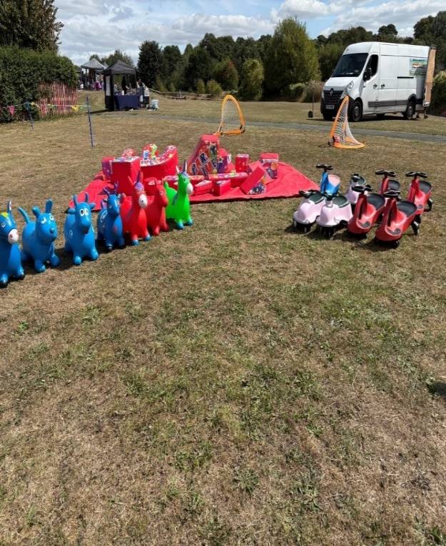

**Information, Guidance and Support**

**Businesses in Wales.**

**Thinking of Starting a Business?**

Business Wales is here to help you with your first steps into self-employment with practical range of guidance and business support.

We have free factsheets on business topics and access to business advice and guidance to help you choose the right business for you, along with online resources to build your confidence in starting a business.

Getting Started

[**Request a business idea factsheet**](https://businesswales.gov.wales/topics-and-guidance/starting-a-business/start-and-business-planning/business-startup-factsheet)

Download our Business Start-up Factsheet to explore different business ideas that might suit you.

[**Self-employment and you**](https://businesswales.gov.wales/starting-up/self-employment)

Is self-employment for you? have a look at our Self Employment guides.

[**Young entrepreneurs – Big ideas**](https://businesswales.gov.wales/bigideas/)

If you’re 25 or under and looking for new opportunities or have a business idea, see our Big Ideas Wales.

[**Start up and business planning**](https://businesswales.gov.wales/starting-up/)

We help aspiring business owners overcome the challenges they face on their journey to starting a business.

[**Business finance**](https://businesswales.gov.wales/businessfinance/)

Use our finance locator to find finance options and how to choose the right type of finance for you.

[**Business Wales Service**](https://businesswales.gov.wales/business-wales-service)

The Business Wales services provides specialist advice and guidance which is fully funded to support people in Wales that are starting, running and growing businesses.

**You may also like**

[**Business Online Support Service (BOSS)**](https://businesswales.gov.wales/boss/)

BOSS is here to help you and your business develop through online learning.

[**Before you start a social business**](https://businesswales.gov.wales/socialbusinesswales/you-start-social-business)

Establish whether or not your idea for a social business is a feasible proposition.

[**Hello Blood**](https://businesswales.gov.wales/heloblod/)

Hello Blood is your fast and friendly Welsh translation and advice service.

**Business Support**

**To get your business started call us on 03000 6 03000**

**\*\*\*\*\*\*\*\*\*\*\*\*\*\*\*\*\*\*\*\*\*\*\*\*\*\*\*\*\*\*\*\*\*\*\*\*\*\*\*\*\*\*\*\*\*\*\*\*\*\*\*\*\*\*\*\*\*\*\*\*\*\*\*\*\*\*\*\*\*\*\*\*\*\*\*\*\*\*\*\*\*\*\*\*\***

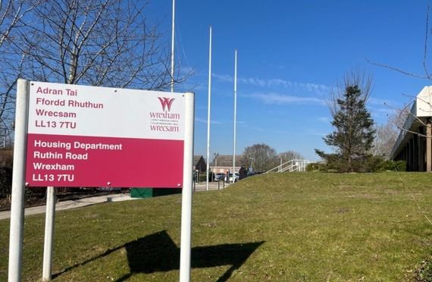

**Before the Match**

Parking outside Wrexham Council’s offices at Ruthin Road, Wrexham LL13 7TU

Buses start running at 1pm

**After the match**

Buses departing 5pm, 5.20pm and 5.40pm from Central Road (Dunelm) and at 6pm and 6.20pm from Mold Road.

**Just £1 return for adults (50p for children)**

*Car park closes at 9.30pm.*

The aim of the park and ride is to reduce congestion.

Using the Ruthin Road Park & Ride also means that your car is parked safely and conveniently. On matchdays, parking enforcement officers will be out and about to make sure that cars are not park illegally or dangerous in and around the town centre.

*************************************************************************************************

|  |
| --- |
|  |
| The altar cross stands above St Trillo's holy well  **The Altar Cross Stands above St Trillo's Holy Well**  **The 'wandering' cross at UK's smallest church that sparked outrage and accusations.**  **The 'people's church' on the North Wales coast is regarded as a place for quiet contemplation.**  **Baby Equipment Bank - Home-Start Wrexham**  **Wrexham Council and Home-Start Wrexham are Celebrating the Success of the Baby Equipment Bank Project, which Supported 83 Families over the Course of a Year.**  **The Baby Equipment Bank project, delivered by Home-Start Wrexham, collects high-quality, pre-loved baby equipment and redistributes it to families across Wrexham through a referral system.**  **With funding from the Welsh Government’s Circular Economy Fund between 2024 and 2025, and with Wrexham Council’s backing, the project was able to help more people with more items, and reach a wider area.**  **The project gave vital support to local families while promoting sustainability and reducing waste, demonstrating the power of partnership between local government and the voluntary sector.**  **Key achievements across 2024-25 included:**   * **Over 1,983kg of baby items diverted from landfill** * **83 families supported with more than 188 individual items** * **Establishment of multiple community-based pick-up points, reducing delivery emissions** * **Recruitment and training of nine new volunteers, strengthening long-term sustainability** * **Engagement with local businesses and charities for storage and donation partnerships**   **Cllr David A Bithell, Deputy Leader and Climate Champion, said: “Over the course of the year the Baby Equipment Bank really made a lasting impact by supporting the local community, reducing waste and lowering carbon emissions. Huge thanks goes to everyone involved.”**  **Cllr Beverley Parry-Jones, Anti-Poverty Champion, said: “The Baby Equipment Bank project brought high-quality, pre-loved baby equipment to 83 families in need of extra support during a time of rising living costs, which is highly commendable. Well done everyone.”**  **Home-Start Wrexham**  **Home-Start Wrexham are a long-established voluntary organisation supporting families through pregnancy and early childhood.**  **The team continue to deliver the Baby Equipment Bank project with new processes and partnerships in place now the period of Circular Economy funding has ended.**  **Pam Hoyle, Home-Start Director, said: “The Baby Equipment Bank project supports Home-Start’s aim to reassure parents that babies and children don’t need sparkling new things, they need a loving and nurturing relationships.**  **“The funding has enabled us to recruit and train a wonderful team of volunteers. Those volunteers are now leading this and can signpost families to other sources of support when needed to make sure Home-Start reaches parents when they need us the most.”**  **Throughout its delivery, the project aligned with the goals of the Well-being of Future Generations (Wales) Act 2015, supporting objectives such as ‘A More Equal Wales’, ‘A Resilient Wales’, and ‘A Globally Responsible Wales’.**  **\*\*\*\*\*\*\*\*\*\*\*\*\*\*\*\*\*\*\*\*\*\*\*\*\*\*\*\*\*\*\*\*\*\*\*\*\*\*\*\*\*\*\*\*\*\*\*\*\*\*\*\*\*\*\*\*\*\*\*\*\*\*\*\*\*\*\*\*\*\*\*\*\*\*\*\*\*\*\*\*\*\*\*\*\*\*\*\*\*\*\*\*\*\*\*\*** |

**VJ Day Remembrance Service in Wrexham**

11.45am on Friday, August 15th at Bodhyfryd

Last updated: 15/08/2025 at 10:58am

Wrexham will be joining the rest of the UK in marking the 80th anniversary of VJ Day (Victory over Japan Day) this Friday, August 15th.

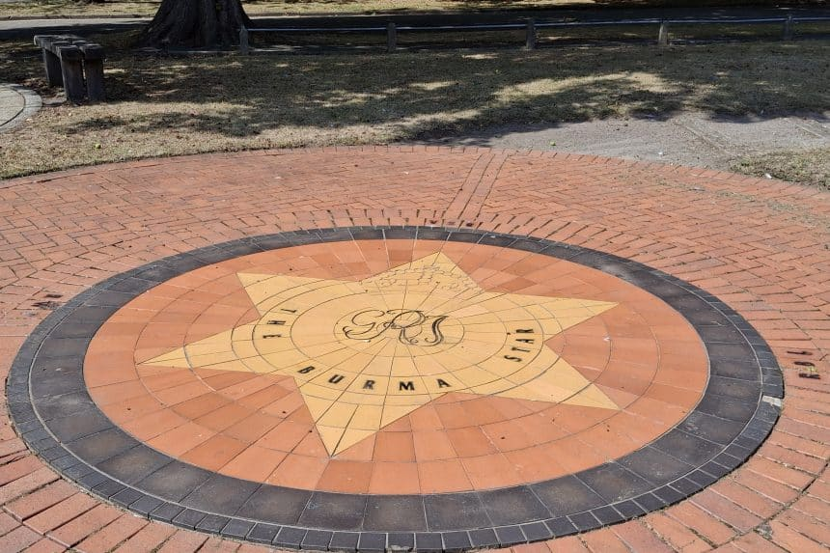

There will be a short service of remembrance at the Burma Star Memorial in Bodhyfryd (near the Cenotaph) starting at 11:45am, which will include the national two-minute silence at 12noon.

Wrexham will be joining the rest of the UK in marking the 80th anniversary of VJ Day (Victory over Japan Day) this Friday, August 15th .

There will be a short service of remembrance at the Burma Star Memorial in Bodhyfryd (near the Cenotaph) starting at 11:45am, which will include the national two-minute silence at 12noon.

The service will be led by Reverand Petra Goodband and everyone is welcome to attend.

Representatives of the Armed Forces will also be in attendance.

There will be other community events taking place in the county borough and across North Wales, including a reception – organised by Friends of Bellevue Park – at Bellevue Park community centre for veterans, friends and family after the service at Bodhyfryd.

Wrexham’s Armed Forces Champion Councillor Beverley Parry-Jones has paid tribute to all those who served in Asia and the Pacific during the Second World War.

Councillor Parry-Jones said: “This Friday marks 80 years since the end of the war with Japan, and it’s important that we take time to remember everyone who served and was affected by this terrible conflict.

“We remember them all on this special anniversary, and take time to time to reflect on the sacrifices and suffering they endured – particularly veterans and their families.”

Wrexham will be joining the rest of the UK in marking the 80th anniversary of VJ Day (Victory over Japan Day) this Friday, 15th August.

There will be a short service of remembrance at the Burma Star Memorial in Bodhyfryd (near the Cenotaph) starting at 11:45am, which will include the national two-minute silence at 12noon.

The service will be led by Reverand Petra Goodband and everyone is welcome to attend.

Representatives of the Armed Forces will also be in attendance.

There will be other community events taking place in the county borough and across North Wales, including a reception – organised by Friends of Bellevue Park – at Bellevue Park community centre for veterans, friends and family after the service at Bodhyfryd.

Wrexham’s Armed Forces Champion Councillor Beverley Parry-Jones has paid tribute to all those who served in Asia and the Pacific during the Second World War.

Councillor Parry-Jones said: “This Friday marks 80 years since the end of the war with Japan, and it’s important that we take time to remember everyone who served and was affected by this terrible conflict.

“We remember them all on this special anniversary, and take time to time to reflect on the sacrifices and suffering they endured – particularly veterans and their families.”



**************************************************************************************

**GCSE results 2025 – Llongyfarchiadau to all our students**

Last updated: 2025/08/21 at 1:07 PM

Share

1 Min Read



SHARE

Cllr Phil Wynn, Lead Member for Education said, “On behalf of Wrexham Council I’d like to say llongyfarchiadau to all our GCSE learners receiving their results today. Your hard work and determination are commendable.

Whether your results met your goals or not, remember this is just one step in your journey. We wish you every success in your next steps – be it further education, apprenticeships, or work.

We are proud of your achievements and wish you well for the future.

************************************************************************************************

**Library News**

**Newyddion Llyfrgelloedd am yr wythnos yn dechrau 24 Awst**

Library News for the week beginning 24th August

## ****Author visit to Gwersyllt Library****

Author Dave Andrews is originally from Wrexham but now lives near Oswestry. He is the author of twelve books.

The Welsh One Hundred Challenge is his latest book, an updated version of the original written 25 years ago.

Dave has visited all 100 peaks again to bring a fresh approach to his guide book. Dave will also talk about his trek to Everest Base Camp.

The event will take place on Wednesday 3rd September, 11.00am at Gwersyllt library.  The event is free of charge but you need to reserve your place.

Please contact the library on 01978 722890 | [gwersyllt.library@wrexham.gov.uk](mailto:gwersyllt.library@wrexham.gov.uk)

**Lego S.T.E.M. Workshops at Wrexham Library**

Join the Brick Consultant for a hands on creative workshop!  This is a great way to boost teamwork, spark imagination, building communication and learning – all whilst having fun.  The sessions are free of charge and will take place Wednesday August 27, 10.00 – 12.00pm and 1.00-3.00pm, but you must be resident in Wrexham or Flintshire.  Sessions are suitable for children aged 5+. To reserve your place call Groundworks North Wales on 01978 757524 | [training@groundworknorthwales.org.uk](mailto:training@groundworknorthwales.org.uk)

**Feedback from the Consultation to Develop Adult Social Care Strategies**

As part of the public consultation to develop social care strategies, members of the public stated that they would like to see events outside of the town centre. So the adult social care team are coming to some of our venues to share the results of their survey. They will be in Rhos Library on 9th September, 1.00-3.00pm; Plas Pentwyn Coedpoeth on 30th September, 10.00-11.30am;  Acton Resource Centre on 1st October, 1.00-2.30pm and Overton Village Hall on 6th October, 2.00-3.30pm.

**Join the library on-line**

Did you know you can join Wrexham Libraries on-line by going to [www.wrexham.gov.uk/libraries](https://links-1.govdelivery.com/CL0/http:%2F%2Fwww.wrexham.gov.uk%2Flibraries/1/01000198dcd0863d-4ee2b0af-6fdc-4b58-b2b6-40991bbe18fd-000000/P3z6Z7WPy05AYs_PVmIlGDebnfrSE-XmhDZQPaChA5s=419). Scroll down and click on Join Wrexham Libraries, fill in the form and click Register. You will receive a confirmation email with your temporary membership number which can use 24/7 on our online services.  Please check you have entered your email correctly and check your Junk folder in case your confirmation goes there.  We look forward to seeing you soon.

Did you know that reading can help you explore new places?  If you’ve just returned from your holidays we have lots of fiction books which could be set in the place you’ve just visited.  Why not set us the challenge to find you a book set in the place you’ve just visited?

### **Welsh Language Book Review**

**Adolygiad Llyfr**

### **Capten gan Meinir Pierce Jones**

Daw Meinir Pierce Jones o Nefyn yn Llŷn. Llwyddodd i wneud bywoliaeth yn trin geiriau - cyfieithu, golygu, ac ysgrifennu i blant ac oedolion.

Capten yw ei thrydedd nofel ac enillydd Gwobr Goffa Daniel Owen 2022.

Seiliwyd y nofel yma ar wir hanes Capten John Jones, Glan Deufor, Morfa Nefyn a gofnodir yng nghyfrol Aled Evans, “Ventures in Sail”.  Pan mae un peth yn darfod, mae rhywbeth arall o redrwydd yn dechrau.

Fel ton yn dilyn ton ar draeth. Yng gwanwyn 1893 mae Elin Jones yn Llŷn yn hiraethu am ei gŵr John sydd i ffwrdd ar y môr ers dros flwyddyn.

Er iddi gychwyn busnes a bod ganddi ei theulu o’i chwmpas, mae’r aros yn hir ac yn anodd.

Ond yna daw newydd annisgwyl am yr hyn a ddigwyddodd iddo, a hynny’n codi hen ofnau a heriau newydd.

************************************************************************************************

The Following Has Been Taken From Facebook



**“MY HUSBAND LET ME STARVE WHILE I BREASTFED OUR NEWBORN —**

**WHAT I DISCOVERED DOWNSTAIRS SHATTERED ME 💔😢**

Even now, my hands tremble as I write this. It’s been five weeks since I gave birth to our precious baby boy — five weeks of endless nights without sleep, raw and cracked skin from breastfeeding, constant diaper changes, and trying to learn motherhood while my body is still tender, stitched, and aching.  
My husband, the man who once swore he’d stand by me as my anchor, decided to invite his mother to stay with us “to help.” But help was the last thing she gave. Instead, she moved in and claimed our home as if it belonged to her. The living room became her territory. She had friends over constantly, the television blared day and night, and dirty dishes stacked up in the sink while I shuffled through the house like a shadow — sore, bleeding, and utterly drained.  
Every time I tried to rest, I was interrupted by the sharp sound of her voice calling for something or the pounding on the door from yet another of her guests. And my husband? He just sat beside her, acting like everything was perfectly normal, blind to the storm brewing inside me.  
But last night… last night was the breaking point.  
I was upstairs, cradling my newborn in the soft glow of the nightlight, his tiny cries filling the room.

My body screamed with pain — my back was on fire, my stitches pulled with every movement, and my stomach was hollow with hunger. I hadn’t had a proper meal all day. As I nursed him, I kept thinking — maybe, just maybe — they’d bring me a plate. Maybe they’d think to check if I needed something. Anything.  
But when I finally made my way downstairs, weak and dizzy, the sight that greeted me ripped the ground from beneath my feet.  
There they were. My husband and his mother, comfortably seated on the couch, their plates piled high, laughing between bites. The coffee table was cluttered with empty takeout boxes — the smell of hot food still thick in the air. They had ordered dinner. They had eaten. They hadn’t saved me a single bite. Not even a thought.  
I froze on the stairs, clinging to the railing just to steady myself. My heart sank, and the sharp sting in my chest wasn’t just from hunger — it was from the crushing weight of being invisible in my own home.  
I wanted to scream, but all that came were tears. Hot, burning tears that blurred the sight of them laughing together while I stood there, empty-handed, empty-stomached, and utterly alone.  
Then my husband finally looked up, casual as if nothing was wrong, and asked, “Oh, did you want some? We figured you were busy.”  
Busy? Busy?! I was upstairs nursing the child I carried for nine months, my body still torn and healing, while they feasted without a second thought. That was the moment something inside me snapped.

*****************************  
The loneliness. The betrayal. The abandonment. It was too much.  
And what I did next?

Let’s just say — he will never forget it. Not now. Not ever.  
👉 Full story in the c0mments… 👇👇

By Pat Davies Williams”

******************************************************************************

If EVER you need to contact a

person who is Extremely Clever

at finding out what is wrong -

with your computer, then I can

honestly recommend

Mr Chris Williams.

(Who is also a very kind and

considerate Gentleman.)

********************************************************************

FOOT CARE By PODIATRIST THOMAS JENESON (excellent)

@ Grosvenor Lodge Clinic

(1 Grosvenor Road, Wrexham, LL11 1BS)

01978 800777 [tajeneson@gmail.com](mailto:tajeneson@gmail.com)

****************************************************************************

ALL BEST WISHES (and THANK YOU)

Sybil (Bremner).

********************************************************************************************