Ruabon News Letter 576



Welcome to Ysgol Rhiwabon from our Headteacher,
Mrs. Melanie Ferron-Evans


Headteacher, Mrs. M. Ferron-Evans

Ysgol Rhiwabon is a warm and vibrant learning community for our 11-16 year olds and I am proud to introduce you to our school.
We are based at the heart of our local community, enjoying excellent links with our feeder primary schools. Our transition planning ensures a smooth and happy start for our Year 7 students and their families.
As our learners progress through the school, we are committed to ensuring that every individual achieves the very best they can.
It is important to us that our young people leave school in Year 11, confident, happy and equipped with the skills for lifelong learning.
Ysgol Rhiwabon has a proud history with values based on tradition and the school motto ‘Nothing Without Labour’. At the same time, we are an innovative and forward-facing school linked to the best educational practice locally, nationally and internationally.
However, we very much see excellent examination results as the foundations for future success. We are not complacent and have set ourselves ever more challenging targets for the years ahead..
It goes without saying that we want our students to be successful academically but of equal importance is that they become well rounded young adults who can go on to make a success of themselves in whatever they choose to do.
Currently we are one of a handful of schools in Wales to be a member of the Prince’s Teaching Institute which has at its heart the aim of developing “inspiring teachers who are knowledgeable and passionate about their subjects”.
We are delighted to have met the very exacting criteria set by the Prince’s Teaching Institute which accurately reflects the vibrant, engaging and challenging teaching and learning that is apparent every day of the week here at Ysgol Rhiwabon.
Often the best way of understanding how a school operates is to ask the parents. Below is a small selection of comments from parents of our current Year 7. I think they speak for themselves:
- “The school uniform looks fantastic, nice to know that students have had input to style and choice.”
- “After School Clubs – fantastic range of activities on offer. My daughter attends netball and has represented the school in matches – she thoroughly enjoys this!”
- “The Lead Learner gave me a phone call to let me know how my son was settling in – it really put my mind at rest.”
- “The transfer to Ysgol Rhiwabon has gone extremely well, with the support and organisation of all the staff. Our daughter has quickly and comfortably adapted to the different way of life at high school and comes home happy every day. ”
A website only gives a flavour of what a school is about. Whether you are a prospective parent or a member of the local community please do feel free to get in touch with us to have a tour of the school or to meet with key members of staff for an informal chat. I am confident that you will be impressed by what you see.
Mrs Melanie Ferron-Evans, Headteacher

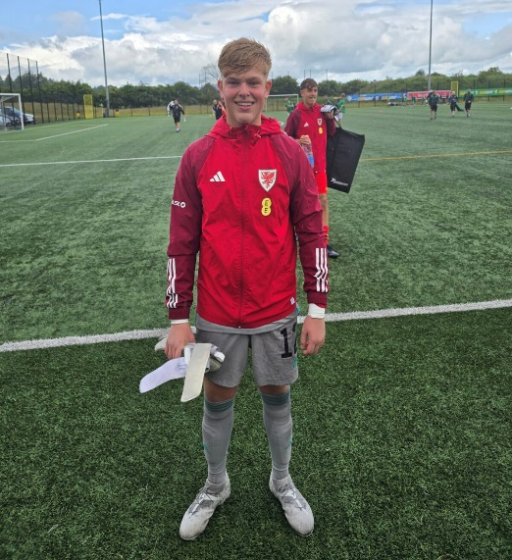

Congratulations to Noah Hind, who recently represented Wales Youth Under 14’s football in a tournament in Northern Ireland.
Feedback back from the coaches was how well he played and how well he represented himself both on and off the pitch.
It was a very good weekend of football, beating some teams by large margins but eventually losing to the Republic of Ireland in the Final 3-2 (to a very harsh last minute penalty!)

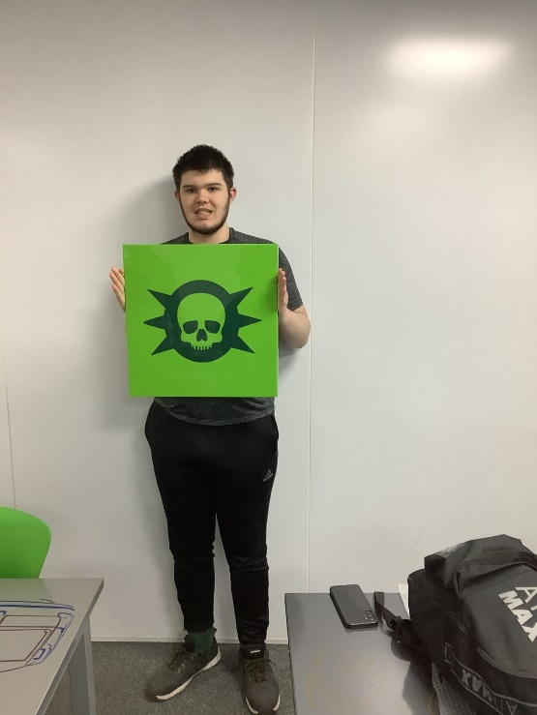
Student of the Year
Thursday, 19th June 2025
Elis White has also studied two Enrichment courses this year.
He studied Body & Paint spraying at Body Perfect and also a motor vehicle course at Coleg Cambria.
He has been awarded ‘Student of the Year’ for his hard work and achievement on his motor vehicle course.
Elis has thoroughly enjoyed his experiences and has grown in confidence.

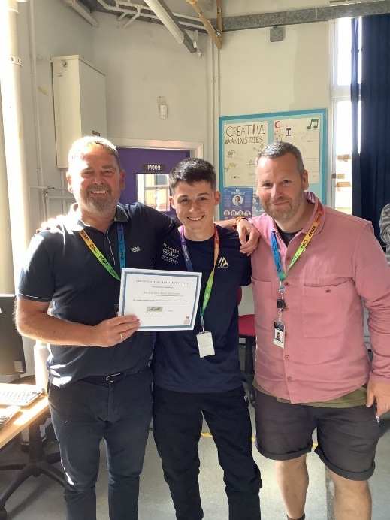
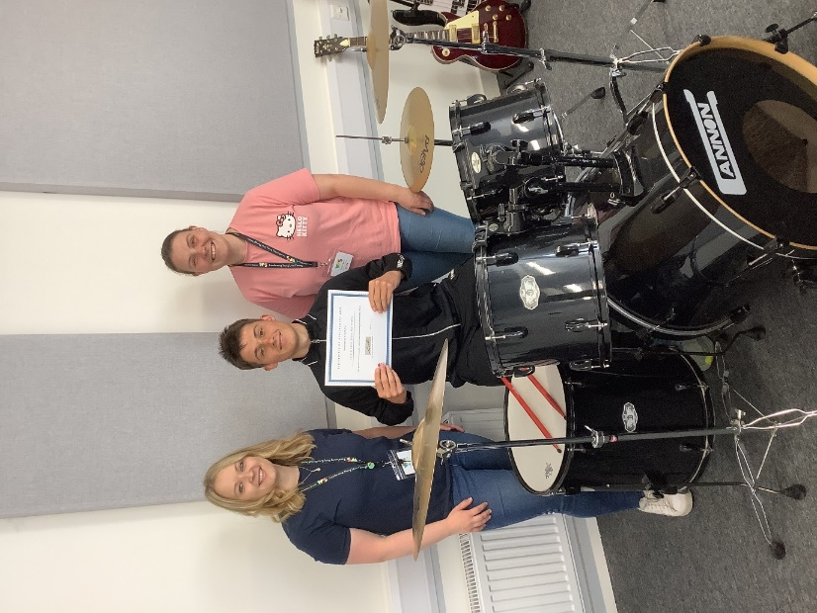

Jack Davies, Year 11, has completed two Enrichment courses this year and excelled in both.
He has achieved 'Student of the Year' in both his Photography course at Coleg Cambria and his Music course at Music Sounds.
Jack has had a fantastic experience this year in college and his confidence has grown enormously.
We wish Jack well in his future career.

**********************************************************************************************


Mullin has been a talismanic figure for Wrexham since Hollywood A-lister Reynolds and fellow actor Rob McElhenney bought the Welsh club in 2021.

Ryan Reynolds says he cannot picture Paul Mullin playing in anything other than a Wrexham strip after the striker joined Wigan on loan.
The 30-year-old has scored 110 goals in 172 games since arriving from Cambridge nearly four years ago as Wrexham won three successive promotions to reach the Championship.

Mullin has been a central figure in the award-winning 'Welcome to Wrexham' TV docuseries and even had a non-speaking cameo role in Reynolds' Deadpool & Wolverine as Welshpool, a Welsh version of Deadpool.
"I can't imagine seeing Mulls on loan and in another kit," Reynolds posted on X. Sign up for the North Wales Live newsletter sent twice daily to your inbox

Wrexham co-owner Ryan Reynolds before a game at the Racecourse Ground (Image: PA Wire/PA Images)
"We wouldn't be where we are without his heart, skill and work ethic. We love you, @PMullin7. SPM (Super Paul Mullin)."
Mullin wished Wrexham good luck on his departure for the 2025-26 campaign, posting on X: "All the best this season! Keep the train rolling", adding a heart emoji.
The forward's game-time at Wrexham was limited last season following surgery on a long-standing back issue.

**********************************************************************************************
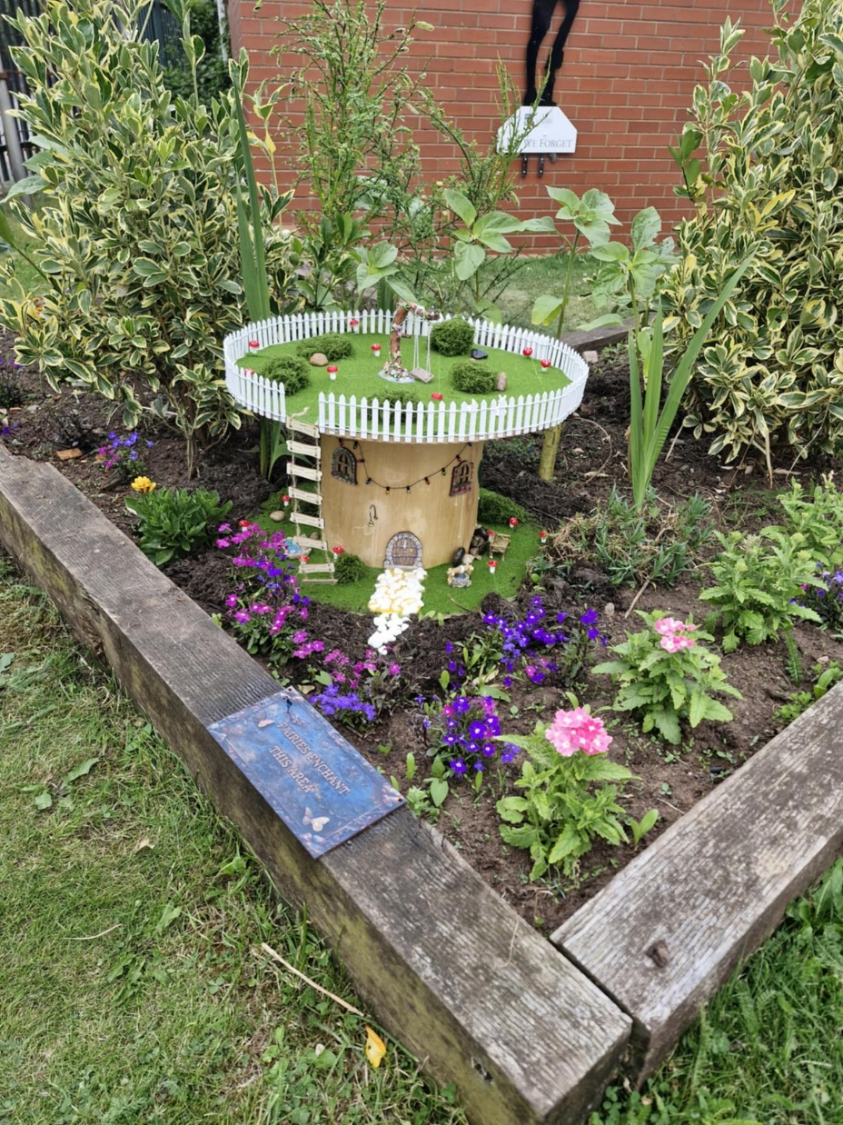

THE 1st RUABON BROWNIES turned 75 last month and are still going strong.

As part of our badge work, girls have learnt about design, recycling and up cycling.
also the girls have turned an old cable reel into their very own fairy house and placed it in the brownie garden we now share with the Ruabon Rainbows.

We'd welcome anyone from the village to view it from afar, but it is quite fragile and made by children so please don't touch.
We still have spaces in Rainbows, Brownies and Guides if anyone would like their child to join.

**********************************************************************************************

Cllr David A Bithell, deputy leader of Wrexham Council and lead member for Strategic Transport said:
“We are pleased to confirm the continuation of the programme of works will resume next week.

“We have worked closely with the contractors to minimise any disruption to the public and will support them to conclude the reversions as swiftly as possible.”

The roads which are reverting are as follows:
- B5445 Marford Hill, Marford
- B5445 Chester Road, Gresford
- A5152 Chester Road, Acton (A483 - Garden Village)
- A5152 Chester Road, Acton (Garden Village - City)
- Ty Gwyn Lane, Acton
- B5100 Rhosnesni Lane, Acton
- Jeffreys Road, Borras
- A534 Holt Road, Wrexham (Hullah Lane to Greyhound)
- A534 Holt Road, Borras (Greyhound to Link Road)
- A525 Ruthin Road, Wrexham
- A541 Mold Road, Gwersyllt

- A525 Kingsmills Road, Hightown
- Kingsmills Loop (Old A525)
- Abenbury Road, Abenbury
- Cefn Road, Abenbury
- A525 Marchwiel Road/Bangor Road, Marchwiel
- A528 Overton Road, Marchwiel
- A525 Bangor Road, Cross Lanes
- B5130 Holt Road/Kiln Lane, Cross Lanes
- B5425 New Road/ Main Road/ Llay New Road, Rhosrobin
- Plas Acton Road, Pandy
- B5425 Llay New Road, Llay
- B5102 Straight Mile/ Croeshowell Hill, Llay
- Gegin Lane, Llay
- Higher Lane, Llay
- Chapel Lane, Llay

- Phoenix Drive, Brymbo
- New High Street, Brymbo
- Railway Road, Brymbo
- B5101, The Lodge
- B5426 Wern Road, Minera
- B5426 Minera Hall Road, Minera
- B5426, The Wern
- B5605 Park Road/Newbridge Road, Rhosymedre
- A539 Llangollen Road, Trevor
- A539 Llangollen Road, Acrefair
- B5070, Chirk
- B5070, Chirk (buffer)
- B5605 Wrexham Road, Johnstown
- B5605 Ruabon Road, Johnstown
- Vauxhall Industrial Estate, Johnstown
- B5605 Ruabon Road, Ruabon
- B5605 New High Street, Ruabon
- B5605 Bridge Street, Ruabon
- A539/B5605 Ruabon Roundabout
- B5097 Plas Bennion to Tatham Road
- Plas Bennion Road/ Copperas Hill
- Plas Bennion Road (buffer).

**********************************************************************************************

Pioneering Aeronautical Apprentice Flies the Flag for Women in Engineering
A Young Apprentice from Llantrisant is breaking barriers in the Aerospace Industry as Wales Celebrates Women in Engineering Day.
First published: 23rd June 2025 Last updated: 23rd June 2025


Georgia Price, 21yrs, was the first female aeronautical engineering apprentice at Newport-based AerFin Ltd, a global aviation company specialising in aircraft and engine component support services.
Currently studying for a degree in Aeronautical Engineering at the University of South Wales, Georgia is blazing a trail for women in STEM careers. Her achievements include winning bronze and gold medals at the Inspiring Skills Competition Wales Manufacturing Team Challenge and the Skills Academy Wales Tomorrow's Talent Award.
Georgia said:
My advice to other women considering an engineering career is to go for it. It's not as daunting as it may look, and everyone is so supportive and welcoming.
Minister for Culture, Skills and Social Partnership Jack Sargeant said:
Georgia's success story is a beacon to all young women who may today be considering a career in engineering. Her achievements also illustrate the value of apprenticeships as a pathway into employment and further education.
The Welsh Government has increased its support for apprenticeships despite financial challenges and the loss of European funding. Core funding has risen from £97 million in 2020 to £144 million in the most recent budget. Latest data published by Medr shows nearly 73,795 new apprenticeship starts have been supported during this Senedd term.
Georgia's employer, AerFin, now has three female apprentices and is committed to developing local talent in the thriving aerospace sector.
Simon Bayliss, AerFin’s chief operating officer said:
Georgia is a great asset to the business. Apprenticeships provide the company with a great opportunity to take on and develop local talent which allows us to grow organically.
First published 23rd June 2025. Last updated 23rd June 2025

*******************************************************************************


​ |   Global Immunization Newsletter - June 2025  Momentum builds to protect immunization post World Health Assembly  The Seventy-eighth World Health Assembly concluded with renewed momentum for immunization, amid global calls to scale up action and investment. Member States affirmed the central role of vaccines in advancing health security, resilience, and equity. Several critical outcomes have significant implications for our collective work.  Upcoming Meetings    - Global Summit: Health & Prosperity through Immunization, 25th June, Brussels, Belgium  - Webinar: 2024 WHO and UNICEF national estimates of immunization coverage, 15th July  - Immunization economics IHEA pre-congress, 19-20th July, Bali, Indonesia  - 15th International Rotavirus Symposium, 30th September – 2nd October, South Africa | ​

Stories

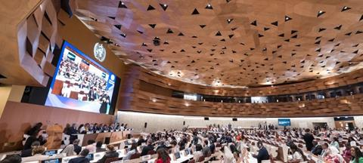 | Global health leaders urge action at WHA78  At Seventy-eighth World Health Assembly, Member States and partners called for urgent action on vaccine-preventable diseases to boost immunization and prevent future outbreaks.

 | How Baduy mothers protect children from VPDs  Ambu Itoh recalls when her five-year-old son caught measles. Though he recovered, the experience deepened her resolve to ensure every child in their Baduy village in Banten Province is protected through vaccination.

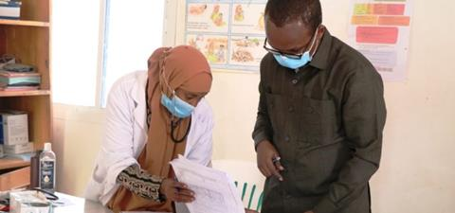 | Behind the scenes at WHO: detecting disease outbreaks  In a world where a virus can cross continents in a matter of hours, monitoring outbreaks, or “disease surveillance,” is more important than ever. But what does that actually mean?

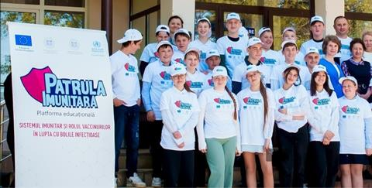 | Immune patrol education package rolls out in Europe  Immune Patrol is a WHO/Europe education package that helps 10–12-year-olds explore and understand immunization through expert-backed content.

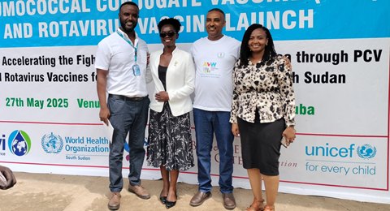 | Civil society drives new vaccine rollouts  Something remarkable is happening for children in Chad, Somalia, and South Sudan: the introduction of new vaccines against pneumonia, diarrhea, and malaria is driving unprecedented progress in child health.

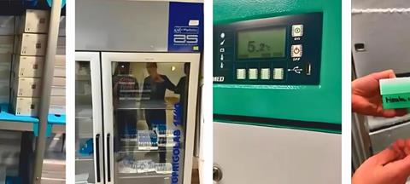 | Virtual lab visit innovates measles & rubella monitoring  A National Measles and Rubella virtual laboratory in Malta demonstrated strong performance and robust management practices, achieving a score of 90.3%.

 | Reaching zero-dose children in Bangladesh  Bangladesh’s commitment to leaving no one behind in immunization is evident through its data-driven planning and community-focused outreach.

WHO and UNICEF estimates of national immunization coverage

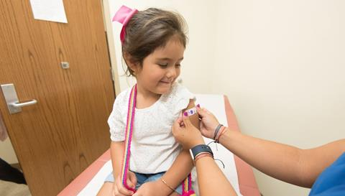 | Based on country-reported data, the annual WHO and UNICEF estimates of national immunization coverage provide the world’s largest dataset on immunization coverage trends for 16 vaccines/antigens/doses across 195 WHO and UNICEF Member States.  The latest estimates will be available as of July 15th here.

New resources

 | - The power of immunization for people living with NCDs  - New tools to equip and empower local actions to improve vaccine uptake  - Video: The Immune Patrol Academy

Past meetings

- Webinar on “Algorithm on classification of suspected measles and rubella cases in the WHO South-East Asia region: recent updates”  - National staff of Burkina Faso take MLM course on immunization program management  - Webinar on immunization research area prioritization for the WHO SE Asia Region | - Geo-Enabled Digital Microplanning: revolutionizing immunization in Bangladesh  - Workshop on immunization and surveillance data management for vaccine-preventable diseases  - Bridging public and private sectors to strengthen urban immunization in Nepal  - Electronic immunization registration in Rajshahi City Corporation: lessons learned

Contributions

 | Contribute to the next issue of the GIN  The next update will be in September 2025. To contribute, please click on this link to submit an article by the 1st of September.  If you have any questions or feedback, please contact: globalimmunnews@who.int

 |  Tweet   Forward
  World Health Organization
  Department of Immunization, Vaccines & Biologicals (IVB)
  Universal Health Coverage/Life

**************************************************************************************************************


If EVER you need to contact a
person who is Extremely Clever
at finding out what is wrong -
with your computer, then I can
honestly recommend
Mr Chris Williams.
(Who is also a very kind and
considerate Gentleman.)

**********************************************************

FOOTCARE
By PODIATRIST THOMAS JENESON (excellent)
@ Grosvenor Lodge Clinic
(1 Grosvenor Road, Wrexham, LL11 1BS)
01978 800777 tajeneson@gmail.com

*****************************************************************************

ALL BEST WISHES (and THANK YOU)
Sybil (Bremner).

*********************************

