Ruabon News Letter 569

£5m to Make Playgrounds
and Play Areas Fantastic
Delivering on our priorities for Better Health
Children’s playgrounds and play spaces across Wales are to be improved so youngsters have better opportunities to play within their local communities.
First published: 10th May 2025 Last updated: 10th May 2025

The Welsh Government is providing an extra £5m to local authorities to purchase items to improve the quality of play spaces, refurbish playgrounds and support the creation of inclusive and accessible play spaces.
Playing positively impacts children and families and is vital in a child’s development, helping them to build their confidence, resilience and self-esteem.
When considering their proposals, local authorities are being asked to gather the views of people including children and their families on play provision in their area; consider play opportunities that are inclusive and encourage all children to play and meet together, and improve access and safety.
Minister for Children, Dawn Bowden visited the refurbished Williams Field Lane playground in Monmouth where she met parents and children who benefit from the facilities.
Funding from the Active Travel Fund has been used to enhance the playground through the Williams Field Lane active travel scheme. This has seen a mixture of planting, natural eco-friendly play areas, equipment such as swings and a host of eco-friendly equipment for children's development like hedgehog houses put in place.
The play area is also used as a Forest School and for ecological work by over morrow Primary School, with the Active Travel network providing safe access.
A parent whose child goes to over morrow Primary School, said:
We use the park every day after school, it is lovely to let the children play together and decompress after the school day.
Another parent said:
“The park is nice, especially if we are slightly early, then we can use it. Also, at the end of the school day the park is nice to stop off at.”

Minister for Children, Dawn Bowden said:
“We want a Wales where all children feel physically, mentally, and emotionally healthy and can access their right to play.
Playgrounds, such as Williams Field Lane playground, are fantastic places for children to play, make friends and enjoy themselves.
This month we celebrate National Children’s Day. This funding will improve children’s experiences and help them build confidence and develop their skills.
We will continue to work with local authorities and partners to support our ambitions in improving opportunities to play and promote the benefits of play for children’s wellbeing”.

Cabinet Secretary for Housing and Local Government, Jayne Bryant said:
“By working closely with local authorities, we’re helping to ensure children in Wales have access to safe and engaging places to play, particularly in areas where families may face additional challenges.
Our £5m investment in these vital community assets is more than just improving playgrounds. It’s about investing in our children's development and wellbeing – and building stronger, better-connected communities across Wales.
This funding was secured through the budget deal between the Welsh Government and Jane Dodds, Leader of the Welsh Liberal Democrats”.

First published 10th May 2025. Last updated 10th May 2025
***************************************************************************************

Stori Brymbo – Sneaky Peak Guided Tours!
For all those budding Palaeontologists, or those just simply interesting in the fascinating history of our area, did you know you can now book to go on a ‘Sneaky Peak’ guided tour of the newly launched Fossil Forest excavation at Stori Brymbo? The tours take place every Sunday, there’s even coffee and cake included in the ticket price and accompanying children under 16 go free! Book here and see what’s being discovered in this historic and evolving area of Wrexham! Stori Brymbo is also part of the worldwide science festival, A Pint of Science this weekend - all the details here!
Wellfest –on Llwyn Isaf!
Saturday 17th May, will have seen Wellfest take place on Llwyn Isaf in Wrexham city centre. A packed programme of live music, workshops, yoga, art, food, live music and poetry, it sounds like a brilliant day out! The aim of the festival is to keep young people’s voices and wellbeing at the centre of the day, stressing the importance of mental well-being within the community. It promises to be a vibrant, fun and inspiring day out for the family – it was a Free Entry.
National Trust Half term round-up
With just a week to go until half term is upon us, check out what our two great National Trust properties have going on. Chirk Castle are shining the spotlight on the Curlew, a much-loved countryside favourite with a week of fun activities. Jake the Storyteller is also around, with tales of birds great and small. It’s all about gardening at Erddig, with border sowing and creative upcycling sessions where you can make a planter and sow a seed. This is as well as the usual wild woodland fun in the Wolf’s Den!

National Eisteddfod is coming to Wrexham!
Did you know the National Eisteddfod is coming to Wrexham this summer, for the first time since 2011! From 2nd – 9th August, the event will take place at Isycoed, on the Eastern outskirts of the city centre. The festival site, known as ‘The Maes’, will attract thousands of visitors to Wrexham, many for the first time. To help give a big welcome to these visitors, the Harddu project is designed to encourage residents to help get involved and offer a big warm welcome to Wrexham! See here for all the details, as we get ready to showcase our wonderful county!
Keep an eye on this newsletter for all Eisteddfod news and updates!

**************************************************************************************************

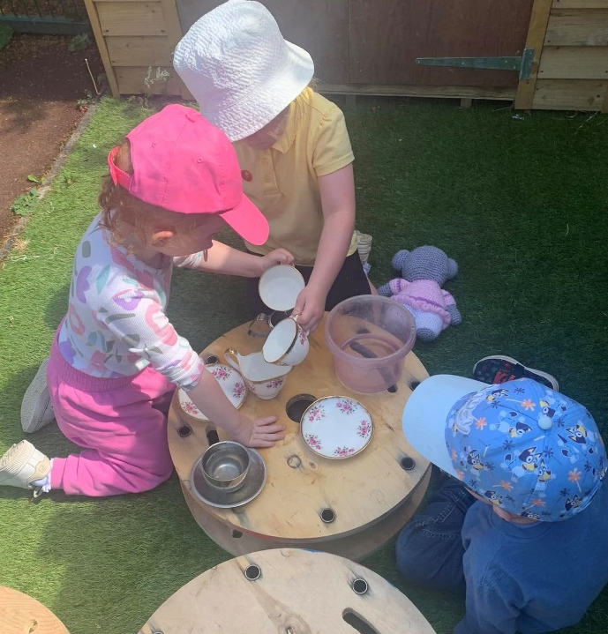

“Little Sunflowers”
are ‘working very hard’ to make sure that
the tea cups are being filled for their friends!
*****************************************************************************************************

Wrexham Council News Young People with Experience of being in care, are sharing the Meaningful Relationships they developed through the Fostering Community that Changed their Lives for the Better.
This is Foster Care Fortnight, which takes place annually and falls between May 12th and May 25th in 2025, the fostering community is celebrating the power of relationships.
Whether it’s the bond between a carer and a child, the relationship created with supportive social workers, or the friendships built with other foster carers in a community, strong relationships are the golden thread that run through all fostering stories.
In Wales, there are more than 7,000 children in care, but only 3,800 foster families.
Foster Wales is aiming to recruit an additional 800 carers by 2028.
Lisa was just three days before her 8th birthday when she went into foster care in Wrexham.
In unfamiliar surroundings, she was scared.
She didn’t understand why she was there.
But 21 years later, the foster family who opened their hearts and home to her as a scared and vulnerable 7-year-old, is still her family today – and they’ve never stopped being there for her.
Lisa says that Foster Care saved her life.
“After years of abuse, they made me feel safe and secure. I wasn’t scared anymore” says Lisa, who is now a mum herself and is studying to become a nurse.
“When I first arrived, I couldn’t read or write.
My foster carers supported me through everything. They got me a tutor, helped me with after-school clubs, and read with me every night.”
“I’ve always been treated as part of the family, no different to how they treated their own children.
They accepted me for who I am, and that’s never changed.”

Lisa lived with her foster family until she was 19 when she moved into her own flat whilst pregnant with her child.
“They told me I could stay as long as I wanted, but I felt it was time to have my own space.
Even then, they supported me every step of the way.
They made sure I had everything I needed to start this next chapter.
They treat my child as their grandchild, and they’re just as involved in our lives now as they’ve always been.”

“I’m still in touch with other children who were fostered by my family. Some of them went back to their birth families, but we’ve all stayed connected.
They feel like extended family to me.”
“Fostering creates those lifelong bonds, even when everyone’s journey is different.”

Cllr Rob Walsh, lead member for children’s and family services, said: “Lisa’s story shows just how important the role of a foster carer can be. Having a safe and secure environment can be life changing for young people who have experienced had a difficult times previously.”
“If you have thought about being a foster carer but aren’t sure what it actually involves, or maybe you know you will be able to offer a young person a caring home but feel you would need support to really make a difference, then please make contact with our team here in Wrexham. They will be able to give you all the information and help that you need.”
To find out more about becoming a Wrexham Foster Carer wrexham.fosterwales.gov.wales/
Meet your local Foster Wales Wrexham team at one of our events:
- May 15th, Information drop-in session at the Wellbeing Hub from 10am – 2pm
- May 20th , Information stall at Tesco (Wrexham city centre) 10am – 2pm.
If you can’t make it to one of these events, call us on 01978 295316 or email fostering@wrexham.gov.uk and we can organise an informal chat or send you some information.
Lisa’s story: “They gave me a chance at life” – Foster Wales Wrexham -
************************************************************

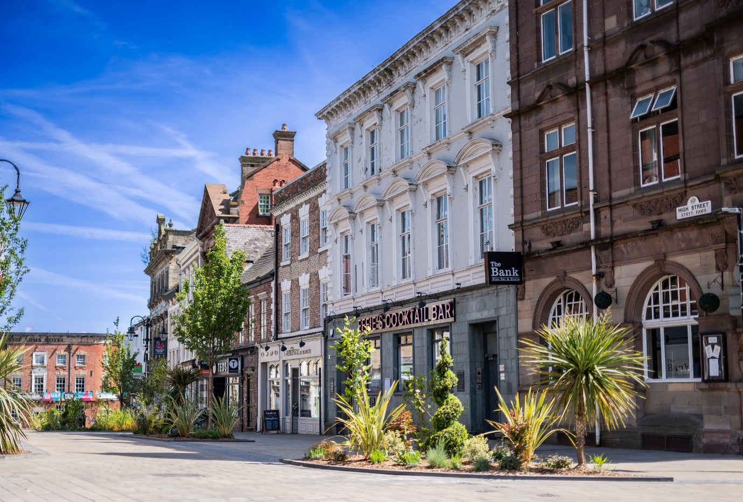

Police have released an update after "disorder" at a high school, which saw armed officers called to the scene. Police were called to Rhyl High School on Thursday afternoon following "an issue between a very small group of pupils, with a larger crowd of onlookers".
A North Wales Police statement said: "We were called shortly after 3pm to report an incident of disorder involving youths outside Rhyl High School. Officers attended the school which resulted in the youths being removed from the area.
*********************************************************************************

North Wales Man and his Son's role in a £31m Drugs Plot was Revealed when Police looked inside a Sports Direct Bag, which was Found in an Audi.
Officers found a major haul of 45kg of cocaine inside Raymond Kinnear's car, which had been left parked inside an industrial unit at a business park.
Kinnear, 63, was afterwards found to have enlisted his son, estate agent Nathan Kinnear, to work in an "administrative" role in order to help him with his criminal activities, which included booking hotel rooms and providing Sports Direct and Aldi bags for life which were then used to store the illicit substances.
****************************************************************************************************

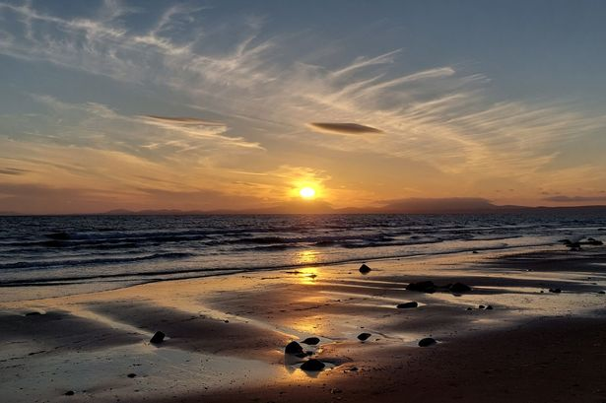
Quality ratings at 44 North Wales Beaches Show Best and Worst for Swimming
Bottom of Form

Sunset at Llandanwg Beach, Gwynedd,
Where the Water Quality is rated 'Excellent' .

Record rises in consumer water bills could lead to improvements on Welsh beaches, according to Natural Resources Wales. The environment regulator wants to see better water quality for swimmers and is pressing water companies for a share of the spoils.
Many beaches in Wales already meet stringent standards, with 75 out of 110 designated bathing sites rated “excellent” (68%). However, among the designated bathing beaches in North Wales, this proportion falls to 52%.
Another sub-par beach is Llandudno’s North Shore. - the scene of a 12-year battle to restore sand to a foreshore now mostly covered by stones. Its water quality is rated only “sufficient” - just one grade above Rhyl Central, where a
no-swim warning has been issued.
Trace amounts of sewage debris and animal faeces are occasionally found on the North Shore, while small amounts of litter are observed regularly.
A recurring issue at the prestige resort is “misconnections” – when waste water pipes from toilets and washing machine are plumbed into surface drains instead of the sewage system. This effluent is then discharged directly to the environment.
After years of work with local property owners, NRW believes misconnections no longer threaten bathing water quality. Neither are local farms and campsites thought to be sources of sea pollution. Nevertheless, NRW said it is continuing to work with Conwy Council to improve matters.

*********************************************************

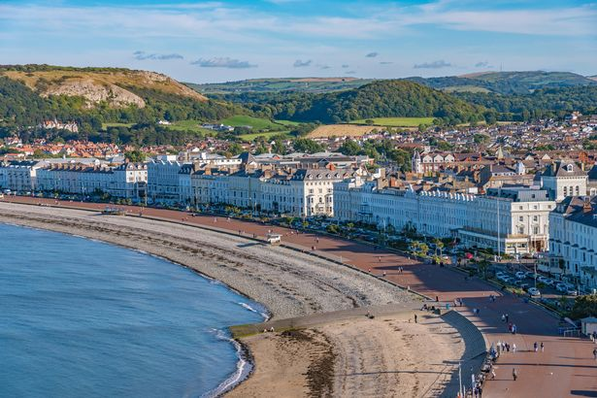
Llandudno's North Shore Beach has Room for Improvement
Also considered merely “sufficient” was Cemaes, Anglesey. Testing found high bacteria loads and monitoring identified the possible source as Afon Meddanen, a tributary of the River Wygyr. As a result, extra fencing has been added to nine riverside farms and more fencing work on the Meddanen was completed earlier this year..
Beach water quality ratings are compiled using four years of testing data. By averaging out the figures over four years, the idea is to give a truer picture for swimmers.
At the start of each year, beach waters are checked for obvious signs of pollution, and to ensure any permitted discharges are operating correctly.
Ceri Davies, NRW’s interim CEO said: “Much progress is being made, and after securing record levels of investment for the environment from water companies through the price review process, we will be pressing for investment in assets affecting our bathing waters, to safeguard their future health.”
Wales now has 112 designated bathing sites – last week, Lisvane and Llanishen reservoirs in Cardiff were added to the list. They join another reservoir used by swimmers which is Rhyl’s Marine Lake.
**********************************************************
Newyddion Llyfrgelloedd
Library News for the week beginning 18th May
Introduction to Smartphones at Chirk Library
Are you struggling to get to grips with your Smartphone?
Groundwork North Wales will be providing a free course on how to learn to use your smartphone.

The course will take place from 30th May to 20th June 2025, 9.30-11.30am.

To reserve your place please call
01978 757524.
Join us at Rhos library on Friday 23rd May, 2.00-4.00pm, for a fascinating session with Kevin Plant, Archivist Records Manager, who will be chatting to us about old maps and artefacts from Rhos. The session is free but you need to reserve your place by contacting the library on 01978 840328 | rhos.library@wrexham.gov.uk
The Hidden Sea Caves of North Wales
That look like a Tropical Paradice
Free Welsh Lessons for Parents at Wrexham Library
Get ready for the Eisteddfod this summer at Wrexham with these free Welsh lessons for parents at Wrexham Library. Clwb Cwtsh are holding weekly sessions at the library, 1.00-2.00pm, every Tuesday.

Half Term Activities at Brynteg Library
Don’t be stuck for something to do with your children this coming half term. Brynteg library have several activities for them to join in with including Lego Club and Elmer Day craft, Story and Rhyme and Slime Making. To reserve your place on any of these session please contact the library on 01978 759523 brynteg.library@wrexham.gov.uk
*****************************************************************************************************************

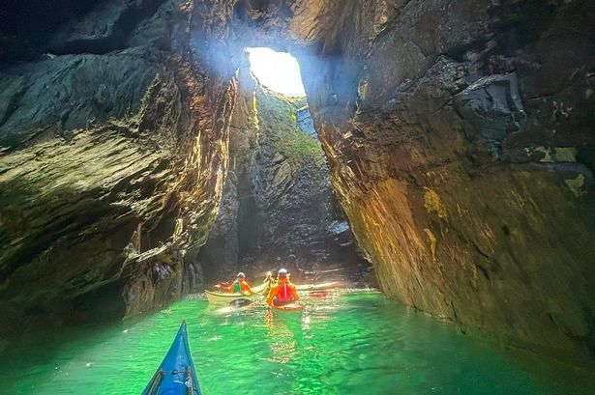

Kayakers Pause to Admire the Beauty of ‘Blowhole Cave’
(Eila Wilkinson Sea Kayaking).
Our community members are treated to special offers, promotions and adverts from us and our partners.
You can check out at any stretch of rugged coastline on Anglesey offers some of the finest clifftop walks in Wales - the views are spectacular, the sea air bracing. But for some, it’s below where the real magic lies.

Here, around the corner from Rhoscolyn on Holy Island, is an intricate array of inlets, clefts and tiny coves hewn out by the sea.

Just beyond Rhoscolyn headland are the area’s two most distinctive features, the natural sea arches of Bwa Du (Black Arch) and Bwa Gwyn (White Arch), the latter moulded from white quartzite rocks.
Powered by
At the foot of the coastline’s towering cliffs are several caves that can be reached only by kayak. One, gaping open like a mouth with giant fangs, has been christened Electric Blue by climbers who can often by seen clambering up the rockface above it.
Perhaps the most impressive is a sea cave known colloquially at the Blowhole. On the right day, when conditions are calm and sunshine streams in, it’s like entering a cathedral, with light dancing on the azure water and scattering across rock walls.
Taking a group of Swiss visitors to the cave this week was Eila Wilkinson, an Amlwch-based kayak guide and coach.
“I must have visited this cave a million times,” she said. “But this week it was extraordinarily spectacular.

Kayakers led by Eila in the spectacular ‘Blowhole Cave’ (Image: Eila Wilkinson Sea Kayaking)
Having coached kayakers for 16 years, operating her own business for the last seven, Eila knows every inch of Anglesey ’s coastline. When swells deepen and the wind picks up, Blowhole Cave gives up another of its secrets.

“You can hear the hiss of escaping air from small gap in the rock,” she said, mimicking the sound. “It’s like a dragon is breathing inside.”

The brightly coloured Serpent's Cave at Porth y Rhwydau further up the coast; Climbing is popular on the area's cliffs - though further up the coast at The Range, a six-month exclusion zone is now in place for all adventure activities.
At Rhoscolyn headland, the most sure-footed inhabitants are an unlikely pair of Kashmiri goats uprooted from Llandudno’s Great Orme.
Startled kayakers passing by often come across them lounging on ledges and gazing curiously at the day-glo interlopers with floats instead of legs.

Navigating under Bwa Gwyn (White Arch) at Rhoscolyn headland (Image: Eila Wilkinson Sea Kayaking)
Anglesey Coastal Path runs above Blowhole Cave, though views of its cavity are obscured by an impressively high dry stone wall. It's near safety railings where the path narrows above a sheer drop.
When the wind and waves pick up, the hidden blowhole spews out spray across surrounding farmland.
In nearby Porth Saint, St Gwenfaen and her fellow missionaries were said to have landed on Anglesey in the 6th century.
Originally from Scotland, or possibly the Isle of Man, she is reputed to have founded a cell on Rhoscolyn Head having climbed the cliffs.

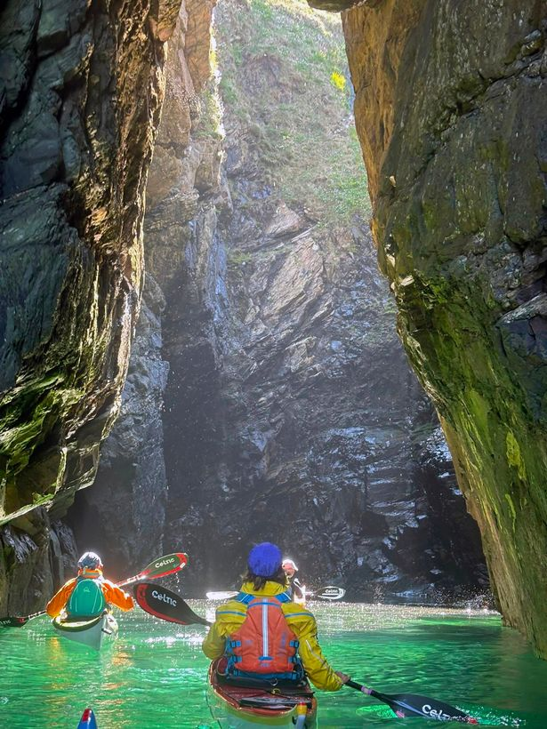
Half a mile away in Rhoscolyn is the only church in Wales dedicated to St Gwenfaen. Once an important place of pilgrimage, Rhoscolyn itself was formerly called Llanwenfaen (Church of Gwenfaen).
On the headland, 230 metres from the blowhole, is St Gwenfaen’s well, one of the best preserved on Anglesey.
Over the last century it’s become associated with mental wellbeing, secured by offering two white pebbles. !
**********************************************************************************
Coleg Cambria Launches New Football Academy with Champions League Finalists PSG

Coleg Cambria has announced a new partnership with the
‘French Football Giant’. ???
******************************************************************************************


If EVER you need to contact a
person who is Extremely Clever
at finding out what is wrong -
with your computer, then I can
honestly recommend
Mr Chris Williams.
(Who is also a very kind and
considerate Gentleman.)

**********************************************************
FOOTCARE
By PODIATRIST THOMAS JENESON (excellent)
@ Grosvenor Lodge Clinic
(1 Grosvenor Road, Wrexham, LL11 1BS)
01978 800777 tajeneson@gmail.com

*****************************************************************************
ALL BEST WISHES (and THANKS)
Sybil (Bremner).

