Ruabon News Letter 565

Wrexham AFC latest

The day's biggest Wrexham AFC stories, sent straight to your inbox. That, helped on by Wycombe Wanderers' 4-0 loss to Charlton Athletic, mean the Reds are now second in the EFL League One table.
A crowd of 12,266 supporters watched on from the stands - and in among them was Wrexham AFC co-chairman Rob McElhenney.
That, helped on by Wycombe Wanderers' 4-0 loss to Charlton Athletic, mean:
The Reds are now Second in the EFL League Table One.
A crowd of 12,266 supporters watched on from the stands - and in among them was Wrexham AFC -Chairman Rob McElhenney.

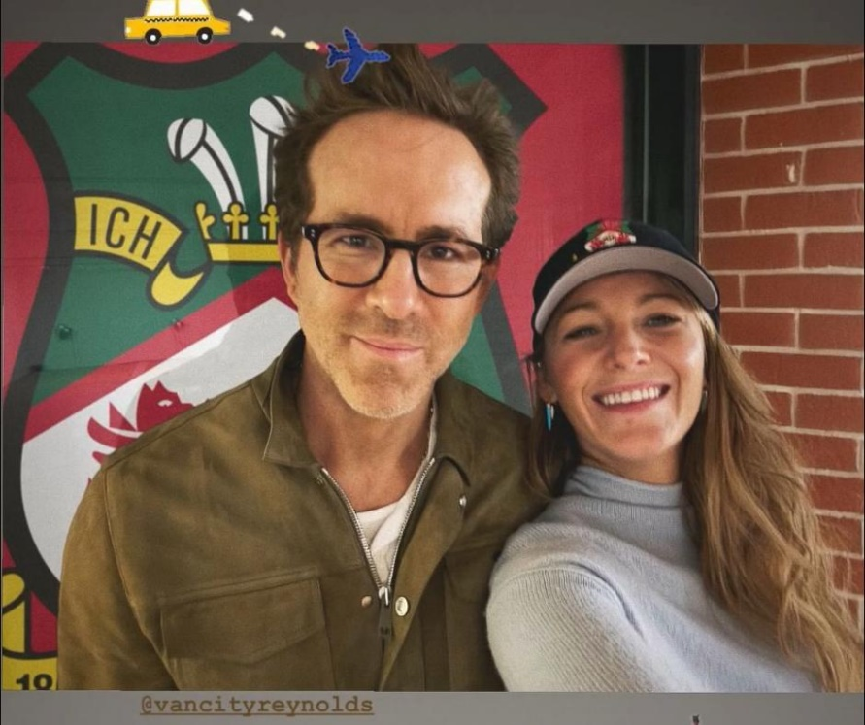
A crowd of 12,266 supporters watched on from the stands - and in among them was Wrexham AFC -Chairman Rob McElhenney.

********************************************************************************************************
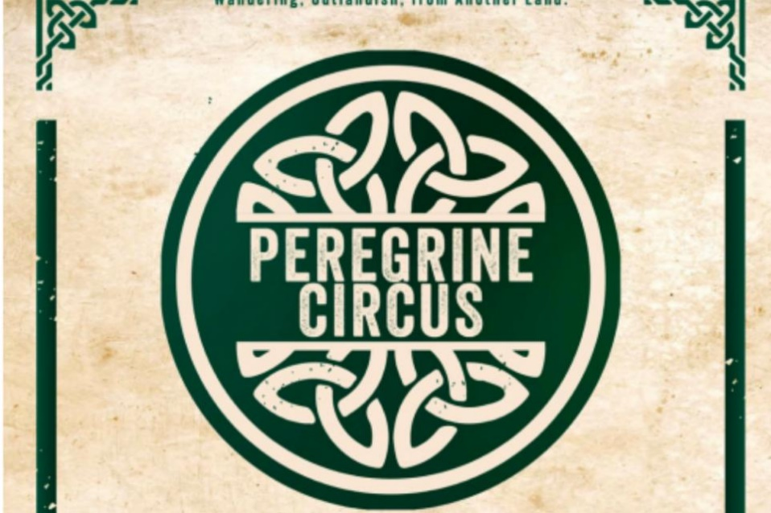

Peregrine Circus, a Rare Art Form in the UK,
This is set to open on May 9th 2025,
in North Wales.
The circus has been created by Robin Timson, who was born in North Wales and has spent the last five years as company manager at the highly acclaimed GiQords Circus.
Mr Timson said: "I chose the name ‘Peregrine Circus’ as the definition of a peregrine is a bird that tends to wander and is migratory.
"It is used in mediaeval Latin to describe someone who comes from another country; foreign or outlandish, which I thought was perfect to describe a travelling circus.
"It also applied to me, as I have been away from home travelling with a circus, and now I have returned home to start my own circus."
Mr Timson has spent the winter building and creating Peregrine Circus at home in Llanddulas.


- Celebrating New Members to the Welsh GI Family
- Blas Cymru Taste Wales Brokerage 2025
- Two Welsh Producers given Prestigious Award
- Carbon Reduction Pilot - It's free: Sign up now!
- Insight Conference 2025: Be Ahead of the Curve
- Welsh Food and Drink Overseas
- Food and Drink Industry Board Wales - Gary Mitchell
- European Buyers Explore the Best of Welsh Meat & Dairy
- Horticultural Cluster at the RWAS Spring Festival
- Judging at the Great Taste Awards
- In Other News
Food & Drink Wales Brand Toolkit - Now Available
Celebrating New Members to the Welsh GI Family
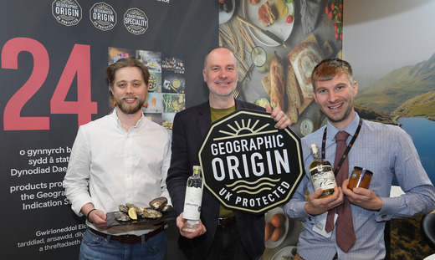
Dovey native botanical gin Pembrokeshire native oysters Pembrokeshire
Rock Oysters and Welsh Heather Honey have now joined the list of Welsh food and drink products granted protected geographical indication (PGI) status under the UK's Geographical Indication (GI) schemes.

The four products have been formally recognised for their distinctive qualities and regional heritage, ensuring only authentic items meeting strict production standards and geographical requirements can be marketed under these protected names, bringing Wales’ total number of GI products to 24.

This recognition gives producers a valuable market advantage while preserving traditional production methods, protecting and championing local products while creating economic opportunity.
These new additions join other popular Welsh products already recognised under the GI scheme, including Anglesey Sea Salt, Welsh Leeks, Pembrokeshire Earlies, Carmarthen Ham and Single Malt Welsh Whisky, showcasing the rich culinary heritage of Wales.

"This recognition strengthens Wales’ growing family of protected foods, showcases the extraordinary quality of our produce, and reflects our commitment to high-quality, sustainable food production.
From the mountains to the coast, Wales produces some of the UK's most iconic foods, cultivated with care and tradition. Each GI product tells the story of our landscape, our producers' expertise and our proud culinary heritage."
These new additions join other popular Welsh products already recognised under the GI scheme, including Anglesey Sea Salt, Welsh Leeks, Pembrokeshire Earlies, Carmarthen Ham and Single Malt Welsh Whisky, showcasing the rich culinary heritage of Wales.
"This recognition strengthens Wales’ growing family of protected foods, showcases the extraordinary quality of our produce, and reflects our commitment to high-quality, sustainable food production

From the mountains to the coast, Wales produces some of the UK's most iconic foods, cultivated with care and tradition. Each GI product tells the story of our landscape, our producers' expertise and our proud culinary heritage."
Wales’ Deputy First Minister, Huw Irranca-Davies, who has responsibility for Climate Change and Rural Affairs

"Having GI Status is a good thing and helps to raise awareness of Botanical gin being provenance-based and produced to such a strict and high quality."

Danny Cameron of Dyfi Native Botanical Gin

Gruffydd Rees of Gwenyn Gruffydd Ltd in Carmarthenshire "I am delighted that Welsh Heather Honey’s precise origin and characteristics have been recognised. The UK GI application process is long, and it is wonderful that Wales is the first UK nation to have a honey receive PGI status."
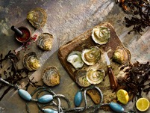
Having a PGI Status will attract a broader audience and market who are more aware of GI products and will allow us to join the GI family which has a number of fantastic products.
“ Jake Davies”

**********************************************

New research reveals extent of north Wales' urban roads covered by 20mph speed limit

New research has mapped out the areas where 20mph speed limits are becoming more common.
*******************************************************************************************************************


Anogir teithwyr i wirio cyn teithio oherwydd tarfu rhwng Henffordd ac Amwythig

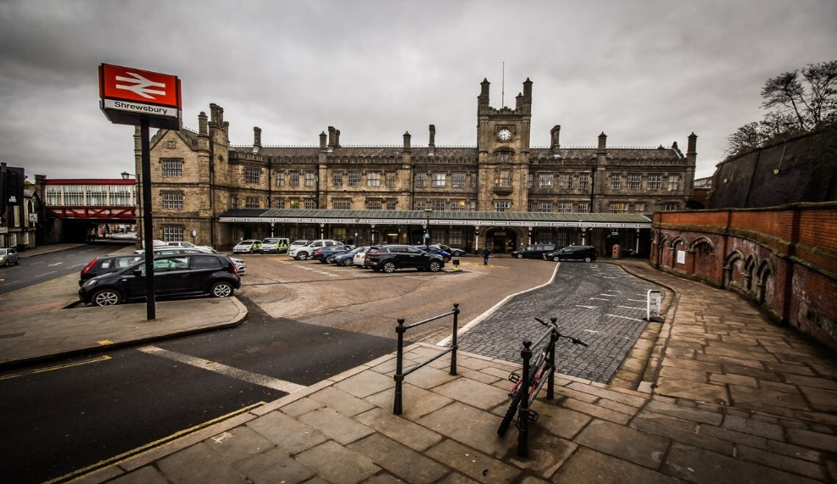
Passengers urged to check before they travel due to disruption between Hereford and Shrewsbury

Rail services between Hereford and Shrewsbury are currently experiencing significant disruption following the collapse of an underground culvert.

Network Rail teams are now on-site and working on fixing the problem.
As a result, train services will not run between Hereford and Shrewsbury and Shrewsbury and Llandrindod.
There will be a full closure of the railway between Hereford and Shrewsbury from Friday 25th April into Tuesday 29th April, however this may change as investigations continue.

Rail Replacement services:
Replacement road transport supplied by Swain's, Keane's, Lakeside, JKT and First Choice will be in operation between Shrewsbury and Hereford and Llandrindod and Shrewsbury to help you complete your journey at no extra cost.
We encourage all passengers to check before they travel for the latest information on rail replacement bus times.

Ticket acceptance:

Your ticket may be used with the following train companies on alternative routes as listed below at no extra cost:
- Avanti West Coast between Chester and Crewe, and between Crewe and Birmingham New Street
- CrossCountry between Manchester Piccadilly and Cardiff Central via Birmingham New Street
- Great Western Railway between Cardiff Central and Bristol Parkway to connect with Cross Country services to/from Birmingham and Manchester
- Northern between Manchester Piccadilly and Crewe

Planned engineering works and rail disruption. Planned engineering works are also ongoing on the Rhymney to Caerphilly lines, and Ebbw Vale to Cardiff and Newport lines. More information on planned railway improvement work can be found here: Rail improvement works
Emergency repair works are also being completed on the Intersection bridge in Cardiff. More information on this work can be found here: Urgent repairs to a bridge near Cardiff Queen Street
More information will be shared as it becomes available.
We apologise to customers for the inconvenience caused.

Wnaethoch chi anfon yr e-bost hwn? Hoffech chi ei anfon yn uniongyrchol atoch chi? / Were you forwarded this email? Would you like it sent directly to you?
Cofrestrwch fi'n uniongyrchol / Sign me up directly


CROESO
The National Eisteddfod is the Largest Cultural Festival in Europe, held in a different part of Wales every year.
Join us in Wrecsam from
2nd-9th August 2025
Welcome to the
Wrecsam National Eisteddfod Website.
The Festival is held on the Outskirts of The City from 2nd-9th August 2025
Try the new Park & Ride at Ruthin Road
Parking outside Wrexham Council’s offices at Ruthin Road, Wrexham LL13 7TU
- Shuttle-buses departing from 3.30pm every
- 20 minutes until 4.50pm.
Just £1 return for adults (50p for children)
Return buses after the game.
Car park closes at 9.30pm.
Wrexham Council recently announced plans to trial a new Park & Ride scheme for this season’s remaining Wrexham AFC home fixtures.
The aim is to reduce congestion and offer convenient match-day parking for fans travelling by car.
The shuttle-bus service is being provided by Arriva North West & Wales, and the scheme is being backed by both the Welsh Government and Transport for Wales (TfW).

*************************************************************************

AMRC Cymru:
Five Years of Making Welsh Businesses Faster and Greener

Five years of practical innovation at the Advanced Manufacturing Research Centre (AMRC) Cymru has helped improve Welsh manufacturing, with businesses learning to work smarter, reduce waste and create better products.


Action-thriller HAVOC, produced with Creative Wales support and released on Netflix .
WHICH IS THE BIGGEST FEATURE FILM EVER SHOT ENTIRELY IN WALES
(according to a recent report by the streaming giant.)

HAVOC, starring Tom Hardy and written/directed by Welsh-born Gareth Evans (The Raid, Apostle, Gangs of London).


Follows a deal gone wrong and a bruised detective having to fight his way through a criminal underworld to rescue a politician's estranged son. The production was shot at Great Point Studios in Cardiff, Dragon Studios in Bridgend and on location across South Wales.

Wales has become one of Netflix’s key production hubs, and has been the filming location for iconic shows like the hit Netflix original Sex Education which was shot at various locations across South Wales over four hugely successful seasons. Thanks to Creative Wales support – the teen comedy drama was able to create a significant amount of job opportunities locally, as well as over 60 trainee and apprenticeship positions for young Welsh creatives, many of whom went on to secure full time roles.

An economic impact report recently published by Netflix reveals that its productions in Wales have contributed over £200 million to the UK economy since 2020, supporting over 500 businesses from all over Wales in that time.
In a nod to its Welsh roots, Netflix has ensured that HAVOC will be available to view with Welsh-language subtitles, much like The Adam Project starring Ryan Reynolds and Dal Y Mellt which was the first S4C Welsh-language drama picked up by Netflix.

HAVOC is the latest in a long line of major TV and film productions filmed in Wales thanks to Welsh Government backing through Creative Wales: from HBO’s House of the Dragon, to Amazon’s recently announced Young Sherlock and the much-acclaimed recent cinematic release Mr Burton.
The £28.6 million of production funding Creative Wales has invested so far in the screen sector is projected to bring an additional £342 million of additional spend into the Welsh economy, meaning for every £1 it has invested, Creative Wales has seen nearly £12 invested back in the Welsh economy.
This investment has delivered 420 trainee placements and apprenticeships, ensuring a thriving pipeline of skilled professionals.

Anna Mallet, Vice President of Production, UK, Netflix, said:
From Sex Education to The Crown, and now to HAVOC, some of our most beloved titles were filmed or produced in Wales. Blessed with incredible creative talent and beautiful natural landscapes, Wales is an amazing place to make entertainment, so Netflix is delighted that our Welsh productions can continue to create such enduring cultural and economic opportunities.
Culture Minister, Jack Sargeant, said:
“ We are immensely proud of our Welsh creative industries, which employ over 35,000 talented individuals, and the world-class infrastructure we have in place for film and TV productions. We are proud to work closely with Netflix, HBO, Amazon and others to bring major productions to Wales. Collaborations like this create jobs, training opportunities and major spend within our economy and are a global platform to showcase everything we offer as a nation.”
********************************************************************************************************

Welsh Pharmacies

Since 2007, Welsh pharmacies have dispensed more than one billion items, helping millions manage their health conditions effectively and free of charge.
Charges were abolished as costs were preventing a third of people from getting their prescribed medication.
People with chronic conditions reported cutting back on food and bills to afford medication, leading to worsening health, increased GP visits and hospital admissions.

Key facts show that:
- more than 313,000 items are prescribed by GPs and dispensed by pharmacies free of charge every working day.
- free prescriptions support thousands with chronic conditions, like asthma, Parkinson’s disease and ulcerative colitis, to access the medicines they need every year
- Welsh residents save nearly £10 for each prescription item they receive in Wales.
Ryan Perrot from Brecon volunteers for Asthma and Lung UK Cymru. He has had severe chronic asthma since he was three and previously spent over £1000 on medication every year.
Speaking about the impact that free prescriptions have had on him, Ryan said:
Free prescriptions haven't just saved me money—they've extended my life.
Before, I'd end up in hospital, missing work, limiting my food shop because I couldn't afford my medication. Now, I can manage my condition better, I take daily tablets and inhalers without the worry of choosing between breathing and eating.
It's enabled me to work and pursue hobbies and most precious of all, play with my grandson, something I thought I wouldn’t be around to do.
People with chronic conditions shouldn't have to pay to breathe—something so basic that most take for granted.
By removing cost barriers, people who need regular medication are more likely to obtain and take the medication they need, contributing to better health outcomes.
Cabinet Secretary for Health and Social Care, Jeremy Miles said:
Free prescriptions are one of Wales' greatest healthcare achievements to date.
I'm proud that we led the UK in taking this bold step, ensuring everyone, regardless of their financial circumstances, can get the medication they need.
Over 18 years, this policy has transformed so many people’s lives, helped thousands manage their conditions effectively, and prevented unnecessary hospital admissions. Healthcare should be based on clinical need, and this is what free prescriptions are about.
As we look to the future, we are committed to this principle, it’s served the people of Wales so well.

*****************************************************************************************************************

A new circus is set to open in North Wales.
New circus to travel around North Wales from May 2025
Mike Harrison

Pope Francis



Thank you to Andrea Jackson for forwarding the following information:
Pope Francis
(April 24th at 1.10 am)
When he died, Pope Francis had only $100 as his personal inheritance. He had no bank accounts, no properties or investments to his name.
Although he could earn 340 thousand euros a year, he never accepted the salary of the Vatican, as he made vows of poverty and lived with justice.
Jorge Bergoglio (Pope Francis) renounced the luxuries of the papal palace and chose to live in the simple Casa Santa Marta.
All his expenses were covered, but his lifestyle was austere and consistent with what he preached.
His candle is held in the Basilica of Saint Peter and his burial will be on Saturday 26th in Basilica Santa Maria La Major Rome and not in the Vatican like its predecessors, the coffin is made of wood.
Their "INHERITANCE" wasn't material... if not MORAL: HUMILITY, COHERENCE and SERVICE.
A great EXAMPLE !!
***************************************************************************************************
Newyddion Llyfrgelloedd
Library News
Newyddion Llyfrgelloedd am yr wythnos yn dechrau 27 Ebrill
Library News for the week beginning 27th April

Tir na n-Og Awards
The Tir na n-Og Awards are the oldest and most popular awards for children’s literature in Wales. Established in 1976, the awards recognise, honour and promote excellence in books for children and young people. They are organised annually by the Department of Children’s Books and Reading Promotion at the Books Council of Wales. The awards have been won by some of our leading authors, including Manon Steffan Ros, Jac Jones, Gareth F Williams, Catherine Fisher and Jackie Morris. Three prizes of £1,000 each are awarded annually to overall winner in three categories. Shortlists of both English and Welsh-language categories have been published and are available from your local library. For more information on these fabulous awards visit Tir na n-Og Awards | Cyngor Llyfrau Cymru
Take a Walk Down Memory Lane at Coedpoeth Library
Have you ever wondered how old a building is or when a club was formed? You can find out the answer at this special event which will explore the history of Coedpoeth with materials from the Coedpoeth Archives.
The event will take place at the library on 13th May, 2.00-3.00pm and is free of charge. To reserve your place contact the library on coedpodth.library@wrexham.gov.uk |01978 722920.
Take a Walk Down Memory Lane at Coedpoeth Library
Have you ever wondered how old a building is or when a club was formed? You can find out the answer at this special event which will explore the history of Coedpoeth with materials from the Coedpoeth Archives. The event will take place at the library on 13 May, 2.00-3.00pm and is free of charge. To reserve your place contact the library on coedpodth.library@wrexham.gov.uk |01978 72292
Meet the Author at Wrexham Library
We have a wonderful opportunity for you to meet award winning travel writer and journalist Ben Aitken. Ben is the author of the successful and humorous book Shootty Break: A Celebration of Unsung Cities, which highlights the UK's unsung and quietly brilliant places - including our very own Wrexham!
To find out what he got up to in Wrexham (spoiler: it involved karaoke at The Golden Lion and a 4-1 win against Barrow), join us for what we know will be a funny and illuminating evening.
The event will take place on 14th May, 6.00pm and is free of charge but you must reserve your place by contacting the library on library@wrexham.gov.uk | 01978 292090. Copies of Ben's book will be available to purchase on the evening.
***********************************************************************************************

Book Review

Review Book

Friends of Dorothy by Sandi Toksvig
Number 4 Grimaldi Street did not look like the sort of house which might surprise you, however Stevie and Amber decide this could be their forever home. One huge problem, 79 year old foul mouthed, straight talking and wise cracking Dorothy has other ideas. She has decided to remain put, and is squatting upstairs.
This is story about family that is not biological, about Mrs Haggerston the nosy neighbour, Dave de Van, and many more character who have hopes and dreams, fears and ambitions, a desire to grab hold of life second chances if only they can hold on and not lose their bottle, and make peace with the past. d you Would you if you could be bold and grab your chance to find happiness?
*******************************


FOOTCARE
By PODIATRIST THOMAS JENESON (excellent)
@ Grosvenor Lodge Clinic(1 Grosvenor Road, Wrexham, LL11 1BS)
01978 800777 tajeneson@gmail.com.

This is by Ashley Middleton
Who also says: “Well done to everyone involved in the club”.
****************************************************************************************************
VERY Best Wishes, Sybil (Bremner).
********************************************************************

