

**BEHAVIOUR POLICY**

This policy was approved by the Governing Body:

Signed: 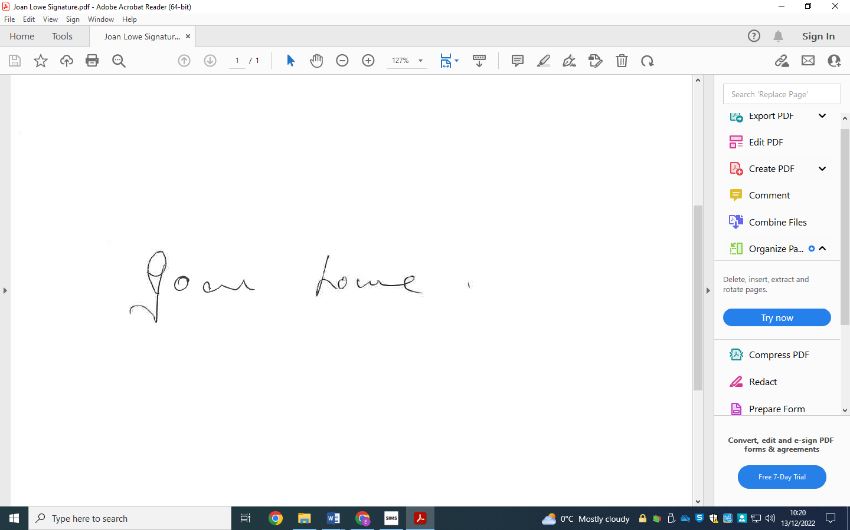

**Chair of Governors**

Date: 4th December 2024

The policy will be reviewed every **3 Years**

Date of next review**: Autumn 2027**

**Introduction**

At Ysgol Rhiwabon, our aim is to provide a welcoming, secure and safe environment, where students achieve the very best they can be. We recognise that the management of challenging behaviour can be a difficult and sensitive aspect of our work. Providing successful, inclusive education requires the need to support all staff and students to ensure that teaching and learning and student wellbeing is at the heart of all we do. Everyone in the school has a right to teaching, learning, social and extracurricular time which is not interrupted by poor behaviour.

# Positive Behaviour Principles

* Every student understands they have the right to feel safe, valued and respected, and learn free from the disruption of others
* All students, staff and visitors are free from any form of discrimination
* Staff and volunteers always set an excellent example to students.
* Rewards and sanctions are used consistently by staff, in line with the behaviour policy
* The behaviour policy is understood by pupils and staff
* The exclusions policy explains that exclusions will only be used as a last resort, and outlines the processes involved in permanent and fixed-term exclusions
* Pupils are helped to take responsibility for their actions
* Families are involved in behaviour incidents to foster good relationships between the school and students’ home life.
* The governing body emphasises that violence or threatening behaviour will not be tolerated in any circumstances.

The policy should be read in conjunction with the following documents:

* Substance Misuse Policy
* Attendance Policy
* Anti-bullying Policy
* Health & Safety Policy
* Restraint Policy
* General Appearance and Mobile Phone Guidelines (appended for information)

**Aims**

This policy gives a broad outline of the management of behaviour in Ysgol Rhiwabon. Good behaviour is essential to the learning process and helps students become responsible citizens. This policy specifically aims to;

* Outline **how students are expected to behave**
* Provide a **consistent approach** to behaviour management
* **Define** what we consider to be unacceptable behaviour, including bullying
* Summarise the **roles and responsibilities** of different people in the school community with regards to behaviour management
* Outline our system of **rewards and sanctions**

**Legislation and Statutory requirements**

This policy is based on advice from the Department for Education (DfE) on:

* [Behaviour and discipline in schools](https://www.gov.uk/government/publications/behaviour-and-discipline-in-schools)
* [Searching, screening and confiscation at school](https://www.gov.uk/government/publications/searching-screening-and-confiscation)
* The Equality Act 2010
* [Supporting pupils with medical conditions at school](https://www.gov.uk/government/publications/supporting-pupils-at-school-with-medical-conditions--3)
* Welsh Government Guidance on exclusion formschools and pupil referral units.

N.B This will be updated termly.

**Policy Elements**

Definitions

Roles and responsibilities

Ysgol Rhiwabon 5 Golden Rules

Staff Training

Behaviour management

Student transition information

Monitoring arrangements

Rewards and sanctions

Bullying

Off-Site Behaviour

Malicious Allegations

Physical Restraint

Confiscations

Links with other policies

Appendix 2: Guidelines sent to parents and included in Student Planners

**Definitions**

**Rewards**

The following definitions provide guidelines about the types of behaviour that may need to be addressed by members of the school staff, although the list is not definitive. They also categorise behaviour into two main areas; misbehaviour and serious misbehaviour.

**Misbehaviour** is defined as:

* Disruption in lessons, in corridors between lessons, and at break and lunchtimes
* Non-completion of classwork or homework
* A poor attitude
* Incorrect uniform
* Defiance – refusal to follow the reasonable instructions of any member of staff.
* Rudeness, either to staff or fellow students.
* Use or sight of Mobile phones during the school day.

**Serious misbehaviour** is defined as:

* Repeated breaches of the school rules
* Any form of bullying, including any misuse of technology to cause hurt to another individual
* Sexual assault, which is any unwanted sexual behaviour that causes humiliation, pain, fear, or intimidation
* False allegations against a member of staff
* Vandalism
* Theft
* Fighting
* Vaping/Smoking
* Any Discriminatory behaviour e.g. Racist, sexist, homophobic, transphobic
* High levels of defiance
* Behaviour that poses a threat to another student or member of staff.
* Behaviour that could adversely affect the reputation of the school.
* Possession of any prohibited items. These are:
  + Knives or weapons
  + Alcohol
  + Illegal drugs
  + Stolen items
  + Vapes, tobacco, cigarette papers.
  + Fireworks
  + Pornographic images
  + Any article a staff member reasonably suspects has been, or is likely to be, used to commit an offence; something that has the potential to cause personal injury to a person or damage to property. Damage to property can include damage to personal belongings or the school building, or community property to and from school.
  + Misuse of technology, including mobile phones or school equipment to cause hurt and distress to others.

Students who are found in possession of a knife or weapon in school or supply, deal or sell drugs or similar substances in school may be excluded permanently. Police will be contacted as appropriate regarding any serious misbehaviours.

**Roles and Responsibilities**

**The Governing Body**

The governing body is responsible for reviewing and approving the Behaviour Policy annually.

The governing body will review this behaviour policy in conjunction with the headteacher and monitor the policy’s effectiveness, holding the headteacher to account for its implementation.

**The Headteacher**

The headteacher is responsible for adapting the policy and reviewing it regularly in conjunction with The Governing Body.

The headteacher will ensure that the school environment encourages positive behaviour, and that staff deal effectively with inappropriate behaviour. This will include monitoring how staff implement this policy to ensure rewards and sanctions are applied consistently and fairly.

**The Staff**

Staff are responsible for:

* Modelling positive behaviour
* Implementing the behaviour policy consistently
* Providing a personalised approach to the specific behavioural needs of students
* Recording behaviour incidents using the schools electronic tracking system (SIMS up to February 2025 and form then on using the BROMCOM System)

The Senior Leadership Team, Lead Learners and Curriculum Leaders will support staff in responding to behaviour incidents.

**Parents/Carers**

Parents are expected to:

* Support their child in adhering to the Ysgol Rhiwabon 5 Golden Rules
* Inform the school of any changes in circumstances that may affect their child’s behaviour
* Discuss any behavioural concerns with the school promptly
* Support the School in promoting good behaviour and addressing inappropriate behaviour
* Attend meetings when required to discuss the individual needs of the child.

**Student Code of Conduct (5 Golden Rules)**

Ysgol Rhiwabon have developed the ‘5 Golden Rules’ through its work with staff and students. It is expected that;

1. We will all treat each other with respect
2. We will all work hard to get the very best from each other
3. We will allow teachers to teach and students to learn without interruption
4. We will be safe in each other’s company and not fight or bully each other
5. We will care for and take pride in our school and local community

**Staff Training**

Our staff are provided with training on managing positive behaviour as part of their induction process.

Positive Behaviour management will also form part of CPD for all staff to ensure continued Professional Learning and Development, through the delivery of the Pivotal Curriculum. This will take place through each academic year.

**Behaviour Management**

**Classroom Management**

Teaching and support staff are responsible for setting the tone and context for positive behaviour within the classroom.

They will:

* Create and maintain a stimulating environment that encourages pupils to be engaged
* Display the ‘5 Golden Rules’ in their classroom
* Develop a positive relationship with pupils, which may include:
  + Greeting students at the start of lessons
  + Establishing clear routines
  + Communicating expectations of behaviour in ways other than verbally
  + Highlighting and promoting good behaviour
  + Concluding the lesson positively and starting the next lesson afresh
  + Having a plan for dealing with low-level disruption (detailed above)
  + Using positive reinforcement including praise and achievement points
  + Using supporting material in all classes as they are developed to promote consistency e.g. THINK Poster Appendix 3

**Student Transition Information**

To ensure behaviour is continually monitored and the right support is in place, information related to student behaviour issues may be transferred to relevant staff at the start of the term or year. Information on behaviour issues may also be shared with new settings for those students transferring to other schools.

**Monitoring Arrangements**

Lead Learners review behaviour with Senior Managers during line management meetings.

Curriculum Leaders review academic progress and any relevant behaviour issues with the Senior Line Manager.

It is part of the Governing Body's role to monitor the behaviour in the school. The Headteacher reports all exclusions in the termly report to Governors. In addition, it is the role of the Students' Committee of the Governing Body to consider the school's Behaviour Policy and make recommendations if it wishes to do so. It also receives details of all exclusions termly, for review. The Students' Disciplinary Committee hears appeals against Fixed Term or Permanent Exclusions to ensure the Headteacher is upholding school sanctions appropriately, following due procedure as set out in The Welsh Government Guidance.

This behaviour policy will be reviewed by the headteacher and Governing Body annually, in consultation with staff and students. At each review, the policy will be approved by the Governing Body. In addition, the Parent/Carer Guidance (Appendix 1) will be reviewed and approved by the Governing Body annually.

**Rewards and Sanctions**

The following provides guidance on the operation of rewards and sanctions at Ysgol Rhiwabon.

The aim of a rewards policy is that students' achievements should be recognised, supported, and rewarded as part of their personal development.

The school has developed its own behaviour monitoring and tracking system which acknowledges those who present good levels of behaviour as well as monitoring those students who require further support or intervention to ensure that their behaviour follows the 5 Golden Rules.

Positive behaviour will be rewarded with:

* Praise
* Achievement points
* Feel Good Friday Post Cards
* Letters or phone calls home to parents
* Bronze, Silver, Gold and Platinum certificates and linked rewards

The school may use one or more of the following sanctions in response to unacceptable behaviour:

* A verbal reprimand
* Behaviour Points
* Using the schools four tier system in lessons (1. Verbal warning not recorded, verbal warning recorded, teacher consequence issued, relocation from lesson)
* Sending the pupil out of the class (2 mins and return)
* Relocation from the lesson
* Expecting work to be completed at home, or at break or lunchtime
* Detention at break or lunchtime, or after school
* Referring the pupil to an appropriate member of staff
* Letters or phone calls home to parents
* Meeting with parents
* Form Tutor and Lead Learner Reports
* IBP and PSP support plans

We will make use of our **Student Reflection and Support System (SRS)** in response to serious or persistent breaches of this policy. This would involve the need for students to be removed from their normal timetables and follow the SRS timetable, where they will be expected to complete the same or similar work as they would in class while supervised. The aim of this is to provide supervised time for students to reflect on their behaviour in a positive way and to complete work in a quiet, calm, and supervised environment. During this time students will be supervised by senior staff in the school canteen during break and lunchtime.

Pupils who refuse to attend more minor consequences such as break, or lunchtime detention may also be booked into SRS for persistent defiance.

If such serious behaviour is repeated, it is likely to lead to a fixed term exclusion. Persistent behaviour of this nature, which affects the smooth and safe running of the school may lead to permanent exclusion.

**Bullying**

Bullying is behaviour by an individual or group, usually repeated over time, that intentionally hurts others either physically or emotionally.

Bullying is expressed through a range of hurtful behaviours: it can happen face-to-face or in the digital environment. It can be carried out by an individual or group but is generally executed in front of an audience to assert power or popularity. It may involve an element of secrecy so that adults are not aware of it.

**Bullying is meant to hurt** – the person or people doing the bullying know what they are doing and mean to do it.

**Bullying often happens more than once** – usually there will be a pattern of behaviour, not just a ‘one-off’ incident.

**Bullying involves an imbalance of power** – the person being bullied will usually find it

very hard to defend themselves.

Details of our school’s approach to preventing and addressing bullying are set out in our separate anti-bullying policy.

**Off Site Behaviour**

Sanctions may be applied where a student has misbehaved off-site when representing the school, such as on a school trip or on the journey to or from school.

**Malicious Allegations**

Where a student makes an accusation against a member of staff and that accusation is shown to have been malicious, the headteacher may impose an appropriate sanction in accordance with this policy.

Please refer to the WCBC Safeguarding and Child Protection Policy for more information on responding to allegations of abuse.

**Physical Restraint**

This policy takes due regard of the Welsh Government Circular 041/2010 – “Safe and Effective Intervention – use of reasonable force.” At Ysgol Rhiwabon we follow the principles and recommendations set out in this guidance. Our aim is to create an environment in which the use of force in relation to a pupil is unlikely and situations are diffused before it becomes necessary.

**Confiscation**

Any prohibited items (listed definitions, serious misbehaviour) found in students’ possession will be confiscated. These items may not always be returned to students. The police will be contacted as appropriate.

We will also confiscate any item which is deemed harmful or detrimental to the smooth running of the school or that contravene school rules e.g. mobile phones. These items will be returned to pupils after discussion with senior leaders and parents, if appropriate.

Searching and screening students is conducted in line with the DfE’s [latest guidance on searching, screening and confiscation](https://www.gov.uk/government/publications/searching-screening-and-confiscation).

**Student Support**

The school recognises its legal duty under the Equality Act 2010 to prevent students with a protected characteristic from being at a disadvantage. Consequently, our approach to challenging behaviour may be differentiated to cater for the needs of the student.

Invariably when students' behaviour falls below the school's expectations, pastoral staff provide guidance to promote improvement. If appropriate, external support services may be called upon to provide counselling and specialist advice. The school makes every effort to enable all pupils to succeed. However, the Governing Body's priority is to ensure, by supporting the effective use of the range of rewards and sanctions available to the school, that successful teaching and learning is promoted and always safeguarded.

The school’s ALN co-ordinator will evaluate a student who exhibits challenging behaviour to determine whether they could possibly have any underlying needs that are not currently being met.

Where necessary, support and advice will also be sought from specialist teachers, an educational psychologist, medical practitioners, and/or others, to identify or support specific needs.

When acute needs are identified in a student, we will liaise with external agencies and plan support programmes for that child. We will work with parents to create the plan and review it on a regular basis.

**Links with other policies**

This behaviour policy is linked to the following policies:

* Exclusions policy
* Safeguarding policy
* Anti-bullying policy

**Appendix 1**

These guidelines are sent to parents annually and form part of the student planners.

**General Appearance**

Like any reasonable organisation we allow no extremes of appearance at Ysgol Rhiwabon. Jewellery is limited to a watch, **one** plain ring and **one** pair of plain gold or silver studs in pierced ears. **No other facial piercings are allowed.** Similarly, we do not permit extreme hairstyles. Whilst I am aware that fashions change, and that yesterday's extreme is tomorrow's normal hairstyle, it should be noted that unnatural colours, 'tram lines' cut into hair, and similar marks or cuts made with hair trimmers, shaved heads or long Mohicans and stripes or bands of colour are considered an extreme of hairstyle unsuitable for school. Excessive make-up (including coloured nail varnish) is also considered unsuitable for school.

Uniform and general appearance will be monitored by staff and in the case of any potential conflict the school Leadership team will be the final arbiter.

**Personal belongings**

Mobile phones – whilst we accept that students will want to have a phone for potential emergencies on the way to and from school, they are to be out of sight, switched off and kept in a bag. If the school policy is not followed, students’ phones will be confiscated for the day. We ask that parents refrain from texting or calling their child during the school day. Urgent messages can be taken by the school office and be dealt with immediately.

All other electrical equipment should be left at home to avoid loss or unnecessary disruption to lessons. This includes earphones which are often attached to mobile phones thus preventing students from hearing instructions which may be vital to their safety.

Students who contravene the uniform and appearance, mobile phone and electrical equipment polices will be asked to take items to the office for safekeeping.

At the end of the day students can reclaim their property.

On the rare occasion when students continue to contravene the policies, parents will be contacted and asked to collect the items from school.

In addition to the above guidance, serious misuse of mobile phones/electronic equipment may lead to other school sanctions including exclusion from school and/or police involvement.

**Appendix 2**

