Ruabon News Letter 418
04.04.2022
PRESS RELEASE
Ken Skates MS | Clwyd South
30/03/22

MS wants internationals to return to
Wrexham’s Racecourse Ground

A Member of the Senedd has called for international football to return to Wrexham.

Ken Skates wants the town’s Racecourse Ground back on the world stage – and says the Reds’ ‘sensational’ comeback win at the weekend shows its more than up to the challenge.
The famous victory – which was even raised in the Senedd yesterday (Tuesday 29th March).

Mr. Skates, a Wrexham AFC season ticket-holder, said to Trefyndd and Wrexham MS Lesley Griffiths: “Saturday's National League match at the Racecourse was a phenomenal event. You and I were both present at it, along with almost 9,000 spectators. And it once again demonstrated how the world's oldest international football stadium can host dramatic and sensational events.

“Would the Government commit to pressing for the return of international matches to the Racecourse as soon as possible?”
Ms Griffiths responded: “The match on Saturday was absolutely extraordinary – I’m still smiling. In my 50 years of attending the Racecourse, I've never seen anything quite like it.

“I think you make a really important point. As a child, that's where I went to watch international matches. I know the new chief executive at the Football Association of Wales is very keen to see games played at the Racecourse.”

Ms Griffiths, a fellow Reds season ticket-holder, added: “I think it's very important for us in north Wales that those games are played, even if they're only friendly games, in the coming years. So I'm sure the Deputy Minister for Arts and Sport will certainly continue to press that with the Football Association of Wales.”

Mr Skates, MS for neighbouring Clwyd South, also highlighted the ‘huge amount’ of funding the Welsh Government has committed to the Wrexham Gateway project – which includes redeveloping the Racecourse’s famous Kop stand.
He said: “Just across from the Racecourse – indeed, part of the Racecourse – is included in the Wrexham Gateway project, to which the Welsh Government has already committed a huge amount of money. Although we've been promised levelling-up funding from the UK Government, this is yet to materialise.

“Would you be able to make a statement on whether you believe the UK Government is in a position to fund this vitally important regeneration project, or is it just warm words that we're hearing?”
Ms. Griffiths responded: “Unfortunately, despite the UK.
Government's promise we wouldn't lose a penny less if we left the European Union, that's not the case. And the funding that is available to the UK Government is much less than had we remained in the European Union.

“I think it’s really vital that the UK Government work with the Welsh Government, and other devolved governments, around the levelling-up fund. It’s got to be a genuine partnership if it's going to work. So I think it's really important that we do see that funding.
-Ends-

Ken Skates MS welcomes funding to
kick-start free school meals for all primary school children
Ken Skates has welcomed the announcement from the Welsh Labour Government that it will be investing £25m in school kitchens and dining facilities, as part of its plans to roll out free school meals to all primary school children.

From September, some of the youngest children in primary schools will begin receiving free school meals as the policy is introduced in a phased way.
Working with schools and local authorities, the Welsh Government will plan and prepare the infrastructure needed for all primary aged pupils to receive free school meals by September 2024.

Revenue funding of up to £200m has been set aside for local authorities to deliver the commitment, with £40m to be provided in 2022-23; £70m in 2023-24 and £90m in 2024-25.

Welcoming the funding, Clwyd South MS Ken Skates said: “I am committed to ensuring that no child in Clwyd South should go hungry and that every child in our primary schools will be able to have a free school meal.
“We are facing an unprecedented cost-of-living crisis. The Welsh Government knows younger children are more likely to be living in relative income poverty, which is why the youngest of our learners will be the first to benefit.
“This cost-of-living crisis is already being felt by families in Clwyd South. Extending free school meals is one of a number of measures the Welsh Labour Government is taking to support people through this difficult time.”

The policy is part of the Co-operation Agreement between the Welsh Government and Plaid Cymru, and will see free school meals extended to all primary school pupils over the next three years.
-ENDS-

WREXHAM CARNIVAL OF WORDS 2022

WREXHAM’S OWN LITERARY FESTIVAL
A highly entertaining programme has been put together for one of Wales’ premier literary festivals. The Wrexham Carnival of Words is now in its 8th year and has become a fixture in the literary calendar in Wales and the borderlands attracting a diverse range of well-known authors. The organisers are very pleased that live audiences will be back for this year’s festival being held between 22nd and 30th April.
Among the many authors highlighting the 2022 Carnival will be Sunday Times bestseller Milly Johnson, one of the Top 10 Female Fiction authors in the UK and the ever-popular Gervase Phinn, best known for his warm-hearted reminiscences as a school inspector in the Yorkshire Dales.
Also appearing this year will be enthralling crime writer Mark Billingham, Simon McGleeve whose book The Snowdonia Killings attracted huge popularity and Kate Ellis who will put in a special appearance at the ever-popular Murder Mystery event.
History fans will not want to miss Barbara Erskine, the queen of the time-shift genre and historical fiction giant Patricia Bracewell who is flying in from the USA especially for the Carnival. Local author Peter Evans will share his journey up the river Dee whilst Chris Clode will share his passion for the north Wales slate quarries, now a UNESCO World Heritage site.
Matthew Hall, who created and wrote the popular television series Keeping Faith and Kavanagh QC, will talk about his life in crime and former government minister Alan Johnson returns to this year’s Carnival to discuss his new book The late Train to Gipsy Hill which is his first thriller. Also appearing at the Carnival will be Sarah Hilary, whose debut novel won the Theakston’s Crime Novel of the Year prize, and award winning short-story writer Carys Davies.
There will be Welsh-language events with up-and-coming your poets Iestyn Tyne and Elan Grug Muse and Bethan Gwanas, the author of over 40 books in Welsh, who will talk about her latest book, co-written with her dog!

Deliverance describes the everyday investigations into poltergeists, ghosts and supernatural phenomena undertaken by the Revd. Dr Jason Bray, Vicar of St Giles Parish Church, the first Anglican deliverance minister to write about his experiences.

Local writers and budding authors will be able to attend a free event to meet other local authors, poets, bloggers, journalists and songwriters and participate in the active panel sessions. Viva Voce is an open mic for local poets to share their work and be entertained by their peers. There will even be a readathon by local book-lovers of George Eliot’s classic novel Middlemarch.

Families are warmly invited to a free event at Yellow & Blue in Henblas Square where children’s storytellers, Jacqui Bloor, Fiona Collins, Jude Lennon, Krishnapyia Ramamoorthy and Sarah Parkinson will be holding “Storytelling for All the Family” on Saturday 24th April.

Festival Director Dylan Hughes has said: “this year’s Carnival is back with a bang with an exciting and varied programme of events, and we’re so pleased to be able to invite live audiences back to see authors and poets in person”.
The programme of events is at: www.wrexhamcarnivalofwords.com.
*****************************************

Tales From Terracottapolis
Wrexham’s considerable contribution to the story of brick, tile and terracotta manufacture forms the foundation for this exhibition.
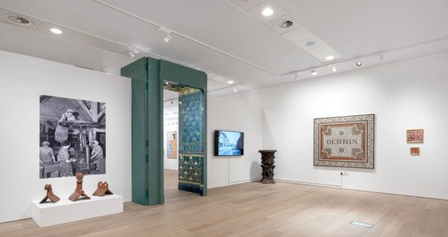
From mid-19th Century up to as late as 2008, Wrexham was known world-wide for its manufacture and international distribution of bricks, tiles and terracotta products.
Nicknamed ‘Terracottapolis’, Wrexham produced distinctively red bricks and decorative tiles that have been used extensively in some of the grandest buildings across the British Isles.
The exhibition utilises artefacts from Wrexham Museum’s collection. These items are accompanied and complemented by contemporary works of art from local practitioners.
A highlight from the exhibition is ‘The Brick Man’ by Antony Gormley, creator of the Angel of the North sculpture in Gateshead.
The Brick Man comes to Wrexham
The Brick Man is a 6ft model for a proposed 120ft tall sculpture that was selected from a competition for an inner-city site at the Holbeck Triangle near Leeds City Station in the late 1980s. The full-scale sculpture was never realised after it ran into objections from city planners. The model and archive for the project in the collection of Leeds Museums and Galleries are now all that remains.
Accompanying the model is archive material from the planning stages of the sculpture. This includes letters and press cuttings that offer a fascinating insight into the public reaction and conversations that took place around the original proposals.
The loan of ‘The Brick Man’ from Leeds Museums & Galleries is supported by the Weston Loan Programme with Art Fund. Created by the Garfield Weston Foundation and Art Fund, the Weston Loan Programme is the first ever UK-wide funding scheme to enable smaller and local authority museums to borrow works of art and artefacts from national collections.
Plan your visit
- Tales from Terracottapolis will be on show from 19th March – 11th June.
- Gallery opening times: 10am-4pm, Monday-Saturday.
Tales From Terracottapolis is a partnership project between Tŷ Pawb and Wrexham Museum and Archives.
The exhibition is supported by the Arts Council of Wales, Wrexham County Borough Council, Leeds Museums and Galleries, Henry Moore Institute’s Archive of Sculptors Papers, the Garfield Weston Foundation and Art Fund.
************************

Wrexham Autism Aware
We will be posting a series of blog posts about the work in our communities to make Wrexham Autism Aware, as well as highlighting the information and support that is available to people and families living with autism.
“Your Space” is a registered charity that works closely with Wrexham Council to provide support for young adults and children on the autism spectrum along with their families.
With events and activities including a teens club, expressive arts, family days out and holiday clubs there is lots to get involved with. You can find out more about the range of activities and support that Your Space offers by visiting their website:
Your Space – Supporting Children and Young People with Autistic Spectrum Conditions (yourspacemarches.co.uk)
********************************
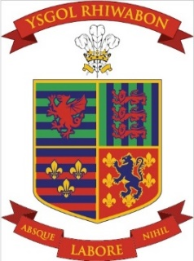
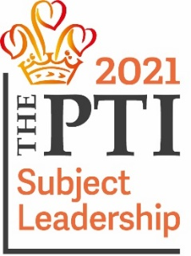
Many thanks for the following four pieces of information from Giles Evans,
Business Manager, Ysgol Rhiwabon.
Ysgol Rhiwabon - Science
This term, Year 7C have been studying the solar system. As part of their project they've calculated the relevant distances of the planets and plotted them on the school field. They also created their own personal mnemonic for remembering their order.
Afterwards in groups, they were allocated a planet and worked had to research using textbooks and Chromebooks. They created presentations which they delivered to the whole class - teaching other students about their planet.
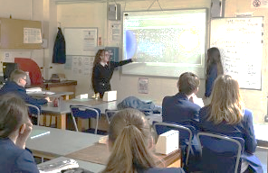
All groups were extremely successful, and they were then presented with a certificate by Mr Callum Edwards as “Mission Accomplished!"
***********************************
Please find below the YouTube information to watch Ysgol Rhiwabon’s performance for The Eistedfodd
https://youtu.be/WCkrGGJNzoQ https://www.ysgolrhiwabon.co.uk/

***********************

Newtown AFC –
Academy Trials 2022-2023
If any players are interested, please scan the QR code on the flyer, using the camera on their phones, and all training details plus a registration form will upload for them to complete.
Download flyer
If you have any queries, please email:
academy@newtownafc.co.uk

There are spaces left for “The Easter Football Day”
************************
Magi Ann visits the library
Magi Ann is fast becoming a favourite character among Welsh children across the country.
Generations of children from Clwyd and beyond have learned to read with the black and white Magi Ann books since the 70s, but today her stories are available for free, and animated on six exciting apps. The apps have now been downloaded over 200,000 times, and Magi Ann’s calendar remains full to the brim with visits at events and eisteddfods all over the country!
Magi Ann will be visiting Chirk Library: 10.30-11.30am, Ruabon Library: 1.15-2.15pm on Monday 11th April, Wrexham Library, 10.00-11.00 and Coedpoeth Library, 2.30-3.30pm on Wednesday 20th April.
We look forward to seeing you!
**********************************
LLyfrgrell Rhiwabon / Ruabon Library
High Street, Ruabon, LL14 6NH
01978 822002
ruabon.library@wrexham.gov.uk
Opening Hours
Monday 12.00pm – 5.00pm
Tuesday Closed
Wednesday 12.00pm – 5.00pm
Thursday 9.00am – 1.15pm
Friday 12.00pm – 5.00pm
*******************
1.Gwau a Sgwrs
2. Dydd Gwener 2pm–4pm
Knit and Natter
Fridays 2pm – 4pm
*************************
Grwp Sgwrsio
Dydd Llun 2pm – 3pm
Welsh Second Language Conversational Group
Mondays 2pm – 3pm
******************
Stori a Chân
Dydd Llun 1:15pm
Story and Rhyme
Mondays 1.15pm
****************************
The Ruabon Readers
Reading group
Meet on the last Wednesday of the month,
from 2-3pm.
Old and new members
are warmly welcome!
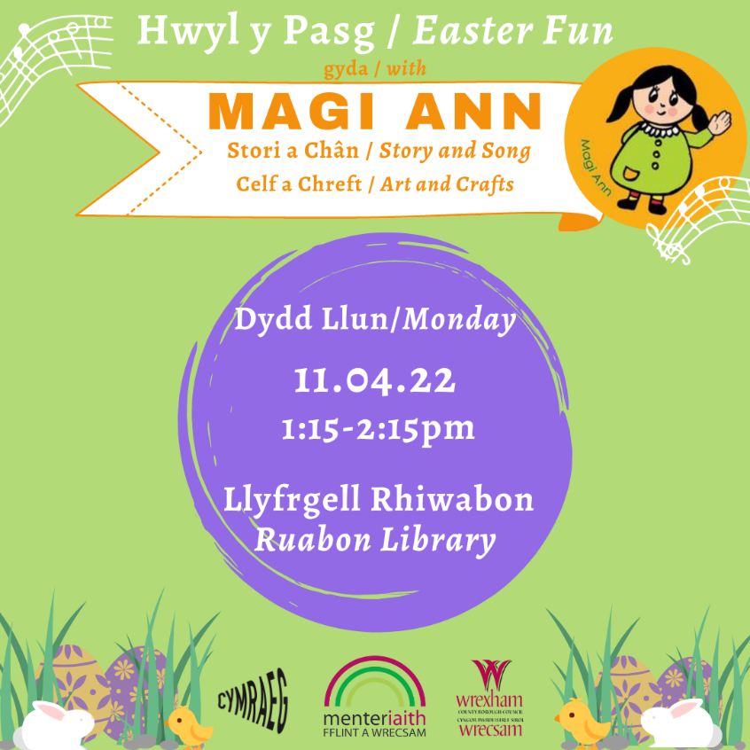

Wrexham Library

Learning at Lunchtime
With energy bills rising there has never been a better time to review your household bills. Join us for this special Learning at Lunchtime at Wrexham Library on Wednesday 6th April, 1-2pm. An energy specialist from Groundworks will be leading the session advising you on how to reduce your costs. For more details call Nerys on 01978 292090

Wrecsam2025 Events

To celebrate Wrexham’s City of Culture 2025 bid why not join us for story times over Easter with storytellers Jacqui Blore, Jude Lennon and Sarah Parkinson. Between them they will be bringing their own special magical stories to all libraries across Wrexham. For more details phone your local library – details can be found at www.wrexham.gov.uk/libraries Sessions will be suitable for young children under 5.

Easter activities at Wrexham Library
Book your places for some free fun activity sessions at Wrexham Library this Easter! There will be Easter Craft session on Wednesday 13th and 20th April, 1-2pm (suitable for children aged 5+); plus we have several story times across the fortnight with professional story teller Jacqui Blore on Thursday 14th April, 10.00am and Magi Ann the popular children’s Welsh character visiting on Wednesday 20 April at 10.00am. Throw into the mix our regular story times for children on Thursday afternoons 2-2.30yp and Friday mornings 10-10.30am and you have a full holiday taken care of. To book your place on the craft sessions please call the library on 01978 292090.
*********************************
Children, young people and volunteers joined together to create new art work to brighten up child health clinic rooms at Wrexham Maelor Hospital.
The volunteering day, held at Wrexham Child Health Centre, was run in partnership between Betsi Cadwaladr University Health Board’s Child and Adolescent Mental Health Services (CAMHS), and Senedd yr Ifanc, run by Wrexham County Council.
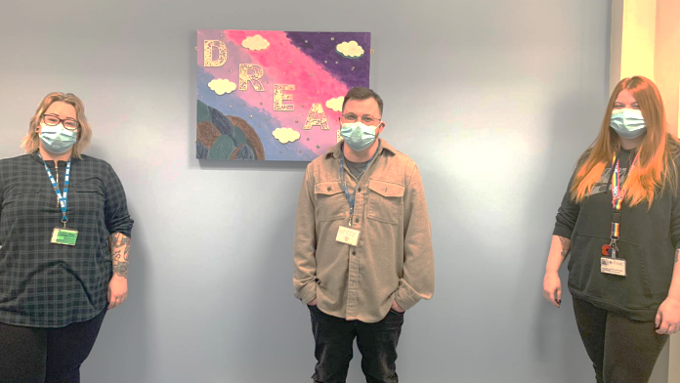

The volunteers’ new art works have been hung up along new freshly painted feature walls in the Child Health Centre’s clinic rooms.
Senedd yr Ifanc is Wrexham’s Youth Parliament, and is made up of young people aged 11-25 who work on the issues that matter to the young people of Wrexham.
The event is part of a wide range of activities being run following feedback from young people. A focus group was created to hear young people’s opinions of the CAMHS environment and what they would suggest to improve the service for the children and young people attending appointments.
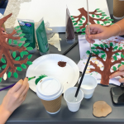
The survey, led by Senedd yr Ifanc, reached a total of 947 children and young people aged 10-25, who lived, worked, socialised or were educated in Wrexham.
Following a report being published in April 2021, CAMHS and the Senedd yr Ifanc have taken a number of actions forward, including improvements to the webpages, clinic rooms, outdoor areas, information and resources for children and young people.
Wendy Pinder, Head of Nursing for Children and Young People, East CAMHS, Neurodevelopmental Services and Learning Disabilities, said: “It was a pleasure to spend the day volunteering with other organisations, along with the children and young people who use our services, creating some art work to improve and add some colour to the clinics. It was such a positive experience for everyone involved, and I’m looking forward to continuing to hold activity events like this in the future.
“Following the feedback we’ve received from the 2021 report, we have developed an action plan which is ongoing and we will continue to implement recommendations.”
CAMHS focus on helping children and young people who experience emotional, behavioural and other psychological difficulties. CAMHS supports families and their children from birth to 18 years and is staffed by multi-disciplinary teams which include CAMHS Practitioners, Nurses, Child Psychiatrists, Clinical Psychologists, and other professionals who work with children and young people.
Caroline Bennett, Participation Coordinator for the Senedd yr Ifanc, said: “It was a lovely session and great to see the young people’s creative sides produce two fantastic pieces of art work. It’s encouraging to see the results of the Senedd yr Ifanc’s consultation and the voice of Wrexham young people start to take shape, thank you to all the staff and young people involved, looking forward to the next volunteering day.”
******************************

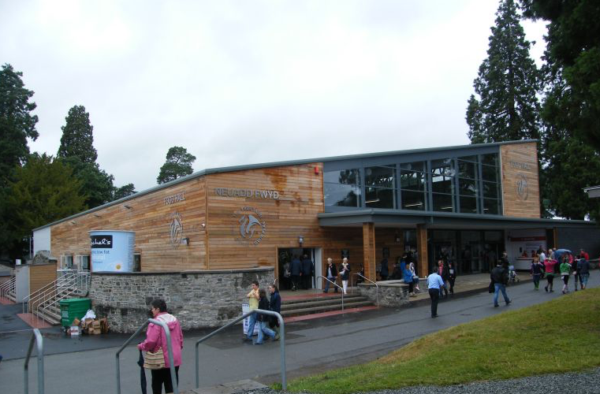

Celebrating Rural Wales #celebratingruralwales

Wales Rural Network's first 'physical' event since 2019

Collaborative Working for a Sustainable Future
Welcome to another edition of our 'Celebrating Rural' newsletter, it's been a while since the last one but we're back, celebrating more fantastic projects supported by the European & Wales' Rural Development Programme.
In this edition we are looking at the importance of sustainability and ways we can protect and manage the beautiful natural resources we have in Wales.
The Sustainable Management Scheme (SMS)

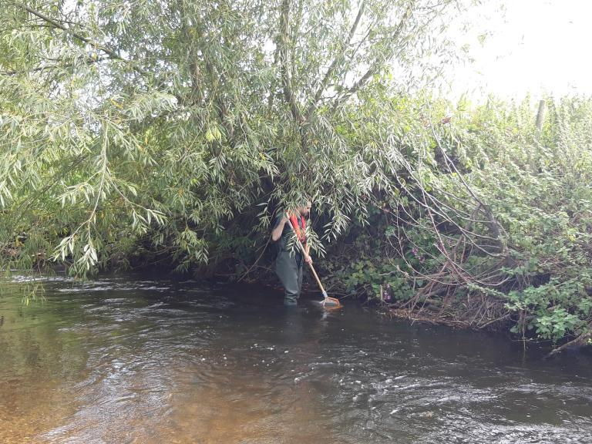
Plans are well underway, contacts have been made and specialist Panel Members are being secured.
Make sure you have one or both days firmly blocked out to attend this celebration event, showcasing the many (and there are thousands) successful projects that have received funding through this Programme.

Collaborative Working for a Sustainable Future
Welcome to another edition of our 'Celebrating Rural' newsletter, it's been a while since the last one but we're back, celebrating more fantastic projects supported by the European & Wales' Rural Development Programme.
In this edition we are looking at the importance of sustainability and ways we can protect and manage the beautiful natural resources we have in Wales.
The Sustainable Management Scheme (SMS) supports direct action on managing natural resources across Wales delivering against the approach and principles laid down in the Environment (Wales) Act 2016 & the Well-being of future Generations (Wales) Act 2015.
The purpose of the scheme is to support collaborative landscape scale projects delivering nature-based solutions to improve the resilience of our natural resources and ecosystems in a way that also delivers benefits to farm businesses and the health and well-being of rural communities.
SMS projects are undertaking actions to enhance biodiversity, improve green infrastructure, sustain better land and water management and importantly, facilitate climate change adaptation and mitigation at landscape scale, through collaborative partnerships.
These collaborations include land owners,farmers and graziers who have seen the benefits working together can bring and have been inspired to work with new and traditional methods.

Rural Development Programme 2014 - 2020 other 'Sustainability of our Natural Resource' Schemes
The Environment and Climate Change is on everyone's mind and Sustainability is key to this cross-cutting theme.
in addition to the Sustainable Management Scheme (SMS), the following funding streams also consider these issues.
Farming Connect - An enhanced programme is providing support which is transforming the business prospects of thousands of farmers and foresters.
EIP Wales - EIP Wales is providing funding to 46 projects from across Wales which are trialling innovative techniques and technologies at a practical level within farming and forestry businesses.
*************************

I wondered
where The
‘Knife Angel’
statue had
been taken.

This magnificent statue is now in the Spitfire Gallery, City Centre, Stoke on Trent.

The Knife Angel has travelled to the 19th host location on the National Youth Anti-Violence Educational Tour and Programme and is on display in Stoke on Trent throughout April.
Organised by Staffordshire Police and Stoke on Trent council, in line with their Ditch the Blade campaign, a civic launch event was held on Saturday 2 April to kickstart the hosting.
The Knife Angel can be visited in Smithfield throughout April, when there will be extensive workshops and initiatives held throughout the hosting period. Stoke on Trent have also arranged for two knife banks to be situated in the city, one with the Knife Angel and one located at Hanley Police and Fire station. Sybil (Bremner).

