RUABON NEWS LETTER 414
07.03.2022
The Planning of the Queen’s Jubilee Celebrations for Ruabon has begun!

Friends of Ruabon will work with the Community Council this year to produce a SPECIAL Summer Fete for the occasion.

As usual the event will take place on the recreation ground behind the Village Hall and the Sports Pavilion – on Saturday 4th June 2022.

Hopefully, there will be a large marquee, (depending on funding) but space will still be limited, so those that would like a stall inside will have to book a place quickly.
The price will be £5. for all stall holders, those outside will need to be prepared for bad weather and bring their own gazebos.
To book a stall please send an email to: <sarahmather13@btinternet.com.

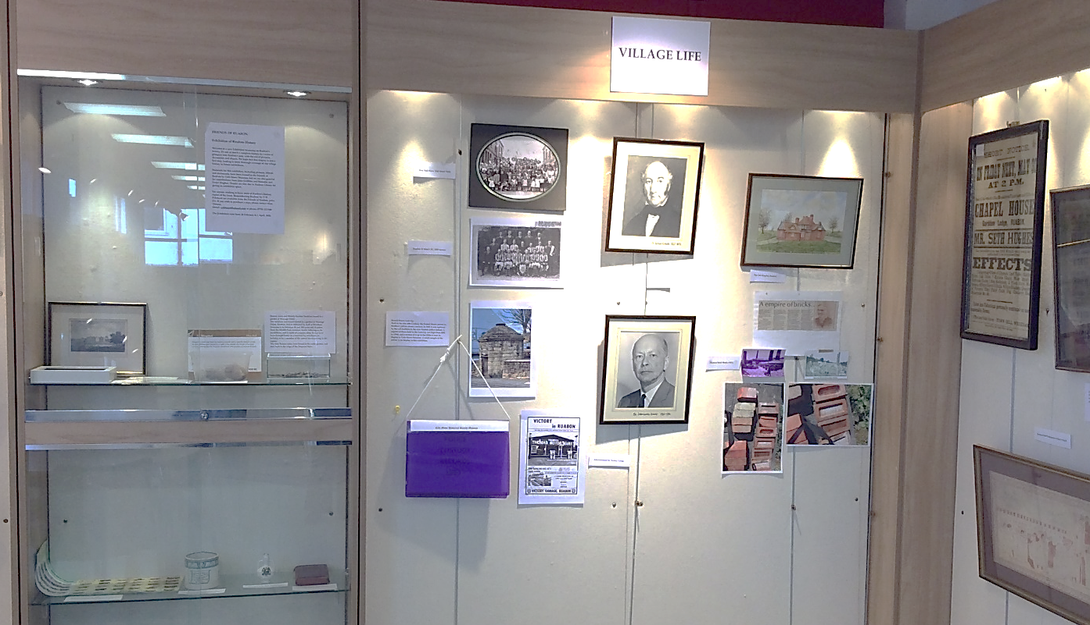
THE FRIENDS OF RUABON
EXHIBITION at RUABON LIBRARY
Set up by Alan Tiltman, who also works with Cefn Museum.
MANY photos and pieces of information
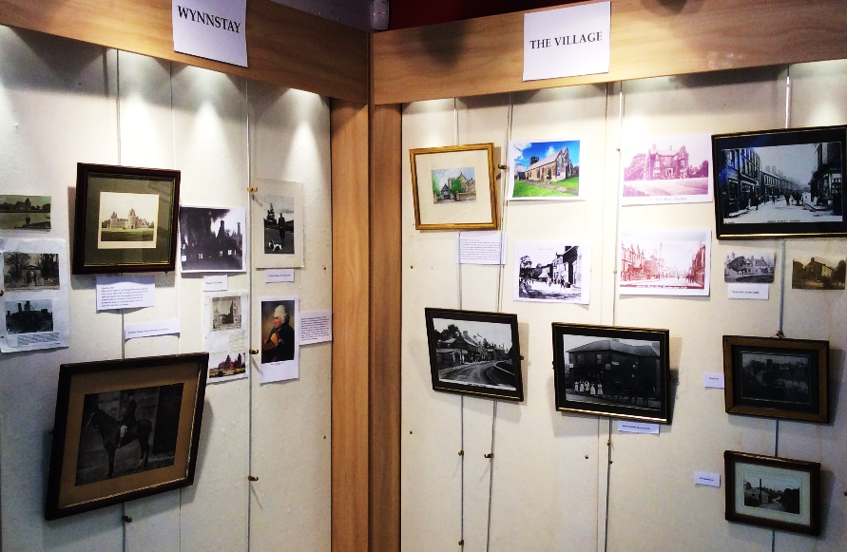
about the village. Photos kindly taken by Rachel.
LLyfrgrell Rhiwabon / Ruabon Library
High Street, Ruabon, LL14 6NH
01978 822002
ruabon.library@wrexham.gov.uk
Opening Hours
Monday 12.00pm – 5.00pm
Tuesday Closed
Wednesday 12.00pm – 5.00pm
Thursday 9.00am – 1.15pm
Friday 12.00pm – 5.00pm
*******************
- Gwau a Sgwrs
- Dydd Gwener 2pm – 4pm
Knit and Natter
Fridays 2pm – 4pm
*************************
Grwp Sgwrsio
Dydd Llun 2pm – 3pm
Welsh Second Language Conversational Group
Mondays 2pm – 3pm
******************
Stori a Chân
Dydd Llun 1:15pm
Story and Rhyme
Mondays 1.15pm

THE FIELD CLUB
is to meet again on
Tuesday, March 15th
in the Church Hall at 2pm, when
Graham Greasley
Will give a talk on

“Thomas Telford”

Snapshot Sessions for Parents
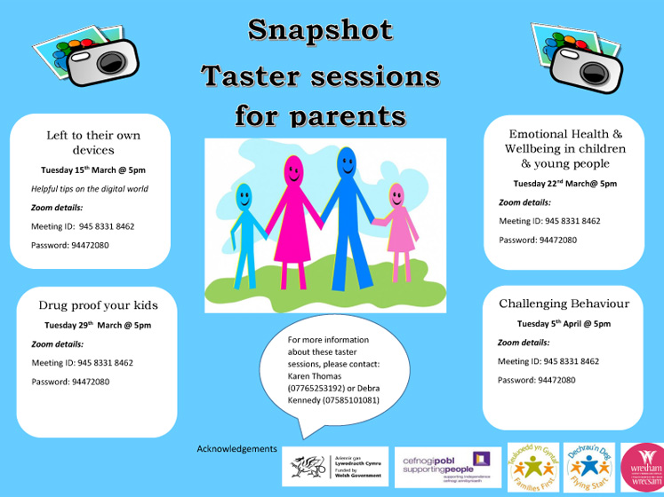
Information giving dates for the March and April Snapshot Sessions for parents: (Eng) and (Cym)

Engineering Apprenticeships With Network Rail
Friday, 4th March 2022
Network Rail are currently looking for Engineering Apprentices on their infrastructure.
This is a great opportunity to start a career with Network Rail, and upon qualifying individuals are guaranteed Technician role, which pays between £30,500 – £41,500 (depending on the discipline and location).
More details about the opportunity can be accessed through the link below:-
Level 3 Engineering Apprenticeship – Network Rail
Post navigation.
******************************

Apprenticeship Opportunities With BLK Sheep
Friday, 4th March 2022
Blk Sheep Baa & Grill have apprenticeship placements available in both catering and hospitality.
Blk Sheep Baa & Grill work closely with Coleg Cambria at both of their venues to provide full support in a work place environment, offering two year contracts for everyone who signs up for the opportunity.
WHAT YOU’LL RECEIVE
- 2 years hands on training, working full time in one of our award winning restaurants
- Industry qualifications in your chosen area of skill
- Additional courses and qualifications available, supported by Cambria for Business
- Flock Star 2 year training passport, trained and signed off in all areas of competence
- Workshops, supplier visits and training days by our hospitality experts
BENEFITS INCLUDE
- A guaranteed minimum 30-hour contract
- Hourly pay above the national apprentice salary rate, with hourly tips paid on top
- Paid annual leave
- Uniforms and meals on duty
- A professional chef knife set worth over £100 (catering apprenticeship)
- Dining out experiences from casual dining to Michelin star
- Trips to our suppliers so you can see the produce go from farm to plate
- Head office work experience days – so you check out what goes on behind the scenes
- Entry for employee of the week vouchers, worth £50 each week
- Annual staff parties
- A fun, friendly and safe working environment with lots of team activities
For more information:- Kim Britton, Bar & Grill HR Co-ordinator, hr@blksheep.co.uk, 01978 869 595 ext.111
************************************
Our students and staff are celebrating our best ever results at Key Stage 4 with a significant improvement, building on last year's success.
**************************

Success at Local Football Tournament.
Thursday, 3rd March 2022
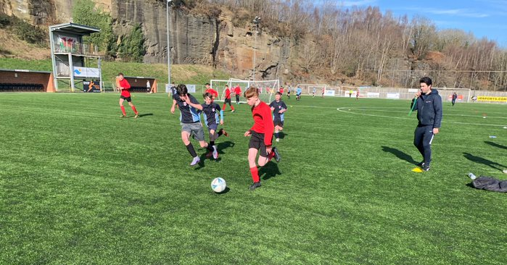
Ysgol Rhiwabon recently took part in a 7 a side tournament at the Cefn Druids FC ground, The Rock. The tournament was open to local secondary schools and was organised by Active Wrexham, with support from Cefn Druids.
Ysgol Rhiwabon sent a mixed Year 7 and Year 8 team to take part. The school team did really well with Tom Broadhurst getting player of the tournament for Year 8 and Kam Platt for Year 7.
Dyfan Roberts got player of the tournament for Year 9, who were up against mostly Year 10 teams.
Danny Lennon was also mentioned as a stand out player for Year 9.
Mr Joe Corless, Teacher of Sports, said ,
” The pupils represented the school really well. Their behaviour and sportsmanship was excellent and they were all a credit to the school and their parents. I think we all felt that it was nice to get out and about in such lovely weather. My thanks to Cefn Druids and Active Wrexham for organising the event”.
*********************

Comedy Night returns

Join us on Friday 11th March 2022 for an evening of stand-up comedy from some of the UK's best touring comedians!

This time our headliner will be Archie Kelly - as seen on TV (Phoenix Nights).

Archie Kelly
Ben Turner
Guy Black
Jonny Brook
Kevin Caswell-Jones (MC)

Tickets: £10 16+
To buy your tickets please go to: https://www.eventbrite.co.uk/e/noson-gomedi-ty-pawb-ty-pawb-comedy-night-tickets-261111540647?aff=MailingList
****************************

Welcome to Terracottapolis…

Introducing our next exhibition

Wrexham’s considerable contribution to the story of brick, tile and terracotta manufacture forms the foundation for this exhibition.
From mid-19th Century up to as late as 2008, Wrexham was known world-wide for its manufacture and international distribution of bricks, tiles and terracotta products.
Nicknamed ‘Terracottapolis’, Wrexham produced distinctively red bricks and decorative tiles that have been used extensively in some of the grandest buildings across the British Isles.
The exhibition will utilise artefacts from Wrexham Museum’s collection. These items will be accompanied and complemented by contemporary works of art from local practitioners.
A highlight of the exhibition will be “The Brick Man” by Antony Gormley, creator of the Angel of the North sculpture in Gateshead.
Read more on line
******************************

Freelance Opportunity: Wrexham Criw Celf and Portfolio Project Coordinator

Tŷ Pawb is looking to appoint an enthusiastic and organised freelance Project Coordinator to deliver the Criw Celf and Portfolio projects in Wrexham.

The fee is £8,250.This is fully inclusive of any travel and subsistence expenses. The fee has been calculated at £150 per day for 55 days – a day’s work consists of 7.5 hours. The role will run from the start of April 2022 to the start of September 2022.
Find out more: https://www.typawb.wales/freelance-opportunity-wrexham-criw-celf-and-portffolio-project-coordinator/
********************
Childcare Funding Application
Funding is available to apply for a variety of resources for your childcare setting. All types of childcare settings can apply for this grant, however settings must be registered with Care Inspectorate Wales (CIW)
Applications will be considered on a first come first served basis, this may lead to some applications not being appraised if the fund is fully committed.
All applications will be considered on an individual basis and payment of the grant is at the absolute discretion of the awarding body.
This grant funding is available for childcare settings based in Wrexham only
The deadline for applications is 12pm 14th March 2022
ICT resources for children
This funding can be utilised to purchase a range of quality ICT learning resources that will support children with their
Speech and language development
Literacy and numeracy
Problem solving skills
General wellbeing
If you have any queries with regard to eligible items please email childcareteam@wrexham.gov.uk
The funding award will be calculated dependent on the number of children your setting is registered to provide care for.
Registered for 10 children or less a maximum of £1000 per setting is available
Registered for 11-19 children a maximum of £1500 per setting is available
Registered for 20 + children a maximum of £2000 per setting is available
Childcare Offer ICT resources
This funding can be utilised to purchase ICT resources for staff to support with the effective operation of the childcare business e.g. laptops or desk top computers, printers, shredders etc.
If you have any queries with regard to eligible items please email childcareteam@wrexham.gov.uk
Please note: you cannot access this funding stream if you have received funding from WCBC within the last 2 years for ICT equipment for staff, or if your setting has access to ICT equipment through Early Education.
A maximum of £1000 per setting is available.
Resources for children
This funding can be utilised to purchase equipment that will support a child to access a childcare setting. This could include:
Car seats, Pushchairs, Buggy boards, Height adjustable tables and chairs. This list is not exhaustive, if you have any queries with regard to eligible items please email childcareteam@wrexham.gov.uk
A maximum of £1,000 per setting is available. https://wcbc-self.achieveservice.com/en/service/Childcare_Application_Funding
******************************
Excel Training 17th & 24th March,18:30 to 21:30,
via Microsoft Teams
These courses are designed to develop the learner’s skills with spreadsheet software and give them the tools necessary to produce professional spreadsheets.
The course will teach how to:-
● Create workbooks
● Open, Close, Save existing workbooks, Insert/delete sheets
● Entering Data
● Types of data
● Format Text and Numbers
● Rows & Columns
● Formulas and functions
● Using AutoFill
● Copy, Cut and Paste
● Print Option
- Excel Window Tour: Ribbon, Tabs, Groups, Formula Bar, Name Box, Number of Columns/Rows, Views: Cell Referencing system.
- Email: childcareteam@wrexham.gov.uk
Tel: 01978 292094
https://www.Facebook.com/WFISChildcareTeam
**********************
Please see below a message from:
Sandra Anderson, Swyddog Ymgysylltu / Engagement Officer. Bwrdd Iechyd Prifysgol Betsi Cadwaladr University Health Board. 07732415679 Sandra.Anderson2@wales.nhs.uk:
Pride Wrexham hosts their first LGBTQ+ conference as part of #Wrecsam2025. 'Welsh Queer, and Right Here'
is an exploration of the diversity of Welsh LGBTQ+ history, the resilience of the community in the present and the ambition of the community for the future.
Whilst at The Wrexham Enterprise Hub, Pride Wrexham will host a marketplace of local and national organisations from across Wales from social groups, youth groups and health initiatives. We will be joined by the panel of the top Welsh LGBTQ+ champions, academics, and activists to discuss the big questions facing Welsh society today. There will be opportunities to network, socialise and ask questions throughout the night. There will be cake and hot beverages available from 6pm to 10pm.
Tickets are free but please book through Eventbrite
**************************

Thank you Paul Tincello for the following information from NE Wales
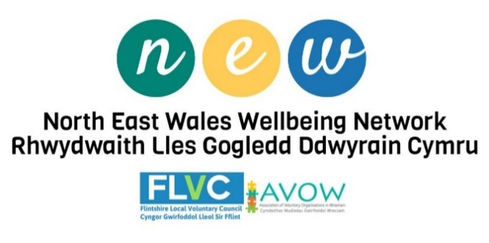
Ending Physical Punishment in Wales
21 March 2022 is a historic moment for children and their rights in Wales. From this day on, physically punishing children will be illegal in Wales.
Find out more about ending physical punishment in Wales, go to https://gov.wales/ending-physical-punishment-children
****************************
Childcare Offer extended as providers receive funding boost
The Childcare Offer will be extended to parents in education and training and parents on adoption leave, the Welsh Government has announced.
From September, parents in education and training and parents who are on adoption leave, if it is in line with the child’s Adoption Support Plan, will be eligible for up to 30 hours of government funded early education and childcare for children aged three and four.
********************************
Initiative launched to assist community centres/clubs
My name is Kimberley and I work for Calon Hearts, a registered charity who specialises in the supply of Defibrillators, related equipment, and training across Wales.
Recent tragic Cardiac Arrest events involving professional sports persons at the peak of their physical fitness, has highlighted the fact that Cardiac Arrest can happen to ANYONE of any age, ANYTIME, ANYWHERE!
If an adult or a child goes into cardiac arrest, without a defibrillator, there is only a 7% chance of survival. If a defibrillator is on the patient within the first 3-5 minutes, the chance of survival is over 70%.
We have therefore launched an initiative to assist community Centres/clubs in Wales to obtain this life-saving equipment. We are currently offering an increased grant of £300 towards the cost of every Defibrillator we supply. Importantly we also provide free online Defibrillator awareness training.
Equipment is available now and can be with you in a matter of days.
To proceed in obtaining a Defibrillator simply complete our short online application to receive a quote via the following link: https://calonhearts.org/apply-for-a-defib
If you have any queries or wish to discuss obtaining a Defibrillator, please contact myself via email: kym@calonhearts.org or telephone 02922 402 670 in Wales to obtain life-saving equipment
************************
Centre for Digital Public Services Inclusion Survey
The Centre for Digital Public Services has been commissioned by the Welsh Government Office of the Chief Digital Officer to create a single directory containing information about what organisations are doing to support digital inclusion across Wales.
This survey asks about what digital inclusion activities your organisation is currently running, has run in the past two years, or is planning to run. This information will then be entered into our directory. The purpose of the directory is two-fold:
- To understand what is happening across Wales, including visualising this as a geographic map of activities, to guide future government policy on digital inclusion
- To help organisations supporting digital inclusion and the people benefitting from their support to find out what else is happening, enabling knowledge sharing and opportunities for joined-up working.
We are striving to collect as much information as we can, to make the directory as accurate as possible. We appreciate the time that you can give to complete this survey.
We are aiming to finish the directory and map by Easter.
The deadline for completing the survey is 25/03/2022.
The link to the survey is available here: https://docs.google.com/forms/d/e/1FAIpQLSezEqiCTsz4VjrKdM0B4cXFLh93BsNhppdxA-GNvO7BmH026w/viewform?usp=sf_link
We look forward to hearing about the great work you are doing to tackle digital inclusion. If you have any questions about the survey or project, you can contact us at: aoife.clark@digitalpublicservices.gov.wales.
*********************
Help build a Better Wales – OECD Questionnaire
The Organisation for Economic Co-operation and Development (OECD) invites you to complete a questionnaire about the future of regional development in Wales, and share it with your network, including family, friends, and associates. This initiative forms part of a collaboration between the OECD and the Welsh Government.
By sharing your thoughts about economic, social, environmental and community development challenges and priorities, you can help build the future of Wales and Welsh local communities!
Your responses will provide critical inputs for a vision-setting workshop on regional development with the Welsh Government and other stakeholders including local authorities, private sector, and the third sector etc, facilitated by the OECD. Your perspective will help the Welsh Government and Welsh Local Authorities improve services, enhance social and economic well-being, and increase the quality of life throughout Wales.
Please reserve about 10 minutes to complete the full questionnaire.
Please click on this link to access the questionnaire:
https://twitter.us16.listmanage.com/track/click?u=570e8d1eea5bb4631e4a69df3&id=a4a64a6b57&e=fb8e1e1222 The questionnaire is only available in English. Please direct any queries direct to The Organisation for Economic Co-operation and Development (OECD)
Response by 9th March 2022.
********************************************
The National Lottery Community Fund,Online Event to Present Community Facilities Research Findings
Online event to present research findings:
Session date – 14:00-15:00pm 14th of March English language
Session date - 11:00-12:00 am 21st of March Welsh Language
Come and join us online, to hear about recent, UK wide, research on running community Centres, village halls, community hubs and other facilities more effectively.
Many community Centres, halls and hubs are re-opening their doors and re-starting activities. The challenges they face with seeking income and volunteers and sustaining themselves in the long term have been made even more difficult by COVID-19. We will be presenting the findings and proposals from research commissioned in 2019, while the research does not capture the impact of COVID-19 directly, we will be using this research to spark further discussions with our stakeholders and grant holders in further meetings during March 2022.
You can read the report here. This event will be an opportunity for you to learn more about the findings of the research and ask questions.
Please register for the event through the following links:
- ENGLISH session (14th of March)
- WELSH session (21st of March)
*************************
AVOW Training Update
AVOW in Wrexham are now open again for face-to-face training and we can now take bookings for the training on:
- Health & Safety
- Emergency First Aid at Work
- Hate Crime Awareness Outreach session (online)
The training has some cost attached depending on if you alleviate poverty in Wrexham through your role of work but am happy to discuss this with you if you contact me.
If you need further information, please contact: Sharon.stocker@avow.org .
***********************
Funded Early Years CPD and Outdoor Play Level 3 with Campfire Cymru Training at Halkyn Castle Wood
Outdoor Skills and wellbeing CPD training
(3-hour course with certificate)
Pick a date; 9th or 30th March, pick a time:11-2pm or 3-6pm
Fully funded for people working with 0-5s in Flintshire
Training will highlight the benefits and science of learning and wellbeing outdoors, give you loads of games and activity ideas, increase your confidence taking children outdoors and super boost your personal wellbeing.
Use this link to book https://bookwhen.com/campfirecymrutraining...
Food and drink included.
Outdoor Play Practitioner Level 2
(2 day course plus individual learning)
Mondays 21st and 28th March; Tuesdays 22nd and 29th March
Course summary:
• Benefits and risks of play in the natural environment
• An holistic approach to implementing outdoor play
• Learn how to facilitate outdoor play
• Sustainable outdoor learning environments
Course contents:
• 2 days of training outdoors
• Watch videos and presentations in your own time
• Reflective tasks based on the training
• Plan and run outdoor play sessions at your own setting
• Outdoor Play Practitioner Level 2 workbook
• Course completed within six months of start date
• Additional support by email & phone as needed
• Total course hours: 50
Entry Qualifications Required:
• Aged 16 years or over.
• Level 1 qualification or equivalent (1 GCSE).
•To qualify for funding - working with 0-5s in Flintshire
e.g., childminders, nursery practitioners, play workers,
teachers, teaching assistants
To book https://bookwhen.com/campfirecymrutraining
Funded by Flintshire Child Development Fund
Further information please email: becks.fowkes@gmail.com.
**********************

1251 (Berwyn) Squadron RAF Air Cadets
"1251 Berwyn are having a recruitment night on 14th March 2022 at 1900GMT to offer exciting opportunities for ALL young people aged 12* - 17.
If you or someone you know is interested, then come down and see what the RAF Air Cadets can offer! We parade every Mondays and Thursday from 1900 - 2100.
1251 Squadron is located at The Green, B5605, Ruabon, LL14 6DP.
For more information, contact oc.1251@rafac.mod.gov.uk or call 01978 821191 on Mondays and Thursdays 1900 - 2100.
*12 year olds must be in year 8".
*************************************

I can thoroughly recommend this GENTLEMAN,
He certainly knows everything about computers and has always, managed to solve all the problems I have had-especially during the past week.

Sadhguru gives the following information on
‘Soil Loss throughout the World’
https://www.youtube.com/watch?v=hyT-6qiubd0
Thank you to Eiri Hedd who has sent in this article.
********************************
AND
Some news to cheer us all

Owain Williams ‘The Astronaut’
was all ready for ’Book Day’ at school last week
**************************
Best wishes everyone
Sybil (Bremner) bremner.millhouse@btinternet.com

