Ruabon News Letter 411
PRESS RELEASES
Ken Skates MS | Clwyd South
“Hi, please find below comments from myself and former MP for Clwyd South, Susan Elan Jones, in relation to the sad news of the death of Aled Roberts. Thanks, Ken.”

‘My former colleague in the Senedd was a ‘true champion for the people and places of our region and nation’.
Aled was a gentleman, a brilliant and professional public servant, a true champion for the people of this area and Wales. He was always good company to have and was utterly dependable.
He believed passionately in his home community of Rhos and the wider area of Wrexham County Borough, serving our communities with understanding and full commitment.
We’ve lost a rare type of politician in Aled – someone who was always polite, compassionate and empathetic at all times. He will be missed by so many people, across the political divide.’
Former MP for Clwyd South, Susan Elan Jones, also grew up in Rhosllannerchrugog and said ‘The community would be united in sadness’, she added: ‘He was an exemplary public servant, who served his home community and the people of Wales with great dedication. He was also a brilliant Welsh Language Commissioner.
We will remember in our thoughts, Llinos and the rest of Aled’s family, his friends at the Stiwt, and his many friends across a large number of organisations that he was involved in.’
~~~~~~~~~~~~~~~~~~~~~
MS and Local Councillor highlight historic parking concerns for residents

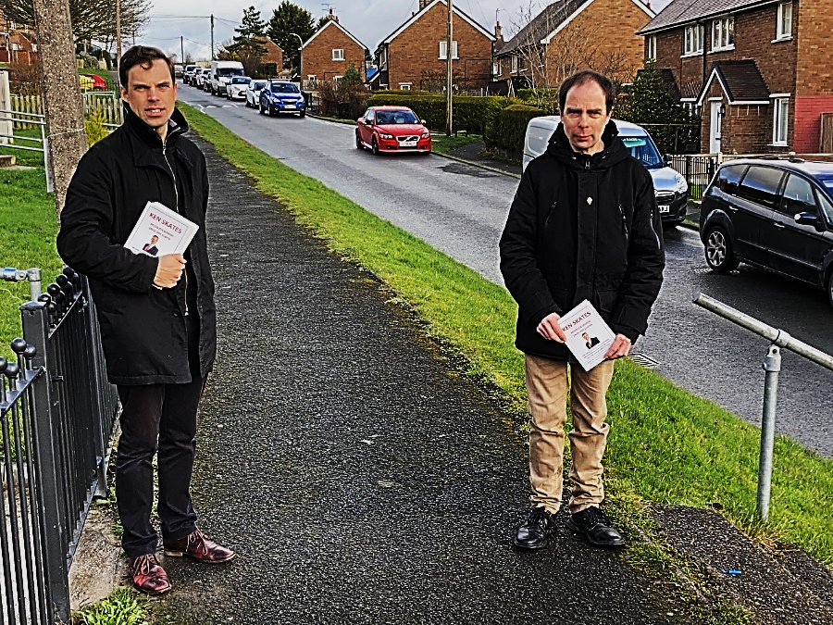
Major parking problems on a Wrexham estate have been going on too long and need urgent attention, local representatives have been told.
People living on Whalley’s Way in Plas Madoc say they are ‘sick and tired’ of the issue, which dates back a number of years, but has got worse with more cars using the road.
Member of the Senedd, Ken Skates, and local county councillor Paul Blackwell spoke to dozens of residents on the estate during a door-to-door surgery.
Clwyd South MS Mr Skates said: “The parking problems on Whalley’s Way have been going on for too long. The same issue came up over and over again during our surgery, and it’s clear the issue isn’t going to go away – people actually said it’s getting worse.”
Cllr Blackwell said: “The road is a very popular cut-through to and from Cefn, and the build-up of traffic can be a nightmare for residents. It’s essentially a single-track road because there are so many cars parked on it. It’s extremely frustrating, and on top of that it’s dangerous.
“In fairness to the council, there isn’t an easy solution – but that
doesn’t help the residents. Myself and Ken are more than happy to work with the council to help resolve these problems.”
Mr Skates said he would be raising the issue formally with Wrexham Council. He added: “A number of residents also said that the volume of traffic on the road often leaves them nowhere to park. We spoke to young parents, older people and those with mobility issues who all said they have to park elsewhere and then struggle with pushchairs, shopping and walking frames.
“I agree with Paul that there might not be a straightforward answer here, but I have asked Wrexham Council to commit to exploring potential solutions. Something has to be done. We have to work together collaboratively and with residents to ease the problem. Motorists can certainly help by driving safely and avoiding using the road as a cut-through." Ends-
Thank you to Amy McAteer for sending in this information
***************************************

Apprenticeship Pathway
Firstly, Wrexham Glyndŵr University is working to boost skills, help companies attract, recruit and retain talented people through a Degree Apprenticeship Programme.

The University is offering six fully funded Degree Apprenticeship Programmes for employees of Welsh companies to access. The courses are Cyber Security, Software Engineering, Mechanical Engineering, Electrical Engineering, Production Engineering, and Low Carbon Energy, Efficiency and Sustainability.
Laura Gough, Head of Enterprise at WGU, said; “We are very pleased to announce we are recruiting for our Degree Apprenticeship programmes so early into 2022 and have funding available to support learners.”

Christine Sheibani, HR Director at Comtek Network Systems (UK) Ltd, said; “The apprenticeships match job experience with the academic knowledge and support available at WGU.”

Lawyer of Notorious Serial Killer Joins WGU
Secondly, in a significant coup for the University, Dylan Rhys Jones joins WGU as the new senior Law lecturer.
In the mid-1990s, Dylan gained a high profile as the defence solicitor of Peter Moore, the manager of a cinema in Bagillt, Flintshire. Moreover, courts convicted Moore of murdering four men within as many months in a killing spree in which he mutilated his victims.

“In 2019, I wrote a book telling the story of when I worked as a criminal lawyer for serial killer Peter Moore. I’ve done a lot of radio and media work and also filmed some documentaries.
I am looking forward to a new challenge with the Law Department at WGU.

“There are a growing number of people who combine university courses with work and family responsibilities. That creates an ideal opportunity for people to look at WGU as a viable option to study Law.
*********************************
WGU Students Celebrate

“WorldSkills” Triumph

Thirdly, “WorldSkills” organises the world championships of vocational skills, and the UK championships is the country’s largest competitive skills and careers event. The finals took place at the end of last year, at which WGU’s Paige Tynan took the gold medal in Forensic Science, with fellow student Jake Sumner winning silver in the Cyber Security category. Paige graduated from the BSc (Hons) Forensic Science with Foundation Year programme and is currently doing a PhD at WGU.
Dylan Rhys Jones
********************

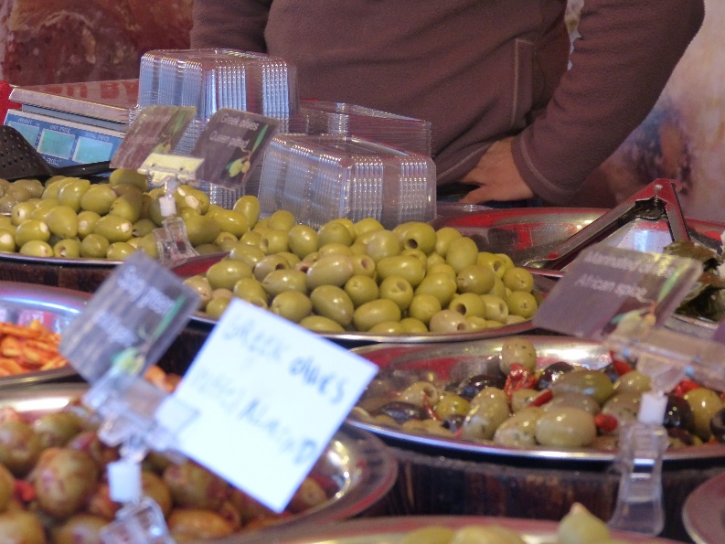

Wrexham Town Centre
will have an international theme to it between
Thursday 17th and Saturday 19th February when a Continental Market Opens for Business.
You can expect to find a mix of international themed traders featuring a host of street food options to tempt the taste buds which will be set in the heart of the town centre.
You’ll be able to browse stalls selling Olives, Nuts and Baklava, Churros and sweets, Gyros, Cheesecakes, Brownies and Waffles, Oriental Noodles, Mexican and Caribbean fare in addition to Native Handicrafts, Steel Jewellery and Wooden Arts and Crafts.
All food stalls have a local authority food rating of 4 or 5
The market opens at 10am every day and closes at 6pm.

Cllr Terry Evans, Lead Member for Economic Development and Regeneration said, “Everyone loves a market and this will be no exception.

“Visiting markets are always welcome and successful in Wrexham and I look forward to seeing their stalls set up ready to trade.”
Don’t forget parking is free after 11am in all town centre car parks except Tŷ Pawb.

Thank you to Derek Jones for both of the following items
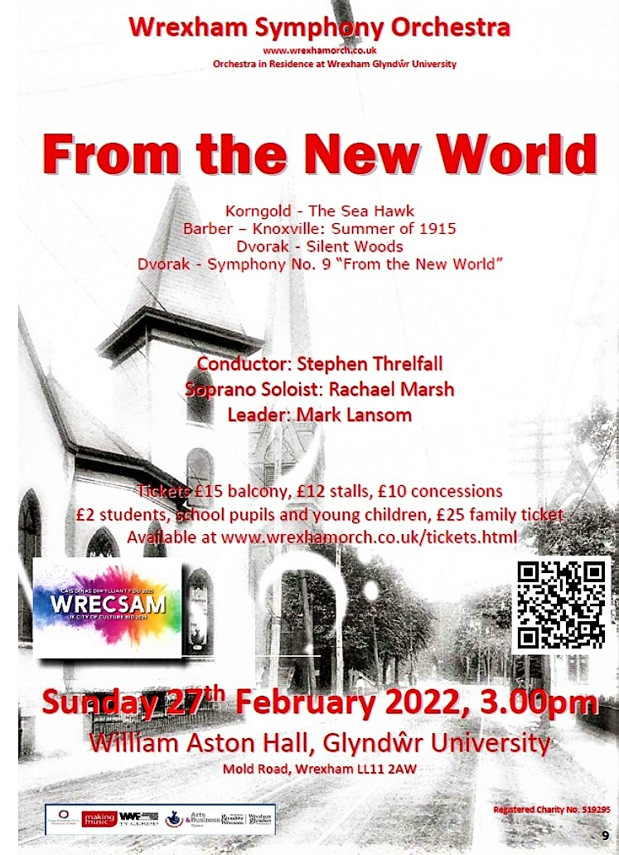

Thank you Paul Tincello for the following information from NE Wales
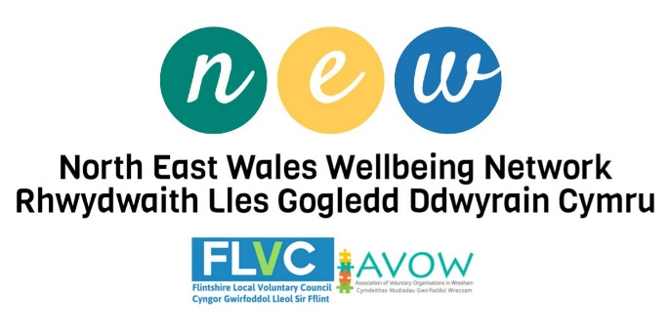
Volunteering Matters Survey
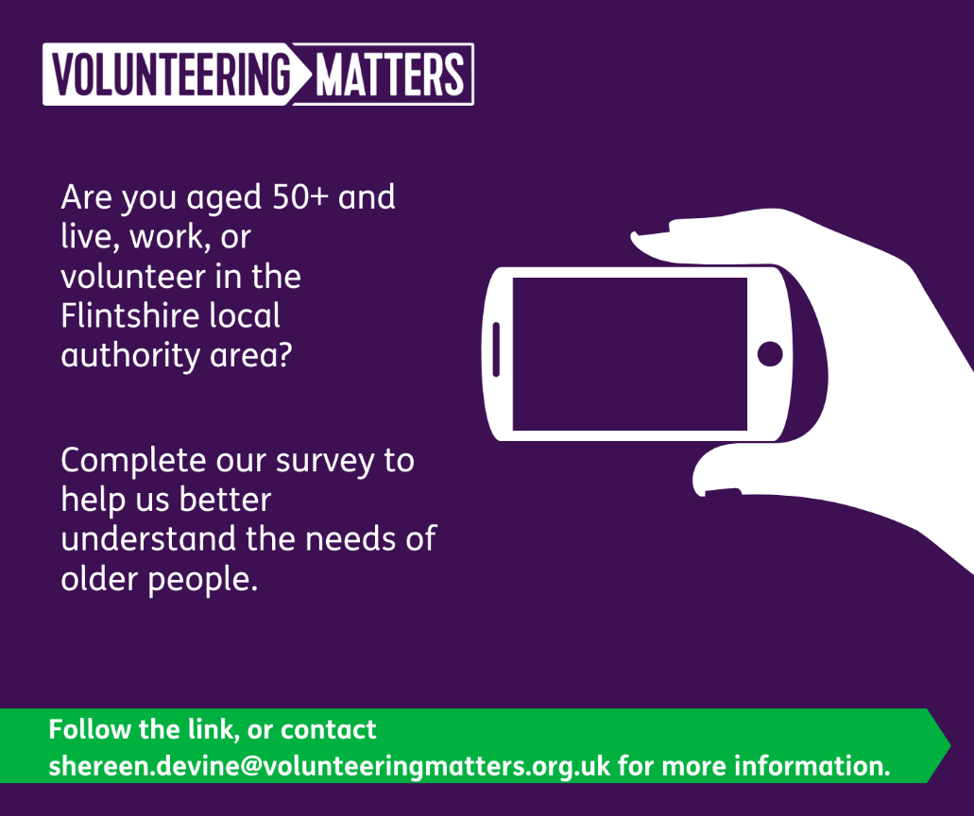
********************************************
JobSense Webinar – 16th February 2022
We would like to invite you to our JobSense webinar on 16th February to find out more about how JobSense can support people with hearing loss and / or sight loss into or towards employment.
No need to book – the link to join the event on Zoom is below – join us on Wednesday 16th February 2022 at 10.00am
Topic: JobSense EW Webinar Time: Feb 16, 2022 10:00 AM London
Join Zoom Meeting https://us02web.zoom.us/j/84622645731
Meeting ID: 846 2264 5731#
*************************************
Easyfundraising Session – 17th February 2022
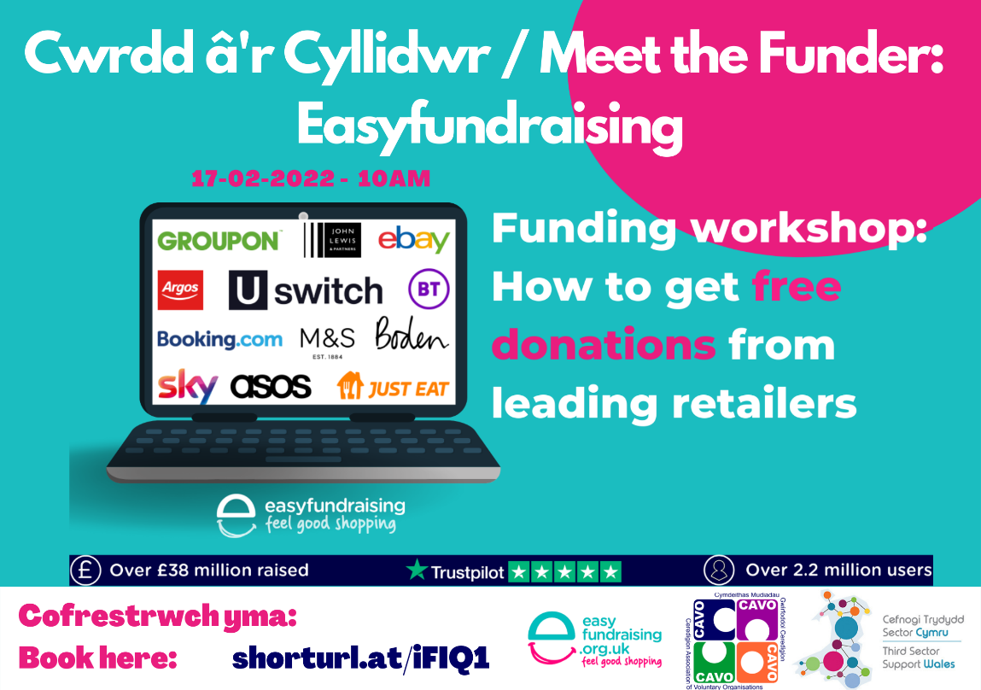
Aura Libraries – Free Winter of Well-being Activities for 0–25-year-olds
Aura Libraries are taking part in this fantastic campaign to provide activities and support wellbeing for our local children and young people between 0-25 years old during February and March. Please can you spread the word about these fantastic opportunities across your networks and with young people that you work with.
https://winterofwellbeing.readingagency.org.uk/
***********************
Fitness , Wellbeing and Pamper Sessions 16-25 year olds
We are offering some very special health and wellbeing opportunities for 16-25 year olds during February and March with our colleagues in the Aura Fitness Team and the Afon Spa. Sign up soon so you don’t miss out on these amazing offers!
For up to 40 young people the choice of: Free manicure or pedicure with gel Or Free Facial; Plus, use of Afon Spa, Deeside Leisure Centre. Free Gym and Fitness membership for 1 month- at any of our Fitness Suites in Flint, Mold, Deeside, or Buckley.
Please email Susannah.Hill@aura.wales to sign up.
Climate Champions-
We're running two online creative writing courses starting in Spring 2022, for children aged 9-11.
Half term: Monday 21st February to Thursday 24th February 11am to 12.30pm
After School: Tuesday 1st March 2022 for 4 weeks, 5pm to 6.30pm.
Courses will be held via Zoom
Participant’s work will be showcased at a special event and will be shared on our e-book platform; to register for any of the courses please email: charles@readnowwritenow.org.uk
**************************************
National Children and Young People Bereavement conference
25th March 2022
I am pleased to confirm that our National Children and Young People Bereavement Conference will take place on Friday 25th March 2022 at the Quay Hotel, Deganwy, Conwy.
This is an amazing opportunity and is available to our Cruse volunteers and partner organisations for FREE and places are available on reservation.
If you are interested, please get in touch with Emma Jones by emailing: emma.jones@cruse.org.uk by Monday 14th of March 2022 to reserve your space at this National Conference.
Please note that places are limited to 40 and due to this restriction, we are expecting high demand. The conference will consist of a 2-hour Theory workshop and a 2-hour Practical hands-on workshop.
Advert for Lay Member of Governance and Audit Committee – Flintshire County Council
We have a vacancy for a lay member on our Governance and Audit Committee and whilst it’s advertised on our website and via WLGA.
Below are the links to the site for further enquires.
https://www.flintshire.gov.uk/en/Resident/Jobs-and-careers/Lay-Member-to-the-Governance-and-Audit-Committee.aspx
https://www.siryfflint.gov.uk/cy/Resident/Jobs-and-careers/Lay-Member-to-the-Governance-and-Audit-Committee.aspx
******************
Valuation Tribunal for Wales

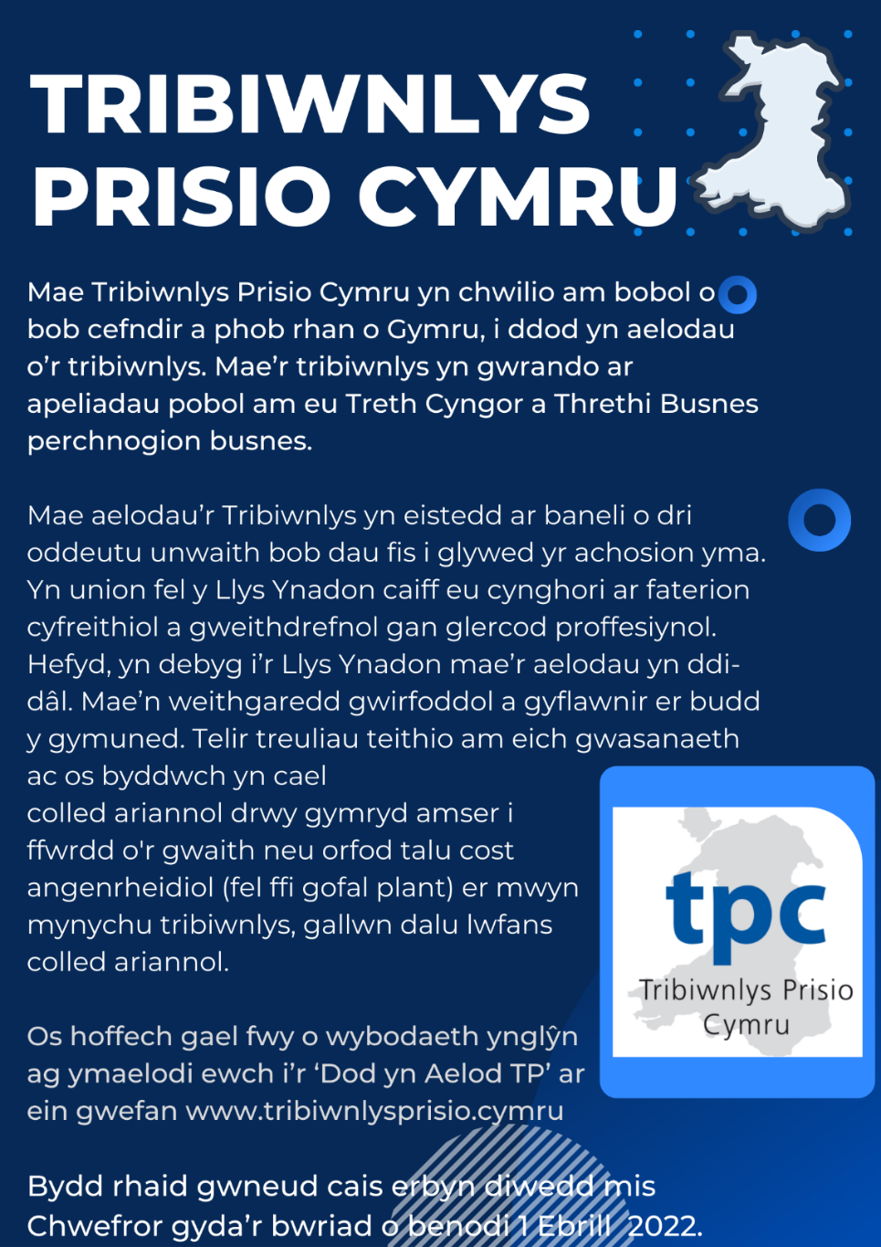
Please contact the Valuation Tribunal for Wales should you have any further queries, on 01633 255003 or email via correspondence@valuationtribunal.wales
You can also access their website directly @ https://www.valuationtribunal.wales/home.html
***************************************
"Last month, the UK government overrode the Welsh government to permit the massive extension of a coal mine.
This will produce 40 million tonnes of coal: in other words, it’s 15 times bigger than the proposed new mine in Cumbria. Yet the media, perhaps because so many English journalists struggle to locate Wales on the map, has scarcely mentioned it." By Bill Smith; who has brought this travesty to our attention since reading George Monbiot’s piece: “Blatant Opportunism” published in the Guardian on 9th February 2022.
*********************************
The following events are all part of the Welsh Government’s Winter of Wellbeing campaign. They have been kindly forwarded to us by the staff at Ruabon Library.

Llyfr Lles
Ydych chi rhwng 7 ac 11 oed (Blynyddoedd 3-6) ac yn mwynhau
ysgrifennu a barddoniaeth?
Ymunwch â ni i greu Llyfr Lles a ysgrifennwyd
ar gyfer pobl ifanc, gan bobl ifanc.
Bydd sesiynau yn cymryd rhan ar Chwefror 18,
Mawrth 4 a Mawrth 11
Sesiynau Cymraeg yn rhedeg yn Llyfrgell Rhos
Sesiynau Saesneg yn rhedeg yn Llyfrgell Wrecsam
Am fwy o wybodaeth ac i archebu eich lle:
Ffoniwch Llyfrgell Rhos ar 01978 840328
Llyfrgell Wrecsam ar 01978 292090
Wellbeing Book
Are you aged between 7 and 11 (Years 3- 6)
and enjoy writing and poetry?
Join us in the creation of a Wellbeing Book
written for young people, by young people.
Sessions take place on 18th February, 4th March and 11th March
Welsh sessions running at Rhos Library
English sessions running at Wrexham Library
For more information and to book your place:
Call Rhos Library on 01978 840328
Wrexham Library on 01978 292090
Mae archebu lle yn hanfodol| Booking is essential
******************
Gweithdy Crefft Manga
Ydych chi'n mwynhau darllen llyfrau Manga? Os felly, beth am ymuno â ni ar ein Gweithdy Crefft Manga Gaeaf Llawn Lles arbennig lle gallwch ddylunio eich matiau diod eich hun gan ddefnyddio beiros acrylig. Yn ystod y sesiwn byddwch hefyd yn cael cyfle i sgwrsio am eich hoff lyfrau Manga a chael cyfle i ysgrifennu adolygiad o'ch hoff lyfr. Yna bydd eich gwaith celf a'ch adolygiadau yn cael eu defnyddio i greu hyrwyddiad llyfr Manga arbennig yn y llyfrgell.
Cynhelir y sesiynau yn llyfrgell Wrecsam ddydd Iau 10fed Mawrth, 4-5pm, a Llyfrgell Brynteg ar ddydd Sadwrn 12fed Mawrth, 11-12pm. Bydd y sesiwn yma yn addas ar gyfer planet 8-14.
Manga Craft Workshop
Do you enjoy reading Manga books? If so, why not join us on our special Winter of Wellbeing Manga Craft Workshop where you can design your own coasters using acrylic pens. During the session you will also get chance to chat about your favourite Manga books and have the opportunity to write a review of your favourite book. Your art work and reviews will then be used to create a special Manga book promotion at the library.
Sessions will take place at Wrexham library on Thursday 10th March, 4-5pm, and Brynteg Library on Saturday 12th March, 11-12pm. This session will be suitable for children aged 8-14.
***************************

Dewch i ymuno â ni am hwyl hanner tymor
gyda sesiynaurhyngweithiol gan Xplore!
Come and join us for half term fun with
interactive sessions from Xplore!
Llyfrgell | Library | Gweithgaredd Activity | Dyddiad ac amser y digwyddiad  Date and time of event | Oed | Age
Wrecsam  Wrexham | ‘Construction’ | 19 Chwefror/February  11-12pm | 3-8
Y Waun  Chirk | ‘Construction’ | 21st Chwefror/February  11-12pm | 3-8
Cefn Mawr | ‘Construction’ | 21st Chwefror/February  2-3pm | 3-8
Brynteg | ‘Astronaut Training’ | 22nd Chwefror/February  11-12pm | 6-10
Coedpoeth | ‘Astronaut Training’ | 23rd Chwefror/February  2.30-3.30pm | 3-7
Gwersyllt | ‘Your Body’ | 24th Chwefror/February  11-12pm | 6-12
Llai  Llay | ‘Your Body’ | 24th Chwefror/February  2-3pm | 6-12
Rhos | ‘Astronaut Training’ | 25th Chwefror/February  11-12pm | 3-7
Rhiwabon  Ruabon | ‘Astronaut Training’ | 25th Chwefror/February  2-3pm | 6-10
Wrecsam  Wrexham | ‘Astronaut Training’ | 5th Mawrth/March  11-12pm | 3-7

Mae archebu lle yn hanfodol. I gael manylion y llyfrgell ewch i www.wrecsam.gov.uk/llyfrgelloedd. Booking is essential.
For library details visit www.wrexham.gov.uk/libraries
*****************************
AMSER CYSTADLEUAETH!
Ble wyt ti'n hoffi darllen?
Dywedwch wrthym ble rydych chi'n hoffi darllen. Tynnwch lun i ni neu ysgrifennwch gerdd am eich hoff le darllen.
Rhoddir gwobrau i enillydd y categorïau oedran canlynol:
8-11 oed, 12-15, 16-25
Rhaid cyflwyno ceisiadau i llyfrgell Owrtyn erbyn 5.00yp dydd Gwener Mawrth 18fed.
Bydd yr enillydd yn derbyn pecyn lliwio Ymwybyddiaeth Ofalgar
COMPETITION TIME!
Where do you like to read?
Tell us where you like to read your books. Draw us a picture or write a poem about your favourite reading place. Prizes will be awarded to the winner of the following age categories: Ages 8-11, 12-15, 16-25
Entries must be submitted to Overton library by 5.00pm on Friday 18th March. The winners will receive a Mindfulness colouring pack

Gweithdai Celf Amgylcheddol
Dewch i ymuno â Tim Pugh sy'n artist amgylcheddol yn rhai o'n llyfrgelloedd! Bydd Tim yn cynnal gweithdai celf amgylcheddol arbennig gan ddefnyddio dail sych fel ysbrydoliaeth ar gyfer ei waith. Os ydych yn oed 7-10 a hoffech chi ymuno yn y sesiynau rhad ac am ddim anhygoel hyn fel rhan o'n tymor Gaeaf Llawn Lles yna cysylltwch â'r llyfrgell yn uniongyrchol i gadw'ch lle.

Environmental Art Workshops
Come and join Tim Pugh who is an environmental artist
at some of our libraries!
Tim will be doing special environmental art workshops using dried leaves as the inspiration for your work. If you are aged 7-10 and would like to join in these amazing free sessions as part of our Winter of Wellbeing season then please contact the library directly to reserve your place.
Llyfrgell y Waun Dydd Mawrth 8 Mawrth 4.30yp 01691 772344
Chirk Library Tuesday 8 March 4.30pm
Llyfrgell Rhiwabon Dydd Mercher 9 Mawrth 4.15yp 01978 822002
Ruabon Library Wednesday 9 March 4.15pm
Llyfrgell Gwersyllt Dydd Gwener 11 Mawrth 4.00yp 01978 722890
Gwersyllt Library Friday 11 March 4.00pm
Llyfrgell Wrecsam Dydd Mercher 16 Mawrth 4.00yp 01978 292090
Wrexham Library Wednesday 16 March 4.00pm
Mae archebu lle yn hanfodol| Booking is essential
***********************

A message from Bill Smith, who has brought this travesty to our attention after reading George Monbiot’s piece in the Guardian on the 9th February entitled: “Blatant Optimism”:
"Last month, the UK government overrode the Welsh government to permit the massive extension of a coal mine. This will produce 40 million tonnes of coal: in other words, it’s 15 times bigger than the proposed new mine in Cumbria. Yet the media, perhaps because so many English journalists struggle to locate Wales on the map, has scarcely mentioned it".
***********************************
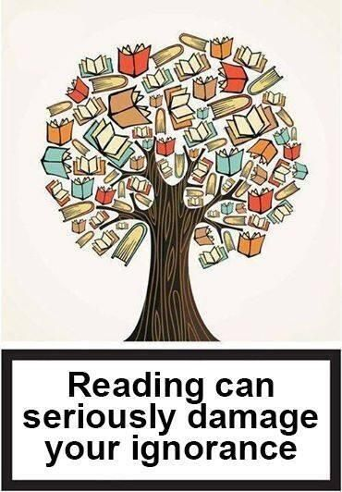

***************************************************
Thank you once again, to all those of you who
have contributed to this News Letter.
ALL items have been gratefully received.
Sybil (Bremner)

