Ruabon News Letter 406
09.01.2022

Landmarks in LEGO® Bricks Exhibition
18.02.2022–07.05.2022
To celebrate the historic connection between Wrexham and Lego® Wrexham Museum will be hosting Brick Built, a special * touring exhibition by Warren Elsmore of famous buildings, monuments and structures made from LEGO bricks.
The exhibition will include Warren’s LEGO museum containing models and products from the early years of the company up to the present day.
A highlight of the exhibition will be the model celebrating the ingenuity of our local World Heritage Site: The Pontcysyllte Aqueduct, created specifically for this exhibition.
Research is ongoing into the history of British Lego and Lego® on the Wrexham Industrial Estate and on the Ruthin Road site. If you worked at or were connected to these sites, please email museum@wrexham.gov.uk
Image: Courtesy of Warren Elsmore.

The following information has been sent in by David Goodban (member of support staff for the Senedd)
PRESS RELEASE
Ken Skates MS | Clwyd South
05/01/22
for immediate publication

MS urges constituents to ‘fight back’ against benefit reductions
People facing benefit cuts are being urged to fight their corner by a Member of the Senedd after hundreds of claimants in his constituency had theirs reinstated on appeal.
In 2020, Ken Skates helped a disabled Cefn Mawr woman who had her Personal Independence Payment (PIP) slashed by more than £80 a week win her appeal to the UK Government’s Department of Work and Pensions (DWP).
Now the Clwyd South MS is repeating his calls for people to ‘fight back’ after learning that at least 440 claimants in his area have won their own appeals in recent years.
He said: “Although benefits are not devolved to Wales and are the responsibility of the UK Government, I have seen an increasing number coming to me for help in recent years after having their PIP or other claims cut by the DWP.
“Many people have been successful in appealing and having them reinstated, but I’m concerned that many feel there is no point or don’t know where to turn. Charities like Scope have also spoken out about this, and it’s important that people know they can fight back.”
Mr Skates previously raised the issue in May 2020 when he helped cancer survivor Karen Richards take on the DWP and win. She also received back-dated payments after the UK Government admitted they should never have taken away her mobility support payments.
PIP is the main disability benefit and is designed to support people with the extra living costs associated with their long-term condition.
As reported by the Liverpool Echo in November, Scope analysed UK Government data between July 2019 and June 2021 and found there had been 12,579 successful appeals for PIP claims each month – equating to a wrong benefit decision being made every minute of the working day. In December, the newspaper also revealed that the DWP had 67% of its PIP decisions reversed.
Mr Skates, who was also an outspoken critic of the UK Government’s cut to Universal Credit, said: “These payments are a lifeline for some of the most vulnerable people in our society, and the fact that so many are being overturned shows the number of incorrect, unfair decisions being made every single day.“The numbers also highlight why people should fight their corner. If they don’t know how to, there is help available, and Scope has some really useful information on its website. There are also other organisations like Citizens Advice which can help free of charge.”
If you want to challenge a benefit decision, you have one calendar month from the date on your decision letter to ask the DWP to ask for a ‘mandatory reconsideration’.
Figures released by the DWP show that, in Clwyd South, there were 100 successful appeals against PIP reductions in the 2016-2017 financial year, 90 each in 2017-18 and 2018-19 and another 80 in 2019-20. Last year 40 of Mr Skates’ constituents managed to get their reductions reinstated. -Ends-
Notes to Editors
- More information on challenging a DWP decision can be found on the Scope website (Challenging a DWP decision | Disability charity Scope UK) or via Citizens Advice (Challenging a PIP decision - appealing against the decision - Citizens Advice)
- Wrexham cancer survivor wins her benefits battle | The Leader (leaderlive.co.uk) (June 1, 2020)
- DWP considering benefit overhaul as 12,000 PIP claimants win appeals each month - Liverpool Echo (November 14, 2021)
- PIP warning issued as DWP disability benefits decisions are overturned - Liverpool Echo
(December 16, 2021)
*********************

Thank you to Paul Tincello for providing the following information
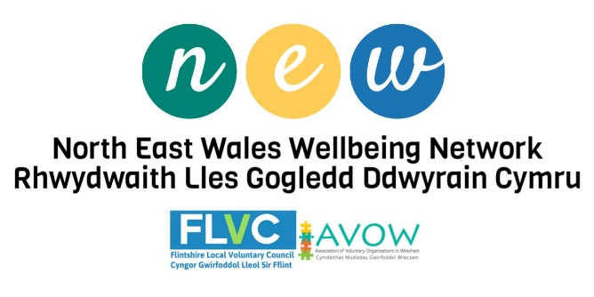
£18 million to strengthen support for children and young
people with Additional Learning Needs
New funding to support children and young people with Additional Learning Needs has been announced by Jeremy Miles, the Minister for Educational and Welsh Language.
£18m will be made available to provide extra support for children and young people with ALN who’ve been affected by the pandemic and to help educational settings as learners move to the new ALN system from this month.
**********************************************
CADR Conference 2022
Shaping Environments; Shaping Lives?
10th of February 2022 | 10:00am | Online
Webinar Registration
The CADR conference is themed around the “Decade of Healthy Ageing” report released by the World Health Organisation, highlighting Age Friendly Environments; ensuring that communities foster the abilities of older people.
Topics covered in the CADR Conference will included: The Environments of Ageing, Working Environments, and Carer Aware Environments.
****************************************

Level 3 Award (City & Guilds) in Management of Volunteers
REGISTER BY 12TH OF JANUARY 2022 TO RECEIVE YOUR 20% DISCOUNT
Ruthin Market Hall has launched a Search for a Bari-Star!
Ruthin Market Hall has launched a search for a budding coffee entrepreneur to help create a new business collaboration in sustainable coffee and wellbeing.
For the chosen Bari-Star we will provide:
• 6 months start-up funding.
• A fully equipped coffee space with high-tech equipment, located inside Ruthin Market Hall.
• A collaboration with a sustainable coffee roaster.
• Marketing package.
• Advanced Barista skills training.
• Mentoring and business development support.
• Inclusion in the new Ruthin Market Hall film series.
We’re looking for someone with Barista and entrepreneurial skills, experience working in coffee retail and with a passion for independent, specialty coffee business.
Further information is available on https://www.ruthinmarkethall.com/bari-star-search:.
Closing date for applications is 22nd of January 2022.
******************************************
Would you like to Home-Start Flintshire
at one of its ‘Stay & Play’ Groups?
*****************************
Gig Buddies Volunteer Role
Do you believe that everyone has the right to go to gigs and events that they love, to party, and to Stay Up Late?
For many people with a learning disability this is impossible.
Volunteer as a Gig Buddy and you can help to change this.
*Age restrictions apply*
to apply for an application form, go to: https://gigbuddies.org.uk/volunteer-application-form/
***********************************
Yn eich barn chi, a oes gan bawb yr hawl i fynd i’w hoff gigiau a digwyddiadau ac Aros i Fyny’n Hwyr?
I lawer o bobl sydd ag anabledd dysgu, mae hynny’n amhosibl.
Gwirfoddolwch fel Ffrind Gif a gallwch newid hyn.
*Mae cyfyngiadau oedran yn berthnasol*
Ffurflen Gais
***********************
Mental Health Support Group for Welsh Speakers
The Welsh language support group is open to all, not just Denbighshire, Flintshire, and Wrexham.
Click here for further information.
**********************************
COVID-19 Economic Resilience Fund Business Support
The Welsh Government has announced a new round of Economic Resilience funding, which will open for applications on 17th of January 2022 – for 2-weeks only! This round of the ERF is targeted at businesses in the hospitality, leisure, and attraction sectors, and their supply chains, who have been materially impacted by a reduction of turnover (at least 60% down) between 13th of December 2021 and 14th of February 2022.
Business Wales has set-up an online eligibility checker to enable businesses to establish eligibility ahead of the fund opening. The eligibility checker is available now.
The fund will begin accepting applications from 17th of January 2022, and close after 2-weeks.
*******************************

The Leche Trust
The Leche Trust is a grant making charity that provides funding of up to £5,000 to UK registered charities, public authorities, or institutions in the areas of the Performing Arts and Conservation.
Performing Arts - supports projects that: promote excellence in professional performance in music, dance, and theatre; new work and on the development of young professionals aged 18 or over; and projects that widen geographical access to the performing arts, e.g., through festivals and touring.
- Conservation - supports projects to conserve historic objects, collections and features of buildings and landscapes which date from the Georgian period or earlier, i.e., pre-1830s. In the case of churches, they will consider supporting the conservation of such features as monuments, wall paintings, stained glass, and historic furniture and fittings.
Preference is given to smaller projects, or specific elements of projects, where their contribution can make a greater impact.
Trustees meet three times a year to review applications, normally in February, June, and October. The next deadline is 28th January 2022, for applications to be considered at the February panel meeting. Read more: The Leche Trust - grants | Funding Wales
***********************
Non-Domestic Rates (NDR) Support Scheme
Local Authorities will once again be delivering the NDR support scheme for organisations (businesses, charities, community groups, and social enterprises), if they are linked to non-essential retail, hospitality, leisure and tourism for rate paying businesses, and have been adversely affected by Covid-19.
Organisation eligible for support will be not-for-profit bodies operating for charitable purposes, but aren’t currently receiving charitable relief or CASC relief, and these are offered at the discretion of Local authorities.
The NDR support scheme will open for applications on 10th of January 2022 and remain open for two full weeks only.
Apply here: Eform | FCC (flintshire.gov.uk).
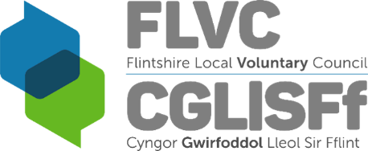
Meet the Funder Online Event with Bernard Sunley Foundation
On Thursday 20th January 2021 11am (online)
- The Bernard Sunley Foundation supports Registered Charities in England and Wales working to raise the quality of life and provide greater opportunities for the young, the elderly, the disabled and the disadvantaged.
This is a fantastic opportunity to speak with the foundation and find out more about their grant-making.
Applications are accepted from CIO’s, Registered Charities, and organizations with ‘exempt’ status, in the following priority areas:
- Community - particularly rural community buildings, and youth groups
- Education – assisting special educational needs, and educational nature & farm visitor centres
- Health – residential care, housing & treatment centers
- Social Welfare – rehabilitation of the homeless, young people at risk, move-on support facilities & daycare centers.
Many grants are between £1,000 - £5,000 with some much larger exceptions. Grants are awarded for capital projects, e.g., building refurbishments, transport, and equipment.
There are no formal application deadlines. Applications can be made at any time. To book onto the event please register here: Microsoft Forms. For more information, please visit www.flvc.org.uk or contact Heather.Hicks@flvc.org.uk. For more detail information about the foundation please visit: www.bernardsunley.org
***************************

The following information has been taken from ‘North West Live News’

Mark Drakeford has his say on Chester FC coronavirus rules dilemma. The First Minister has called in officials in the hope of finding a solution

Chester's Deva Stadium
There are hopes "a sensible pragmatic solution" can be found over the dispute between Chester and the Welsh authorities over fans attending football matches, Wales' First Minister has said.
Non-league Chester FC fear going out of business if the club is made to play behind closed doors.
The English National League North side is being investigated by police over potential Covid breaches after more than four thousand fans attended two matches at their home ground, which straddles the Wales and England border, over the festive period.
The club's stadium straddles the border, with the front gates, car park and main office door in England but the pitch in Wales.
Elite sporting events in Wales are currently being played behind closed doors after new rules to tackle the spread of the Omicron variant came into force on Boxing Day.
First Minister Mark Drakeford said Welsh Government officials would be discussing the issue with the club, police and local authority.
The club's Swansway Chester Stadium straddles the border.
"I've already asked my senior officials to have discussions today with the police, with the club, with the local authority that owns the

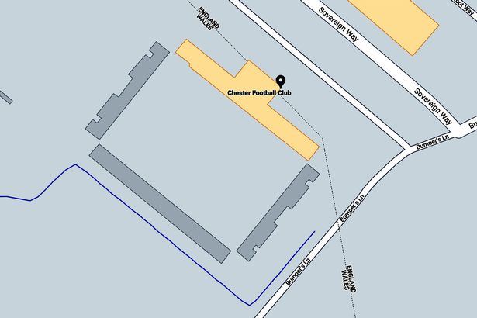

ground, the Chester local authority," he told Sky's Trevor Phillips on Sunday.
"I'm sure there is a sensible pragmatic solution here but doesn't mean that the club is placed in jeopardy, but doesn't result in the law being broken either."
There are no restrictions in England and Chester's home matches against Fylde and Telford on 28th December and 2nd January which were attended by crowds of 2,075 and 2,116 respectively.
The club has since been informed by North Wales Police and Flintshire Council they may have broken Welsh Government rules and they would be risking doing so again by hosting more crowds.
The club, who consider themselves English with an English registered address, are now fearing the potential consequences and are seeking legal advice.
Chairman Andy Morris told the PA news agency last week: "As a club we rely on gate receipts. If the enforcement is we have to play behind closed doors, we are not a Welsh club, so we are not entitled to the financial support.
"The entire future of the club could be in doubt. There is no financial support for English clubs playing behind closed doors at the moment. It could be the end of the club.
"I don't think there is any clear jurisdiction in terms of which rules apply but we have been acting within English legislation since the stadium was built in 1992.
******************************
News From Wrexham County Borough Council
The popular Free Gym for Juniors programme has been extended to March 2022 thanks to funding from the Winter Wellbeing Fund.
All 11-16 year olds in secondary education are invited to take part and they’re available at:
- Wrexham Waterworld – 01978 297300
- Chirk Leisure and Activity Centre – 01691 778666
- Gwyn Evans Leisure and Activity Centre – 01978 288540
- Queensway Stadium – 01978 355826
Please contact your local centre direct for further information about the sessions.
******************************
If you are working-age and live in Wrexham, you could be entitled to a one-off payment of £100 to help with your fuel bills this winter.
If your household has one person receiving one of the welfare benefits listed below, and they are also responsible for paying the energy bills, make sure you apply.
- Income Support
- Income Based Job Seekers Allowance
- Income Related Employment and Support Allowance
- Universal Credit
- Working Tax Credits
It doesn’t matter how you pay for fuel (pre-payment meter, direct debit or quarterly) you will still be able to apply.
For more information and to apply, visit the Winter fuel support scheme page on our website.
All applications must be received by February 18, 2022.
Payments will be made between January and March 31, 2022.
******************************
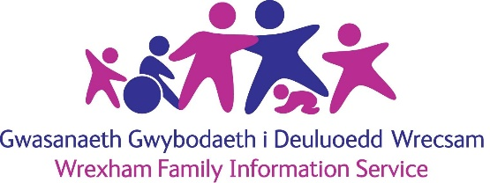
The following information has been forwarded by Sandra Anderson (BCUHB - Communications)

Child Development Toddler Group
Sustainability Fund
Purpose of the Child Development Toddler Group Sustainability Fund
To provide sustainability funding to support Toddler Groups to continue operating or to reopen following the challenges of Covid-19 where no other public funding has been provided to cover the same costs.
Guidance
Grant Criteria
- Grants of up to a £1,000 allocated on a first come first served basis.
- Toddler groups must be community lead.
- Toddler Groups must be based in Wrexham County Borough.
- Toddler Groups must be a charitable organisation, however the service does not have to be registered with the Charity Commission.
- The service must be open and operational or commit to opening in September and remain open for a minimum of 6 weeks.
Please take note of the below guidance before making an application.
Toddler Groups
- To demonstrate eligibility for the grant, settings must provide the following supporting evidence:
  - Proof the service operates within Wrexham County Borough e.g. evidence of rental agreement or hire facilities
  - Risk assessment that demonstrates how you are currently providing the service, or going to provide the service, and how you will adhere to Welsh Government Guidelines on safe practice during Covid-19.
  - The Toddler Group will also be required to outline how the grant will support the viability of the service, and the risks associated with not receiving the funding.
Please note: A service cannot get funding from two sources of public funding for the same purpose (if you are unsure if you have already received funding that would make you exempt from applying to this funding stream, please contact the Childcare Team for assistance). You will still be able to apply for funding for the period 1st September 2021 to 30th September 2021 if you have previously received funding for a different period e.g. if you have received the Moon Dance funding or any other revenue funding between the period 1st April 2021 to the 31st August 2021.
- Only one application can be considered per service.
Use of the Funding
Funding can be utilised for the following reasons:
- Sustainability e.g. lost revenue from unfilled spaces
- Rent
- Staff Wages
- Cleaning supplies and equipment
- Purchase of resources and equipment to support children’s development
Please note: This list is not exhaustive if you have any queries in regard to eligible items please contact the childcareteam@wrexham.gov.uk
Other Funding
- You are required to inform us if you are applying for or receiving grant funding from another source for the same purpose.
- You will be required to complete a monitoring report as a condition of receiving grant funding. Subsequent funding requests will be withheld should monitoring reports not be returned by the deadline provided.

Applications
- Applications will be considered on a first come first served basis, this may lead to some applications not being appraised if the fund is fully committed.
- All applications will be considered on an individual basis and payment of the grant is at the absolute discretion of the awarding body;
- Applications will only be considered at funding panel if:
- All sections on the form have been completed in full;
- All required evidence has been submitted;
- Applications are legible and signed by the appropriate persons.
Please submit your application to childcareteam@wrexham.gov.uk.
Please apply for an application form from: The Wrexham Family Information Service on (Child care agency in Wrexham, Wales)
Address: 35 Rhosddu Rd, Wrexham LL11 1AU
Phone: 01978 292094; email address: fis@wrexham.gov.uk.
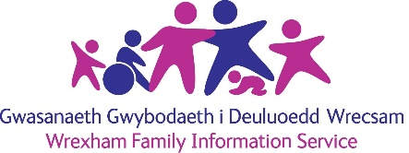
************************
Grŵp Datblygu Plant Bach
Cronfa Gynaliadwyedd
Diben y Gronfa Gynaliadwyedd Grŵp Datblygu Plant Bach
Darparu arian cynaliadwyedd i gefnogi Grwpiau Plant Bach er mwyn iddynt barhau i weithredu neu ailagor drwy gydol heriau Covid-19 pan nad oes arian cyhoeddus arall wedi ei ddarparu i gynnwys yr un costau.
Canllawiau
Meini Prawf Grant
- Grantiau hyd at £1,000 wedi’u dyrannu ar sail y cyntaf i'r felin.
- Mae’n rhaid i grwpiau plant bach gael eu harwain gan y gymuned.
- Mae’n rhaid i Grwpiau Plant Bach gael eu lleoli ym Mwrdeistref Sirol Wrecsam.
- Mae’n rhaid i Grwpiau Plant Bach fod yn sefydliad elusennol, fodd bynnag, nid yw’r gwasanaeth angen cofrestru gyda’r Comisiwn Elusennau.
- Mae’n rhaid i’r gwasanaeth fod yn agored ac yn weithredol neu ymrwymo i agor ym mis Medi a pharhau’n agored am isafswm o 6 wythnos.
Sylwer ar y canllawiau isod cyn cyflwyno cais.
Grwpiau Plant Bach
- Er mwyn arddangos cymhwysedd am y grant, mae’n rhaid i leoliadau ddarparu’r dystiolaeth gefnogol ganlynol:
  - Profi bod y gwasanaeth yn gweithredu o fewn Bwrdeistref Sirol Wrecsam e.e. tystiolaeth o gytundeb rhentu neu gyfleusterau llogi
  - asesiad risg sy’n dangos sut rydych yn darparu’r gwasanaeth ar hyn o bryd, neu’n mynd i ddarparu’r gwasanaeth a sut y byddwch yn cadw at Ganllawiau Llywodraeth Cymru ar arfer diogel yn ystod Covid-19.
  - Bydd gofyn hefyd i Grŵp Plant Bach amlinellu sut y bydd y grant yn cefnogi hyfywedd y gwasanaeth, a’r risgiau cysylltiedig os na dderbynnir yr arian.
Sylwch: Ni all gwasanaeth dderbyn arian o ddwy ffynhonnell o arian cyhoeddus at yr un diben (os nad ydynt yn siŵr os ydynt eisoes wedi derbyn arian fyddai’n eich eithrio rhag gwneud cais i’r ffrwd gyllido hon, cysylltwch â’r Tîm Gofal Plant am gymorth). Byddwch yn parhau i allu ymgeisio am gyllid ar gyfer y cyfnod 1 Medi 2021 i 30 Medi 2021 os ydych wedi derbyn cyllid yn flaenorol ar gyfer cyfnod gwahanol e.e. os oeddech wedi derbyn yr arian Moondance neu unrhyw gyllid refeniw arall rhwng y cyfnod 1 Ebrill 2021 a 31 Awst 2021.
- Dim ond un cais y gellir ei ystyried fesul gwasanaeth.
Defnyddio’r Cyllid
Gellir defnyddio’r cyllid at y dibenion canlynol:
- Cynaliadwyedd e.e. colli refeniw oherwydd lleoedd heb eu llenwi
- Rhent
- Cyflogau staff
- Cyflenwadau ac offer glanhau
- Prynu adnoddau ac offer i gefnogi datblygiad plant.
ymholiadau am eitemau cymwys, gallwch gysylltu â’r childcareteam@wrexham.gov.uk for an application form

LLyfrgrell Rhiwabon / Ruabon Library
High Street, Ruabon, LL14 6NH
01978 822002
ruabon.library@wrexham.gov.uk
Opening Hours
Monday 12.00pm – 5.00pm
Tuesday Closed
Wednesday 12.00pm – 5.00pm
Thursday 9.00am – 1.15pm
Friday 12.00pm – 5.00pm
*******************
- Gwau a Sgwrs
- Dydd Gwener 2pm – 4pm
Knit and Natter
Fridays 2pm – 4pm
*************************
Grwp Sgwrsio
Dydd Llun 2pm – 3pm
Welsh Second Language Conversational Group
Mondays 2pm – 3pm
******************
Stori a Chân
Dydd Llun 1:15pm
Story and Rhyme
Mondays 1.15pm
*******************

Top Cover Image: ‘Artist’, Graeme Reed

Print International 2021

04/12/2021 – 26/02/2022

Tŷ Pawb hosts the return of the prestigious, biennial Print International exhibition.
Print International 2021 will include 139 pieces of artwork by artists from ten countries following a tremendous response to this year’s Open Call with over four hundred artworks submitted.
Amongst this exhibition there is also artwork featured by artists, practitioners and educators from the Regional Print Centre to celebrate its 20th Anniversary.
The judges for this year are Leonie Bradley (Editor of Printmaking Today, artist and elected member of the Society of Wood Engravers), Tracy Hill (Artist, Research Associate Artlab Contemporary Print Studios, UCLan.) and Nigel Morris (Artist/Printmaker, Facilitator, Coordinator of RPC).
Special thanks to the exhibition sponsors, John Purcell Paper, Regional Print Centre, Printmaking Today magazine and Arts Council Wales.

PLAN YOUR NEXT VISIT
*********************
Despite the virus that is still causing as all so much trouble – it seems as there are still a great deal of amazing events occuring locally. Best wishes all, Sybil (Bremner).

