Ruabon News LetteR 405
03.01.2022
A message from WCBC below

“Together let’s raise the bar on our ambition #Wrecsam2025 - Wrexham is awesome!
From singing under the massive floodlights at the Cae-Ras, to multi-cultural dancing at Ty Pawb – Wrexham is awesome!
From crowd-surfing watching Neck Deep at Focus Wales to taking in a sunrise along our UNESCO World Heritage site-Wrexham is mint!
We have so many amazing businesses on our doorstep, including a factory manufacturing the covid vaccine -Wrexham is awesome!
We want to tell the world how awesome we are- and – well – we can’t do it without you.
Becoming UK City of Culture 2025
Wrexham is the only region in Wales through to the longlist of areas competing for UK City of Culture 2025 title.
The next stage of the UK City of Culture competition is in February when the longlist will shrink from 8 to 3…but our ultimate goal is to progress even further and win this competition for Wrexham!
During this period (and beyond) we need to be SHOUTING about how awesome Wrexham is so that the judges can hear us.
Winning the competition would be a once in a lifetime opportunity for a transformational change, bringing investment, jobs, pride and an international audience to see how awesome we are- as well as having a long lasting legacy once our year of hosting is finished.
From Pontfadog to Pentre Broughton, Rhosnesni to Rhosllanerchrugog and even the remote summit of Cadair Berwyn (the highest point in Wrexham) – we want to make sure that every community has the chance to participate and benefit from Wrexham becoming UK City of Culture.
********************************

Ysgol Rhiwabon Christmas Concert
The annual Ysgol Rhiwabon Carol concert in St Marys Church Ruabon was again held this year but differently.
This year we have made a 'Virtual Carol Concert' for the whole community to view to brighten our times.
The link below will take viewers direct to the Concert, which is also now available on our You Tube TV Channel (link at the end).
https://www.youtube.com/watch?v=NTQQJJP0ruc

Headteacher, Mrs Melanie Ferron-Evans said:
“We are very proud of our pupils' talents and are delighted that we have been able to showcase them from St Marys Church using our You Tube TV Channel.
I hope you enjoy the concert and I wish everyone a Merry Christmas”.
The link to the You Tube TC Channel is here: : https://www.youtube.com/channel/UCDtDhHaXefbS0hFSmW7ryUQ
All the latest school and local community can also be found on the main website at.
https://www.ysgolrhiwabon.co.uk/

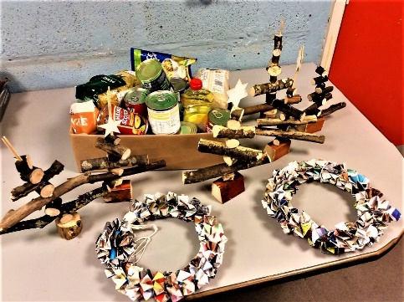
Ysgol Rhiwabon
Raise funds for
Alder Hey
Year 9 pupils have been raising money for charity with a Christmas theme during December. The pupils have been making paper wreaths made from magazines and old celebration tubs. They have also been making mini Christmas trees out of branches of trees. These items have been sold to staff and pupils and over £30 has been raised for Alder Hey children's hospital.
For the 3rd year running the pupils have also been donating to the ‘Reverse Advent’ which involves pupils bringing in items of food every day for the food bank.
Thanks to all the pupils who bought in food items and for the hard work making the different items.
***********************
More Information
Ysgol Rhiwabon have launched their own YouTube channel due to the success of their releases over the last twelve months.
The school has partnered with Firebox Media who have produced the films. Please follow the link to view the channel directly: –
https://www.youtube.com/channel/UCDtDhHaXefbS0hFSmW7ryUQ
Firebox Media can be contacted on email fireboxmedia@outlook.com
Media enquiries about Ysgol Rhiwabon should be directed to Giles Evans, Business Manager on Evansg341@hwbmail.net
Background information Ysgol Rhiwabon, is an open entry secondary school, on the Shropshire / Wrexham border, with just over 550 students. Set in 17 acres of grounds with significant playing fields, tennis courts and a multi-use games area.
The school recently gained the prestigious Princes Teaching Institute Leadership Programme Mark and is the only secondary school in North Wales in the PTi.
**********************************

Ken Skates welcomes plans for
Community Bank in Wales
Member of the Senedd for Clwyd South, Ken Skates, has welcomed the announcement that the Welsh Labour Government is working with Monmouthshire Building Society to accelerate the establishment and roll-out of a community bank across Wales.
Welsh Labour’s manifesto for Senedd election earlier this year included a commitment to creating a Community Bank for Wales, supporting its growth so it can open an initial 30 branches over the next decade.
Economy Minister Vaughan Gething has confirmed that Monmouthshire Building Society, working with the Welsh Government and Cambria Cydfuddiannol Ltd (CCL), will deliver Banc Cambria – which will aim to provide everyday full retail banking services in communities by 2023.
The UK has one of the least diverse Retail Banking systems in Europe, dominated by a small number of very large banks which operate according to a shareholder-value business model, seeking to maximise profits.
Since Welsh Ministers initially set out plans to explore the creation of a Community Bank for Wales, traditional High Street banks have further accelerated their retreat from Wales’ high streets.
Mr Skates, whose constituency is the worst-affected in North Wales, launched the plans for the Community Bank during his time as Economy Minister.
He said: “Over the last few years, we’ve all seen the big banks leave our local communities and high streets, leaving many people without access to accessible banking services. Clwyd South has seen 80% of its high street banks close since 2015 – more than any other area of North Wales – and now has just one surviving branch.
“I raised this issue in the Senedd earlier this year and was pleased to welcome Banc Cambria's project lead Mark Hooper to Clwyd South last month. I'm delighted that the plans are progressing at pace.
"Unlike other banks, this will be owned and controlled by members – not outside shareholders. Communities across North Wales have been abandoned by their banks and the UK Government's scrapping of its agreement with the sector that that last branch in each community should remain open. We desperately need this.
"Banc Cambria cannot replace the increasing number of branches closed, but will focus on communities that have lost provision. I will continue to make the case for Clwyd South. I hope this will provide a positive impact on our communities and high streets and improve access to financial help and support in locations that are convenient for the people of Clwyd South."
Banc Cambria aims to provide full everyday banking services for individuals and small businesses, accessible by telephone, online and face-to-face. It hopes to have a customer launch during 2023.
ENDS
***********************************

THURSDAY 23 DEC 2021, 00:01 Economy Minister Vaughan Gething

£120m financial support for businesses in Wales impacted by Omicron

£120 miliwn o gymorth ariannol i fusnesau yng Nghymru yr effeithiwyd arnynt gan Omicron

Businesses in Wales impacted by the rapid spread of the Omicron virus, will be eligible for emergency financial support under a new Welsh Government support package.

The Economy Minister, Vaughan Gething, has announced the details of the £120m funding which will be available for retail, hospitality, leisure and tourism business and their supply chains affected by the move to alert level two, as announced by the First Minister on Wednesday 22 December.

Under the latest package, retail, hospitality, leisure and tourism business who pay Non Domestic Rates will be entitled to a payment of £2,000, £4,000 or £6,000 depending on their rateable value. Businesses will need to re-register their details, through a quick and easy online process, with their local authority in order to receive their payments. Registration will open via local authority websites from the WC 10th of January
The Welsh Government has decided to extend this support to non-essential retail so that smaller shops, and Travel Agents will be supported and our high streets can continue to thrive. In England, support is not available to non-essential retail.
In addition, impacted hospitality and leisure businesses and their supply chains will be able to apply for top up funding from a new Economic Resilience Fund (ERF). Eligible businesses can apply for grants of between £2,500k - £25,000, with grants dependent on their size and number of employees. The application window for ERF will open in week commencing 17th January 2022 with payments starting to reach businesses within days.
Local Authorities will also administer a Discretionary fund for business and sole traders who do not pay rates. The fund will provide £500 to sole trader and freelancers and £2,000 to employing businesses in impacted sectors. Further details to follow on business.wales.
An eligibility checker which will help businesses to gauge how much they can expect to receive under the new support package will be available on the Business Wales website by the start of 2022.
Economy Minister, Vaughan Gething, said:
“We fully understand the continued challenges faced by businesses, however we are facing a very serious situation in Wales. A wave of infections caused by the new, fast-moving and very-infectious omicron variant is headed our way, this means taking early action to try and control its spread – and limit the impact on Welsh businesses.
“Since the start of the pandemic, we’ve provided over £2.2bn of support to businesses throughout Wales to help them manage their way through difficult circumstances.
“We will continue to monitor the impact of the spread of Omicron on businesses in Wales, and will consider whether additional emergency funding is needed in the new year.”
Business.Wales will be updated with details, frequently asked question and support guidance.

Notes to editors
The £120m package is designed to support businesses impacted by the spread of Omicron through the period from 13th December to the 14th February. This timeframe is linked to the expected impact of Omicron on Welsh businesses. It is not based on the expectation that restrictions will continue into mid –February
- As a result of the new emergency support packages, the Welsh Government is withdrawing its £35m Business Support Fund, announced in November, in order to re-allocate and process emergency payments as soon as possible. All existing offers will of course be honoured.
- A £3m Spectator Sports Fund will also be available to support clubs and sporting venues affected by the new measures to protect public health.
- Discretionary fund - Local authorities will also deliver a £10m discretionary fund via a short application process. Sole traders, freelancers and taxi drivers will be able to apply for £500 and businesses that employee people but do not pay business rates can apply for £2,000.
- Non Essential Retail Hospitality Leisure and Tourism businesses in receipt of Small Business Rate Relief (SBRR) and with a rateable value of £12,000 or less will be eligible for a £2,000
- Non Essential Retail Hospitality Leisure and Tourism businesses with a rateable value of between £12,001 and £51,000 will be eligible for a £4,000 payment if impacted by the restrictions.
- Non Essential Retail Hospitality Leisure and Tourism businesses with a rateable value of between £51,001 and £500,000 will be eligible for a £6,000 payment if impacted by the restrictions.
- Qualifying supply chain businesses will be eligible for support if they have a greater than 40% reduction in turnover during the restriction period.
From Boxing Day, the alert level two measures will mean:
- A general requirement of 2m social distancing in all premises open to the public and workplaces, where reasonable.
- The rule of six will apply to gatherings in regulated premises, such as hospitality, cinemas and theatres.
- All licensed premises will need to take additional measures to protect customers and staff, including table service and collecting contact details.
- Face coverings will be required in hospitality settings at all times apart from when seated.
- Large events will not be allowed indoors or outdoors. The maximum number of people who can gather at an indoor event will be 30 and 50 outdoors.
- There will be an exception for team sports, up to 50 spectators will be able to gather, in addition to those taking part.
- There is also an exception for events involving children.
****************************
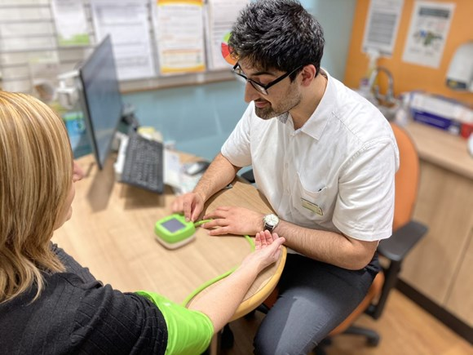
Wider range of services to be provided by pharmacies across Wales
The changes mean patients will have accessible and convenient NHS services closer to home which will in turn free up GPs and other NHS services for patients with more complex needs.
The Health Minister, Eluned Morgan, has approved changes following re-negotiation of the Community Pharmacy Contractual Framework with Community Pharmacy Wales, the representative body for community pharmacies in Wales.
The agreement will introduce a national clinical community pharmacy service enabling all pharmacies to provide treatment for common minor ailments, access to repeat medicines in an emergency, annual flu vaccinations, and some forms of emergency and regular contraception. The agreement also includes plans to roll out a Wales-wide pharmacy prescribing service which will allow appropriately trained pharmacists to treat an extended range of conditions that currently require people to visit their GP.
Health Minister Eluned Morgan said:
“The reforms to the community pharmacy contractual framework represent the most fundamental change to the way pharmacies operate since the inception of the NHS more than 70 years ago.”
“Our ‘new prescription’ for community pharmacy sets out a collaborative, innovative and progressive approach to the delivery of pharmaceutical care. Pharmacists are experts in medicines and undertake extensive training to help people manage a range of common ailments. Utilising the skills of community pharmacy teams will mean we are able to better meet the needs of the NHS and people in Wales now and for future generations.
“We are always looking for innovative ways for our health service to improve services for patients and these substantial reforms will help pharmacies better meet the changing expectations of Welsh citizens and the NHS.”
Russell Goodway, Chief Executive at Community Pharmacy Wales (CPW) said:
“Community pharmacists have argued for many years that they could make a greater contribution to the needs of NHS Wales and its patient population by delivering a wider range of clinical services.
“The Covid-19 pandemic clearly demonstrated that to be the case and CPW is delighted to have been able to work collaboratively with Welsh Government, during challenging times, to develop a new contractual framework for community pharmacies in Wales which will make the local pharmacy the first port of call for a range of clinical services dealing with a host of conditions which at the moment require a GP appointment.
“This agreement bodes well for the community pharmacy network across Wales and will avoid the pitfalls facing colleagues in England where funding for community pharmacies has been cut.”
Initially pharmacist prescribers will be able to prescribe medicines for acute illnesses like urinary tract and upper respiratory tract infections, and also prescribe routine contraception.
By April 2024 funding for independent prescribing services will increase from £1.2m to £20.2m per year and funding for the community pharmacy clinical services will increase from £11.4m to £20.0m per year.
Funding continues to be made available to support for pharmacists undertaking independent prescribing training and pre-registration pharmacy technician training.
In addition to the reforms, the Welsh Government has provided funding for pharmacies to implement innovative automated systems. Dispensing robots and ATM style prescription systems that allow prescriptions to be collected 24 hours a day will improve convenience for people collecting prescriptions and make pharmacies more efficient, providing greater access to the clinical services available.
Since April 2019, 24 pharmacies across Wales have benefited from an investment of nearly £500,000 to support adopting new and innovative technologies.
Notes to editors
Chief Pharmaceutical Officer Andrew Evans is available for interview via the Welsh Government press office.
A filming opportunity to see that the automated prescription collection machines is available at a pharmacy in Neath.
A Community Pharmacy Wales spokesperson is also available. Please contact Susan Bowen at Camlas on 07930 991382 to arrange.
Pharmacies are encouraged to consider the benefits of installing a collection machine - https://www.pharmaself24.co.uk/
*******************************

9.4% rise in Local Government funding
The settlement provides funding to deliver commitments including the real Living Wage for care workers, the teachers’ pay deal, support on business rates, and the Council Tax Reduction Scheme.
Rebecca Evans, Minister for Finance and Local Government, said: “This is a good settlement for local government, one that provides councils with a stable platform to plan their budgets for the coming financial year and beyond.
“We fully recognise the pressures local authorities are facing, and will continue to work closely with local government so we can meet the shared challenges we face and deliver services to benefit the people of Wales.” A seven-week consultation on the provisional settlement has opened today, which will end on 8th February 2022.
More information can be found in a written statement published on 21.12.2022:
https://gov.wales/written-statement-provisional-local-government-settlement-2022-23.
This information has been sent in by David Goodban, who also brings our attention to the fact that:
Wrexham has had the 7th highest rise out of the 22 councils.
**********************
The following information has been sent in by Dawn Hughes Lloyd, Manager, Ruabon Medical Centre
“Subject:
Level 1: BCUHB COVID-19 Vaccination Update/ Diweddariad Brechiadau COVID-19 BIPBC:
Sent on behalf of Dr Nick Lyons – Executive Medical Director:
“Dear All, Our latest COVID-19 vaccination update is now available on our website. Thank you for your continued support.
English: https://bcuhb.nhs.wales/covid-19/covid-19-vaccination updates/vaccination-update45/ Cymraeg: https://bipbc.gig.cymru/covid-19/brechlyn-covid-19/y-diweddaraf-ar-frechlynnau/y-diweddaraf-ar-frechlynnau50/
Diolch. Thank you.”
********************************
Thank you to Paul Tincello for sending in the following posters for the Red Cross

Wrexham Museum
Now open again from 11am-4pm Mon-Sat
The cafe and shop are open too.
A few changes have been introduced to help ensure that everyone feels safe so you can relax and enjoy your visit.

Courtyard Café
- There will be a new seating layout and menu in the Courtyard Café, but the same great service and location as ever!
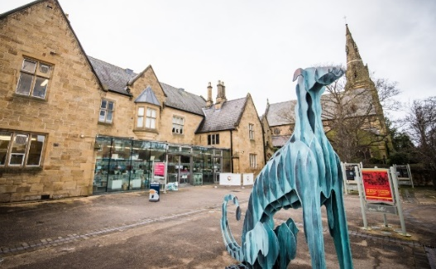
- Let’s hope for a sunny few months – you can dine outside if you wish.

Toilets
- Toilet facilities will be available for visitors to the museum, the archives and the cafe. Please ask for the key at the reception desk.

Shop
- The shop will be open so you can still purchase the usual range of great gifts, cards and books.
- We encourage the use of contactless payment and ask all shop customers to respect social distancing guidelines.

Archives
- We recommend visitors to the Archives book ahead owing to space restrictions.
- The museum will be open between 11am-4 pm Monday to Saturday. This will allow time to ensure all public areas are properly cleaned.
- There will be regular cleaning of key touch points throughout the galleries during the day.
- There will be hand sanitiser at the entrance to the building. All visitors will be asked to clean their hands on arrival.
- All visitors will be asked for their contact details to support the government’s ‘Test, Trace and Protect’ programme.
- We recommend visitors wearing face masks while in the galleries.
- All visitors will be asked for their contact details to support the government’s ‘Test, Trace and Protect’ programme.
- We recommend visitors wearing face masks while in the galleries.
- There will be a limit on numbers in the galleries so that social distancing will be possible for all our visitors.
- We have introduced a one-way system throughout the galleries. Look out for the floor signs for directions.
- For families, there will be a new children’s trail to help guide younger visitors (and their accompanying adults) during their visit.
- Admission to the museum and archives is free. Donations welcome.
- Last admission is at 3.30 p.m.

Archives
- We recommend visitors to the Archives book ahead owing to space restrictions.
- Email archives@wrexham.gov.uk or telephone 01978 297 480.
- Last admission is at 3.30 p.m.

Collections
- The Collections Centre will be open by appointment. Please email museumcollections@wrexham.gov.uk or telephone 01978 297 460.

What can I see?
- The exhibitions and displays in the museum’s three galleries tell the stories of Wrexham, Wales and the wider world.
- Gallery 1 is the space where you can explore the museum collections and the stories they reveal of Wrexham’s past.. Meet 4,000 year old Brymbo Man; See the Bronze Age Rossett Hoard and watch two specially produced films that explain how the hoard was made nearly three thousand years ago; Sit back and relax in the Hippodrome as you watch films about Wrexham Lager, Wrexham FC and Wrexham’s mining past.
- In Gallery 2 you still have a chance to see our exhibition, Forgotten Wars: The Royal Welch Fusiliers Around The World
- Meanwhile in Gallery 3 you can see Back To School: an exhibition chronicling how school locally has changed over the past two centuries through memories, mementos, archives and old photographs.
Steve Grenter, Heritage Services Manager, said: “We are delighted to finally be able to welcome visitors back to Wrexham Museum. We’ve worked hard to ensure visitors can enjoy the museum safely, as well as the fantastic food available in the café and the unique gifts from the shop.
“We hope to see regular visitors returning to the museum and this is also an ideal opportunity for newcomers to come and experience what’s on offer and find out more about Wrexham’s rich and colourful past.”
For more information contact Wrexham Museum museumcollections@wrexham.gov.uk or
Telephone: 01978 297 460.
And remember to give them a follow on Facebook, Twitter and Instagram
************************************

.

Wrexham Play Sufficiency Innovation Grant 2021-22

This short term grants programme has been set up in response to the Welsh Government recently making some funding available to support children’s play and specifically the Welsh Play Sufficiency.
Duty.
The purpose of this grant’s programme is therefore to improve children’s (including teenager’s) opportunities for play with the aim of helping to secure sufficient opportunities for play across the county borough.
The grants programme is open to any organisations or groups working with or in support of children and their play in Wrexham.
Applications can be made for up to £2,000, however depending on the demand for funding and the suitability of applications received the WCBC Play and Youth Support Team may decide to award projects less or more than initially requested, where appropriate.
Due to the short time-scales and pressure to get this funding spent. The final deadline for applications will be Sunday, January 23, 2022
Please read the grant guidelines before applying. You can apply using the link below: https://myaccount.wrexham.gov.uk/en/service/Wrexham_Play_Sufficiency_Innovation_Grant_2021_22_Application_Form
**************************

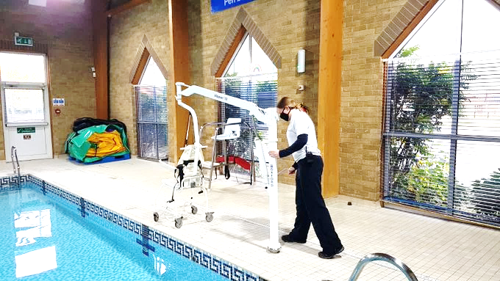
Hoists at 2 Wrexham Swimming Pools

As part of our ongoing commitment to accessibility, we have installed hoists at our swimming pools located at Waterworld and Chirk Leisure and Activity Centre.
********************
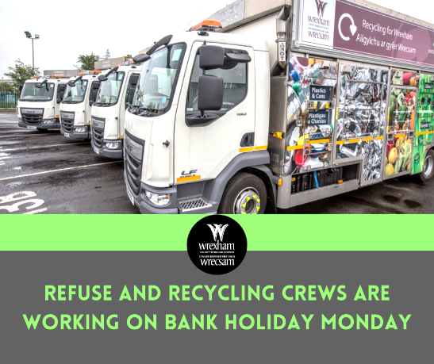
Our refuse and recycling crews will be working on Monday, January 3, even though it’s a bank holiday.
If your collection day is on Monday, please put your general waste, recycling and food waste out to be
collected.

*************************

Ryan Reynolds and Rob McElhenney donate £10,000 to a fundraiser after the tragic death of one of the players’ babies.

Baby Arthur was born on December 14 to parents Kesley Edwards and Wrexham midfielder Jordan Davies, 23, but sadly he was stillborn.
The grieving parents have since set up the fundraiser after receiving support from stillbirth and neonatal death charity Sands following the tragedy.
Shortly after the ‘gofundme’ page was created on New Year's Day, a donation of £10,000 was made by "Rob, Kaitlin, Ryan and Blake For Arthur".
Thanks to this donation, the pair have now raised almost £12,500 for the charity, which supports anyone affected by the death of a baby.
On the fundraising page Ms Edwards said: "Our baby boy, Arthur Andrew Davies was born sleeping on the 14th December 2021.
"The support we received during this time was amazing.
"The suite is away from the labour ward and provided accommodation with a kitchen, lounge, bedroom and bathroom to make the circumstances as nice as possible.
"The midwives provided around the clock care and made sure we were comfortable and they really couldn’t do enough for us.
"We were given the time we needed with our boy and were supported throughout.

Wrexham player, Jordan Davies (Image: Hadyn Iball / North Wales Live)
"They also provided us with a memory box with things to cherish forever.
"We are forever grateful for Sands and all the staff in the Wrexham Maelor."
Sands works in partnership with health professionals to try to ensure that bereaved parents and families receive the best possible care and funds research that could help to reduce the number of babies dying and families devastated by this tragedy.

Sign up to the North Wales Live newsletter

Did you know we offer a free email newsletter service?
Each North Wales Live bulletin delivers the latest breaking news, what's on events and the hottest talking points straight to your inbox.
For more information about how to subscribe click here.
A heartbroken Ms Edwards has also tweeted about her experience, stating that "no one should ever have to go through the pain of losing their baby", adding that she hopes Arthur's fundraiser will help other grieving families.
Following Arthur's death, Davies, who is in his second spell with the Welsh side, shared the news on social media, writing: "We never got to spend our lives with you, but you have placed a huge mark on our hearts, forever. Heaven has gained a perfect little angel!"
To pay tribute to Arthur or leave a message of support for Kelsey and Jordan please use the comments section below or visit the gofundme page here.
**************************

Ruabon Library will be open again
on Wednesday 5th January

LLyfrgrell Rhiwabon / Ruabon Library
High Street, Ruabon, LL14 6NH
01978 822002
ruabon.library@wrexham.gov.uk
Opening Hours
Monday 12.00pm – 5.00pm
Tuesday Closed
Wednesday 12.00pm – 5.00pm
Thursday 9.00am – 1.15pm
Friday 12.00pm – 5.00pm
*******************
- Gwau a Sgwrs
- Dydd Gwener 2pm – 4pm
Knit and Natter
Fridays 2pm – 4pm
*************************
Grwp Sgwrsio
Dydd Llun 2pm – 3pm
Welsh Second Language Conversational Group
Mondays 2pm – 3pm
******************
Stori a Chân
Dydd Llun 1:15pm
Story and Rhyme
Mondays 1.15pm
*******************

***********************************

I do hope you all will be able to have a really enjoyable year
in

