Ruabon News Letter 403
05.12.2021
Christmas Celebrations at St Mary’s Church
A Christmas Tree Festival has been agreed, when trees will be welcomed on the 10th of December.
Viewing the trees will be from 11th to the 31st December.
An outdoor nativity with a donkey, has also been agreed to take place on Saturday 18th December.
Of course all best laid plans depend on any future restrictions, which may be imposed when the outcome of the variant Omicron has been tested.

“Light up a Life”
event for
Nightingale House Hospice
at
St Mary’s Church, Ruabon
on
Thursday 9th December at 6.30pm
This campaign gives everyone the opportunity to remember and to celebrate a loved one’s life in a positive way.
By donating to Nightingale House, we will enter the loved one’s name into our ‘Book of Honour’ and will also light up a light on the hospice tree of lights in the hospice grounds as well as entering their names into our ‘Books of Honour’.
Every year in or around early December, we hold a Light up a Life service in Wrexham (this year at St Giles Parish Church in Wrexham) and also at other Churches within our community.
One such service is at St Mary’s Church Ruabon, which is a shared service between St Mary’s, Ruabon and St Mary’s Chirk.
Even if their loved one hasn’t been a patient at our hospice, their families are still most welcome to dedicate a light for them and join
Us at one of our services, including those families whose loved ones have sadly passed away as a result of Covid
**************************************

Rachel Taylor – Captain of the Women’s Welsh Rugby teamwas at Ysgol Rhiwabon recently to coach the girls’ rugby team.
Joined by the Ysgol Dinas Bran team, Rachel put the two teams through their paces, and passed on her experience to the up-and-coming players.

Thank you to Dawn Hughes Lloyd, Ruabon Practice Manager for sending in the following information
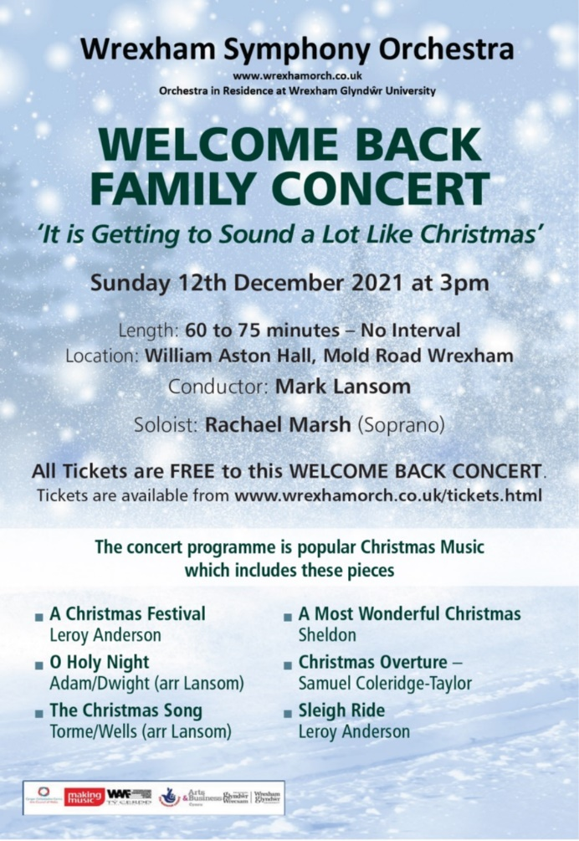

Ken Skates MS | Clwyd South
02/12/21
‘Tremendous’ Clwyd South Care Homes highlighted in the Senedd
Member of the Senedd Ken Skates highlighted the ‘tremendous’ efforts of care homes in his constituency throughout coronavirus pandemic in the Senedd this week.
During questions to the Minister for Health and Social Services, the Clwyd South MS took the opportunity to ask what the Welsh Government is doing to help drive recruitment into the social care sector in North Wales and pressed the Minister on how the recent
announcement of £42m of extra funding – in addition to the £248m already confirmed – will benefit local care settings.
Deputy Minister for Health and Social Services, Julie Morgan, said “the Welsh Government was funding a national advertising and social media campaign to attract more people to the care sector, adding: “We are supporting a range of targeted initiatives to encourage the take-up of employment in social care. We fund regional staff to support campaigns led by local authorities and by health boards.”
Mr Skates said: “Thank you, Minister, that’s excellent to hear, and I’m sure you’d agree that throughout the pandemic care homes in my constituency of Clwyd South have dealt incredibly well with the huge challenges that coronavirus has brought, often to the
detriment of both the physical and the mental health of staff.
“On behalf of those care settings in my constituency, can I ask how the £42m of extra funding announced by the Welsh Government will help them?”
The Deputy Minister responded: “I thank Ken Skates for his recognition of the tremendous work that has been done in the care sector during the pandemic.
“We were very pleased to allocate the additional £42m, and that was announced through the health and social care winter plan. And the winter plan sets out how this investment will provide community-based integrated responses, and additional support for carers
and for families.
“I know that the recovery plan responses we have received from local authorities show that Clwyd South will benefit from targeted financial support for providers of social care, increasing the current number of volunteers and the recruitment of additional workforce
for specific service areas such as complex disability services, domiciliary care, children's services and supported living.
“Where providers have not been able to resume the provision of day-care services, for example, there will be financial support and also investment to support additional technology within residential facilities and more activities for residents.”
Afterwards, Mr Skates said: “Staff and volunteers at care homes in Clwyd South have gone way above the call of duty during the pandemic, adapting to their world being turned upside down on top of the usual demands of providing such professional and compassionate care.
“The demands on the social care settings have never been greater, and I’m pleased the Welsh Government has recognised this and shown its commitment to supporting them.”
The Welsh Government’s NHS winter plan was published recently after months of planning and significant investment in health and social care to mitigate the effects of the pandemic.
More than £248m has already been invested through the NHS recovery fund to help health boards tackle waiting times and transform the way they deliver services such as non-urgent patient transport, which will help ease pressure on ambulance services and ensure patients can access the care they need.-Ends-
**********************************

Ken Skates MS | Clwyd South
02/12/21
Shoppers urged to support small businesses
in run-up to Christmas

People are being encouraged to shop local ahead of Small Business Saturday.
Local Member of the Senedd Ken Skates is backing the grassroots campaign, which urges consumers to help high street shops and independent businesses in their communities.
Saturday (December 4) marks this year’s campaign, and the Clwyd South MS wants to see the small local firms who ‘have gone above and beyond’ during the pandemic supported in the run-up to Christmas and into 2022.
Mr Skates said: “The campaign aims to make a positive lasting impact on small businesses. It’s more important than ever this year that we shop locally and support those businesses that have supported us throughout these incredibly difficult times.
“Our small businesses have gone above and beyond throughout the coronavirus pandemic.
“As I have said many times before, they are the lifeblood of our towns and villages here in Clwyd South. Research has shown that for every £1 spent with a small or medium-sized business around 63p stays in the local economy, compared to 40p with a larger company.
“Shopping local creates more local jobs, it’s better for the environment and it helps to make sure our local shops and services continue to be the backbone of our high streets.”
To highlight the campaign, Mr Skates visited small businesses in Llangollen this week.
He added: “Small local businesses are often competing with the big guns – multinational chains and major franchises backed by huge advertising and marketing budgets.
“A lot of small businesses like IT-Pro, ProAdventure and SFTW have built their excellent reputations up through sheer hard work and word of mouth, and they’re just three of the dozens of fantastic examples in Llangollen and the hundreds across Clwyd South.”
The Welsh Government has targeted much of its £1.7bn+ support package – the most comprehensive anywhere in the UK – towards small businesses throughout the pandemic.
In June, Welsh Ministers extended the 100% discount for all businesses and charities in the leisure and hospitality sectors until April 2022. Retailers in properties with a rateable value of up to £500,000 will also continue to receive full discounts for the remainder of the year.-Ends-
***************************************
Ken Skates MS welcomes changes
to improve access to GPs in Clwyd South
Member of the Senedd Ken Skates MS has welcomed the announcement of changes at GP surgeries in Clwyd South which will help to end the 8am scramble to book an appointment.
Health Minister Eluned Morgan announced the measures this week as part of an agreement to change the current GP contract.
The changes, which are backed by £12m of extra investment from the Welsh Labour Government, will help end the morning scramble to book an appointment. The revised contract will make it clear the practice of releasing appointments daily at 8am is no longer acceptable.
Instead, the new GP access commitment will help ensure people are triaged appropriately. If an appointment is needed, people will receive one which is right for their clinical needs.
Where appropriate, people may also be signposted to another service – or healthcare professional – who can help or support them.
The new General Medical Services (GMS) contract deal will also include an uplift to pay for GPs and practice staff and extra funding to increase capacity and staffing to help to respond to winter pressures.
Welcoming the changes, Ken Skates said: “I am very pleased that the Welsh Labour Government has agreed a new contract with GPs which significantly improves the way in which appointments are currently handled.
“These new changes will allow practices to better manage patient needs, and will put an end to the 8am bottleneck where patients have to telephone numerous times in an attempt to secure an appointment.

“I am also glad that the agreed changes also reward all staff working in general practice with a pay rise.”
The £4m of extra funding will be made available to GPs for the next three financial years to ensure the retention of the additional capacity and in support of the commitment made around access to services. ENDS.
**********************************
There’s some very special visitors to Tŷ Pawb this December as life size Singing Penguins are set to take centre stage and are sure to be a hit with old and young alike.
There are three in total all singing festive songs in beautiful harmony
The food court will be holding music on 10th December.
A Comedy Night will be held on 10th December and there will be a ‘Wrexham Makers Market’ on 11th December.
To complement the penguins there’ll be Penguin Crafts on 11th December and a screening of children’s favourite “Happy Feet” on 18 December.
All the above events are free to enter and you can find out more details on the Tŷ Pawb website.
For £3 per person there is “Winter Print Making” on 18th and 23rd December.
There’s also a Christmas Party Night with popular band Rhythm Train. This takes place between 7.30pm to 12 midnight/tickets cost £12 per person.
Rhythm Train hail from Wrexham and the five highly experienced musicians guarantee a unique, lively and polished event!
****************************************

LETTERS TO SANTA AT WREXHAM LIBRARY
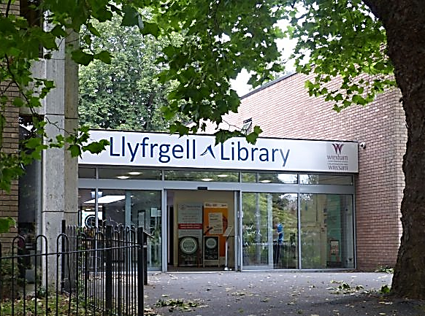
Thinking of writing a letter to Father Christmas this year? Why not send it from Wrexham Library.
Once again Wrexham Library will be collecting your Christmas letters and sending them off to everyone’s favourite jolly bearded gentleman.
Simply collect your writing paper from the library, post your letters to Santa in their festive post box and receive a reply from the man himself!
Replies will be available within a week, and available to collect from their festive display.
******************************

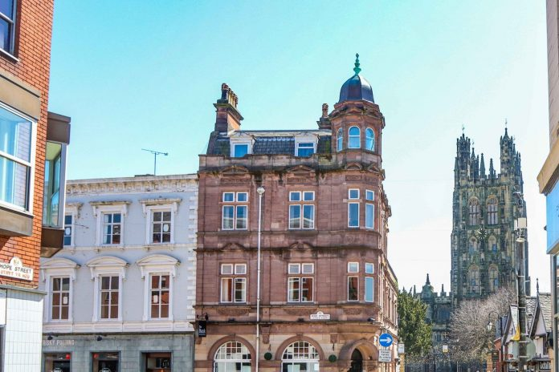
CITY STATUS BENEFITS STATEMENT SUMMARISES THE 10 KEY

BENEFITS FOR WREXHAM

A summary of the independent work for city status outlining the key benefits of city status is being shared with Councillors, partners and residents in advance of the decision that will be taken by the Council in December.

The statement identifies 10 key benefits that Wrexham could capitalise on if it becomes a city, including:
- Increased sense of local pride.
- A platform to promote Wrexham.
- Opportunities for local institutions and businesses to raise their profile and attract investment. e.g. University
- More potential to attract skilled and ambitious students, employees and investors to Wrexham. e.g. Hospital
- Opportunities for the community, infrastructure, and services to grow and develop more sustainably.
- A focus for future branding and marketing campaigns.
- Greater awareness of Wrexham’s history, culture and language – attracting more visitors and supporting the local economy.
- More potential to attract major projects.
- The ability to collaborate with Welsh and UK cities on specific city projects and initiatives.
- Increased expectations of ‘place making’ that in turn create more vibrant places to live, work and invest.

The statement has been published ahead of a key decision by Wrexham Council’s Executive Board on whether to submit a bid for city status and was part of the decision agreed at Council to promote the benefits as widely as possible.

Councillor Mark Pritchard, Leader of Wrexham Council, says:
“The statement has been written by the experts appointed to look at city status as part of a wider piece of place shaping work and summarises the key benefits from their research. This statement provides all of us in Wrexham with a really valuable insight and short summary into the key benefits of becoming a city.”

Councillor David A Bithell, Deputy Leader of Wrexham Council, adds:
“The report makes it clear that city status would be part of a bigger place shaping picture, and one of many tools that will help strengthen community well-being, identity and pride in Wrexham.”

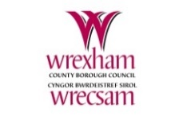
LLyfrgrell Rhiwabon / Ruabon Library
High Street, Ruabon, LL14 6NH
01978 822002
ruabon.library@wrexham.gov.uk
Opening Hours
Monday 12.00pm – 5.00pm
Tuesday Closed
Wednesday 12.00pm – 5.00pm
Thursday 9.00am – 1.15pm
Friday 12.00pm – 5.00pm
*******************
Gwau a Sgwrs
Dydd Gwener 2pm – 4pm
Knit and Natter
Fridays 2pm – 4pm
*************************
Grwp Sgwrsio
Dydd Llun 2pm – 3pm
Welsh Second Language Conversational Group
Mondays 2pm – 3pm
******************
Stori a Chân
Dydd Llun 1:15pm
Story and Rhyme
Mondays 1.15pm

This latest news brings Ruabon Library
ALMOST back to normal!
Thank you to Paul Tincello for the following information:
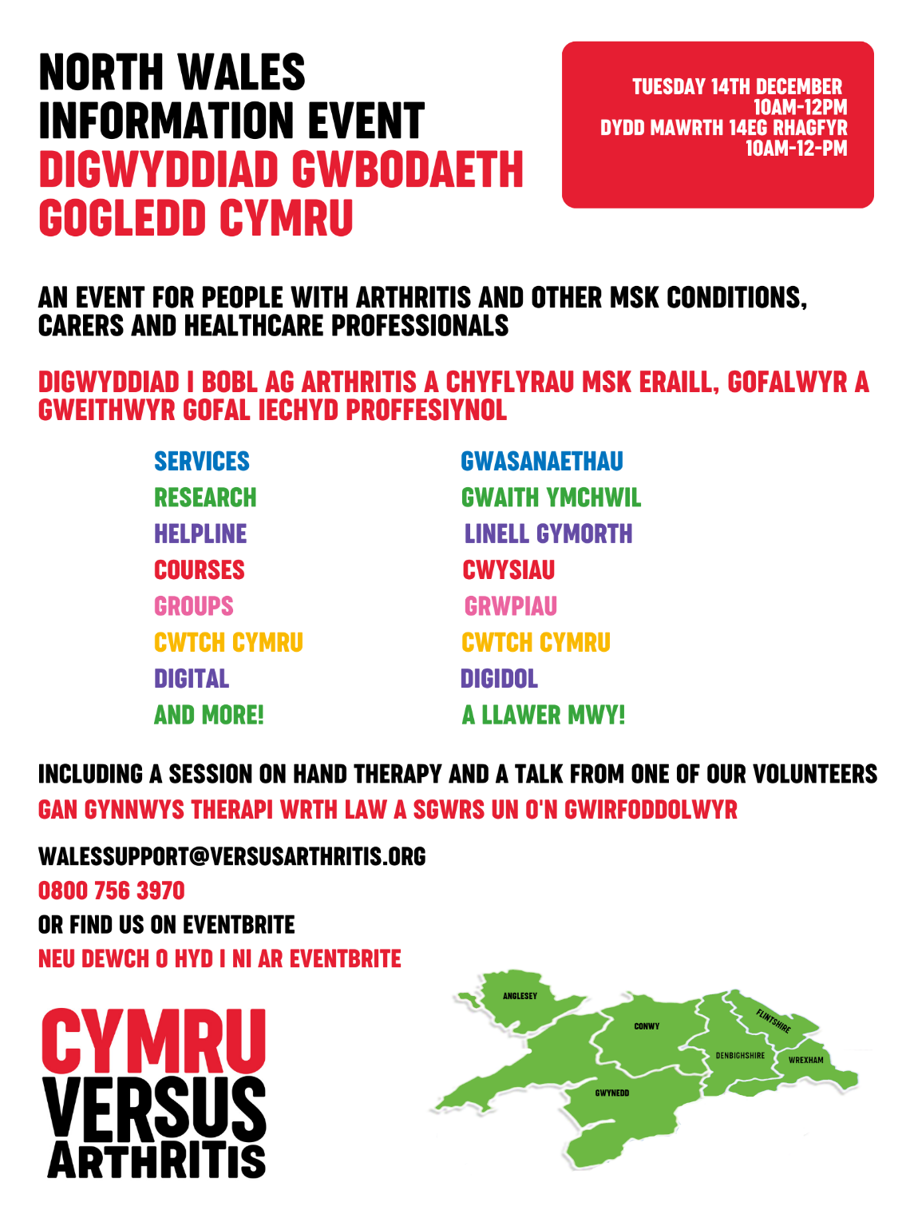
Cymru Versus Arthritis Information Event. Here is the link to the event:Registration:https://www.google.com/search?q=Cymru+Versus+Arthritis+Information+Event&rlz=1C1AVFC_enGB806GB807&oq=Cymru+Versus+Arthritis+Information+Event&aqs=chrome..69i57j33i160.7584j0j7&
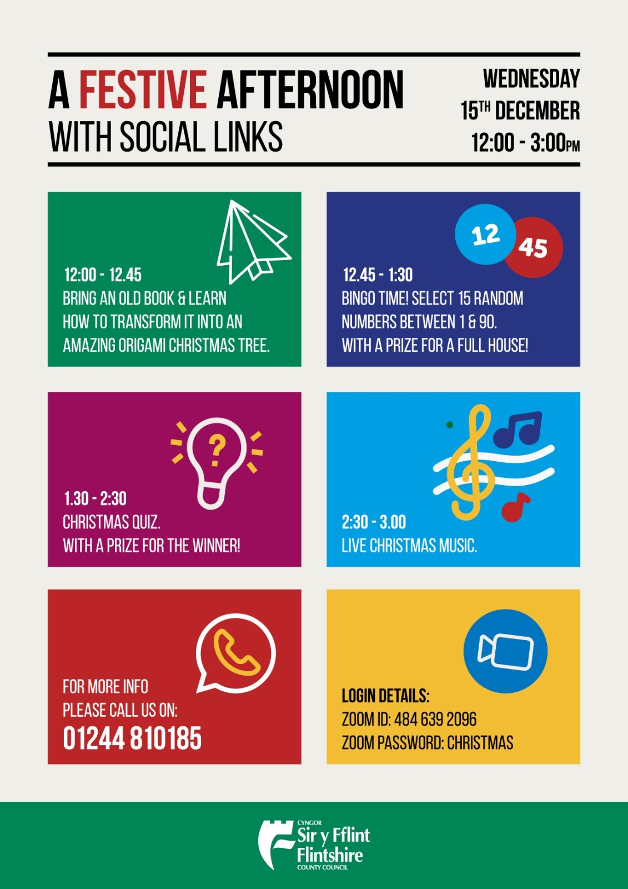

For those of you who missed seeing the following petition:
The Senedd is going to debate the petition that people signed:
“New laws to protect rare red squirrels from habitat loss which causes population decline”. https://petitions.senedd.wales/petitions/244852
The debate is scheduled for 8th December 2021.
Once it has been published, you will be able to find the agenda for the meeting here: https://business.senedd.wales/ieListMeetings.aspx?CommitteeId=401
You’ll be able to watch online on https://www.senedd.tv/
Once the debate has happened, we will email you a video and transcript. Thanks, The Petitions team, Senedd.
*******************************

