**Ruabon News Letter 400**

**15.11.2021**

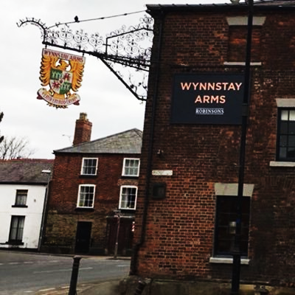

**A message from**

The Wynnstay Arms Hotel

Ruabon

**Don't know where to hold your Christmas works do this year or maybe you just want to party the night away with friends?**

**Why not join us at The Wynnstay Arms in Ruabon for our Christmas Party Nights on**

***Friday 10th December***?

***Saturday 11th December***?

***Friday 17th December***?

***OR*** ***Saturday 18th December***?

**Tickets are £15.00 each, which include: Christmas Buffet and DJ to dance the night away.**

**Bar closes @ 11.30pm**

**For tickets:**

**Pop in or call the Wynnstay on 01978 822 187**

*******************

**LLyfrgrell Rhiwabon / Ruabon Library**

**High Street,**

**Ruabon**

**LL14 6NH**

**Description: Description: Description: cid:image001.png@01D12868.DFDFC8F0 01978 822002**

Description: Description: Description: http://www.wrexham.gov.uk/assets/png/address.png **ruabon.library@wrexham.gov.uk**

**Opening Hours**

Monday 12.00pm – 5.00pm

Tuesday Closed

Wednesday 12.00pm – 5.00pm

Thursday 9.00am – 1.15pm

Friday 12.00pm – 5.00pm

*******************

Llyfrgell Rhiwabon

**Gwau a Sgwrs**

Dydd Gwener 2.00 – 4.00

Ruabon Library

**Knit and Natter**

Fridays 2:00 – 4.00

**Llyfrgell Rhiwabon**

**Ruabon Library**

**Welsh Second Language**

**Conversational Group**

**Grwp Sgwrsio**

**Dydd Llun Tachwedd 1af: 2pm-3pm**

**Monday, 1st November:** **2pm-3pm**

************************

**Llyfrgell Rhiwabon**

Stori a Chân

Dydd LLun, 8 Tachwedd 1:15

**Ruabon Library**

**Story and Rhyme**

Monday, 8 November 1:15pm

[](https://pixabay.com/photos/book-star-open-book-magic-read-2160539/)*****************************

Ydych chi yn mwynhau darllen?

**Do you enjoy reading?**

**Fyddech chi yn hoffi rhannu a chymharu eich profiad o ddarllen?**

**Would you like to share and compare your**

**reading experience?**

Byddem yn hoffi eich gwahodd i gyfarfod ar

**Ddydd Mercher 1 Rhagfyr am 2yp**

i drafod aildechrau y

**Grwp Darllen** yn **Llyfrgell Rhiwabon**

**We would like to invite you to a meeting on**

**Wednesday 1st December at 2pm**

**to discuss restarting the**

**Reading Group in Ruabon Library**

**Am fwy a fanylion ffoniwch 01978 822002**

**For more information call 01978 822002**

**\*\*\*\*\*\*\*\*\*\*\*\*\*\*\*\*\*\*\*\***

**BOOKINGS ARE NOW BEING TAKEN-**

**FOR MONTHLY EXHIBITIONS TO TAKE PLACE**

**AT RUABON LIBRARY**

**(NOVEMBER 2021 has already been booked!)**

**\*\*\*\*\*\*\*\*\*\*\*\*\*\*\*\*\*\*\*\*\*\*\*\*\*\*\***

**PONTCYSYLLTE AQUEDUCT AND CANAL WORLD HERITAGE SITE WEBSITE RELAUNCHED AFTER MAKE-OVER**

November 12, 2021

[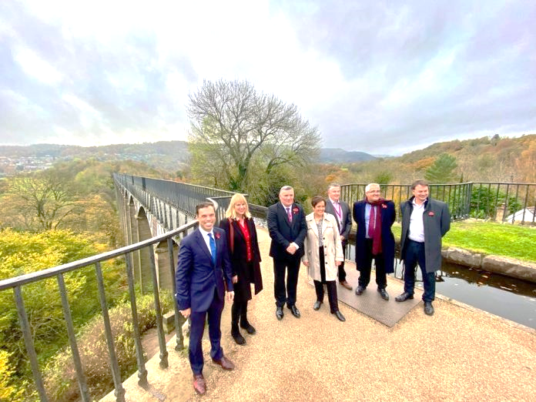](https://news.wrexham.gov.uk/wp-content/uploads/2021/11/Aqueduct-website-makeover.jpg)The Pontcysyllte Aqueduct and Canal UNESCO World Heritage Site website has had a makeover to meet accessibility standards, making it easily available and fully bilingual on mobile phones and tablets.

In addition to the new look, the website now offers access to new learning content and collections not normally available, giving a virtual experience from home, allowing you to watch, read and discover this iconic place and experience some of the greatest aqueducts, tunnels, cuttings and embankments ever built.

This has been achieved through the addition of new education and learning activities for families and schools, telling the story through objects and the creation of virtual tours of the 11 mile corridor.

The website was launched during a visit from the Deputy Minister for Arts and Sport, Dawn Bowden to Pontcysyllte Aqueduct and Canal World Heritage Site.  During the visit, the Deputy Minister, said; “I’m delighted to visit this remarkable site – and to meet with people who have such a passion for this World Heritage Site.  The new website will help to introduce the aqueduct and canal to new audiences of all ages.

“The past eighteen months has been challenging for so many sectors, and I’m pleased to hear that the Cultural Recovery Funding from the Welsh Government has been of assistance during this difficult time.

“It’s great to hear that the team is now looking to the future and at plans which will ensure that the Pontcysyllte Aqueduct and Canal World Heritage Site continues to deliver benefits, both economic and cultural for our communities, our businesses and our young people – and to be a positive beacon promoting the region and Wales throughout the world.”

Ian Bancroft, Chair of the World Heritage Site Board said “The updated website gives all the information you need to visit not only the Pontcysyllte Aqueduct but also the surrounding towns, villages and attractions along the 11 miles of the World Heritage Site.

“Along with Wales’ other three World Heritage Sites – Pontcysyllte is a vital cog in Wrexham’s tourism offer and having this easily accessible modern website will only further enable a greater understanding of the site and allow visitors to plan ahead in order to continue visiting this remarkable area.”

Mark Evans, director for Wales from Glandŵr Cymru, said: “The 11 miles of the UNESCO World Heritage Site attracts thousands of boaters and tourists to Wales every year. The website will now help promote this special site across the world and allow people to discover the history of this globally important heritage site.

“The Llangollen Canal is part of this beautiful landscape and is home to some engineering masterpieces, including the impressive Pontcysyllte Aqueduct, which is well worth a visit for the views over the Dee Valley.

“Our research shows spending time next to water makes us all feel happier and healthier so plan your visit today and come and see this wonderful part of Wales.”

Cllr Terry Evans, Lead Member for Economic Development and Regeneration, said, “Having a website that is both modern and fully accessible to all is essential to satisfy the global audience that this site attracts.

“It also gives a virtual visitor experience for those who are not fortunate enough to be able to visit in person. I would like to thank everyone involved for their work on this website and look forward to seeing the progress on the Business Ambassador Scheme.”

World Heritage Site Business Ambassador Scheme.

The website will continue to develop with the introduction later in the year of a World Heritage Site Business Ambassador Scheme which builds on the existing North Wales Tourism Ambassador scheme.

It’s designed for tourism businesses from within the 11-mile World Heritage Site to be featured following the completion of a couple of short modules, showing a commitment and dedication to going that extra mile to advocate the area to visitors.

This will help support post Covid tourism business recovery and continue to develop a thriving tourism economy, with truly passionate people at the heart of it.

You can visit the website at [www.pontcysyllte-aqueduct.co.uk](http://www.pontcysyllte-aqueduct.co.uk/)

[*SAFLE TREFTADAETH Y BYD DYFRBONT PONTCYSYLLTE A’R GAMLAS*](https://www.pontcysyllte-aqueduct.co.uk/cy/)

The new look website has been supported by funding from the Welsh Government’s Regional Tourism Engagement Fund and new activities funded through Wales Cultural Recovery Fund.

This exciting project has been developed on behalf of the World Heritage Site by Glandŵr Cymru, the Canal and River Trust in Wales, in partnership with Wrexham Council and provides information and a great educational resource to prospective visitors, enabling them to plan their visit.

***************************

**The Wrexham Town Centre Policing team is continuing its ‘OP BLUE INSTINCT CAMPAIGN’**

to prevent residents becoming a victim of burglary.

Being a victim of burglary is a scary prospect but you can prevent this by taking some simple but effective measures:

* Lock your door and windows even when home
* Don’t leave your home in darkness, leave a light on or use a light timer to give the impression someone is in
* Keep valuables out of sight from windows and keys out of reach from doors

Door step crime can take many forms and is carried out by criminals that target those most vulnerable in our communities. Always be on your guard and if you’re unsure don’t open your door. If in doubt keep them out!

If you are caught off guard let your local policing team know as soon as possible. They can help. Call 101 or report online at [www.northwales.police.uk/contact/live-chat-support](http://www.northwales.police.uk/contact/live-chat-support).

In an emergency always call 999!

You can also report any rogue traders and bogus callers to Wrexham Trading Standards on 01978 298997 or visit [trading.standards@wrexham.gov.uk](mailto:trading.standards@wrexham.gov.uk).

Wrexham Town Neighbourhood Policing Team Sergeant Dave Smith, said, “The nights are drawing in, which means that you may be getting home from work after it goes dark and unlit houses attract criminals.

“There’s lots you can do including using automatic timers or motion sensors and if possible installing CCTV. Try to arrange for someone to take in any parcels you are expecting to avoid them being left out for any length of time.

“We should all be on the lookout for scams and cold callers and report them as soon as possible.

“We’ll be out and about in the community over the coming weeks and will be happy to offer to advice about how to stay safe in the winter months.

**”Neighbourhood Watch groups**

You’re also encouraged to help look after each other by signing up to the [Community Alert Scheme](https://www.northwalescommunityalert.co.uk/) and consider joining or forming a [Neighbourhood Watch Group](https://www.northwales.police.uk/advice/advice-and-information/wsi/watch-schemes-initiatives/neighbourhood-watch/).

By working together, burglars will be deterred from areas that are ***taking action, to keep them out.***

Thanks to Paul

Tincello for the

following

information.

**Subsidised Places Available for Intensive Leadership Training**

 Organisations from Wales are being invited to apply to Spring Impact’s Scale Accelerator Programme, in what will be the final opportunity to benefit from National Lottery Community Fund subsidised places.   
You can find further information at: [https:**//wcva.cymru/subsidised-places-available-for-intensive-leadership-training/**](https://wcva.cymru/subsidised-places-available-for-intensive-leadership-training/) **Applications are open until 17th of January 2022**. To find out more visit[**Spring Impact**](https://flvc.us14.list-manage.com/track/click?u=8a46a8b28bb94092e3b49979b&id=883c45033c&e=006862eff8). Date for your diary – Spring Impact will be joining us for a free online event **on 30th November at 2 pm** to tell us more about the Scale Accelerator: Leaders of Scale programme. For more information, please visit WCVA’s [Events page](https://flvc.us14.list-manage.com/track/click?u=8a46a8b28bb94092e3b49979b&id=b4304d572d&e=006862eff8):

**https://www.eventbrite.co.uk/o/wcva-cggc-12161492678**

**************************

***Glyndŵr University announces new  
BSC (Hons) Nutrition and Dietetics Degree from 2022***

 It will offer the chance to work closely with local partners within health, social care, and industry to offer student dietitians an inclusive, supportive, and enjoyable university experience that is unique to the North Wales area.  Graduates are eligible for full membership of the British Dietetic Association (BDA) and associated specialist groups.   
The degree confers eligibility for registration with the Health and Care Professions Council (HCPC) to practice as a Dietitian in the UK.  For more information about the BSc (Hons) Nutrition and Dietetics course, please visit: [***https://glyndwr.ac.uk/courses/Undergraduate-courses/Nutrition-and-Dietetics/***](https://glyndwr.ac.uk/courses/Undergraduate-courses/Nutrition-and-Dietetics/)

*********************

**Tesco Community Grant**

 Tesco are looking for applications from local community groups across the regions of North Wales to apply for funding, with a focus on:

* young persons and families,
* food poverty and
* food insecurity

The grant is open to all registered charities and not-for-profit organisations, with priority given to projects that provide support to young people, we are looking for applications for your local store. Grants are awarded through a public vote in store, the 1st place project will be awarded a maximum available amount of £1500, with £1000 and £500 also available for 2nd and 3rd places.  
 If you would like to apply the website is [https://tescocommunitygrants.org.uk/](https://flvc.us14.list-manage.com/track/click?u=8a46a8b28bb94092e3b49979b&id=5c23e6e89f&e=006862eff8)  which includes the online application form.  
 The guidance and advice for the grant is here: [https://docs.google.com/document/d/1_gCLGVkpswQ9x6INcmRyHdh05cgdzLnZDPmBZj7O9iw/edit](https://flvc.us14.list-manage.com/track/click?u=8a46a8b28bb94092e3b49979b&id=77f5dd2079&e=006862eff8)  
 The deadline for applications is **26th November 2021**  
If you have any queries about the grant please contact Geraint Hughes [Geraint.Hughes@groundworknorthwales.org.uk](mailto:Geraint.Hughes@groundworknorthwales.org.uk)

****************************

**Your Community, Your Choice: Community groups in Flintshire are being urged to bid for a share of a £60,000 pot of money seized from criminals**

 The initiative is a partnership between North Wales Police and Crime Commissioner, Mr Dunbobbin, the North Wales Police and Community Trust (PACT) and North Wales Police. According to Andy Dunbobbin, the Your Community Your Choice fund will be used to recycle the ill-gotten gains of criminals for the benefit of communities across the region.  
 The Your Community Your Choice fund will open for applications on 15 November, with a deadline of 10 December 2021.  A shortlist of applicants will be chosen by a special panel and voting opens on January 10 and runs until February 4, and winners will be chosen by a public poll.

* 3 community groups in each county in North Wales will receive up to £2,500 each.
* 3 organisations working across three or more counties will receive £5,000 each.

All bids need to support the commissioner’s Police and Crime Plan in which delivering safer neighbourhoods and supporting communities are key priorities.  
 **Completed applications must be returned by e-mail to** [yourcommunityyourchoice@nthwales.pnn.police.uk](mailto:yourcommunityyourchoice@nthwales.pnn.police.uk) **by 5pm on the closing date of 10th of December 2021**.  
For more information go to the PACT website [www.pactnorthwales.co.uk](https://flvc.us14.list-manage.com/track/click?u=8a46a8b28bb94092e3b49979b&id=6a085303ba&e=006862eff8)

*****************************

**National Bereavement Support Grant Launched**

 The Bereavement Framework offers funding support to organisations that commission or provide bereavement services.  Unfortunately, not everyone will have the support they need to help cope with the grief of losing a loved one and some additional help may be necessary.   
This is why on 29 October 2021, The Deputy Minister for Mental Health and Well-being, Lynne Neagle launched [the National Framework for the Delivery of Bereavement Care in Wales](https://flvc.us14.list-manage.com/track/click?u=8a46a8b28bb94092e3b49979b&id=1d7e9d91e3&e=006862eff8)**.**  
 Several voluntary organisations were actively involved in the National Bereavement Steering Group and contributed to the development of the Framework.  
The framework is being supported by a £1m Bereavement Support Grant for 2021 to 2024. Any voluntary organisation can apply and applications from a collaboration of organisations is also welcome, but Projects need to be in line with the three components of bereavement support described by the National Institute for Health and Clinical Excellence (NICE). [More information about project criteria is available](https://flvc.us14.list-manage.com/track/click?u=8a46a8b28bb94092e3b49979b&id=09d9624732&e=006862eff8) on the application page.  
The framework recognises the compassionate nature of people in Wales when supporting those facing the loss of a loved one. It also sets the urgent goal to do this more fairly across the whole of Wales, to better support those who need it.  
**The deadline for applications is 4 pm, Friday 26 November 2021.**

**[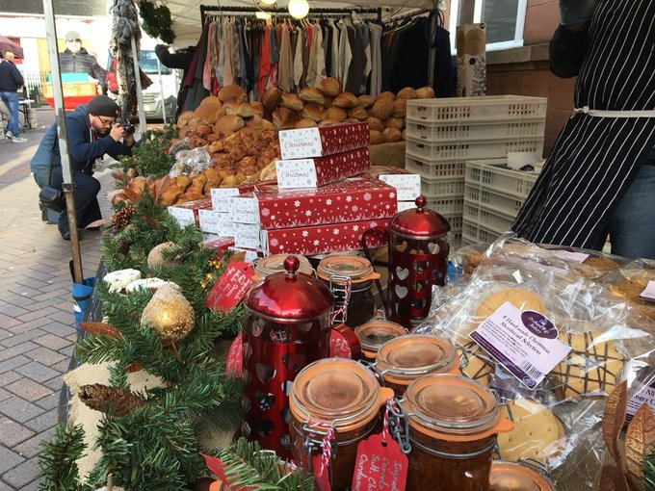](https://twitter.com/wrexhamcbc/status/1459114335406628865/photo/1)**\*\*\*\*\*\*\*\*\*\*\*\*\*\*\*\*\*\*\*\*\*\*\*\*\*\*\*\*\*\*\*\*\*\*

**The annual Victorian Christmas Fair makes a welcome return on Thursday 9th December when it opens to the public at 12 noon.** <https://orlo.uk/qiHrn>

**[](https://news.wrexham.gov.uk/wp-content/uploads/2021/11/World-childrens-day.jpg)**\*\*\*\*\*\*\*\*\*\*\*\*\*\*\*\*\*\*\*\*\*\*\*\*\*\*\*\*\*\*\*\*\*\*\*\*\*\*\*\*\*\*\*\*\*\*\*\*\*\*\*\*

**This week, Wrexham will be turning blue to celebrate World Children’s Day**

and you are invited to come along to Ty Pawb for a great day of fun. On November 18, come along to Ty Pawb, 3-7.30pm, and join in our free celebration with free food, information market stalls, play activities, live music, open mic, magic and much more. We would love to see everyone have fun at the open mic so bring your instruments!!

* We will also be judging the ‘What does having a voice mean to you?’ competition. Children and young people can win a £100 voucher of their choice by creating a piece of work in any medium – written, art, music, video etc. The deadline for entries will be November 16 and there will be three age categories – 10 and under, 11-16 years and 17-25 years.

If you would like any further information please contact us on [youngvoices@wrexham.gov.uk](mailto:youngvoices@wrexham.gov.uk) or phone Caroline 07800688979, Tricia 07800688985 or Jane 07808787777.

We are looking forward to seeing you at our event and your competition entries.

We are also asking you to wear something blue (the internationally recognised colour of World Children’s Day) on the day to help bring attention to the importance of children’s rights.

The official date of World Children’s Day is November 20, when Wrexham Council will be turning the Guildhall blue! Other buildings across North Wales will be doing the same so keep a look out if you are out and about. If you are in Wrexham at 5pm on the day, why not stop by the Guildhall and have your photo taken to show your support for children’s rights.

************************

The Wrexham Town Centre Policing team is continuing its Op Blue Instinct campaign to prevent residents becoming a victim of burglary.

Being a victim of burglary is a scary prospect but you can prevent this by taking some simple but effective measures:

* Lock your door and windows even when home
* Don’t leave your home in darkness, leave a light on or use a light timer to give the impression someone is in
* Keep valuables out of sight from windows and keys out of reach from doors

Door step crime can take many forms and is carried out by criminals that target those most vulnerable in our communities. Always be on your guard and if you’re unsure don’t open your door. If in doubt keep them out!

If you are caught off guard let your local policing team know as soon as possible. They can help. Call 101 or report online at [www.northwales.police.uk/contact/live-chat-support](http://www.northwales.police.uk/contact/live-chat-support).

In an emergency always call 999!

You can also report any rogue traders and bogus callers to Wrexham Trading Standards on 01978 298997 or visit [trading.standards@wrexham.gov.uk](mailto:trading.standards@wrexham.gov.uk).

Wrexham Town Neighbourhood Policing Team Sergeant Dave Smith, said, “The nights drawing in means that you may be getting home from work after it goes dark and unlit houses attract criminals.

“There’s lots you can do including using automatic timers or motion sensors and if possible installing CCTV. Try to arrange for someone to take in any parcels you are expecting to avoid them being left out for any length of time.

“We should all be on the lookout for scams and cold callers and report them as soon as possible.

“We’ll be out and about in the community over the coming weeks and will be happy to offer to advice about how to stay safe in the winter months.”

**Neighbourhood Watch groups**

You’re also encouraged to help look after each other by signing up to the [Community Alert Scheme](https://www.northwalescommunityalert.co.uk/) and consider joining or forming a [Neighbourhood Watch Group](https://www.northwales.police.uk/advice/advice-and-information/wsi/watch-schemes-initiatives/neighbourhood-watch/). By working together burglars will be deterred from areas that are taking action to keep them out.

*******************************

**Thank you to David Goodban for keeping us all up to date with information from the Senedd**

**PRESS RELEASE**

**Ken Skates MS | Clwyd South**

**15/11/21**

**Businesses asked for feedback as community bank plans progress**

***Small businesses were asked for feedback on local banking services when the man spearheading plans for the UK’s first community bank visited Wrexham.***

Clwyd South MS Ken Skates welcomed Mark Hooper from Banc Cambria to his constituency on Friday (November 12) for further discussions on how the Community Bank of Wales could benefit local communities.

Mr Skates raised the issue of local bank closures in the Senedd earlier this year after previously launching the Community Bank plans during his time as Economy Minister. His Clwyd South constituency has seen 80% of its high street banks close since 2015 – more than any other area of North Wales – and now has just one surviving branch.

He said: “Banc Cambria is working with the Welsh Government to create the UK’s first community bank, which will provide everyday banking throughout Wales. Unlike other banks, it will be owned and controlled by members – not outside shareholders.

“As I have said previously, communities right across North Wales have been abandoned by the big banks and left high and dry by the UK Government abandoning its agreement with the sector that that last branch in each community should remain open. We need this.

“While I am hopeful that Clwyd South will be chosen for one of the first few Community Bank branches in Wales, Mark’s visit was about talking to small businesses in our area and finding out what they need and how this project could help. ”After a walk around Ruabon with local councillor Dana Davies and talking to high street businesses including Ruabon Discount Store, Tracey’s Nail & Beauty Salon and Caroline’s, it was on to Cefn Mawr to chat with more small firms.

Mr Skates said: “It was really a very productive morning showing Mark around Ruabon and Cefn and talking to local businesses.”

Mr Hooper said: “Small business owners told us from first-hand experience what it’s like to operate without a local bank branch. Whether it’s depositing cash or dealing with an issue regarding mandates, you have to take time out of your business, and nobody wants that.” **Ends-**

**\*\*\*\*\*\*\*\*\*\*\*\*\*\*\***

**Thank you to John Faragher for sending in the following photo with his observation.**

**“Gossamer Spiders’ Webs**

Out walking yesterday afternoon (Sunday 14th November) with the sun so bright and low it was quite magical seeing gossamer webs covering the fields. They were only visible when looking in the direction of the sun.

John Faragher.”