Ruabon News Letter 391
13.09.2021
PE Extra Curricular Clubs
Friday, 10th September 2021
All weekly clubs will start straight after school and finish at 4:15pm. Students will need their PE kits for all after school clubs.
The timetable is as follows:
(The Lunchtime sports activities timetable will be published shortly.)
 | Activity | Year Groups | Venue
Monday | NO CLUBS DUE TO MEETINGS
Tuesday | Girls Football | All Years | Sports Hall
Wednesday | Netball | All Years | Sports Hall
 | Football | KS3 Only | School Field
Thursday | Rugby | All Years | School Field
Friday | Basketball | All Years | Sports Hall
 | Football | KS4 Only | School Field

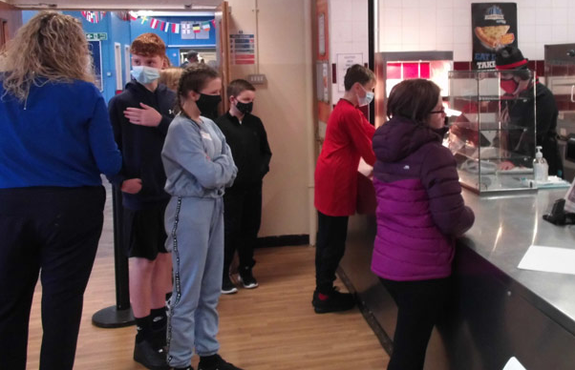
The Year 7 intake started settling into life at Ysgol Rhiwabon on their first day
Showing a form group getting to know about the Dining Hall,
Now they will be in full school uniform and feeling part of the school
Flu Vaccines (07/09/2021)
Flu vaccines have been delayed by up to 2 weeks.
We are unable to contact patients until a clear delivery date of vaccines has been confirmed. We have an update on the 09/09/2021.
We will keep patients updated as soon as we have more information.

COVID-19 vaccine booster
We are still awaiting final advice from the Joint Committee on Vaccination and Immunisation (JCVI) on the scope of the COVID-19 booster programme.
We ask those who are likely to be eligible based on the JCVI’s interim advice to please be patient and remember that there is no need to contact us to book an appointment. You will be contacted directly when it is your turn.
Due to the way in which the COVID-19 and Flu vaccinations are delivered and the expected start dates for the respective campaigns, it will not be standard practice to give people these jabs at the same time.

BD Blood Bottle Shortage (03/09/2021)
Ruabon Medical Centre have been provided with the following notice by NHS WSSP in regard to the blood bottle shortage:-
The following key messages have been issued by NHSWSSP (Briefing Note 6) for use with patients who have had their blood tests delayed due to the ongoing supply issue. Please note, the guidance issued in relation to this issue is clear that a clinical assessment of the need for a test is required. The below should only be used once that individual clinical assessment* has been undertaken.
We will be updating the website when supplies become more readily available. If you require urgent care, please call surgery for more advice. We apologize for any inconvenience this causes.

The information above has been supplied by the Ruabon Medical Centre

Ruabon Bowling Club
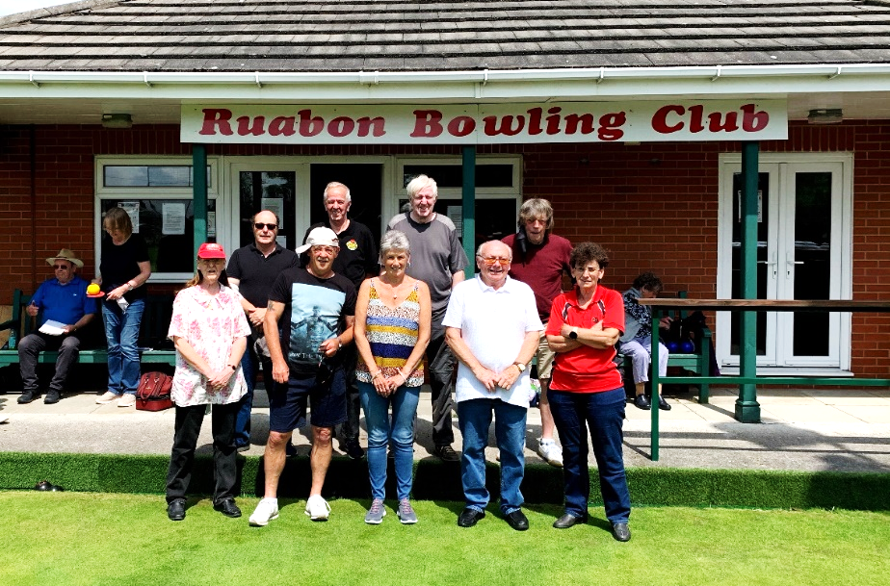

The Ruabon Vets Team formed this year
Wrexham Pairs League (Mondays)
Ruabon won 6-2 away to Johnstown A on Monday 6th Sept.
Vets League (Tuesdays)
Ruabon won 7-3 away to Bersham B on 7th September
(Oswestry League (Tuesdays)
(The Oswestry Bowling League season is now finished.
Wrexham Saturday League
Ruabon won 8-6 at home to Chirk AAA A on 11th September
**************************
Vets Social Group meets up for friendlies and general chat on Monday, Thursday and Friday mornings. Members are always looking for new members with the only criteria being: ‘you must be over 60yrs’. However, Crown Green Bowls is for everyone and is indeed a family sport with all ages able to play together, so if you are looking for something new to do as the pandemic restrictions reduce why not try something new and bring the family to have a go.
If you want to know more or a chat about it then please contact: Paul Tincello on 07841 688820.

Wider choice of COVID tests to be available for international travellers
A wider choice of test providers will be available for people returning to Wales from overseas to book PCR tests from 21 September, Health Minister Eluned Morgan confirmed today.
The change comes as new standards and spot checks are being introduced, which will help to address long-standing concerns and issues about the market for PCR tests for all travellers returning to the UK.
The Competitions and Market Authority (CMA) has also made a series of recommendations to the UK Government to further improve the travel testing market.
All travellers returning to the UK from overseas must take PCR tests on their return home to help identify any new cases of coronavirus and prevent its onward spread. Until now, these must be NHS tests for Welsh residents – people living in other parts of the UK have had a wider choice of test provider.
But concerns have been raised about issues with some of the private test providers, including inaccurate and misleading advertised prices, slow delivery and processing of tests and results not flowing into Welsh systems.
New legislative standards for private test providers will come into force from 21 September. They will include ensuring that test results and genomic sequencing – which is used to identify any new variants – are processed and reported quickly and within a comparable time period to NHS tests.
Health Minister Eluned Morgan said:
“Given the new regulations and the impact on standards for private tests, we will make changes to the rules to enable people travelling to Wales to book tests with private sector providers, if they wish. NHS tests will also continue to be available to book.
“These changes will come into effect from 21 September to coincide with the new standards coming into force in England.
“I welcome the progress that has been made in addressing the significant concerns we have raised with UK Government, especially with the introduction of new regulatory standards on 21 September. I also expect further improvements following the publication of the CMA report and acceptance of the recommendations to further improve outcomes.
“It’s important to remember that coronavirus is still with us, and our advice continues to be that people should avoid all non-essential international travel.”
If you do need to travel overseas, you can check the current guidance on the requirements for arriving in Wales GUIDANCE

Rules for foreign travel to and from Wales: coronavirus (COVID-19)
Explains what you must do if you are travelling to or from Wales.
First published:

Documents
Rules for foreign travel to and from Wales: coronavirus (COVID-19)

Rules for foreign travel to and from Wales: coronavirus (COVID-19), HTML

Travel: coronavirus

Travel to Wales: COVID-19 testing and isolation
The current list of eligible private test providers can be found on the gov.uk website.
(The information above has been sent in by David Goodban, member of Senedd support staff)

*******************

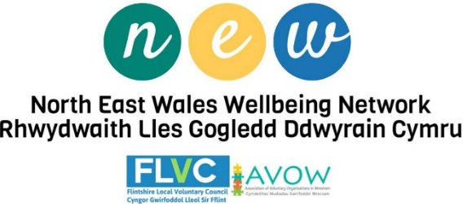
Survey reveals more than two thirds of Welsh adults would have both the flu and COVID-19 vaccines together this year
A survey commissioned by Public Health Wales has revealed that just over two thirds of adults in Wales (70 per cent) would happily accept a flu and COVID-19 vaccine at the same time this year, with 89 per cent also happy to accept a COVID-19 booster, if offered.
A survey commissioned by Public Health Wales has revealed that just over two thirds of adults in Wales (70 per cent) would happily accept a flu and COVID-19 vaccine at the same time this year, with 89 per cent also happy to accept a COVID-19 booster, if offered.
Anne McGowan, Nurse Consultant for health Protection at Public Health Wales said: “Vaccination is one of the most effective ways of protecting ourselves from serious disease, so it’s really encouraging to see that so many people understand this and are willing to accept both COVID-19 vaccines and boosters, and flu vaccines this year. This will be critical for protecting the people of Wales from serious illness and hospitalisation over the winter months and beyond.”
The survey revealed that the perception of risk from COVID-19 is still low among young people (i.e. 18-34 year olds) with 62 per cent disagreeing they are at high risk of catching COVID-19 compared to others and 28 per cent disagreeing they can get seriously ill if they catch COVID-19
Anne continued: “With increasing numbers of young people testing positive for Coronavirus, it is of concern that so many still believe that their risk of catching or becoming seriously ill with Coronavirus is low, when we know this not to be the case. While the younger a person is the lower their overall risk from coronavirus, young adults can still get long Covid – which is when symptoms of the disease persist for an extended period. We would strongly urge anyone, whatever the age, if offered the COVID-19 vaccine, to accept it. This way we can limit the spread of the virus and protect the population. The more people who are vaccinated, the better equipped we are to deal with the virus.”
The report also showed that more than two thirds (73 per cent) regard health professionals as a reliable source of information about the COVID-19 vaccine, followed by Public Health Wales at 71 per cent.
Public Health Wales is commissioning a survey with YouGov every two months, where at least 1,000 people will be interviewed to understand the Welsh public’s feelings about vaccines, specifically COVID-19 and flu vaccines.
***********************
Closing educational engagement gap for young carers is key to improving health and well-being of future generations
A new study, published by Public Health Wales evidences the negative impact that caring responsibilities have on educational participation in those aged 16-22, and how this has greatest impact on those living in the most deprived areas.
The research brings together National Survey for Wales’s data over three years and found that:
- 1 in 5 young people aged 16 – 22 years in Wales have caring responsibilities
- Males and females in this age group are equally likely to be young carers
- Overall, the proportion of young people in full time education is lower amongst young carers (45 per cent in carers, compared to 54 per cent in non-carers), and this difference is greater in those living in more deprived areas.
**********************************
Public Health Network Cymru Webinar:
The Importance of Social Prescribing
15th September 2021 | 2pm – 3pm
Your invitation to join Adult Learners’ Week 2021
Adult Learners’ Week plays a major role in promoting opportunities for individuals to learn new skills, find resources to support health and well-being, start new hobbies or to open conversations about retraining and making a fresh start.
The Adult Learners’ Week platform has been developed to host information, courses, and special events to connect people to partners and stakeholders across Wales and beyond.
Last year, they hosted over 500 online courses from a wide range of organisations including The Open University, BT, Harding Evans Solicitors, the National Museum Wales, Sport Wales, Head 4 Arts and Swansea Lifelong Learning Service. Working in partnership with the Welsh Government, they successfully launched the platform as part of a multi-media campaign to promote adult learning at the height of the COVID-19 pandemic. Watch this video to find out more.
This year, as part of the Adult Learners’ Week campaign they are planning for a mix of online, live and in-person events and courses, taster sessions, open days, and outreach events, that will be promoted to people across Wales throughout August and September. .
£1.9m to address food poverty in Wales communities
Over £1.9m of funding is being awarded to organisations across Wales to help tackle food poverty and addressing food insecurity within local communities. They will also focus on addressing food issues in a more sustainable way, working with local and regional partners to meet the specific needs of their communities.
AVOW, the local voluntary council for Wrexham County Borough, have been awarded over £91,000 to refit local food banks and co-ordinate services.
**********************

Ruabon Community Council, the Bowling Club and Friends of Ruabon
All have come together to bring the storage issue at The Sports Pavilion to a conclusion.
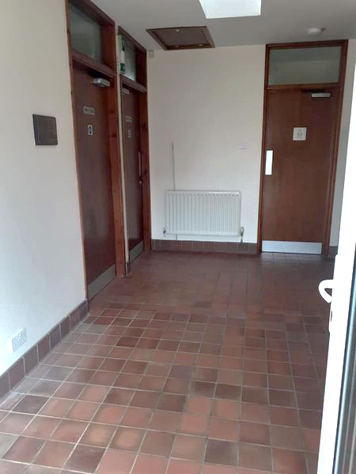
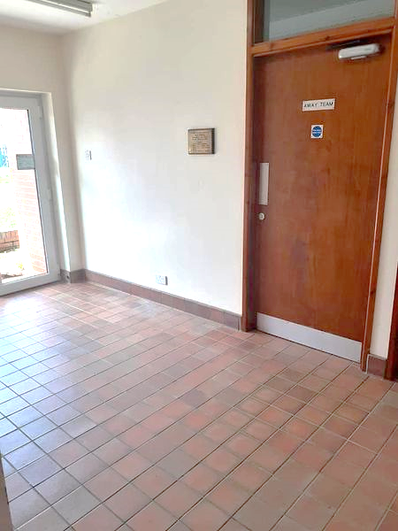
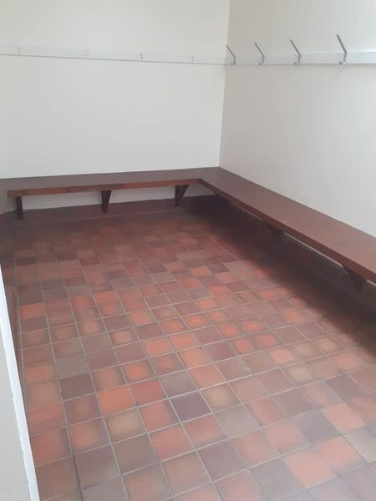
Amazing team work and a fantastic job done, with the changing rooms back into action after years of non-use.

with amazing team work from the RCC, Ruabon Bowling Club and Friends of Ruabon, THANK YOU! We can't express how grateful we all feel.

After many meetings, the great ideas, the team spirit and the willingness against all odds.

A special thanks to Mike, from RRFC, who repaired the doors.
A wonderful experience with all these groups, working together with once purpose, to prepare for the use of the changing rooms, you've done it!

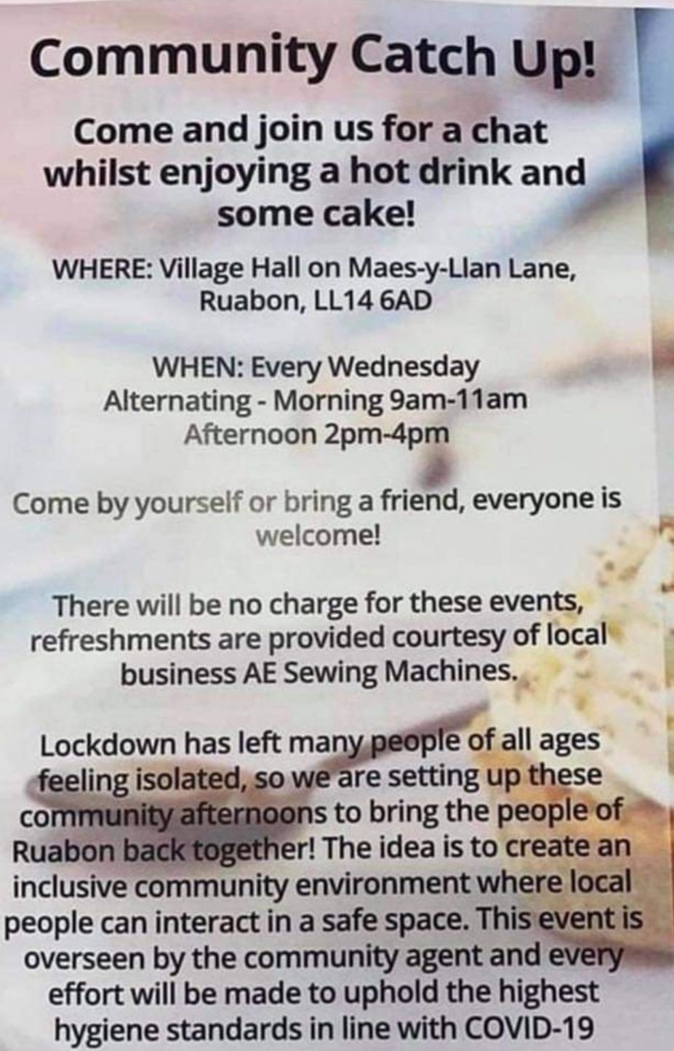

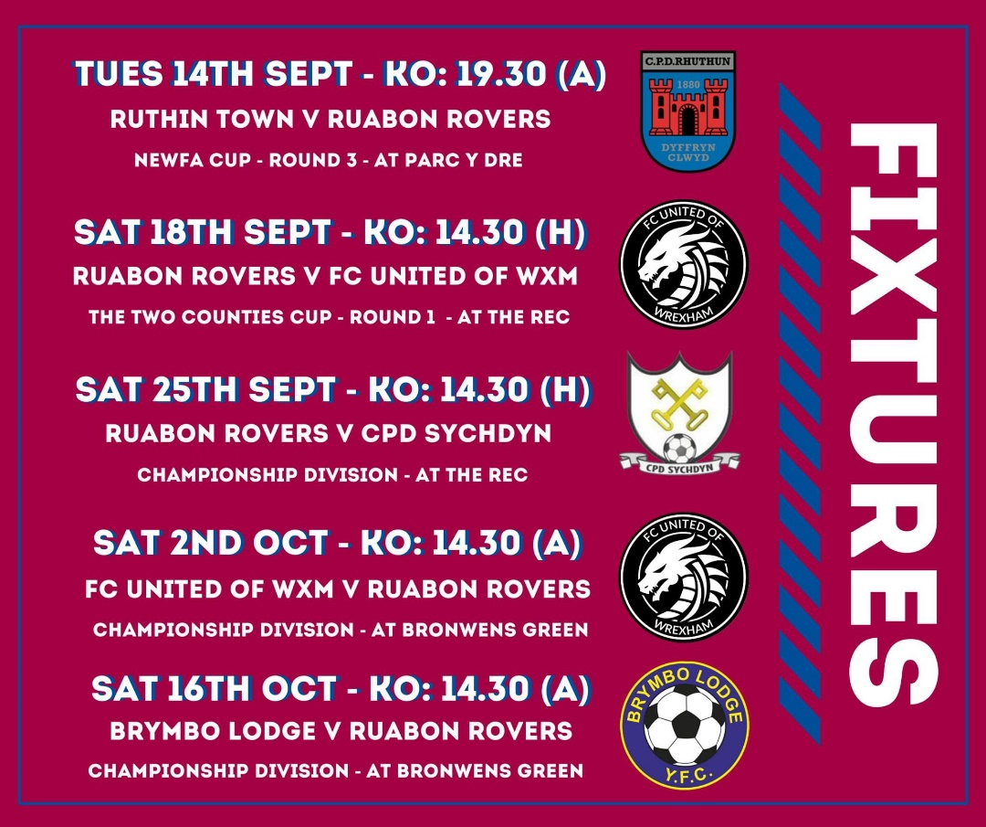

********************
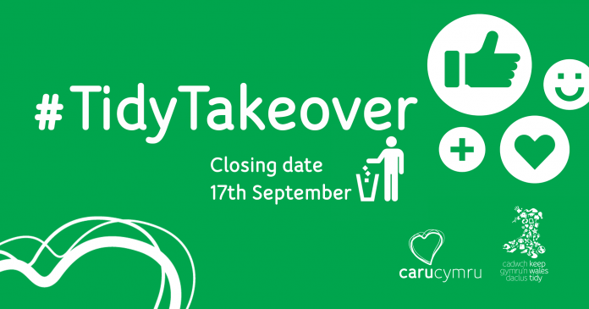
Are you under 25 years old? Want to help keep your local area tidy, plus be in with the chance of winning a voucher to spend at a zero-waste shop near you and a goodie bag?
If so, you’ll want to get involved in Keep Wales Tidy’s #TidyTakeover online challenge.

How to take part
All you need to do is help clean-up your local area during September, find the weirdest or the oldest item you can (or both), and post it on either your own or Keep Wales Tidy’s social media channels.
When posting, make sure to tag in Keep Wales Tidy on Instagram, Twitter or Facebook and use the hashtags #CaruCymru and #TidyTakeover, along with your name, age, what you found and where.
It can be an image or a video, but if it’s a video, please grab the item from the right-hand side of the screen and pass it across to your left. This is because Keep Wales Tidy will be creating a takeover together video at the end of the month where they will join everyone’s clips together.
“Do a positive thing”
Cllr David A Bithell, Lead Member for Environment and Transport, said: “The #TidyTakeover is a great chance for young people to do a positive thing in their local area, plus there’s the added bonus of a prize to win! The clean-ups can be big or small, but we please ask anyone who takes part to make sure they stay safe and take the all the necessary hygiene precautions.”
For guidance on picking litter safely, see below. Good luck!
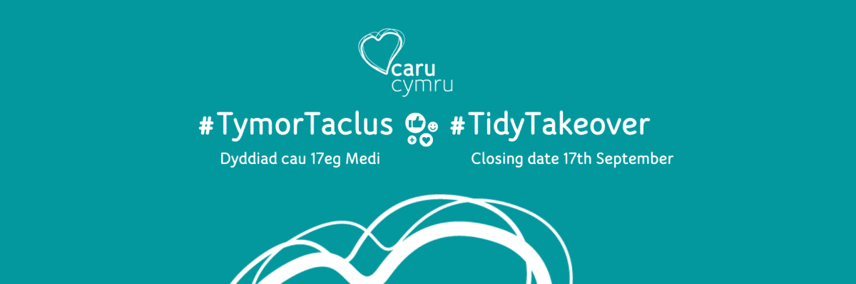

Tidy Takeover Competition
Under 25? Help us promote a litter free Wales, and be in with a chance of winning a zero-waste shopping voucher with our Tidy Takeover competition.
Our growing network of litter picking hubs across Wales are now re-opening as part of our Caru Cymru initiative. Offering all the equipment needed to carry out a safe clean-up, including litter pickers, hi-vis vests, rubbish bags and hoops.
To promote the great work that is happening all over Wales, with many communities coming together to clean up their areas on a weekly basis. We are encouraging younger people under the age of 25 to head out and take part in cleaning up their local area this September.
Get involved! Our Tidy Takeover competition is running from the start of September until the 17th and gives those that take part the chance of winning a voucher to spend at an ethical shop near you and be crowned our winner on Social Media.
All you’ll need to do is clean-up your local area during September, find the weirdest or the oldest item you can find (or both) and post these on our social media channels or your own.
It can be an image or a video. But if it’s a video, you’ll need to grab the item from the right-hand side of their screen and pass it to their left as we’ll be editing our takeover video together at the end of the month.
Your clean-ups can be big or small, you can use our littler picking hub equipment or not, as long as you are picking litter in a safe and controlled environment.
Please note, young people under the age 18 must be accompanied by an appropriate adult and supervised at all times.
#TidyTakeover
Remember you’ll need to tag in Keep Wales Tidy on Instagram, Twitter or Facebook and use the hashtags #CaruCymru and #TidyTakeover, along with your name, age, what you found and where.
Caru Cymru has received funding through the Welsh Government Rural Communities - Rural Development Programme 2014-2020, which is funded by the European Agricultural Fund for Rural Development and the Welsh Government.
For more information please get in touch on comms@keepwalestidy.cymru and we can’t wait to see what you find.
*************************

Pledge from Wrexham County Borough Council
“ENOUGH’S ENOUGH!
MOBILE CAMERAS TO BE USED TO TACKLE FLY TIPPING
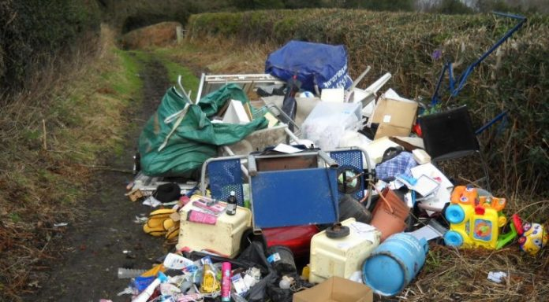

“Like you, we’re fed up with the unacceptable levels of fly tipping that’s taking place in the county borough.
That’s why we’ve brought in mobile CCTV cameras which will allow us to be flexible and respond to reports of fly-tipping, particularly where we are seeing repeated occurrences. We hope that these cameras will assist us in catching and prosecuting offenders; and ultimately improving our local communities.”
£1.9m to address food poverty in Wales communities
Over £1.9m of funding is being awarded to organisations across Wales to help tackle food poverty and addressing food insecurity within local communities. They will also focus on addressing food issues in a more sustainable way, working with local and regional partners to meet the specific needs of their communities.
AVOW, the local voluntary council for Wrexham County Borough, have been awarded over £91,000 to refit local food banks and co-ordinate services.
LLyfrgrell Rhiwabon / Ruabon Library
High Street,
Ruabon
LL14 6NH
- 01978 822002
- ru
- abon.library@wrexham.gov.uk
www.wrexham.gov.uk/libraries
Wrexham Libraries
- @WxmLibraries
Opening Hours
Monday 12.00pm – 5.00pm
Tuesday Closed
Wednesday 12.00pm – 5.00pm
Thursday 9.00am – 1.15pm
Friday 12.00pm – 5.00pm

All of our library buildings are now open fully
You will no longer have to make an appointment to visit.
Please make sure you wear a face covering unless you exempt, as it is a legal requirement to do so in Wales.
We would also ask that you sanitise your hands on arrival and maintain a good social distance whenever you can.
We look forward to welcoming you back!
**********************
Thank you everyone for your contributions.
The final page is a poem by Nia Evans which says everything about her dilemma. Get well soon Nia.

With Love from Devon

Oh! Send me a postcard from Devon,
You lucky Trio, I do miss.
The weather here is quite stunning
But there’s no wine, fish n chips by the sea.

Within 4 walls I’m just chillin’,
For 10 days, on countdown I am.
Grateful forever, to be, so healthy,
As 2 jabs were gifted to me.

“Give us a shout” echoes my fair village folk,
Neighbourhood news via screen keeps me sane.
Dairy deliveries, Flowers and sweeties
make priceless appearances on my step.

Oh! But send me a postcard from Devon,
To travel with you would have been bliss.

by Nia Evans

