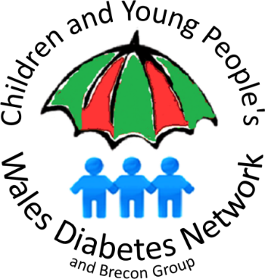**The Children and Young People’s Wales Diabetes Network**

Office Address: Cardigan House, University Hospital of Wales,

Heath Park, Cardiff, CF14 4XW

Network Manager: **Jon Matthias**

**Jon.Matthias@wales.nhs.uk Tel. 07989 193175**

18 June 2020

Dear Director of Education

I am contacting you to request that an important health message is cascaded to all families through your schools’ communication systems.

NHS Wales wishes to inform the public that despite the Coronavirus situation, services are still ‘open for business’. NHS services are very well equipped to look after patients safely if they are unwell.

It is important for all parents to know the signs and symptoms of undiagnosed Type 1 diabetes in children, which is a medical emergency. If parents notice **ANY** of the key symptoms of Type 1 diabetes, they need to make an **urgent** GP appointment, or contact their Out of Hours service.

The main symptoms of Type 1 diabetes are called the 4 Ts:

**THIRST** (often all the time)

**TOILET** (needing to urinate more often)

**TIREDNESS**

**THINNER** (losing weight)

On the following page we have included some pre-prepared messages and graphics, which we would greatly appreciate all your schools, both primary and secondary, to communicate urgently to parents.

There is more information available about Type 1 diabetes on the Diabetes UK ‘Know Type 1’ campaign web-page: [www.diabetes.org.uk/in_your_area/wales/campaigning/know-type-1---wales](https://www.diabetes.org.uk/in_your_area/wales/campaigning/know-type-1---wales)

Many thanks in advance,

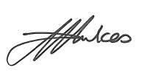

Dr Davida Hawkes

Chair, Children and Young People’s Wales Diabetes Network

**The Children and Young People’s Wales Diabetes Network**

Office Address: Cardigan House, University Hospital of Wales,

Heath Park, Cardiff, CF14 4XW

Network Manager: **Jon Matthias**

**Jon.Matthias@wales.nhs.uk Tel. 07989 193175**

**Message for parent mail:**

Dear Parents,

The NHS has asked for this message to be sent out to you.

Undiagnosed Type 1 diabetes in children requires urgent medical attention

If your child has ANY of the main symptoms of Type 1 diabetes please make an **urgent** GP appointment or contact the Out of Hours service. The main symptoms are known as the 4 Ts – Thirst, Toilet, Tiredness, Thinner. If you notice your child is thirsty or using the toilet more frequently, is always feeling tired, or has lost weight recently, seek immediate medical advice.

NHS services are very well equipped to look after children safely if they are unwell. Please do not delay seeking medical advice because of Covid-19.

There is more information available here:

<https://www.diabetes.org.uk/in_your_area/wales/campaigning/know-type-1---wales>

**Twitter post for schools (please also include link):**

If your child is poorly don’t delay seeking medical advice because of Covid-19. Undiagnosed Type 1 diabetes in children is an emergency. If your child has ANY symptoms #4Ts make an urgent GP appointment. @CYPDN_Wales @DiabetesUKCymru

<https://www.diabetes.org.uk/in_your_area/wales/campaigning/know-type-1---wales>