Name:
Class:

The Power of Persuasion!

3 weeks of Independent tasks to prepare you for your Non-Fiction written and spoken assessments this half term!

Your teacher may wish to guide you through one task at a time or may offer you opportunities to choose your own tasks.

Lesson 1: Persuasive Techniques
These are the persuasive techniques used in English. Try to match them to the correct definitions.
DIRECT ADDRESS |  | True statements that can be proven by research
ALLITERATION |  | Using the same word or phrase multiple times
FACTS |  | Using verbs at the start of the sentence which command the reader to do or think something
OPINIONS |  | Including witty phrases, word play or jokes to engage the reader
RHETORICAL QUESTIONS |  | Referring to the reader in person by using “you”, “your”, “we” or “our”
REPETITION |  | A fact that is in the form of a number (e.g. percentage, fractions)
EMOTIVE LANGUAGE |  | Using a series of words beginning with the same letter
STATISTIC |  | Using a list of three adjectives or examples
TRIPLE |  | Asking questions of the reader
IMPERATIVES |  | A personal belief that may be argued against
HUMOUR |  | Using words that are intended to cause increased effect upon readers such as sympathy

Now have a go at writing your own sentences using each of them:
D:
A:
F:
O:
R:
R:
E:
S:
T:
I:
H:
Now try to highlight and label each technique present in this advert:

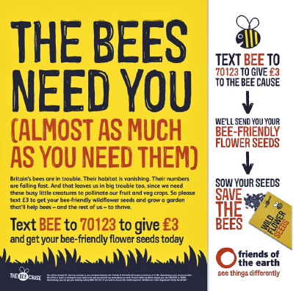
Anything else you found particularly effective? Tell me about it here:
Lesson 2: Positive Language
Another powerful persuasive tool is the use of positive language. For each of the following themes, try to write down some adjectives that could be used that have positive suggestions:

Topic | Positive word 1 | Positive word 2 | Positive word 3
Dogs | Bouncing | Adorable | Friendly
School
Food
Rollercoasters
Countryside
Technology

The opposite to this, of course, is to use negative words. Have a go:

Topic | Positive word 1 | Positive word 2 | Positive word 3
Dogs | Uncontrollable | Snarling | Vicious
Drugs
Holidays
Homelessness
Weather
Food

Highlight any positive words and add labels to explain what these word choices suggest and how they help to persuade you to visit:
Word | Why it sounds positive | Why this is persuasive

5 most powerful positive words and why they are effective:
Lesson 3: Using what you have learned, have a go at writing a persuasive opening page for the school website. Think about how you could describe the school using only positive vocabulary:
Planning:

Writing: ___________________________________________________________________________________________________________________________________________________________________________________________________________________________________________________________________________________________________________________________________________________________________________________________________________________________________________________________________________________________________________________________________________________________________________________________________________________________________________________________________________________________________________________________________________________________________________________________________________________________________________________________________________________________________________________________________________________________________________________________________________________________________________________________________________________________________________________________________________________________________________________________________________________________________________________________________________________________________________________________________________________________________________________________________________________________________________________________________________________________________________________________________________________________________________________________________________________________________________________________________________________________________________________________________________________________________________________________________________________________________________________________________________________________________________________________________________________________________________________________________________________________________________________________________________________________________________________________________________________________________________________________________________________________________________________________________________________________________________________________________________________________________________________________________________________________________________________________________________________________________________________________________________________________________________________________________________________________________________________________________________________________________________________________________________________________________________________________________________________________________________________________________________________________________________________________________________________________________________________________________________

Self/ Peer Assessment:
W
W
W
E
B
I

Lesson 4: Emotive Language
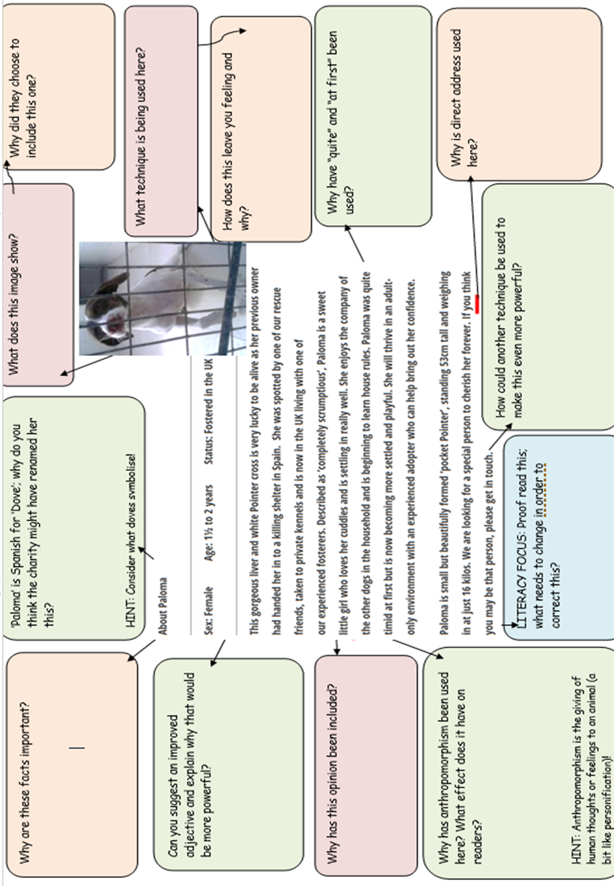
Read the following advert for a pet adoption charity and answer the questions surrounding it:
Lesson 5: Adopt me!
Using what you have learned so far, choose one of the following dogs and have a go at writing a persuasive adoption advertisement. Remember to focus on the positives and on appealing directly to your reader:
Dogs:

Planning:
Your adoption advert:
____________________________________________________________________________________________________________________________________________________________________________________________________________________________________________________________________________________________________________________________________________________________________________________________________________________________________________________________________________________________________________________________________________________________________________________________________________________________________________________________________________________________________________________________________________________________________________________________________________________________________________________________________________________________________________________________________________________________________________________________________________________________________________________________________________________________________________________________________________________________________________________________________________________________________________________________________________________________________________________________________________________________________________________________________________________________________________________________________________________________________________________________________________________________________________________________________________________________________________________________________________________________________________________
Self/ Peer Assessment:

W

Lesson 6: Persuasive pictures
How might picture choices help to persuade readers? Can you think of any ideas?

Colours can also be persuasive. For each colour, think of any symbolism that may be suggested by it:

Lesson 7: For each text, use labels to explain why the images chosen are powerful and how these help to persuade you to do what the text wants:
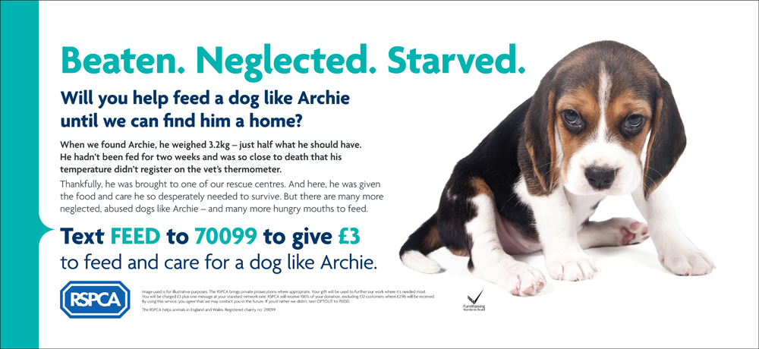
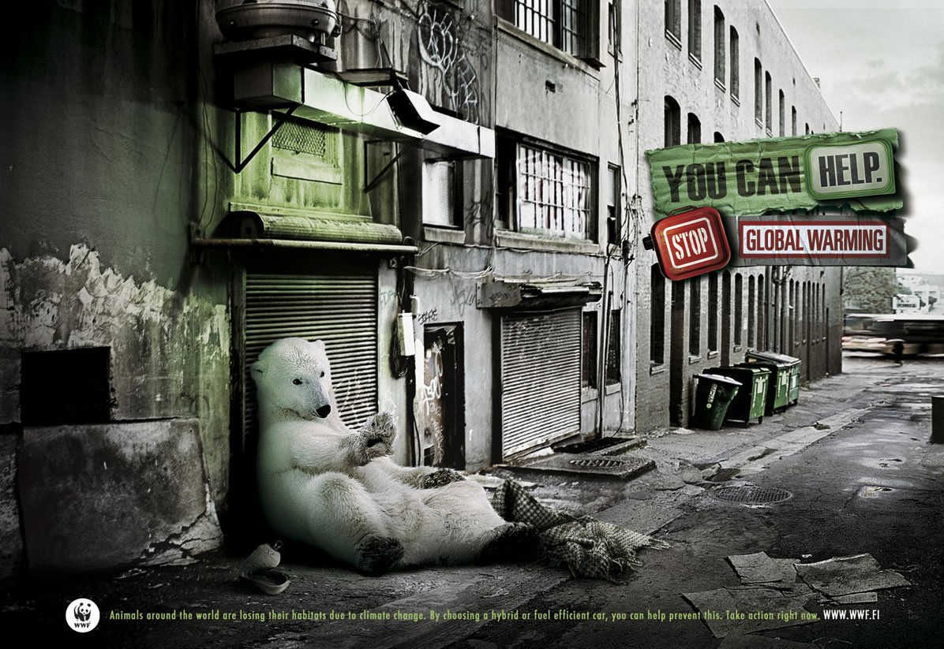
Lesson 8: Now choose an emotive topic you would like to promote in school. Design an advertisement poster below and label this to explain why you have included the images/ colours and graphics you have:
Lesson 9: Powerful Problem Solvers
If you are trying to persuade someone to give you something or to change their way of thinking, you have to be able to solve the problems they will come up.
For example, if you want your teacher to let you talk during written tasks, you need to offer them realistic suggestions for how to make sure this is effective and they are still getting what they want (which is you learning)!!
Have a go at coming up with some solutions to these issues:

Without putting students through GCSEs, how else can we find out how good someone will be at the jobs they are applying for?

If we’re going to go ‘Plastic Free’, what can we do to replace the plastics used in cars, computers, televisions, hygiene products and everything else?!

If you want me to buy each student their own equipment, how on earth am I going to afford it?
What can we do to support children with mental health concerns without letting them be absent from school?

If the jets were banned from flying through Machynlleth and Dolgellau, then how would we still generate the money lost from tourism?

If students are allowed to wear their own clothes, how can we make sure they learn how to dress professionally in the future?

If mobile phones are a risk to public health, how can the risks to teenagers be minimised?

Lesson 10: Your assessments will include presented speeches in front of an audience.
How many reasons can you come up with for why someone may deliver a speech? Have you ever seen one in real life or on TV, perhaps?

Read the speech below and highlight everything it does which helps it to be powerful and persuasive.
My name is Greta Thunberg. I am 16 years old. I come from Sweden. And I speak on behalf of future generations.
I know many of you don’t want to listen to us – you say we are just children. But we’re only repeating the message of the united climate science.
Many of you appear concerned that we are wasting valuable lesson time, but I assure you we will go back to school the moment you start listening to science and give us a future. Is that really too much to ask?
In the year 2030 I will be 26 years old. My little sister Beata will be 23. Just like many of your own children or grandchildren. That is a great age, we have been told. When you have all of your life ahead of you. But I am not so sure it will be that great for us.
I was fortunate to be born in a time and place where everyone told us to dream big; I could become whatever I wanted to. I could live wherever I wanted to. People like me had everything we needed and more. Things our grandparents could not even dream of. We had everything we could ever wish for and yet now we may have nothing.
Now we probably don’t even have a future any more.
Because that future was sold so that a small number of people could make unimaginable amounts of money. It was stolen from us every time you said that the sky was the limit, and that you only live once.
You lied to us. You gave us false hope. You told us that the future was something to look forward to. And the saddest thing is that most children are not even aware of the fate that awaits us. We will not understand it until it’s too late. And yet we are the lucky ones. Those who will be affected the hardest are already suffering the consequences. But their voices are not heard.
Is my microphone on? Can you hear me?
Around the year 2030, 10 years 252 days and 10 hours away from now, we will be in a position where we set off an irreversible chain reaction beyond human control, that will most likely lead to the end of our civilisation as we know it. That is unless in that time, permanent and unprecedented changes in all aspects of society have taken place, including a reduction of CO2 emissions by at least 50%.
And please note that these calculations are depending on inventions that have not yet been invented at scale, inventions that are supposed to clear the atmosphere of astronomical amounts of carbon dioxide.
Furthermore, these calculations do not include unforeseen tipping points and feedback loops like the extremely powerful methane gas escaping from rapidly thawing arctic permafrost.
Nor do these scientific calculations include already locked-in warming hidden by toxic air pollution. Nor the aspect of equity – or climate justice – clearly stated throughout the Paris agreement, which is absolutely necessary to make it work on a global scale.
We must also bear in mind that these are just calculations. Estimations. That means that these “points of no return” may occur a bit sooner or later than 2030. No one can know for sure. We can, however, be certain that they will occur approximately in these timeframes, because these calculations are not opinions or wild guesses.
These projections are backed up by scientific facts, concluded by all nations through the IPCC. Nearly every single major national scientific body around the world unreservedly supports the work and findings of the IPCC.
Did you hear what I just said? Is my English OK? Is the microphone on? Because I’m beginning to wonder.
During the last six months I have travelled around Europe for hundreds of hours in trains, electric cars and buses, repeating these life-changing words over and over again. But no one seems to be talking about it, and nothing has changed. In fact, the emissions are still rising.
When I have been travelling around to speak in different countries, I am always offered help to write about the specific climate policies in specific countries. But that is not really necessary. Because the basic problem is the same everywhere. And the basic problem is that basically nothing is being done to halt – or even slow – climate and ecological breakdown, despite all the beautiful words and promises.
The UK is, however, very special. Not only for its mind-blowing historical carbon debt, but also for its current, very creative, carbon accounting. Since 1990 the UK has achieved a 37% reduction of its territorial CO2 emissions, according to the Global Carbon Project. And that does sound very impressive. But these numbers do not include emissions from aviation, shipping and those associated with imports and exports. If these numbers are included the reduction is around 10% since 1990 – or an an average of 0.4% a year, according to Tyndall Manchester.
The fact that we are speaking of “lowering” instead of “stopping” emissions is perhaps the greatest force behind the continuing business as usual. The UK’s active current support of new exploitation of fossil fuels – for example, the UK shale gas fracking industry, the expansion of its North Sea oil and gas fields, the expansion of airports as well as the planning permission for a brand new coal mine – is beyond absurd.
This ongoing irresponsible behaviour will no doubt be remembered in history as one of the greatest failures of humankind.
I hope my microphone was on. I hope you could all hear me.

What were the ten most powerful things she did and why were these effective?

Lesson 11: Choose an issue that is important to you and imagine you are going to deliver a speech in the local community to raise awareness of why this problem exists and how it can be helped.
Create a plan in the space below with at least 4 main ideas related to your argument.
If you’re stuck for what to talk about, perhaps try:
Farming? Dolgellau issues? GCSE pressure? Mental health? Animal cruelty? Plastics in the environment? Underfunding in Wales?
Paragraph idea | DAFORREST techniques x2-5 per para | Powerful words x2-5 per para | Ambitious punctuation choice
Lesson 12: Complete your speech in the space below:
____________________________________________________________________________________________________________________________________________________________________________________________________________________________________________________________________________________________________________________________________________________________________________________________________________________________________________________________________________________________________________________________________________________________________________________________________________________________________________________________________________________________________________________________________________________________________________________________________________________________________________________________________________________________________________________________________________________________________________________________________________________________________________________________________________________________________________________________________________________________________________________________________________________________________________________________________________________________________________________________________________________________________________________________________________________________________________________________________________________________________________________________________________________________________________________________________________________________________________________________________________________________________________________________________________________________________________________________________________________________________________________________________________________________________________________________________________________________________________________________________________________________________________________________________________________________________________________________________________________________________________________________________________________________________________________________________________________________________________________________________________________________________________________________________________________________________________________________________________________________________________________________________________________________________________________________________________________________________________________________________________________________________________________________________________________________________________________________________________________________________________________________________________________________________________________________________________________________________________________________________________________________________________________________________________________________________________________________________________________________________________________________________________________________________________________________________________________________________________________________________________________________________________________________________________________________________________________________________________________________________________________________________________________________________________________________________________________________________________________________________________________

Self/ Peer Assessment:
W
W
W
E
B
I

