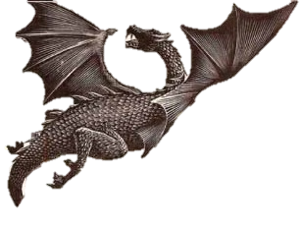

Name:

Class:

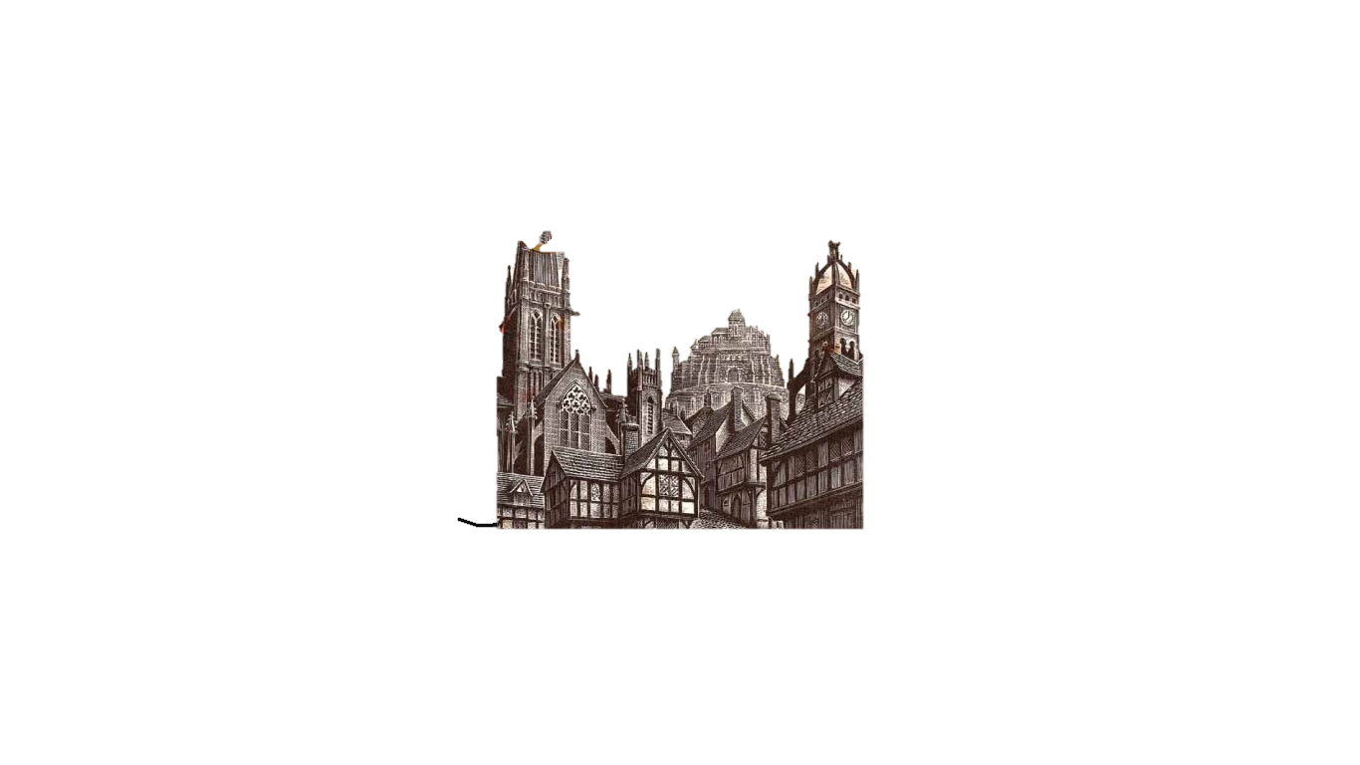**Fantasy Fiction**

Lesson 1: The Fantasy Genre

The Fantasy genre has been around for a lot longer than people think. You are going to try to define what fantasy is by:

1. Watching a number of fantasy film trailers
2. Ready some fantasy blurbs
3. Looking at some fantasy artwork

Then complete the comparison chart before you try to define ‘fantasy’ in your own word.

1. Film Trailer notes:

|  |  |  |
| --- | --- | --- |
| The Hobbit | Harry Potter | Pans Labyrinth |
|  |  |  |

Fantasy fiction blurbs:

Rachel Hartman – ‘Seraphina’

In her *New York Times* bestselling and Morris Award-winning debut, Rachel Hartman introduces mathematical dragons in an alternative-medieval world to fantasy and science-fiction readers of all ages.   
  
Four decades of peace have done little to ease the mistrust between humans and dragons in the kingdom of Goredd. Folding themselves into human shape, dragons attend court as ambassadors, and lend their rational, mathematical minds to universities as scholars and teachers. As the treaty's anniversary draws near, however, tensions are high.  
  
Seraphina Dombegh has reason to fear both sides. An unusually gifted musician, she joins the court just as a member of the royal family is murdered—in suspiciously draconian fashion. Seraphina is drawn into the investigation, partnering with the captain of the Queen's Guard, the dangerously perceptive Prince Lucian Kiggs. While they begin to uncover hints of a sinister plot to destroy the peace, Seraphina struggles to protect her own secret, the secret behind her musical gift, one so terrible that its discovery could mean her very life.

Hope Mirlees – ‘Lud-in-the-mist’

Lud-in-the-Mist, the capital city of the small country Dorimare, is a port at the conﬂuence of two rivers, the Dapple and the Dawl. The Dapple has its origin beyond the Debatable Hills to the west of Lud-in-the-Mist, in Fairyland. In the days of Duke Aubrey, some centuries earlier, fairy things had been looked upon with reverence, and fairy fruit was brought down the Dapple and enjoyed by the people of Dorimare. But after Duke Aubrey had been expelled from Dorimare by the burghers, the eating of fairy fruit came to be regarded as a crime, and anything related to Fairyland was unspeakable. Now, when his son Ranulph is believed to have eaten fairy fruit, Nathaniel Chanticleer, the mayor of Lud-in-the-Mist, finds himself looking into old mysteries in order to save his son and the people of his city.

George R. R. Martin – ‘A Game of Thrones’

Long ago, in a time forgotten, a preternatural event threw the seasons out of balance. In a land where summers can last decades and winters a lifetime, trouble is brewing. The cold is returning, and in the frozen wastes to the north of Winterfell, sinister and supernatural forces are massing beyond the kingdom’s protective Wall. At the center of the conflict lie the Starks of Winterfell, a family as harsh and unyielding as the land they were born to. Sweeping from a land of brutal cold to a distant summertime kingdom of epicurean plenty, here is a tale of lords and ladies, soldiers and sorcerers, assassins and bastards, who come together in a time of grim omens.  
  
Here an enigmatic band of warriors bear swords of no human metal; a tribe of fierce wildlings carry men off into madness; a cruel young dragon prince barters his sister to win back his throne; and a determined woman undertakes the most treacherous of journeys. Amid plots and counterplots, tragedy and betrayal, victory and terror, the fate of the Starks, their allies, and their enemies hangs perilously in the balance, as each endeavors to win that deadliest of conflicts: the game of thrones.

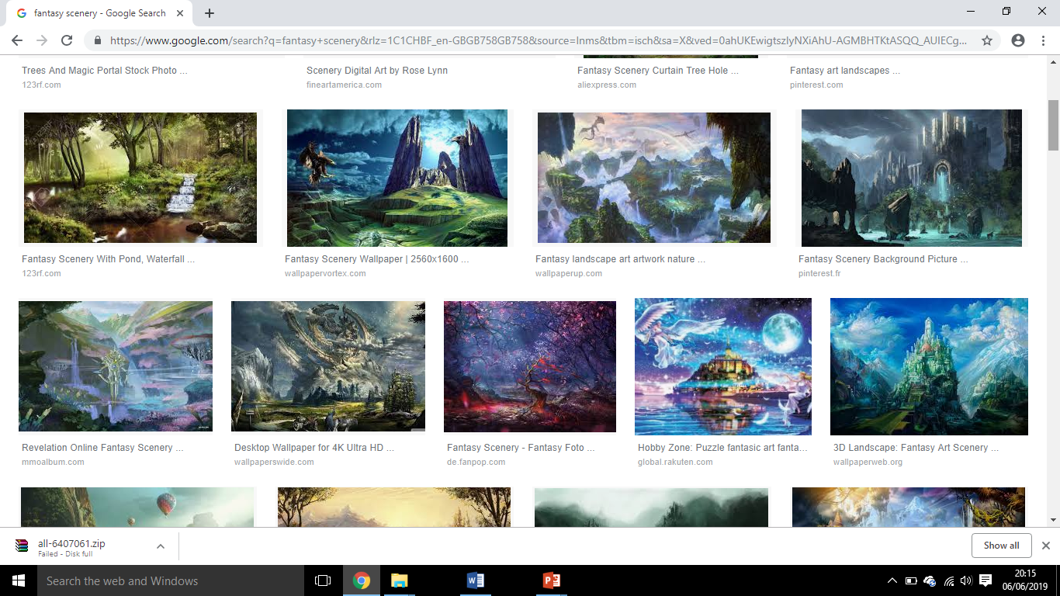Fantasy art:

Lesson 2: Complete the venn diagram to compare what these have in common.

The Fantasy Genre

If you were going to create a fantasy cake, what would it look like but more importantly, what ingredients would you need?

Challenge: Think about how much of each ingredient you would need – the more important, the higher the amount!

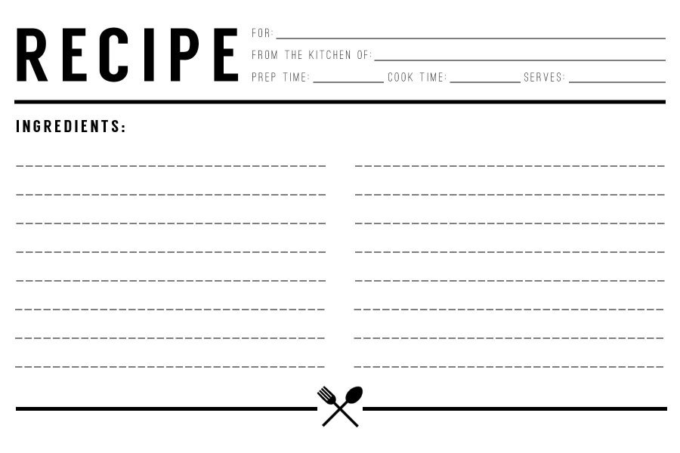

Design your cake here:

Magic – 5oog

Unicorn poop – 100g

Lessons 3 & 4: What makes fantasy so special?

The key to a brilliant fantasy story is the descriptive writing. If you are going to explore an unreal world, you need to be able to bring this to life clearly in the reader’s head.

When reading an extract, which different techniques should you look out for?

|  |  |
| --- | --- |
| Language Techniques | Structural techniques |
|  |  |

Today, we will begin with word level analysis. Read the passage below and highlight any words that help to give you a detailed and interesting idea of what is going on!

Use different colours to highlight verbs, adverbs, nouns and adjectives.

J. R. R. Tolkien – ‘The Hobbit’

There he lay, a vast red-golden dragon, fast asleep; thrumming came from his jaws and nostrils, and wisps of smoke, but his fires were low in slumber.  
Beneath him, under all his limbs and his huge coiled tail, and about him on all sides stretching away across the unseen floors, lay countless piles of precious things, gold wrought and unwrought, gems and jewels, and silver redstained in the ruddy light.   
  
Smaug lay, with wings folded like an immeasurable bat, turned partly on one side, so that the hobbit could see his underparts and his long pale belly crusted with gems and fragments of gold from his long lying on his costly bed.  
  
Behind him where the walls were nearest could dimly be seen coats of mail, helms and axes, swords and spears hanging; and there in rows stood great jars and vessels filled with a wealth that could not be guessed. To say that Bilbo's breath was taken away is no description at all. There are no words left to express his staggerment, since Men changed the language that they learned of elves in the days when all the world was wonderful. Bilbo had heard tell and sing of dragon-hoards before, but the splendour, the lust, the glory of such treasure had never yet come home to him. His heart was filled and pierced with enchantment and with the desire of dwarves; and he gazed motionless, almost forgetting the frightful guardian, at the gold beyond price and count.   
  
He gazed for what seemed an age, before drawn almost against his will, he stole from the shadow of the doorway, across the floor to the nearest edge of the mounds of treasure. Above him the sleeping dragon lay, a dire menace even in his sleep. He grasped a great two-handled cup, as heavy as he could carry, and cast one fearful eye upwards. Smaug stirred a wing, opened a claw, the rumble of his snoring changed its note.

Now that you have highlighted the most interesting words, discuss the effect they have on helping you to picture this scene and use the table below to explain the best five:

|  |  |  |
| --- | --- | --- |
| Word | Meaning | Why this was effective |
|  |  |  |
|  |  |  |
|  |  |  |
|  |  |  |
|  |  |  |
|  |  |  |

Lesson 5: Use a thesaurus to find a synonym (better version) of each word on the list. Then put this word into your word search.

|  |  |  |  |  |  |  |  |  |  |  |  |  |  |  |  |  |  |  |  |
| --- | --- | --- | --- | --- | --- | --- | --- | --- | --- | --- | --- | --- | --- | --- | --- | --- | --- | --- | --- |
|  |  |  |  |  |  |  |  |  |  |  |  |  |  |  |  |  |  |  |  |
|  |  |  |  |  |  |  |  |  |  |  |  |  |  |  |  |  |  |  |  |
|  |  |  |  |  |  |  |  |  |  |  |  |  |  |  |  |  |  |  |  |
|  |  |  |  |  |  |  |  |  |  |  |  |  |  |  |  |  |  |  |  |
|  |  |  |  |  |  |  |  |  |  |  |  |  |  |  |  |  |  |  |  |
|  |  |  |  |  |  |  |  |  |  |  |  |  |  |  |  |  |  |  |  |
|  |  |  |  |  |  |  |  |  |  |  |  |  |  |  |  |  |  |  |  |
|  |  |  |  |  |  |  |  |  |  |  |  |  |  |  |  |  |  |  |  |
|  |  |  |  |  |  |  |  |  |  |  |  |  |  |  |  |  |  |  |  |
|  |  |  |  |  |  |  |  |  |  |  |  |  |  |  |  |  |  |  |  |
|  |  |  |  |  |  |  |  |  |  |  |  |  |  |  |  |  |  |  |  |
|  |  |  |  |  |  |  |  |  |  |  |  |  |  |  |  |  |  |  |  |
|  |  |  |  |  |  |  |  |  |  |  |  |  |  |  |  |  |  |  |  |
|  |  |  |  |  |  |  |  |  |  |  |  |  |  |  |  |  |  |  |  |
|  |  |  |  |  |  |  |  |  |  |  |  |  |  |  |  |  |  |  |  |
|  |  |  |  |  |  |  |  |  |  |  |  |  |  |  |  |  |  |  |  |
|  |  |  |  |  |  |  |  |  |  |  |  |  |  |  |  |  |  |  |  |
|  |  |  |  |  |  |  |  |  |  |  |  |  |  |  |  |  |  |  |  |
|  |  |  |  |  |  |  |  |  |  |  |  |  |  |  |  |  |  |  |  |
|  |  |  |  |  |  |  |  |  |  |  |  |  |  |  |  |  |  |  |  |

|  |  |  |
| --- | --- | --- |
| Word | Synonym (in word search) | Example in a sentence |
| Large |  |  |
| Tiny |  |  |
| Colourful |  |  |
| Light |  |  |
| Dark |  |  |
| Hard |  |  |
| Soft |  |  |
| Old |  |  |
| Quick |  |  |
| Exciting |  |  |
| Scared |  |  |
| Confused |  |  |

Once complete, write a fantasy paragraph that uses all of these words!

**Lessons 6&7: Read the extract below and highlight/ annotate how the writer has created mood and atmosphere. Then write an essay of 3-5 PEE paragraphs about the impressions you had of this place.**

October arrived, spreading a damp chill over the grounds and into the castle. Madam Pomfrey, the nurse, was kept busy by a sudden spate of colds among the staff and students. Her Pepperup potion worked instantly, though it left the drinker smoking at the ears for several hours afterward. Ginny Weasley, who had been looking pale, was bullied into taking some by Percy. The steam pouring from under her vivid hair gave the impression that her whole head was on fire.   
  
Raindrops the size of bullets thundered on the castle windows for days on end; the lake rose, the flower beds turned into muddy streams, and Hagrid's pumpkins swelled to the size of garden sheds. Oliver Wood's enthusiasm for regular training sessions, however, was not dampened, which was why Harry was to be found, late one stormy Saturday afternoon a few days before Halloween, returning to Gryffindor Tower, drenched to the skin and splattered with mud.   
  
Even aside from the rain and wind it hadn't been a happy practice session. Fred and George, who had been spying on the Slytherin team, had seen for themselves the speed of those new Nimbus Two Thousand and Ones. They reported that the Slytherin team was no more than seven greenish blurs, shooting through the air like missiles.   
  
As Harry squelched along the deserted corridor he came across somebody who looked just as preoccupied as he was. Nearly Headless Nick, the ghost of Gryffindor Tower, was staring morosely out of a window, muttering under his breath, ". . . don't fulfill their requirements . . . half an inch, if that . . ."

______________________________________________________________________________________________________________________________________________________________________________________________________________________________________________________________________________________________________________________________________________________________________________________________________________________________________________________________________________________________________________________________________________________________________________________________________________________________________________________________________________________________________________________________________________________________________________________________________________________________________________________________________________________________________________________________________________________________________________________________________________________________________________________________________________________________________________________________________________________________________________________________________________________________________________________________________________________________________________________________________________________________________________________________________________________________________________________________________________________________________________________________________________________________________________________________________________________________________________________________________________________________________________________________________________________________________________________________________________________________________________________________________________________________________________________________________________________________________________________________________________________________________________________________________________________________________________________________________________________________________________________________________________________________________________________________________________________________________________________________________________________________________________________________________________________________________________________________________________________________________________________________________________________________________________________________________________________________________________________________________________________________________________________________________________________________________________________________________________________________________________________________________________________________________________________________________________________________________________________________________________________________________________________________________________________________________________________________________________________________________________________________________________________________________________________________________________________________________________________________________________________________________________________________________________________________________________________________________________________________________________________________________________________________________________________________________________________________________________________________________________________________________________________________________________________________________________________________________________________________________________________________________________________________________________________________________________________________________________________________________________________________________________________________________________________________________________________________________________________________________________________________________________________________________________________________________________________

**Lesson 8: Use different colours to highlight the different parts of the success criteria you have achieved:**

* **Followed PEE structure**
* **Included a quote**
* **Zoomed in on different words or techniques in the quote**
* **Used subject terminology to name techniques used**
* **Mentioned the effect on the reader**

**Then set two stars and a wish:**

**🟉  
🟉**

**W:**

**Then rewrite one paragraph and try to meet your target (wish):**

________________________________________________________________________________________________________________________________________________________________________________________________________________________________________________________________________________________________________________________________________________________________________________________________________________________________________________________________________________________________________________________________________________________________________________________________________________________________________________________________________________________________________________________________________________________________________________________________________________________________________________________________________________________________________________________________________________________________________________________________________________________________________________________________________________________________________________________________________________________________________________________________________________________________________________________________________________________________________________________________________________________________________________________________________________________________________________