GCSE PE
SPORT STAR FITNESS PROFILE
Name: ___________ Form:________
Insert Picture of Sport Star here

Athlete’s name…………………………………….
Sport………………………………….

Explanation of project
This project is an introduction to some of the things we will be looking at during the two year GCSE PE course. The research that you carry out will give not only prepare you for September, it will enable you to complete your coursework more easily once you are in Year 10. This is to be submitted during our first lesson in September.

You can choose your favourite sports star from any sport. You will then research all of the things that go into making this athlete successful in their sport. It can be typed or hand written. Remember the more detail the better!

You can use lots of websites to help you complete this project; however, a good one to get you started is BBC Bitesize.
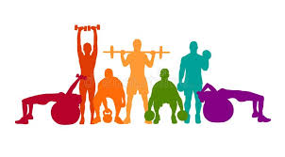
To find the relevant topics click the following:
- Secondary
- Wales – GCSE
- Subjects – Physical Education
- Exam specification – WJEC
- Topic – Health, fitness and exercise

If you need any help at all feel free to email me on jonesa1466@hwbcymru.net

Good luck and stay safe!
Mrs Jones

Introduction
Explain in the box below why we exercise. You need to talk about the health and fitness benefits. Relate briefly to different sports and then to the athlete’s sport.

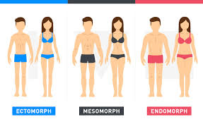
- Gender:
- Age:
- Weight:
- Height:
- Body Type:
Please circle – Ectomorph / Mesomorph / Endomorph
- Medical / Health issues:
- Past Injuries and how this may have impacted on their sporting performance:
- Brief playing experiences (e.g. clubs, competitions, etc.):

Current training schedule (if you can find it out):
Monday
Tuesday
Wednesday
Thursday
Friday
Saturday
Sunday

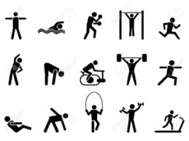

Components of fitness
In the table below write about the components of fitness that are most important to your athlete. In addition you may talk specifically about playing position and specific components of fitness.
COMPONENT OF FITNESS | DEFINITION | HOW THIS COMPONENT IS USED IN THEIR SPORT
MUSCULAR STRENGTH | The ability to use voluntary muscles repeatedly without tiring.
MUSCULAR ENDURANCE

CARDIOVASCULAR ENDURANCE

POWER

BALANCE

AGILITY

FLEXIBILITY

COORDINATION

SPEED

REACTION TIME

ADD A PARAGRAPH OR TWO ABOUT WHICH COMPONENTS OF FITNESS YOU THINK ARE MOST IMPORTANT FOR YOUR ATHLETE’S SPORT
………………………………………………………………………………………………………………………………………………………………………………………………………………………………………………………………………………………………………………………………………………………………………………………………………………………………………………………………………………………………………………………………………………………………………………………………………………………………………………………………………………………………………………………………………………………………………………………………………………………………………………………………………………………………………………………………………………………………………………………………………………………………………………………………………………………………………………………………………………………………………………………………………………………………………………………………………………………………………………………………………………………………………………………………………………………………………………………………………………………………………………………………………………………………………………………………………………………………………………………………………………………………………………………………………………………………………………………………………………………………………………………………………………………………………………………………………………………………………………………………………………………………………………………………………………………………………………………………………………………………………………………………………………………………………………………………………………………………………………………………………………………………………………………………

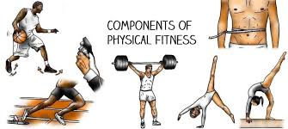

Fitness testing
Fitness testing is important to assess the baseline fitness of an athlete and the help set them training goals. For the tests listed below can you explain how the test is carried out (procedure), which component of fitness are being tested. In addition if you can find out what males and females would need to achieve to score an excellent result, as well as a professional athlete in your chosen sport would achieve in this test! I have done the first one for you to help.
Good websites to help you with this are eater www.topendsports.com or www.brianmac.co.uk
Fitness Test | Component of fitness | Test procedure | Results
Multistage fitness test (Bleep test) | Cardiovascular Endurance | Running between 2 lines 20m apart in time to recorded beeps. Athletes run in time to the beeps until they can no longer reach the line in time. | Excellent:  Men – over level 13  Women – over level 12  My athlete (netball) Level 10 or above for National Squad
Hand grip dynamometer
One rep max test

12 minute cooper run

Sit and reach test

30m sprint test

60 second sit up test

60 second press-up test
Illinois agility test
Alternate hand wall throw test
Standing stork test
Vertical jump test

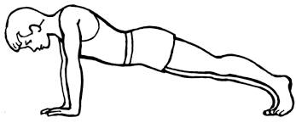

Diet and Nutrition
The body needs a balance of nutrients to stay healthy. There are 5 groups of nutrients (macronutrients). What an athlete eats is just as important as their training. Fill in the table below to explain the purpose of each macronutrient and what food sources they can be found in. I have done the first one for you.
 | Purpose | Examples
Protein | Tissue growth and repair – known as the body’s building blocks. | Meat, fish, eggs, lentils, nuts and seeds.
Carbohydrates
Fats
Vitamins
Minerals
Water

Athlete’s Diet
Research a typical day’s diet for your chosen athlete or an athlete within that sport. What do they eat and drink? How many calories do they need?
……………………………………………………………………………………………………………………………………………………………………………………………………………………………………………………………………………………………………
……………………………………………………………………………………………………………………………………………………………………………………………………………………………………………………………………………………………………
……………………………………………………………………………………………………………………………………………………………………………………………………………………………………………………………………………………………………
……………………………………………………………………………………………………………………………………………………………………………………………………………………………………………………………………………………………………

