Geography GCSE Year 10
As we have missed a number of lessons in school we need to try and maintain some of the knowledge you have already gained and expand your knowledge of new topics. The work on BBC Bitesize will help greatly help once you return to school. I will be sending out more lessons in the future.
Go to the website below and work through the section on Weather, climate and ecosystems, this is Unit 5 and the unit we covered up to January. For each section click on the revise section and where there are videos make sure you watch them. Once you have finished a section complete the test. If your score wasn’t perfect, go back over the revision section and then try the test again.
If you are happy with your progress on Unit 5 you may move onto the next unit on development.

https://www.bbc.co.uk/bitesize/topics/zwvysrd

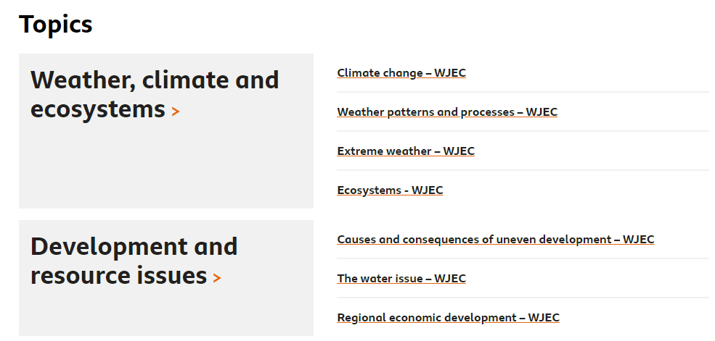

The following is a useful lesson on Climate change that should consolidate your knowledge on what you have covered in Theme 5.
https://www.bbc.co.uk/bitesize/articles/zhvwjhv

Mr Forman

