PRACTICE QUESTIONS

KEY QUESTION 1:

IMPACT OF FIRST WORLD WAR

Q1. This question is about the impact of the First World War
Source A

[Map showing the territorial terms of the Treaty of Versailles]
Use Source A and your own knowledge to describe the territorial clauses of the Treaty of Versailles [6]
____________________________________________________________________________________________________________________________________________________________________________________________________________________________________________________________________________________________________________________________________________________________________________________________________________________________________________________________________________________________________________________________________________________________________________________________________________________________________________________________________________________________________________________________________________________________________________________________________________________________________________________________________________________________________________________________________________________________________________________________________________________________________________________________________________________

Q1. This question is about the impact of the First World War
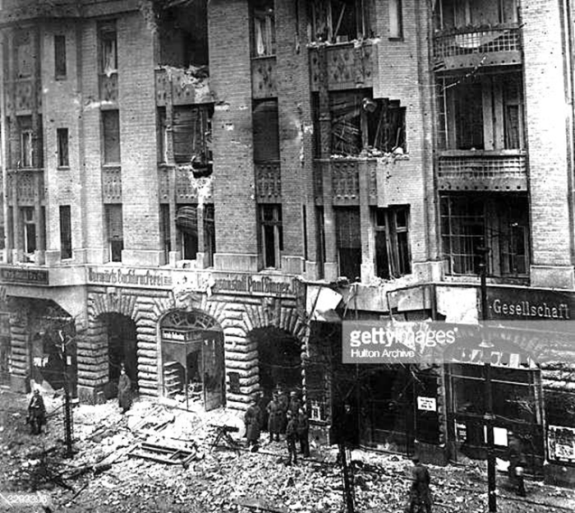
Source A

[Photograph showing damage to the offices of the socialist newspaper 'Vorwarts' Berlin 1919]
Use Source A and your own knowledge to describe the Spartacist uprising of 1919 [6] ______________________________________________________________________________________________________________________________________________________________________________________________________________________________________________________________________________________________________________________________________________________________________________________________________________________________________________________________________________________________________________________________________________________________________________________________________________________________________________________________________________________________________________________________________________________________________________________________________________________________________________________________________________________________________________________________________________________________________________________________________________________________________________________________________________________________________________________________________________

Q2. This question is about the impact of the First World War
Describe the French Occupation of the Ruhr in 1923 [8]
________________________________________________________________________________________________________________________________________________________________________________________________________________________________________________________________________________________________________________________________________________________________________________________________________________________________________________________________________________________________________________________________________________________________________________________________________________________________________________________________________________________________________________________________________________________________________________________________________________________________________________________________________________________________________________________________________________________________________________________________________________________________________________________________________________________________________________________________________________________________________________________________________________________________________________________________________________________________________________________________________________________________________________________________________________________________________________________________________________________________________________________________________________________________________________________________________________________________________________________________________________________

Q3. This question is about the impact of the First World War
Study the source below and then answer the question which follows.
Source B
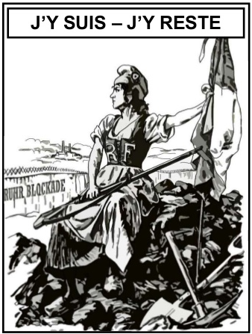

[A British cartoon from Punch 1923, the writing translates ‘Here I am – Here I stay’]
What was the purpose of Source B? [8]
[Use details from Source B and your own knowledge and understanding of the historical context to answer the question.]
______________________________________________________________________________________________________________________________________________________________________________________________________________________________________________________________________________________________________________________________________________________________________________________________________________________________________________________________________________________________________________________________________________________________________________________________________________________________________________________________________________________________________________________________________________________________________________________________________________________________________________________________________________________________________________________________________________________________________________________________________________________________________________________________________________________________________________________________________________________________________________________________________________________________________________________________________________________________________________________________________________________________________________________________________________________________________________________________________________________________________________________________________________________________________________________________________________________________________________________________________________________________________________________________________________________________________________________________________________________________________________________________________________________________________________________________________________________________________________________________________________________________________________________________________________________________________________________________________________________________________________________________________________________________________________________________________________________________________________________________________________________________________________________________________________________________________________________________________________________________________________________________________________________________________________________________

PRACTICE QUESTIONS

KEY QUESTION 2:
RECOVERY OF WEIMAR

Q1. This question is about the recovery of the Weimar
Source A
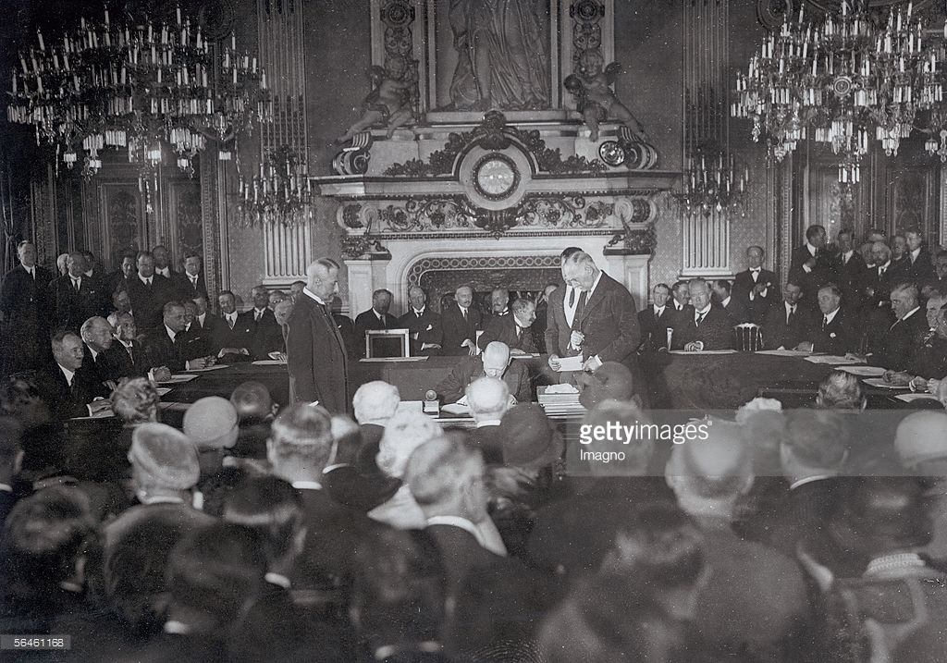

[Stresemann signing the Locarno Pact, 1925]
Use source A and your own knowledge to describe the Locarno Pact of 1925. [6] ______________________________________________________________________________________________________________________________________________________________________________________________________________________________________________________________________________________________________________________________________________________________________________________________________________________________________________________________________________________________________________________________________________________________________________________________________________________________________________________________________________________________________________________________________________________________________________________________________________________________________________________________________________________________________________________________________________________________________________________________________________________________________________________________________________________________________________________________________________

Q5. This question is about the recovery of Weimar Republic.
How significant was the Dawes Plan to Stresemann’s ‘golden age’? [16]
[Use your own knowledge and understanding of the issue to support your answer]
Marks for spelling punctuation and the accurate use of grammar and specialist language are allocated for this question. [3]
__________________________________________________________________________________________________________________________________________________________________________________________________________________________________________________________________________________________________________________________________________________________________________________________________________________________________________________________________________________________________________________________________________________________________________________________________________________________________________________________________________________________________________________________________________________________________________________________________________________________________________________________________________________________________________________________________________________________________________________________________________________________________________________________________________________________________________________________________________________________________________________________________________________________________________________________________________________________________________________________________________________________________________________________________________________________________________________________________________________________________________________________________________________________________________________________________________________________________________________________________________________________________________________________________________________________________________________________________________________________________________________________________________________________________________________________________________________________________________________________________________________________________________________________________________________________________________________________________________________________________________________________________________________________________________________________________________________________________________________________________________________________________________________________________________________________________________________________________________________________________________________________________________________________________________________________________________________________________________________________________________________________________________________________________________________________________________________________________________________________________________________________________________________________________________________________________________________________________________________________________________________________________________________________________________________________________________________________________________________________________________________________________________________________________________________________________________________________________________________________________________________________________________________________________________________________________________________________________________________________________________________________________________________________________________________________________________________________________________________________________________________________________________________________________________________________________________________________________________________________________________________________________________________________________________________________
PRACTICE QUESTIONS

KEY QUESTION 3:

END OF THE WEIMAR REPUBLIC

Q3. This question is about the end of the Weimar Republic.
Study the source below and then answer the question which follows.
Source B
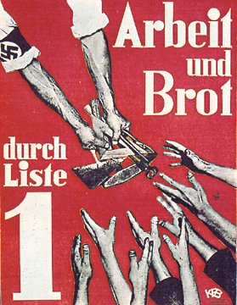

[A Nazi election poster, 1932. The text reads ‘Work and Bread’]

What was the purpose of source B? [8]
(Use details from Source B and your own knowledge and understanding of the historical context to answer the question.)
______________________________________________________________________________________________________________________________________________________________________________________________________________________________________________________________________________________________________________________________________________________________________________________________________________________________________________________________________________________________________________________________________________________________________________________________________________________________________________________________________________________________________________________________________________________________________________________________________________________________________________________________________________________________________________________________________________________________________________________________________________________________________________________________________________________________________________________________________________________________________________________________________________________________________________________________________________________________________________________________________________________________________________________________________________________________________________________________________________________________________________________________________________________________________________________________________________________________________________________________________________________________________________________________________________________________________________________________________________________________________________________________________________________________________________________________________________________________________________________________________________________________________________________________________________________________________________________________________________________________________________________________________________________________________________________________________________________________________________________________________________________________________________________________________________________________________________________________________________________________________________________________________________________________________________________________________________________________________________________________________________________________________________________________________________________________________________________________________________________________________
Q5. This question is about the end of the Weimar Republic.
How far did Nazi propaganda contribute to the Weimar Republic’s collapse between 1929 and 1933? [16]
[Use your own knowledge and understanding of the issue to support your answer]
Marks for spelling punctuation and the accurate use of grammar and specialist language are allocated for this question. [3]
__________________________________________________________________________________________________________________________________________________________________________________________________________________________________________________________________________________________________________________________________________________________________________________________________________________________________________________________________________________________________________________________________________________________________________________________________________________________________________________________________________________________________________________________________________________________________________________________________________________________________________________________________________________________________________________________________________________________________________________________________________________________________________________________________________________________________________________________________________________________________________________________________________________________________________________________________________________________________________________________________________________________________________________________________________________________________________________________________________________________________________________________________________________________________________________________________________________________________________________________________________________________________________________________________________________________________________________________________________________________________________________________________________________________________________________________________________________________________________________________________________________________________________________________________________________________________________________________________________________________________________________________________________________________________________________________________________________________________________________________________________________________________________________________________________________________________________________________________________________________________________________________________________________________________________________________________________________________________________________________________________________________________________________________________________________________________________________________________________________________________________________________________________________________________________________________________________________________________________________________________________________________________________________________________________________________________________________________________________________________________________________________________________________________________________________________________________________________________________________________________________________________________________________________________________________________________________________________________________________________________________________________________________________________________________________________________________________________________________________________________________________________________________________________________________________________________________________________________________________________________________________________________________________________________________________________

PRACTICE QUESTIONS

KEY QUESTION 4:
NAZI CONSOLIDATION OF POWER

Q3. This question is about the Nazi consolidation of power.
Study the source below and then answer the question which follows.
Source B
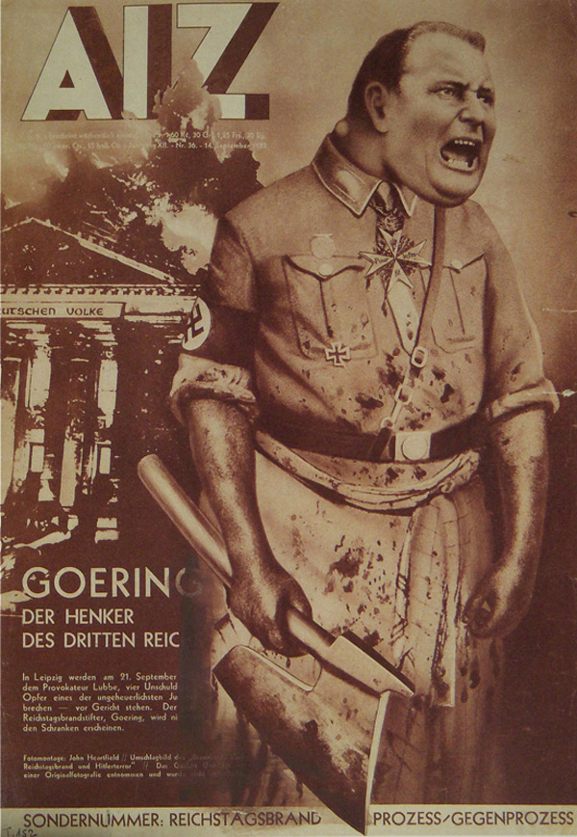
[A cartoon entitled ‘Goering the executioner’ showing Goering outside the burning Reichstag. It was published in a Communist magazine after the Reichstag fire in 1933.]

What was the purpose of source B? [8]
[Use details from Source B and your own knowledge and understanding of the historical context to answer the question]
__________________________________________________________________________________________________________________________________________________________________________________________________________________________________________________________________________________________________________________________________________________________________________________________________________________________________________________________________________________________________________________________________________________________________________________________________________________________________________________________________________________________________________________________________________________________________________________________________________________________________________________________________________________________________________________________________________________________________________________________________________________________________________________________________________________________________________________________________________________________________________________________________________________________________________________________________________________________________________________________________________________________________________________________________________________________________________________________________________________________________________________________________________________________________________________________________________________________________________________________________________________________________________________________________________________________________________________________________________________________________________________________________________________________________________________________________________________________________________________________________________________________________________________________________________________________________________________________________________________________________________________________________________________________________________________________________________________________________________________________________________________________________________________________________________________________________________________________________________

Q5. This question is about the Consolidation of power.
Was the Night of the Long Knives the most significant event in Hitler’s consolidation of power? [16]
[Use your own knowledge and understanding of the issue to support your answer]
Marks for spelling punctuation and the accurate use of grammar and specialist language are allocated for this question. [3]
__________________________________________________________________________________________________________________________________________________________________________________________________________________________________________________________________________________________________________________________________________________________________________________________________________________________________________________________________________________________________________________________________________________________________________________________________________________________________________________________________________________________________________________________________________________________________________________________________________________________________________________________________________________________________________________________________________________________________________________________________________________________________________________________________________________________________________________________________________________________________________________________________________________________________________________________________________________________________________________________________________________________________________________________________________________________________________________________________________________________________________________________________________________________________________________________________________________________________________________________________________________________________________________________________________________________________________________________________________________________________________________________________________________________________________________________________________________________________________________________________________________________________________________________________________________________________________________________________________________________________________________________________________________________________________________________________________________________________________________________________________________________________________________________________________________________________________________________________________________________________________________________________________________________________________________________________________________________________________________________________________________________________________________________________________________________________________________________________________________________________________________________________________________________________________________________________________________________________________________________________________________________________________________________________________________________________________________________________________________________________________________________________________________________________________________________________________________________________________________________________________________________________________________________________________________________________________________________________________________________________________________________________________________________________________________________________________________________________________________________________________________________________________________________________________________________________________________________________________________________________________________________________________________________________________________________

PRACTICE QUESTIONS

KEY QUESTION 5:

NAZI ECONOMIC, SOCIAL AND RACIAL POLICY

Q3. This question is about the Nazi economic, social and racial policy
Study the source below and then answer the question which follows.
Source A
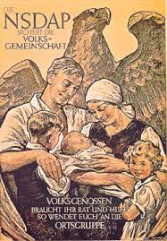
[A Nazi poster of 1937 showing the central role of women. It says ‘The Nazi Party protects the national community’ ]
Use Source A and your own knowledge to describe the role of women in Nazi Germany. [6]
__________________________________________________________________________________________________________________________________________________________________________________________________________________________________________________________________________________________________________________________________________________________________________________________________________________________________________________________________________________________________________________________________________________________________________________________________________________________________________________________________________________________________________________________________________________________________________________
Q4. This question is about Nazi economic, social and racial policy
Study the sources below and then answer the question that follows.
Source B
Mob law ruled in Berlin throughout the afternoon and evening as hordes of hooligans took part in an orgy of destruction. I have never seen an anti-Jewish outbreak as sickening as this. I saw fashionably dressed women clapping their hands and screaming with glee while respectable mothers held up their babies to see the ‘fun’. No attempt was made by the police to stop the rioters.

[An account of Kristallnacht published in the Daily Telegraph, a British newspaper, on 12 November 1938]
Source C
The death of a loyal party member by the Jewish murderer has aroused spontaneous anti-Jewish demonstrations through the Reich. In many places Jewish shops have been smashed. The synagogues, from which the teachings hostile to the state and people are spread have been set on fire. Well done to those Germans who have ensured revenge for the murder of an innocent German.

[An account of Kristallnacht published in Der Sturmer, an anti-Semitic German newspaper, on 10th November 1938]
Which of the sources is more useful to an historian studying Kristallnacht? [12]
[You should refer to both sources in your answer and use your knowledge and understanding of the historical context.]
______________________________________________________________________________________________________________________________________________________________________________________________________________________________________________________________________________________________________________________________________________________________________________________________________________________________________________________________________________________________________________________________________________________________________________________________________________________________________________________________________________________________________________________________________________________________________________________________________________________________________________________________________________________________________________________________________________________________________________________________________________________________________________________________________________________________________________________________________________________________________________________________________________________________________________________________________________________________________________________________________________________________________________________________________________________________________________________________________________________________________________________________________________________________________________________________________________________________________________________________________________________________________________________________________________________________________________________________________________________________________________________________________________________________________________________________________________________________________________________________________________________________________________________________________________________________________________________________________________________________________________________________________________________________________________________________________________________________________________________________________________________________________________________________________________________________________________________________________________________________________________________________________________________________________________________________________________________________________________________________________________________________________________________________________________________________________________________________________________________________________________________________________________________________________________________________________________________________________________________________________________________________________________________________________________
Q5. This question is about Nazi economic, social and racial policy
Did the lives of all Germans improve in Nazi Germany in the 1930s? [16]
[Use your own knowledge and understanding of the issue to support your answer]
Marks for spelling punctuation and the accurate use of grammar and specialist language are allocated for this question. [3]
__________________________________________________________________________________________________________________________________________________________________________________________________________________________________________________________________________________________________________________________________________________________________________________________________________________________________________________________________________________________________________________________________________________________________________________________________________________________________________________________________________________________________________________________________________________________________________________________________________________________________________________________________________________________________________________________________________________________________________________________________________________________________________________________________________________________________________________________________________________________________________________________________________________________________________________________________________________________________________________________________________________________________________________________________________________________________________________________________________________________________________________________________________________________________________________________________________________________________________________________________________________________________________________________________________________________________________________________________________________________________________________________________________________________________________________________________________________________________________________________________________________________________________________________________________________________________________________________________________________________________________________________________________________________________________________________________________________________________________________________________________________________________________________________________________________________________________________________________________________________________________________________________________________________________________________________________________________________________________________________________________________________________________________________________________________________________________________________________________________________________________________________________________________________________________________________________________________________________________________________________________________________________________________________________________________________________________________________________________________________________________________________________________________________________________________________________________________________________________________________________________________________________________________________________________________________________________________________________________________________________________________________________________________________________________________________________________________________________________________________________________________________________________________________________________________________________________________________________________________________________________________________________________________________________________________________

PRACTICE QUESTIONS

KEY QUESTION 6:

TERROR AND PERSUASION

Q1. This question is about terror and persuasion.
Study the source below and then answer the question which follows.
Source A
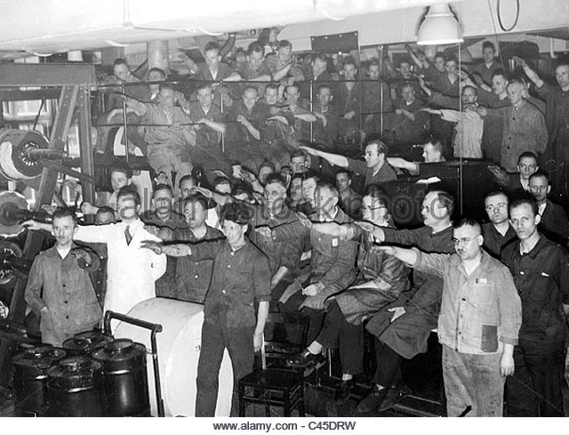
[Factory workers listening to a radio broadcast by Hitler, 1934]
Use Source A and your own knowledge to describe how media was used to persuade German Citizens to support the Nazi Party. [6]
__________________________________________________________________________________________________________________________________________________________________________________________________________________________________________________________________________________________________________________________________________________________________________________________________________________________________________________________________________________________________________________________________________________________________________________________________________________________________________________________________________________________________________________________________________________________________________________
Q3. This question is about Terror and persuasion
Study the source below and then answer the question which follows.
Source A
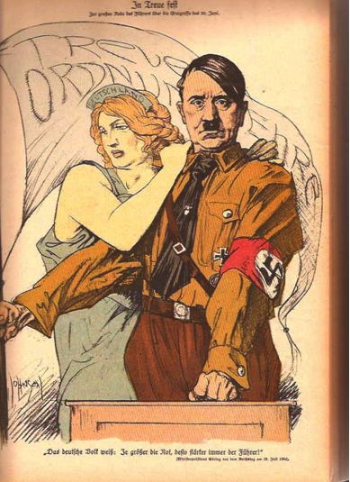

[A propaganda poster of 1934 which says ‘Loyalty, Honour and order’]

What was the purpose of Source B? [8]
[Use details from Source B and your own knowledge and understanding of the historical context to answer the question.]
________________________________________________________________________________________________________________________________________________________________________________________________________________________________________________________________________________________________________________________________________________________________________________________________________________________________________________________________________________________________________________________________________________________________________________________________________________________________________________________________________________________________________________________________________________________________________________________________________________________________________________________________________________________________________________________________________________________________________________________________________________________________________________________________________________________________________________________________________________________________________________________________________________________________________________________________________________________________________________________________________________________________________________________________________________________________________________________________________________________________________________________________________________________________________________________________________________________________________________________________________________________________________________________________________________________________________________________________________________________________________________________________________________________________________________________________________________________________________________________________________________________________________________________________________________________________________________________________________________________________________________________________________________________________________________________________________________________________________________________________________________________________________________________________________________________________________________________________________________________________________________________________________________________________________________________________________________________________________________________
Q4. This question is about Terror and persuasion.
Study the sources below and then answer the question that follows.
Source A
Finally, I alone created, on my own initiative, the State Secret Police Department. This is the instrument which is so much feared by the enemies of the Sate, and which is chiefly responsible for the fact that in Germany and Prussia today there is no question of a Marxist or communist danger.

[Herman Goering explains about his role in setting up the Gestapo in his book Germany Reborn, written in 1934]
Source B
In a cafe, a 64 year old women remarked to her companion at the table: ‘Mussolini (leader of Italy) has more political sense in one of his boots than Hitler has in his brain.’ The remark was overheard and five minutes later the woman was arrested by the Gestapo who had been alerted by telephone.

[An incident reported in the Rhineland, July 1938]
Which of the sources is more useful to an historian studying the role of the Gestapo in Nazi Germany? [12]
[You should refer to both sources in your answer and use your knowledge and understanding of the historical context.]
______________________________________________________________________________________________________________________________________________________________________________________________________________________________________________________________________________________________________________________________________________________________________________________________________________________________________________________________________________________________________________________________________________________________________________________________________________________________________________________________________________________________________________________________________________________________________________________________________________________________________________________________________________________________________________________________________________________________________________________________________________________________________________________________________________________________________________________________________________________________________________________________________________________________________________________________________________________________________________________________________________________________________________________________________________________________________________________________________________________________________________________________________________________________________________________________________________________________________________________________________________________________________________________________________________________________________________________________________________________________________________________________________________________________________________________________________________________________________________________________________________________________________________________________________________________________________________________________________________________________________________________________________________________________________________________________________________________________________________________________________________________________________________________________________________________________________________________________________________________________________________________________________________________________________________________________________________________________________________________________________________________________________________________________________________________________________________________________________________________________________________________________________________________________________________________________________________________________________________________________________________________________________________________________________________
PRACTICE QUESTIONS

KEY QUESTION 7:

HITLER’S FOREIGN POLICY

Q2. This question is about Hitler’s foreign policy.
Describe Hitler’s foreign policy aims. [8]
________________________________________________________________________________________________________________________________________________________________________________________________________________________________________________________________________________________________________________________________________________________________________________________________________________________________________________________________________________________________________________________________________________________________________________________________________________________________________________________________________________________________________________________________________________________________________________________________________________________________________________________________________________________________________________________________________________________________________________________________________________________________________________________________________________________________________________________________________________________________________________________________________________________________________________________________________________________________________________________________________________________________________________________________________________________________________________________________________________________________________________________________________________________________________________________________________________________________________________________________________________________

Q4. This question is about Hitler’s foreign policy
Study the sources below and then answer the question that follows.
Source A
Herr Hitler returned here yesterday, a conquering hero. His triumphant welcome was shared by the army he sent to Austria. Flowers were strewn in the path of the armoured cars. If any Austrian was against him on Friday, they either hid their faces or were completely converted yesterday and today.

[A report from Germany published in the Times on Monday 14th March 1938, after German troops entered Austria]
Source B
I imagine that the event which is in our minds today, the Anschluss, will be the cause of regret, of sorrow, perhaps indignation. The event cannot be regarded by His majesty’s government with indifference….The immediate result must be to intensify the sense of uncertainty and insecurity in Europe. This is not a moment for hasty decisions or for careless words. As regards our defence programmes…we have decided to make a fresh review, and in due course we shall announce what further steps we may think it necessary to take.

[A question from a Nazi math’s textbook, 1933]

[From a speech by Neville chamberlain, British Prime Minister, to the House of Commons, 14th March 1938]
Which of the sources is more useful to an historian studying the Anschluss of 1938? [12]
[You should refer to both sources in your answer and use your knowledge and understanding of the historical context.]
__________________________________________________________________________________________________________________________________________________________________________________________________________________________________________________________________________________________________________________________________________________________________________________________________________________________________________________________________________________________________________________________________________________________________________________________________________________________________________________________________________________________________________________________________________________________________________________________________________________________________________________________________________________________________________________________________________________________________________________________________________________________________________________________________________________________________________________________________________________________________________________________________________________________________________________________________________________________________________________________________________________________________________________________________________________________________________________________________________________________________________________________________________________________________________________________________________________________________________________________________________________________________________________________________________________________________________________________________________________________________________________________________________________________________________________________________________________________________________________________________________________________________________________________________________________________________________________________________________________________________________________________________________________________________________________________________________________________________________________________________________________________________________________________________________________________________________________________________________________________________________________________________________________________________________________________________________________________________________________________________________________________________________________________________________________________________________________________________________________________________________________________________________________________________________________________________________________________

Q5. This question is about Hitler’s foreign policy.
Hitler’s main aim in foreign policy was to unite all German-speaking people in a single country. To what extent do you agree with this interpretation? [16]
[Use your own knowledge and understanding of the issue to support your answer]
Marks for spelling punctuation and the accurate use of grammar and specialist language are allocated for this question. [3]
__________________________________________________________________________________________________________________________________________________________________________________________________________________________________________________________________________________________________________________________________________________________________________________________________________________________________________________________________________________________________________________________________________________________________________________________________________________________________________________________________________________________________________________________________________________________________________________________________________________________________________________________________________________________________________________________________________________________________________________________________________________________________________________________________________________________________________________________________________________________________________________________________________________________________________________________________________________________________________________________________________________________________________________________________________________________________________________________________________________________________________________________________________________________________________________________________________________________________________________________________________________________________________________________________________________________________________________________________________________________________________________________________________________________________________________________________________________________________________________________________________________________________________________________________________________________________________________________________________________________________________________________________________________________________________________________________________________________________________________________________________________________________________________________________________________________________________________________________________________________________________________________________________________________________________________________________________________________________________________________________________________________________________________________________________________________________________________________________________________________________________________________________________________________________________________________________________________________________________________________________________________________________________________________________________________________________________________________________________________________________________________________________________________________________________________________________________________________________________________________________________________________________________________________________________________________________________________________________________________________________________________________________________________________________________________________________________________________________________________________________________________________________________________________________________________________________________________________________________________________________________________________________________________________________________________________

